EE313 Matlab HW 9

# Problem 1:

## Code:

## 

## Graph:

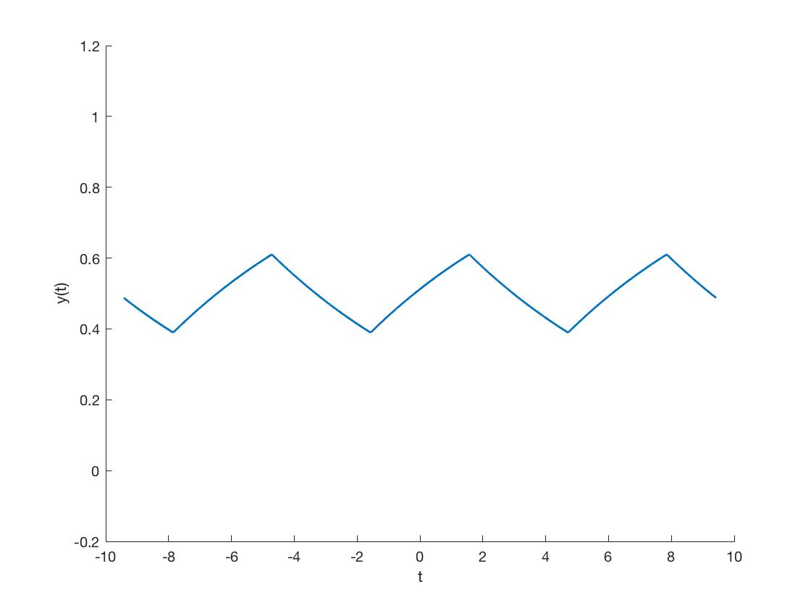

# Problem 2:

## Code:



## Graph:

