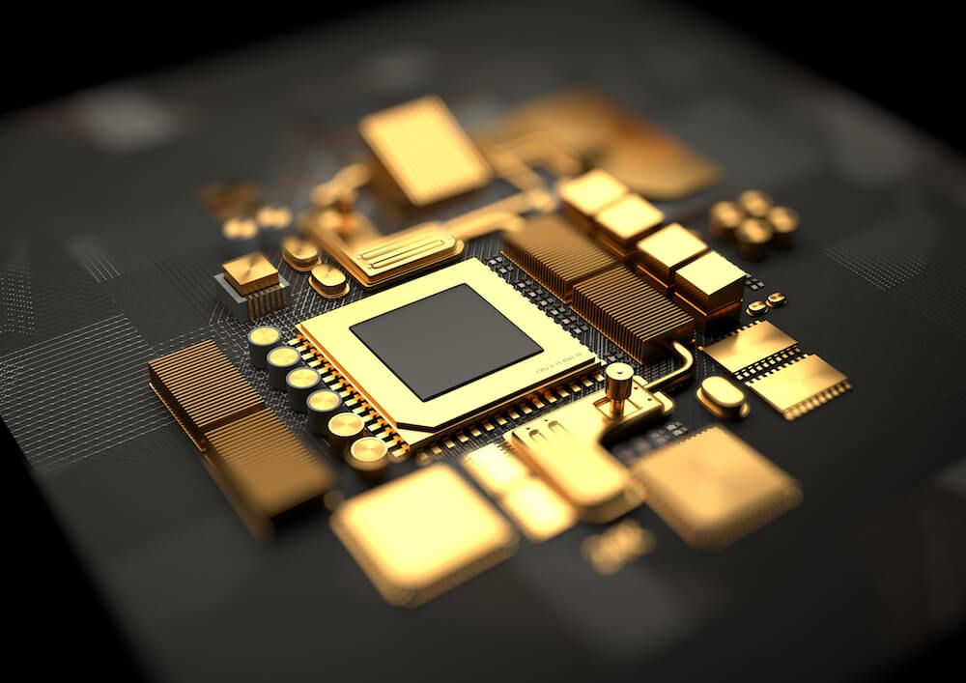

|  |
| --- |
| OpenMP  Vector Sorting |
|  |
| COMPUTER ARCHITECTURE  Sergio Silvestre Pavón  Josue Carlos Zenteno Yave |

Introduction

For this assignment we have used two different kind of processors, the ones that we had available at the moment of doing the measures. These processors are ‘ Intel Core i7-8750H ’ and ‘ Intel Core i5-7200U ’ respectively.

We thought that taking measures with both of them could be interesting, in order to also show what is the difference between two different kinds of processors exetucing the same program, and how do they improve their preformance with the parallelization of the program.

Furthermore we have depicted in some plots how the execution time behaves when we ‘play’ with different vector sizes, these plots are, in a more precise way, dot plots with a line that shows in a better what we have said.

One thing to take into account is that the Task 2 is not explained in this document, as it was required to be explained as comments in the source code.

Task 1

For this task, as it is stated in the assignment, we have taken some measures and collected the more significant of them in the following charts. Time is measured in ms and size of the vector reffers to the number of elements that the vector. (The complete set of measures is placed at the end of this document)

Intel Core i5-7200U

|  |  |  |  |  |  |  |
| --- | --- | --- | --- | --- | --- | --- |
| Size  Alg | 10 | 100 | 1000 | 10000 | 100000 | 200000 |
| A | 0.03025799 | 0.11798233 | 1.95284766 | 106.1719299 | 5644.5460390 | 20460.150972 |
| B | 0.02289666 | 0.08530766 | 2.29401566 | 83.91503000 | 8314.5898930 | 31102.613464 |
| C | 0.02942833 | 0.20012600 | 6.97919060 | 312.0844530 | 37636.218750 | 140526.68696 |
| D | 0.02826400 | 0.19659600 | 7.38811933 | 262.3261896 | 29729.957390 | 114154.29732 |

Intel Core i7-8750H

|  |  |  |  |  |  |  |
| --- | --- | --- | --- | --- | --- | --- |
| Size  Alg | 10 | 100 | 1000 | 10000 | 100000 | 200000 |
| A | 0.01012366 | 0.03917133 | 1.17783200 | 63.29890433 | 3878.0865746 | 15561.694973 |
| B | 0.00769933 | 0.02525733 | 1.43228333 | 58.73236433 | 5878.2683309 | 23695.176663 |
| C | 0.00900966 | 0.05991400 | 3.83168433 | 223.6413363 | 26977.390251 | 109398.75507 |
| D | 0.00994266 | 0.06362633 | 4.12101699 | 182.0911991 | 20388.736503 | 83265.275556 |

As we can see, there is, in fact, a difference between the two processors that we are testing. But this difference is only visible on the response times while executing the different algorithms. Therefore as we cn also see, the algorithms have the same behavior independently of the Architecture.

So, analizyng every algorithm in a more exhaustive way we can observe these facts:

1. Using small vector sizes, we can not appreciate a big difference between on and another algorithm, as they have very similar response times. But the difference between them appears when we set a large vector size, where both Algorithm C and D increments dramatically the response time in comparison to the other algorithms.
2. The behaviors of the algorithms are very close to the Exponential behavior as they don't grow following a straight line (what happens if the response time would have growth in a propotional way). So we can state that multiplying the input by 10 does not imply that the response time will grow 10 times too, it will grow much more.
3. There is not an absolute 'winner', there is not an algorithm that is always the fastest one, as it depends on the vector size, in very low vector sizes the fastes Algorithm is B but when th einput grows the fastest algorithm is A. That leads to think that if you want to compute very small vector sizes you should use the Algorithm B and if you want to compute very large vector you should use A, but it is a little bit tricky as if we look the difference on the response times, there is not a notorious difference between A and B in small vector sizes. So this can generally be insignificant, but if we are trying to be as precise as possible (for example in real time programs or distributed systems) it is a fact that algorithm B is faster than A in the very beggining.

A very different situation exist talking about the 'looser', as the worse algorithm talking about response times is Algorithm C, this algorithm has proved that is very unneficent as it's response time is the one tha grows faster and faster with respect to the others.

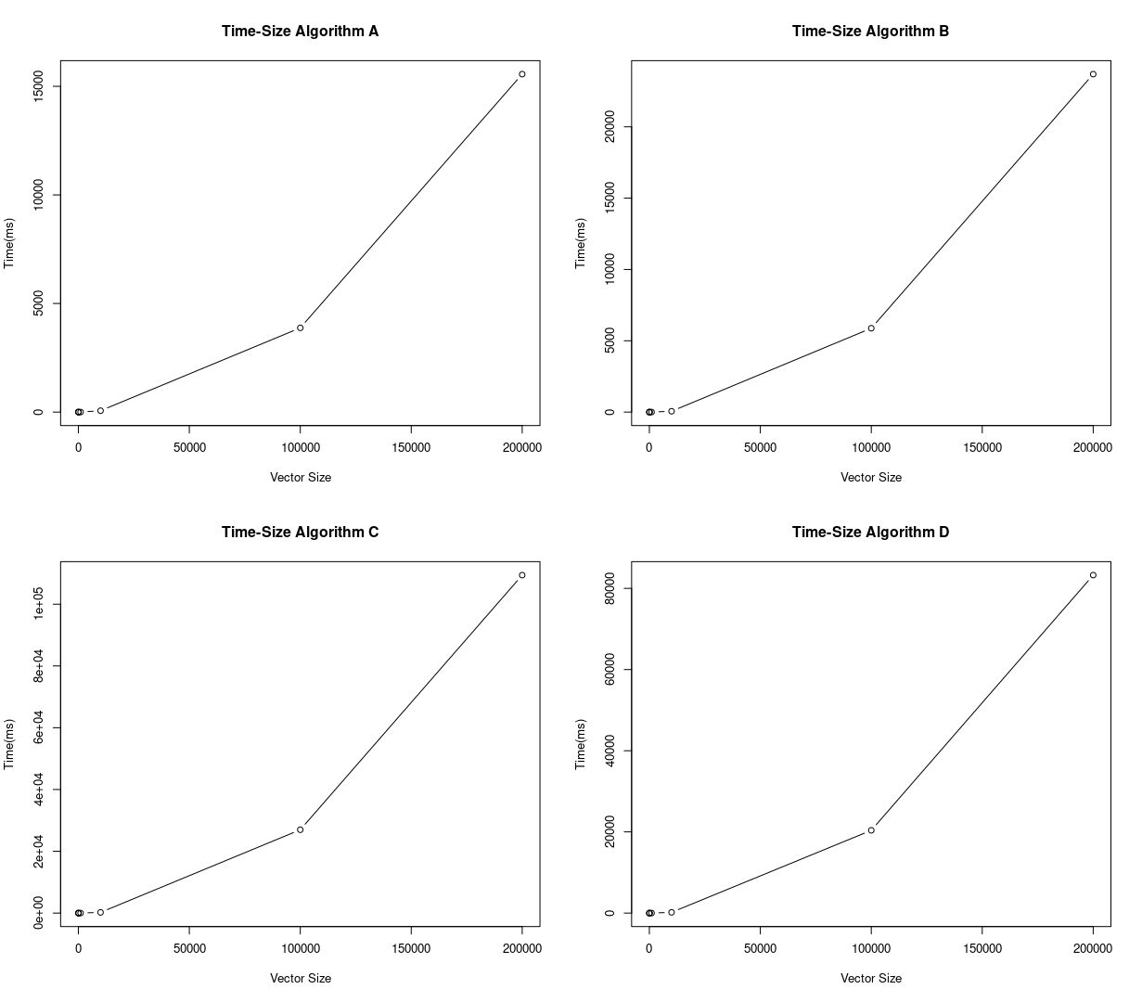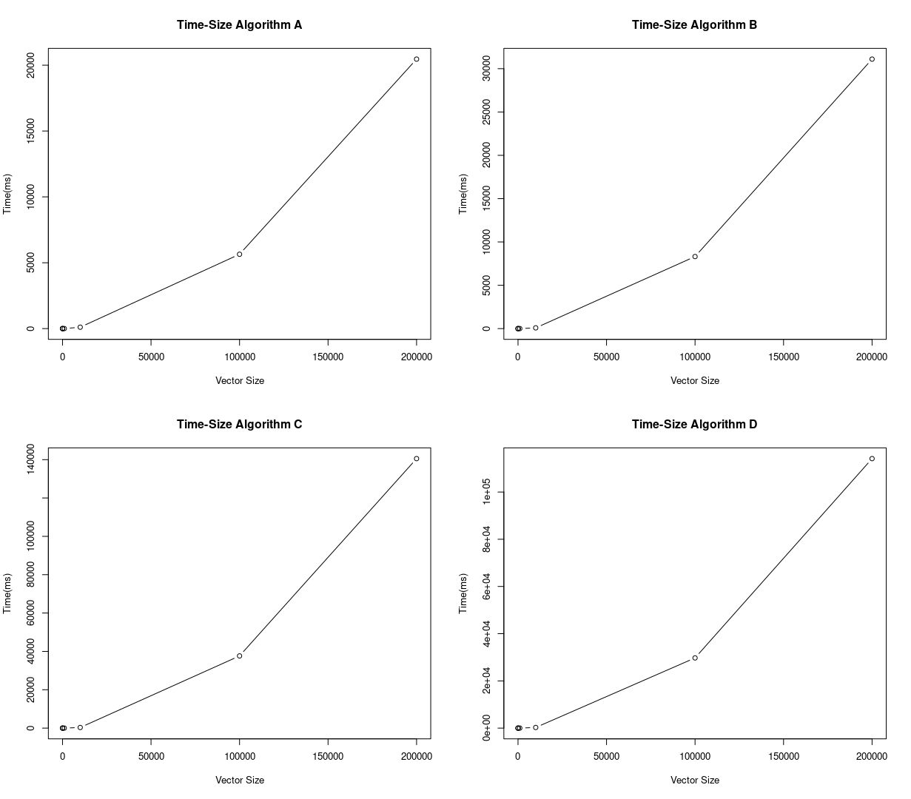We have represented the algorithm Time-Size plots:

Intel Core i5-7200U

Intel Core i7-8750H

Task 3

For this task, as it is stated in the assignment, we have taken again some measures and collected the more significant of them in the following charts but, with the main difference that in this time we have taken the measures with the parallelized source code. Time is measured in ms and size of the vector reffers to the number of elements that the vector. (The complete set of measures is placed at the end of this document)

Intel Core i5-7200U

|  |  |  |  |  |  |  |
| --- | --- | --- | --- | --- | --- | --- |
| Size  Alg | 10 | 100 | 1000 | 10000 | 100000 | 200000 |
| A | 0.05035433 | 0.39354566 | 0.62213433 | 51.31171699 | 4157.4183153 | 16356.7031736 |
| B | 0.01720600 | 0.02897066 | 0.92546300 | 73.45548100 | 7211.3050546 | 28191.0550566 |
| C | 0.01270233 | 0.04832933 | 2.50017300 | 273.4751610 | 33189.870487 | 132822.440236 |
| D | 0.03248133 | 0.18695233 | 3.64057499 | 109.7173650 | 11466.426697 | 43237.7163926 |

Intel Core i7-8750H

|  |  |  |  |  |  |  |
| --- | --- | --- | --- | --- | --- | --- |
| Size  Alg | 10 | 100 | 1000 | 10000 | 100000 | 200000 |
| A | 0.02755333 | 0.06028066 | 0.46698333 | 38.05365033 | 2814.8695793 | 11225.2330333 |
| B | 0.01431200 | 0.04213366 | 0.70653833 | 55.77766633 | 5368.1400043 | 21242.2937066 |
| C | 0.01461666 | 0.06046333 | 1.89549333 | 207.4096066 | 24970.167456 | 100109.238919 |
| D | 0.05795233 | 0.21679099 | 1.83298366 | 38.99261433 | 3343.9230059 | 15970.4816176 |

As we see, there is a markable difference between the parallelized code and the non-parallelized, this difference is even more evident when we watch at the larger vector sizes. So, for that reason, we will focus on this larger vector sizes (specifically 200000), as we can prove in a more detailed way, how much improvement exists.

Now by using Amdahl’s law we can calculate the speed gain for algorithms A and D, and only those, as algorithms B and C are non parallelizables as they have different kinds of dependences.

## Speed gain A

Intel Core i7-8750H

SgA =

Intel Core i5-7200U

SgA =

## Speed gain D

Intel Core i7-8750H

SgD =

Intel Core i5-7200U

SgD =

As we can see there is, in fact, an improvement between the non-parallelized and the parallelized code. And we can also see that the fact of having more cores, helps with the fact of increasing the performance even more. As we can have more things happening at the same time.

Therefore we can answer the questions made in the presentation segment. It’s a fact that two different processors with different architectures neither increase the performance in the same proportion nor have the same speed executing the algorithms.

This time we have depicted the Time-Size dot plots to show how the algorithms behave.

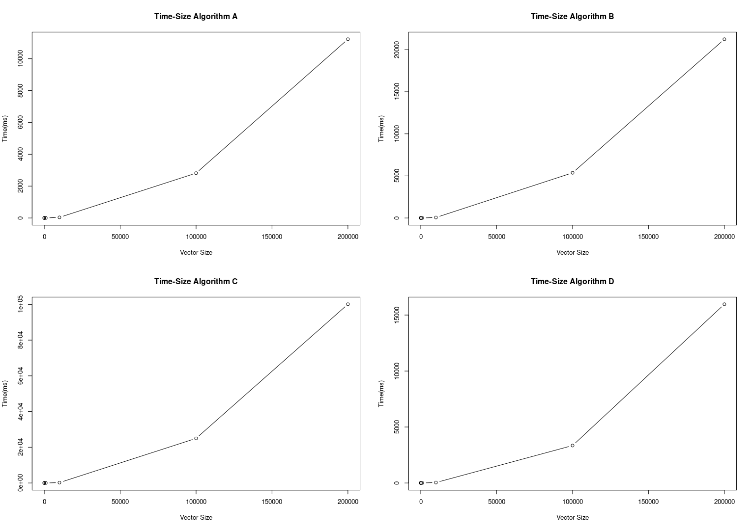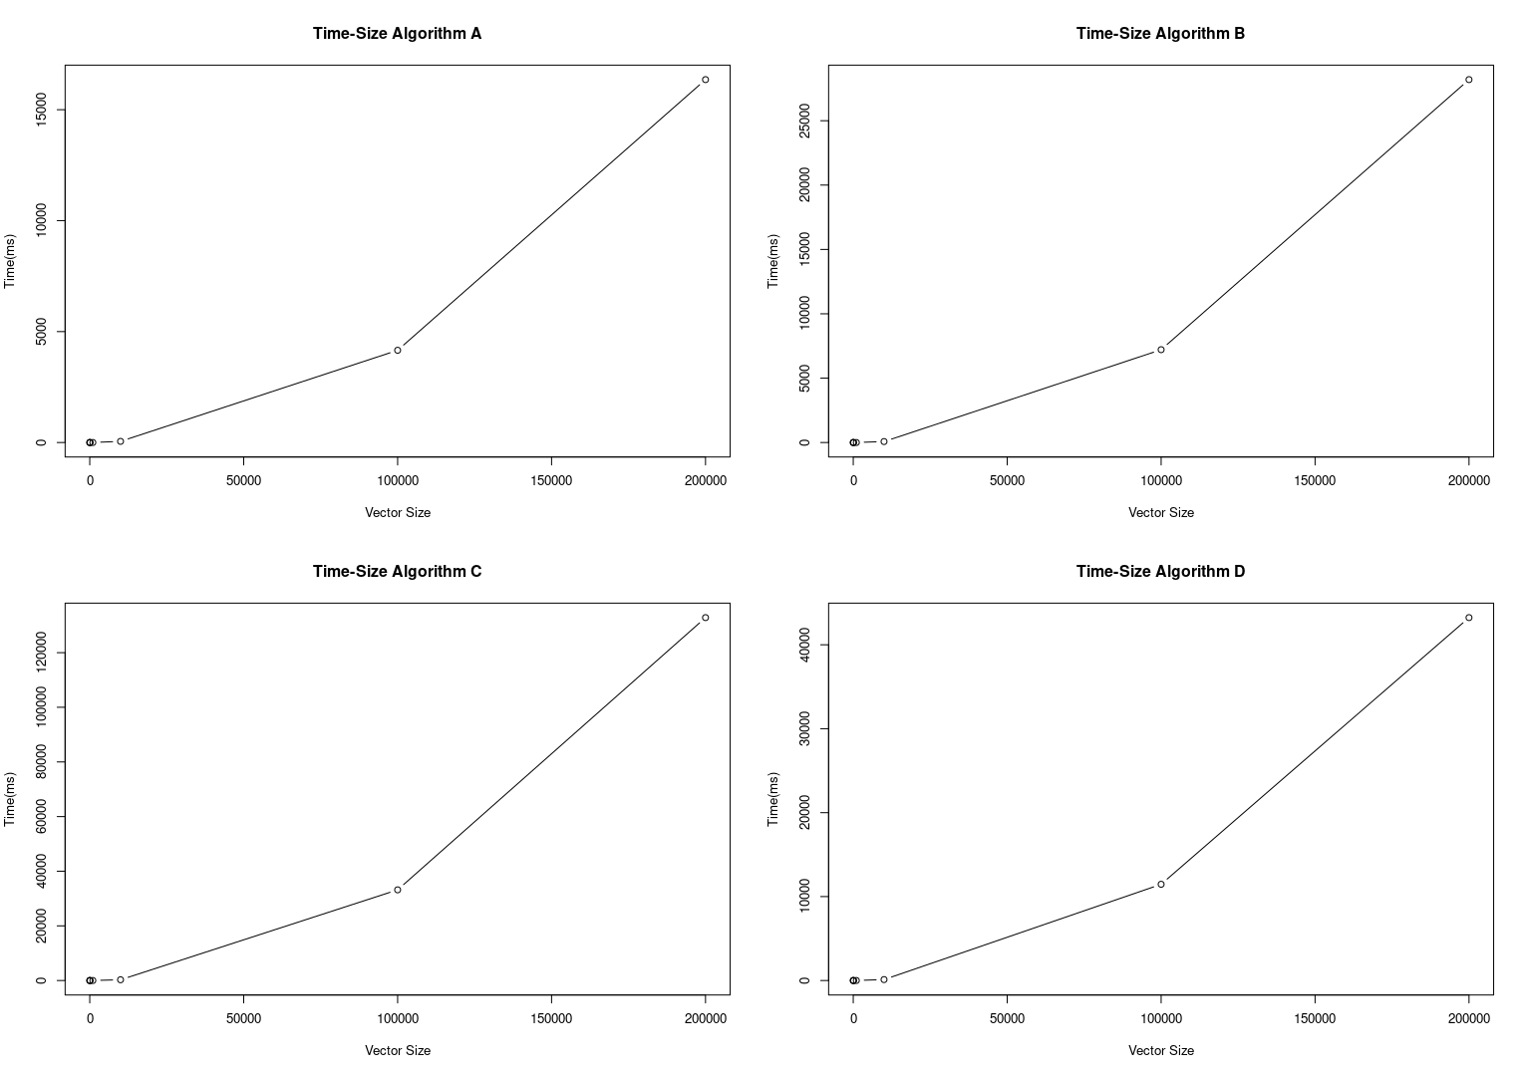

Intel Core i5-7200U

Intel Core i7-8750H

Annex

## Sequential Complete Measurements

Intel Core i7-8750H

Measurement 10:

A:

1: 0.01039600 miliseconds

2: 0.01408500 miliseconds (slowest)

3: 0.01030600 miliseconds

4: 0.00592100 miliseconds (fastest)

5: 0.00966900 miliseconds

B:

1: 0.00734600 miliseconds

2: 0.01408500 miliseconds (slowest)

3: 0.00828500 miliseconds

4: 0.00615900 miliseconds (fastest)

5: 0.00746700 miliseconds

C:

1: 0.00967500 miliseconds

2: 0.01274500 miliseconds (slowest)

3: 0.00713000 miliseconds

4: 0.00595600 miliseconds (fastest)

5: 0.01022400 miliseconds

D:

1: 0.01015300 miliseconds

2: 0.01131600 miliseconds (slowest)

3: 0.00877000 miliseconds

4: 0.00796600 miliseconds (fastest)

5: 0.01090500 miliseconds

Delete the slowest and the fastest and average of the other three

A: (0.01039600 + 0.01030600 + 0.00966900) /3 = 0.010123666666666666

B: (0.00734600 + 0.00828500 + 0.00746700) /3 = 0.007699333333333333

C: (0.00967500 + 0.00713000 + 0.01022400) /3 = 0.009009666666666668

D: (0.01015300 + 0.00877000 + 0.01090500) /3 = 0.009942666666666667

Measurement 100:

A:

1: 0.03900600 miliseconds

2: 0.04384300 miliseconds

3: 0.02517900 miliseconds (fastest)

4: 0.04787600 miliseconds (slowest)

5: 0.03466500 miliseconds

B:

1: 0.02695700 miliseconds

2: 0.02620000 miliseconds

3: 0.01770100 miliseconds (fastest)

4: 0.02977200 miliseconds (slowest)

5: 0.02261500 miliseconds

C:

1: 0.06100300 miliseconds

2: 0.06554400 miliseconds

3: 0.04175500 miliseconds (fastest)

4: 0.07483000 miliseconds (slowest)

5: 0.05319500 miliseconds

D:

1: 0.06211800 miliseconds

2: 0.06996100 miliseconds

3: 0.04224500 miliseconds (fastest)

4: 0.07208400 miliseconds (slowest)

5: 0.05880000 miliseconds

Delete the slowest and the fastest and average of the other three

A: (0.03900600 + 0.04384300 + 0.03466500) /3 = 0.039171333333333336

B: (0.02695700 + 0.02620000 + 0.02261500) /3 = 0.02525733333333333

C: (0.06100300 + 0.06554400 + 0.05319500) /3 = 0.059914

D: (0.06211800 + 0.06996100 + 0.05880000) /3 = 0.06362633333333333

Measurement 1000:

A:

1: 0.68390500 miliseconds (fastest)

2: 1.42196900 miliseconds (slowest)

3: 1.12428100 miliseconds

4: 1.20408300 miliseconds

5: 1.20513200 miliseconds

B:

1: 0.88215500 miliseconds (fastest)

2: 1.88515300 miliseconds (slowest)

3: 1.30627500 miliseconds

4: 1.48693000 miliseconds

5: 1.50364500 miliseconds

C:

1: 2.24796800 miliseconds (fastest)

2: 4.83558700 miliseconds (slowest)

3: 3.69439600 miliseconds

4: 3.81240100 miliseconds

5: 3.98825600 miliseconds

D:

1: 2.32730300 miliseconds (fastest)

2: 4.93812600 miliseconds (slowest)

3: 3.87867200 miliseconds

4: 4.04516500 miliseconds

5: 4.43921400 miliseconds

Delete the slowest and the fastest and average of the other three

A: (1.12428100 + 1.20408300 + 1.20513200) /3 = 1.1778320000000002

B: (1.30627500 + 1.48693000 + 1.50364500) /3 = 1.4322833333333334

C: (3.69439600 + 3.81240100 + 3.98825600) /3 = 3.831684333333333

D: (3.87867200 + 4.04516500 + 4.43921400) /3 = 4.121016999999999

Measurement 10000:

A:

1: 64.97279100 miliseconds (slowest)

2: 64.19168400 miliseconds

3: 63.41531600 miliseconds

4: 49.45484300 miliseconds (fastest)

5: 62.28971300 miliseconds

B:

1: 57.81129200 miliseconds (fastest)

2: 58.73213600 miliseconds

3: 58.46788200 miliseconds

4: 59.61375800 miliseconds (slowest)

5: 58.99707500 miliseconds

C:

1: 219.09739000 miliseconds (fastest)

2: 227.46944000 miliseconds (slowest)

3: 226.63727600 miliseconds

4: 223.32350000 miliseconds

5: 220.96323300 miliseconds

D:

1: 175.14914200 miliseconds (fastest)

2: 186.44133300 miliseconds (slowest)

3: 182.75133400 miliseconds

4: 179.04777700 miliseconds

5: 184.47448600 miliseconds

Delete the slowest and the fastest and average of the other three

A: (64.19168400 + 63.41531600 + 62.28971300) /3 = 63.29890433333333

B: (58.73213600 + 58.46788200 + 58.99707500) /3 = 58.73236433333333

C: (226.63727600 + 223.32350000 + 220.96323300) /3 = 223.64133633333336

D: (182.75133400 + 179.04777700 + 184.47448600) /3 = 182.09119900000005

Measurement 100000:

A:

1: 3924.43045100 miliseconds

2: 3863.09089300 miliseconds

3: 3834.38163800 miliseconds (fastest)

4: 3943.90602400 miliseconds (slowest)

5: 3846.73838000 miliseconds

B:

1: 5915.61565300 miliseconds

2: 5825.32269000 miliseconds (fastest)

3: 5843.26538500 miliseconds

4: 6046.89200100 miliseconds (slowest)

5: 5875.92395500 miliseconds

C:

1: 26943.56309300 miliseconds

2: 26905.27193500 miliseconds

3: 26873.29061900 miliseconds (fastest)

4: 27146.60216700 miliseconds (slowest)

5: 27083.33572500 miliseconds

D:

1: 20291.91485000 miliseconds (fastest)

2: 20350.22445000 miliseconds

3: 20446.95861100 miliseconds (slowest)

4: 20438.90855700 miliseconds

5: 20377.07650400 miliseconds

Delete the slowest and the fastest and average of the other three

A: (3924.43045100 + 3863.09089300 + 3846.73838000) /3 = 3878.0865746666664

B: (5915.61565300 + 5843.26538500 + 5875.92395500) /3 = 5878.268330999999

C: (26943.56309300 + 26905.27193500 + 27083.33572500) /3 = 26977.390251

D: (20350.22445000 + 20438.90855700 + 20377.07650400) /3 = 20388.736503666663

Measurement 200000:

A:

1: 15611.59104100 miliseconds

2: 15498.32431600 miliseconds

3: 15629.13347700 miliseconds (slowest)

4: 15575.16956300 miliseconds

5: 15028.67622300 miliseconds (fastest)

B:

1: 23702.88593300 miliseconds

2: 23697.32919500 miliseconds

3: 23826.00264400 miliseconds (slowest)

4: 23685.31486200 miliseconds

5: 21712.29571300 miliseconds (fastest)

C:

1: 109164.76463800 miliseconds

2: 109391.60571600 miliseconds

3: 109398.22876900 miliseconds (slowest)

4: 109639.89487900 miliseconds

5: 101041.97649700 miliseconds (fastest)

D:

1: 83039.38122900 miliseconds

2: 83271.19046700 miliseconds

3: 83485.25497400 miliseconds

4: 83638.08041700 miliseconds (slowest)

5: 75778.99928700 miliseconds (fastest)

Delete the slowest and the fastest and average of the other three

A: (15611.59104100 + 15498.32431600 + 15575.16956300) /3 = 15561.694973333331

B: (23702.88593300 + 23697.32919500 + 23685.31486200) /3 = 23695.17666333333

C: (109164.76463800 + 109391.60571600 + 109639.89487900) /3 = 109398.75507766668

D: (83039.38122900 + 83271.19046700 + 83485.25497400) /3 = 83265.27555666666

Intel Core i5-7200U

Measurement 10:

A:

1: 0.04789200 miliseconds (slowest)

2: 0.02926600 miliseconds

3: 0.02086400 miliseconds (fastest)

4: 0.02747000 miliseconds

5: 0.03403800 miliseconds

B:

1: 0.02791100 miliseconds

2: 0.01754400 miliseconds (fastest)

3: 0.01817900 miliseconds

4: 0.02260000 miliseconds

5: 0.03184400 miliseconds (slowest)

C:

1: 0.03082100 miliseconds

2: 0.03009300 miliseconds

3: 0.02352300 miliseconds (fastest)

4: 0.04102900 miliseconds (slowest)

5: 0.02737100 miliseconds

D:

1: 0.02492700 miliseconds

2: 0.02916300 miliseconds

3: 0.02357000 miliseconds (fastest)

4: 0.03676200 miliseconds (slowest)

5: 0.03070200 miliseconds

Delete the slowest and the fastest and average of the other three

A: (0.02926600+0.02747000+0.03403800) /3 = 0.030257999999999997

B: (0.02791100+0.01817900+0.02260000) /3 = 0.022896666666666666

C: (0.03082100+0.03009300+0.02737100) /3 = 0.029428333333333334

D: (0.02492700+0.02916300+0.03070200) /3 = 0.028264

Measurement 100:

A:

1: 0.11278200 miliseconds

2: 0.13496100 miliseconds

3: 0.05250400 miliseconds (fastest)

4: 0.10620400 miliseconds

5: 0.19603500 miliseconds (slowest)

B:

1: 0.07614500 miliseconds

2: 0.09286800 miliseconds

3: 0.02710600 miliseconds (fastest)

4: 0.08691000 miliseconds

5: 0.13861300 miliseconds (slowest)

C:

1: 0.20096300 miliseconds

2: 0.19111600 miliseconds

3: 0.09713800 miliseconds (fastest)

4: 0.20829900 miliseconds

5: 0.27409900 miliseconds (slowest)

D:

1: 0.21114900 miliseconds

2: 0.19245800 miliseconds

3: 0.15323400 miliseconds (fastest)

4: 0.18618100 miliseconds

5: 0.30385500 miliseconds (slowest)

Delete the slowest and the fastest and average of the other three

A: (0.11278200+0.13496100+0.10620400) /3 = 0.11798233333333334

B: (0.07614500+0.09286800+0.08691000) /3 = 0.08530766666666667

C: (0.20096300+0.19111600+0.20829900) /3 = 0.20012600000000003

D: (0.21114900+0.19245800+0.18618100) /3 = 0.196596

Measurement 1000:

A:

1: 5.57368300 miliseconds (slowest)

2: 1.86236000 miliseconds

3: 2.29279300 miliseconds

4: 1.70339000 miliseconds

5: 1.69719400 miliseconds (fastest)

B:

1: 5.41146800 miliseconds (slowest)

2: 2.06240100 miliseconds

3: 2.73795000 miliseconds

4: 2.05725300 miliseconds (fastest)

5: 2.08169600 miliseconds

C:

1: 14.54388900 miliseconds (slowest)

2: 6.04039000 miliseconds

3: 9.25284000 miliseconds

4: 5.64434200 miliseconds

5: 4.30718000 miliseconds (fastest)

D:

1: 9.79168100 miliseconds (slowest)

2: 5.88649300 miliseconds

3: 9.73108300 miliseconds

4: 6.54678200 miliseconds

5: 3.92546800 miliseconds (fastest)

Delete the slowest and the fastest and average of the other three

A: (1.86236000+2.29279300+1.70339000) /3 = 1.9528476666666668

B: (2.06240100+2.73795000+2.08169600) /3 = 2.2940156666666667

C: (6.04039000+9.25284000+5.64434200) /3 = 6.979190666666668

D: (5.88649300+9.73108300+6.54678200) /3 = 7.388119333333333

Measurement 10000:

A:

1: 109.25207400 miliseconds

2: 97.63302400 miliseconds (fastest)

3: 110.63868000 miliseconds

4: 112.98691400 miliseconds (slowest)

5: 98.62503600 miliseconds

B:

1: 84.14285200 miliseconds

2: 86.85032200 miliseconds (slowest)

3: 82.15001300 miliseconds

4: 80.31590400 miliseconds (fastest)

5: 85.45222500 miliseconds

C:

1: 316.97606300 miliseconds

2: 326.95380900 miliseconds (slowest)

3: 303.84590900 miliseconds (fastest)

4: 304.26317400 miliseconds

5: 315.01412200 miliseconds

D:

1: 266.00106800 miliseconds

2: 265.96868600 miliseconds

3: 245.49389200 miliseconds (fastest)

4: 255.00881500 miliseconds

5: 272.03367800 miliseconds (slowest)

Delete the slowest and the fastest and average of the other three

A: (109.25207400+110.63868000+98.62503600) /3 = 106.17192999999999

B: (84.14285200+82.15001300+85.45222500) /3 = 83.91503

C: (316.97606300+304.26317400+315.01412200) /3 = 312.084453

D: (266.00106800+265.96868600+255.00881500) /3 = 262.32618966666666

Measurement 100000:

A:

1: 5365.43000600 miliseconds (fastest)

2: 5724.46013600 miliseconds

3: 5812.30752500 miliseconds (slowest)

4: 5632.61628900 miliseconds

5: 5576.56169400 miliseconds

B:

1: 8233.84477700 miliseconds

2: 8417.49496600 miliseconds

3: 8520.75287700 miliseconds (slowest)

4: 8292.42993800 miliseconds

5: 8195.77333700 miliseconds (fastest)

C:

1: 37467.53372700 miliseconds (fastest)

2: 37814.11073600 miliseconds (slowest)

3: 37797.61288200 miliseconds

4: 37494.21686400 miliseconds

5: 37616.82650800 miliseconds

D:

1: 29682.94504100 miliseconds

2: 30225.44848800 miliseconds (slowest)

3: 29267.47120300 miliseconds (fastest)

4: 29890.15135700 miliseconds

5: 29616.77579900 miliseconds

Delete the slowest and the fastest and average of the other three

A: (5724.46013600+5632.61628900+5576.56169400) /3 = 5644.546039666667

B: (8233.84477700+8417.49496600+8292.42993800) /3 = 8314.589893666665

C: (37797.61288200+37494.21686400+37616.82650800) /3 = 37636.218751333334

D: (29682.94504100+29890.15135700+29616.77579900) /3 = 29729.957398999995

Measurement 200000:

A:

1: 22777.58730800 miliseconds

2: 23021.42176000 miliseconds (slowest)

3: 19006.40999000 miliseconds (fastest)

4: 19109.34519000 miliseconds

5: 19493.52041800 miliseconds

B:

1: 33149.57607400 miliseconds

2: 34149.45030100 miliseconds (slowest)

3: 29173.34608700 miliseconds (fastest)

4: 29329.18235800 miliseconds

5: 30829.08196000 miliseconds

C:

1: 152230.99320800 miliseconds (slowest)

2: 148376.38411800 miliseconds

3: 135095.29466500 miliseconds (fastest)

4: 137464.46489400 miliseconds

5: 135739.21187700 miliseconds

D:

1: 127526.09602400 miliseconds (slowest)

2: 120767.69417300 miliseconds

3: 100963.64701000 miliseconds (fastest)

4: 102505.21123700 miliseconds

5: 119189.98656500 miliseconds

Delete the slowest and the fastest and average of the other three

A: (22777.58730800+19109.34519000+19493.52041800) /3 = 20460.150972

B: (33149.57607400+29329.18235800+30829.08196000) /3 = 31102.613464

C: (148376.38411800+137464.46489400+135739.21187700) /3 = 140526.68696300001

D: (120767.69417300+102505.21123700+119189.98656500) /3 = 114154.297325

## Parallel Complete Measurements

Intel Core i7-8750H

Measurement 10:

A:

1: 0.01248100 miliseconds (fastest)

2: 0.04412200 miliseconds

3: 0.01988400 miliseconds

4: 0.01865400 miliseconds

5: 0.08978900 miliseconds (slowest)

B:

1: 0.00447000 miliseconds (fastest)

2: 0.02201300 miliseconds

3: 0.01043400 miliseconds

4: 0.01048900 miliseconds

5: 0.05212800 miliseconds (slowest)

C:

1: 0.00445000 miliseconds (fastest)

2: 0.02192000 miliseconds

3: 0.01108600 miliseconds

4: 0.01084400 miliseconds

5: 0.05136700 miliseconds (slowest)

D:

1: 0.01888900 miliseconds (fastest)

2: 1.03387900 miliseconds (slowest)

3: 0.02535300 miliseconds

4: 0.02557400 miliseconds

5: 0.12293000 miliseconds

Delete the slowest and the fastest and average of the other three

A: (0.04412200 + 0.01988400 + 0.01865400) /3 = 0.027553333333333336

B: (0.02201300 + 0.01043400 + 0.01048900) /3 = 0.014312

C: (0.02192000 + 0.01108600 + 0.01084400) /3 = 0.014616666666666667

D: (0.02535300 + 0.02557400 + 0.12293000) /3 = 0.05795233333333333

Measurement 100:

A:

1: 0.02988900 miliseconds

2: 0.07564300 miliseconds

3: 0.07531000 miliseconds

4: 0.02940900 miliseconds (fastest)

5: 0.14737700 miliseconds (slowest)

B:

1: 0.01750200 miliseconds (fastest)

2: 0.06405600 miliseconds

3: 0.04406500 miliseconds

4: 0.01828000 miliseconds

5: 0.08624400 miliseconds (slowest)

C:

1: 0.03432600 miliseconds

2: 0.07839800 miliseconds

3: 0.06866600 miliseconds

4: 0.03370200 miliseconds (fastest)

5: 0.16101000 miliseconds (slowest)

D:

1: 0.16653800 miliseconds

2: 0.20850400 miliseconds

3: 0.27533100 miliseconds

4: 0.16361400 miliseconds (fastest)

5: 0.43648200 miliseconds (slowest)

Delete the slowest and the fastest and average of the other three

A: (0.02988900 + 0.07564300 + 0.07531000) /3 = 0.06028066666666667

B: (0.06405600 + 0.04406500 + 0.01828000) /3 = 0.04213366666666666

C: (0.03432600 + 0.07839800 + 0.06866600) /3 = 0.060463333333333334

D: (0.16653800 + 0.20850400 + 0.27533100) /3 = 0.21679099999999998

Measurement 1000:

A:

1: 0.47139800 miliseconds

2: 0.44409000 miliseconds

3: 0.48546200 miliseconds

4: 0.53848700 miliseconds (slowest)

5: 0.41745800 miliseconds (fastest)

B:

1: 0.70087400 miliseconds

2: 0.69907400 miliseconds

3: 0.71966700 miliseconds

4: 0.87331400 miliseconds (slowest)

5: 0.66968600 miliseconds (fastest)

C:

1: 1.89537800 miliseconds

2: 1.88250000 miliseconds

3: 1.90860200 miliseconds

4: 1.92862800 miliseconds (slowest)

5: 1.85987100 miliseconds (fastest)

D:

1: 1.98383400 miliseconds (slowest)

2: 1.81747500 miliseconds

3: 1.94989000 miliseconds

4: 1.71877400 miliseconds (fastest)

5: 1.73158600 miliseconds

Delete the slowest and the fastest and average of the other three

A: (0.47139800 + 0.44409000 + 0.48546200) /3 = 0.4669833333333333

B: (0.70087400 + 0.69907400 + 0.71966700) /3 = 0.7065383333333334

C: (1.89537800 + 1.88250000 + 1.90860200) /3 = 1.8954933333333335

D: (1.81747500 + 1.94989000 + 1.73158600) /3 = 1.8329836666666666

Measurement 10000:

A:

1: 35.95244400 miliseconds (fastest)

2: 40.80395100 miliseconds

3: 41.60670800 miliseconds (slowest)

4: 36.91932000 miliseconds

5: 36.43768000 miliseconds

B:

1: 55.26651700 miliseconds (fastest)

2: 55.72184500 miliseconds

3: 56.05269600 miliseconds

4: 55.55845800 miliseconds

5: 56.08673700 miliseconds (slowest)

C:

1: 207.28626100 miliseconds (fastest)

2: 207.39735900 miliseconds

3: 208.34786300 miliseconds

4: 206.48359800 miliseconds

5: 209.27298400 miliseconds (slowest)

D:

1: 39.69119100 miliseconds

2: 36.83044100 miliseconds (fastest)

3: 38.17354200 miliseconds

4: 39.11311000 miliseconds

5: 39.88995400 miliseconds (slowest)

Delete the slowest and the fastest and average of the other three

A: (40.80395100 + 36.91932000 + 36.43768000) /3 = 38.05365033333333

B: (55.72184500 + 56.05269600 + 55.55845800) /3 = 55.777666333333336

C: (207.39735900 + 208.34786300 + 206.48359800) /3 = 207.4096066666667

D: (39.69119100 + 38.17354200 + 39.11311000) /3 = 38.992614333333336

Measurement 100000:

A:

1: 2908.61869400 miliseconds (slowest)

2: 2824.74016100 miliseconds

3: 2785.01909400 miliseconds (fastest)

4: 2794.57509300 miliseconds

5: 2825.29348400 miliseconds

B:

1: 5410.88241100 miliseconds

2: 5423.03718200 miliseconds (slowest)

3: 5301.08004000 miliseconds (fastest)

4: 5343.69249100 miliseconds

5: 5349.84511100 miliseconds

C:

1: 25311.24818200 miliseconds (slowest)

2: 25110.63779300 miliseconds

3: 24944.89910600 miliseconds

4: 24902.14547600 miliseconds

5: 24897.71910100 miliseconds (fastest)

D:

1: 3289.19256100 miliseconds

2: 3266.58956700 miliseconds (fastest)

3: 3669.08366600 miliseconds (slowest)

4: 3412.69223100 miliseconds

5: 3329.88422600 miliseconds

Delete the slowest and the fastest and average of the other three

A: (2824.74016100 + 2794.57509300 + 2825.29348400) /3 = 2814.869579333333

B: (5410.88241100 + 5343.69249100 + 5349.84511100) /3 = 5368.140004333333

C: (25110.63779300 + 24902.14547600 + 24897.71910100) /3 = 24970.167456666666

D: (3289.19256100 + 3412.69223100 + 3329.88422600) /3 = 3343.9230059999995

Measurement 200000:

A:

1: 11257.44863600 miliseconds (slowest)

2: 11232.00675400 miliseconds

3: 11238.27032800 miliseconds

4: 11205.42201800 miliseconds

5: 11157.11326200 miliseconds (fastest)

B:

1: 21254.62607300 miliseconds

2: 21242.69950900 miliseconds

3: 21229.55553800 miliseconds

4: 21267.98886200 miliseconds (slowest)

5: 21214.29985000 miliseconds (fastest)

C:

1: 100182.61500700 miliseconds (slowest)

2: 100100.02078200 miliseconds

3: 100170.27975800 miliseconds

4: 100057.41621700 miliseconds

5: 99841.46536900 miliseconds (fastest)

D:

1: 15733.19340200 miliseconds

2: 15550.93918500 miliseconds (fastest)

3: 16048.67282700 miliseconds

4: 16479.94229400 miliseconds (slowest)

5: 16129.57862400 miliseconds

Delete the slowest and the fastest and average of the other three

A: (11232.00675400 + 11238.27032800 + 11205.42201800) /3 = 11225.233033333332

B: (21254.62607300 + 21242.69950900 + 21229.55553800) /3 = 21242.293706666667

C: (100100.02078200 + 100170.27975800 + 100057.41621700) /3 = 100109.23891900001

D: (15733.19340200 + 16048.67282700 + 16129.57862400) /3 = 15970.481617666666

Measurement 10:

Intel Core i5-7200U

A:

1: 0.06670300 miliseconds

2: 0.01486800 miliseconds (fastest)

3: 0.02801600 miliseconds

4: 0.11082200 miliseconds (slowest)

5: 0.05634400 miliseconds

B:

1: 0.02771800 miliseconds

2: 0.00817900 miliseconds (fastest)

3: 0.01113700 miliseconds

4: 0.06372500 miliseconds (slowest)

5: 0.01276300 miliseconds

C:

1: 0.02841600 miliseconds (slowest)

2: 0.00811900 miliseconds (fastest)

3: 0.01117800 miliseconds

4: 0.01420200 miliseconds

5: 0.01272700 miliseconds

D:

1: 0.12824800 miliseconds (slowest)

2: 0.02090100 miliseconds (fastest)

3: 0.04004000 miliseconds

4: 0.03061400 miliseconds

5: 0.02679000 miliseconds

Delete the slowest and the fastest and average of the other three

A: (0.06670300 + 0.02801600 + 0.05634400) /3 = 0.050354333333333334

B: (0.02771800 + 0.01113700 + 0.01276300) /3 = 0.017206

C: (0.01117800 + 0.01420200 + 0.01272700) /3 = 0.012702333333333335

D: (0.04004000 + 0.03061400 + 0.02679000) /3 = 0.032481333333333334

Measurement 100:

A:

1: 0.03436900 miliseconds (fastest)

2: 0.04475600 miliseconds

3: 1.10100100 miliseconds

4: 2.86040600 miliseconds (slowest)

5: 0.03488000 miliseconds

B:

1: 0.02211300 miliseconds (fastest)

2: 0.02429000 miliseconds

3: 0.08517500 miliseconds (slowest)

4: 0.03949200 miliseconds

5: 0.02313000 miliseconds

C:

1: 0.04245400 miliseconds (fastest)

2: 0.05837900 miliseconds

3: 0.10296900 miliseconds (slowest)

4: 0.05795000 miliseconds

5: 0.04458400 miliseconds

D:

1: 0.16278600 miliseconds (fastest)

2: 0.26195500 miliseconds (slowest)

3: 0.22170800 miliseconds

4: 0.16766000 miliseconds

5: 0.17148900 miliseconds

Delete the slowest and the fastest and average of the other three

A: (0.04475600 + 1.10100100 + 0.03488000) /3 = 0.3935456666666666

B: (0.02429000 + 0.03949200 + 0.02313000) /3 = 0.02897066666666667

C: (0.04245400 + 0.05795000 + 0.04458400) /3 = 0.048329333333333335

D: (0.22170800 + 0.16766000 + 0.17148900) /3 = 0.1869523333333333

Measurement 1000:

A:

1: 0.57259800 miliseconds

2: 0.66636000 miliseconds

3: 0.56567500 miliseconds (fastest)

4: 0.69060500 miliseconds (slowest)

5: 0.62744500 miliseconds

B:

1: 0.82741100 miliseconds (fastest)

2: 0.97361600 miliseconds

3: 0.85241600 miliseconds

4: 1.03269200 miliseconds (slowest)

5: 0.95035700 miliseconds

C:

1: 2.38671800 miliseconds

2: 2.57299000 miliseconds

3: 2.36105200 miliseconds (fastest)

4: 2.66008200 miliseconds (slowest)

5: 2.54081100 miliseconds

D:

1: 2.42979500 miliseconds

2: 2.23074100 miliseconds (fastest)

3: 5.48405000 miliseconds (slowest)

4: 4.99323900 miliseconds

5: 3.49869100 miliseconds

Delete the slowest and the fastest and average of the other three

A: (0.57259800 + 0.66636000 + 0.62744500) /3 = 0.6221343333333333

B: (0.97361600 + 0.85241600 + 0.95035700) /3 = 0.925463

C: (2.38671800 + 2.57299000 + 2.54081100) /3 = 2.500173

D: (2.42979500 + 4.99323900 + 3.49869100) /3 = 3.6405749999999997

Measurement 10000:

A:

1: 50.02389800 miliseconds (fastest)

2: 50.09122000 miliseconds

3: 51.43956100 miliseconds

4: 52.83681500 miliseconds (slowest)

5: 52.40437000 miliseconds

B:

1: 72.71324100 miliseconds (fastest)

2: 73.53724900 miliseconds

3: 73.81418500 miliseconds (slowest)

4: 73.23794300 miliseconds

5: 73.59125100 miliseconds

C:

1: 272.41097100 miliseconds (fastest)

2: 273.61119300 miliseconds (slowest)

3: 273.33708600 miliseconds

4: 273.59779100 miliseconds

5: 273.49060600 miliseconds

D:

1: 102.50148700 miliseconds (fastest)

2: 109.09236100 miliseconds

3: 112.25615700 miliseconds (slowest)

4: 111.85549400 miliseconds

5: 108.20424000 miliseconds

Delete the slowest and the fastest and average of the other three

A: (50.09122000 + 51.43956100 + 52.40437000) /3 = 51.311716999999994

B: (73.53724900 + 73.23794300 + 73.59125100) /3 = 73.455481

C: (273.33708600 + 273.59779100 + 273.49060600) /3 = 273.475161

D: (109.09236100 + 111.85549400 + 108.20424000) /3 = 109.71736500000002

Measurement 100000:

A:

1: 4216.48310300 miliseconds

2: 4114.46901100 miliseconds (fastest)

3: 4124.32188000 miliseconds

4: 4131.44996300 miliseconds

5: 4258.64411800 miliseconds (slowest)

B:

1: 7201.44162900 miliseconds

2: 7205.84123600 miliseconds

3: 7226.63229900 miliseconds

4: 7159.72950700 miliseconds (fastest)

5: 7271.28447200 miliseconds (slowest)

C:

1: 33096.25428500 miliseconds (fastest)

2: 33131.06523600 miliseconds

3: 33241.59186000 miliseconds

4: 33196.95436500 miliseconds

5: 33464.89452900 miliseconds (slowest)

D:

1: 11467.38410300 miliseconds

2: 11487.33056400 miliseconds

3: 11444.56542600 miliseconds

4: 10706.74630500 miliseconds (fastest)

5: 11839.44780200 miliseconds (slowest)

Delete the slowest and the fastest and average of the other three

A: (4216.48310300 + 4124.32188000 + 4131.44996300) /3 = 4157.418315333333

B: (7201.44162900 + 7205.84123600 + 7226.63229900) /3 = 7211.305054666667

C: (33131.06523600 + 33241.59186000 + 33196.95436500) /3 = 33189.870487

D: (11467.38410300 + 11487.33056400 + 11444.56542600) /3 = 11466.426697666668

Measurement 200000:

A:

1: 16337.37880000 miliseconds

2: 16259.46421000 miliseconds (fastest)

3: 16402.96622300 miliseconds

4: 16329.76449800 miliseconds

5: 16438.21989800 miliseconds (slowest)

B:

1: 28026.05121500 miliseconds (fastest)

2: 28234.73145000 miliseconds (slowest)

3: 28221.49599700 miliseconds

4: 28153.07239400 miliseconds

5: 28185.36132600 miliseconds

C:

1: 132535.57325000 miliseconds (fastest)

2: 132765.17177100 miliseconds

3: 132622.94696100 miliseconds

4: 133079.20197700 miliseconds

5: 133554.64992200 miliseconds (slowest)

D:

1: 43217.16676200 miliseconds

2: 42256.73874500 miliseconds (fastest)

3: 43201.65890900 miliseconds

4: 43294.32350700 miliseconds

5: 45067.96703800 miliseconds (slowest)

Delete the slowest and the fastest and average of the other three

A: (16337.37880000 + 16402.96622300 + 16329.76449800) /3 = 16356.703173666669

B: (28234.73145000 + 28153.07239400 + 28185.36132600) /3 = 28191.055056666664

C: (132765.17177100 + 132622.94696100 + 133079.20197700) /3 = 132822.44023633332

D: (43217.16676200 + 43201.65890900 + 43294.32350700) /3 = 43237.71639266666