Name : Atabe Sikadi Jouse Etta
Campus : A
Department : Software Engineering
Matriculation Number:

SQL Exercise

- List the physcisians working in the clinic? (Name)
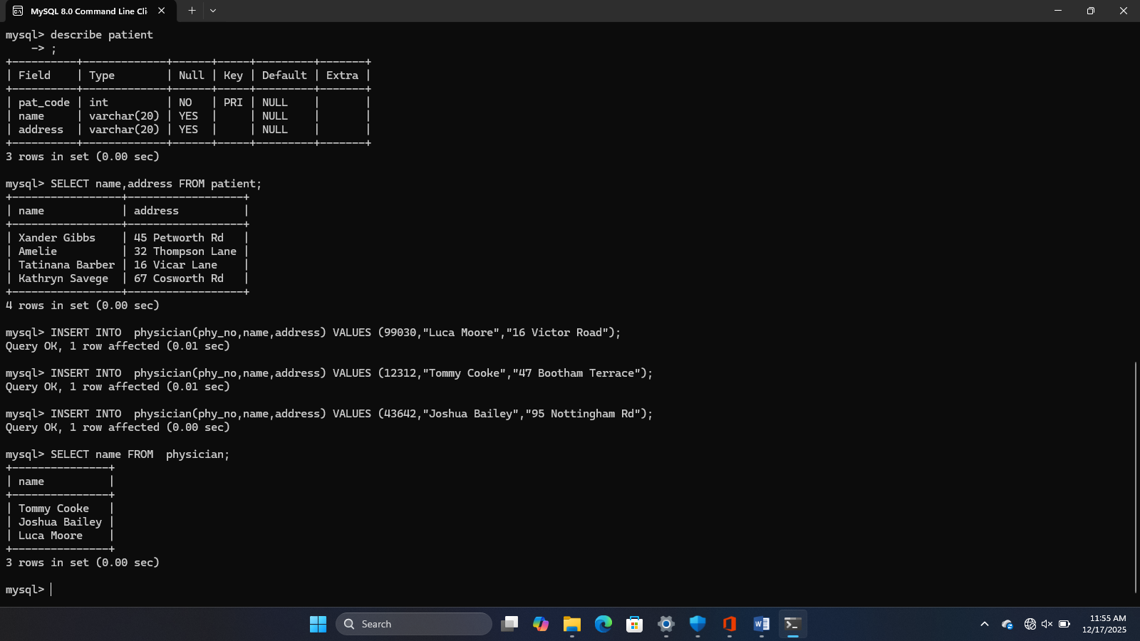

2. List the names and address of the patients? (Name,address)
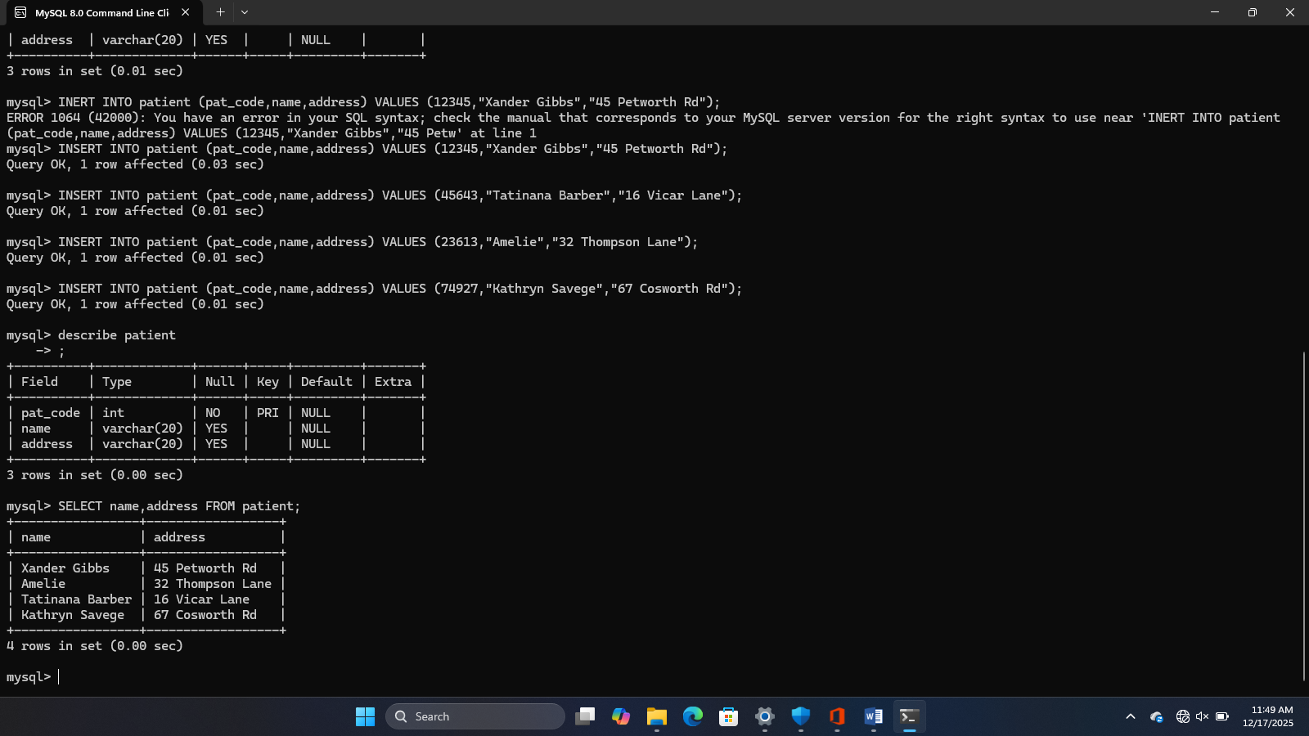

3.List the dates of all appointments of all patient 12345 ? (date)
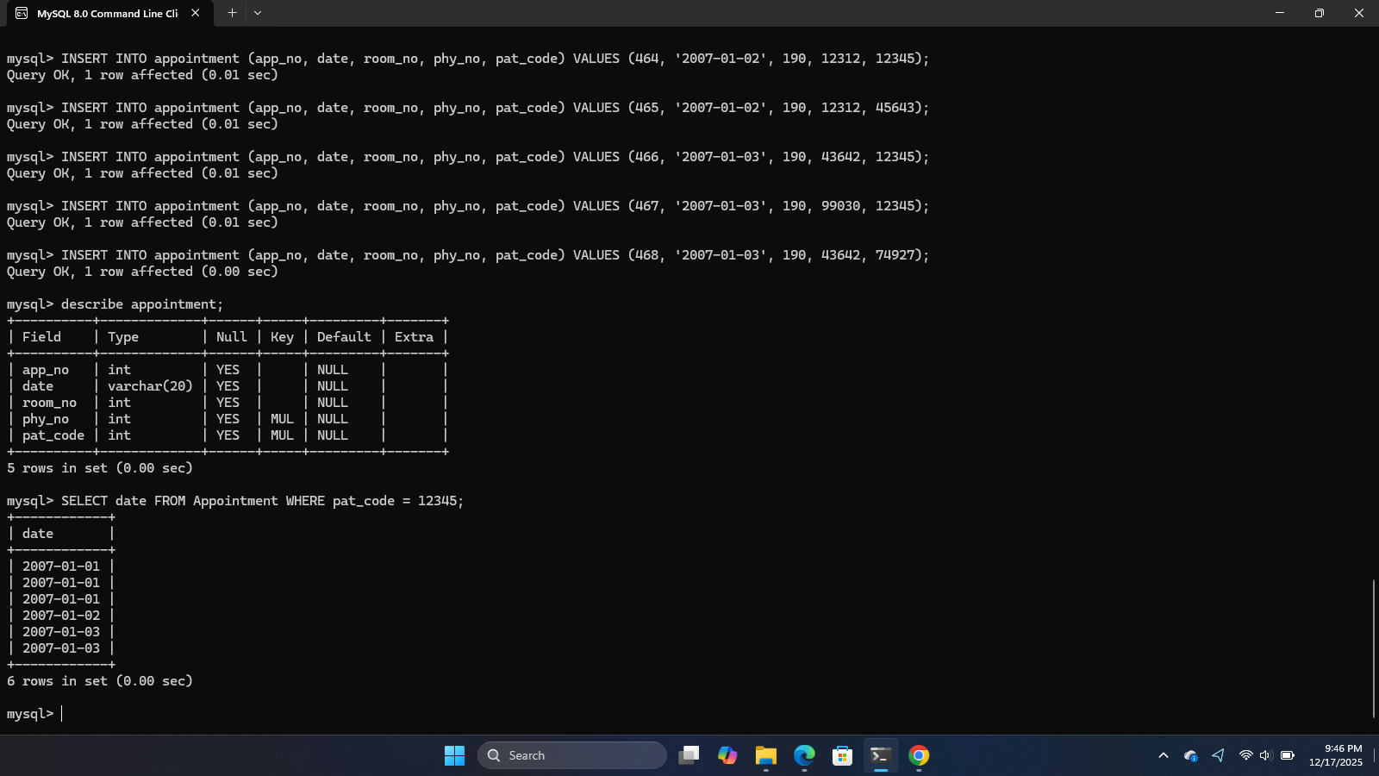

4. What are the existing conditions in the database in alphabetical order? (Designation)

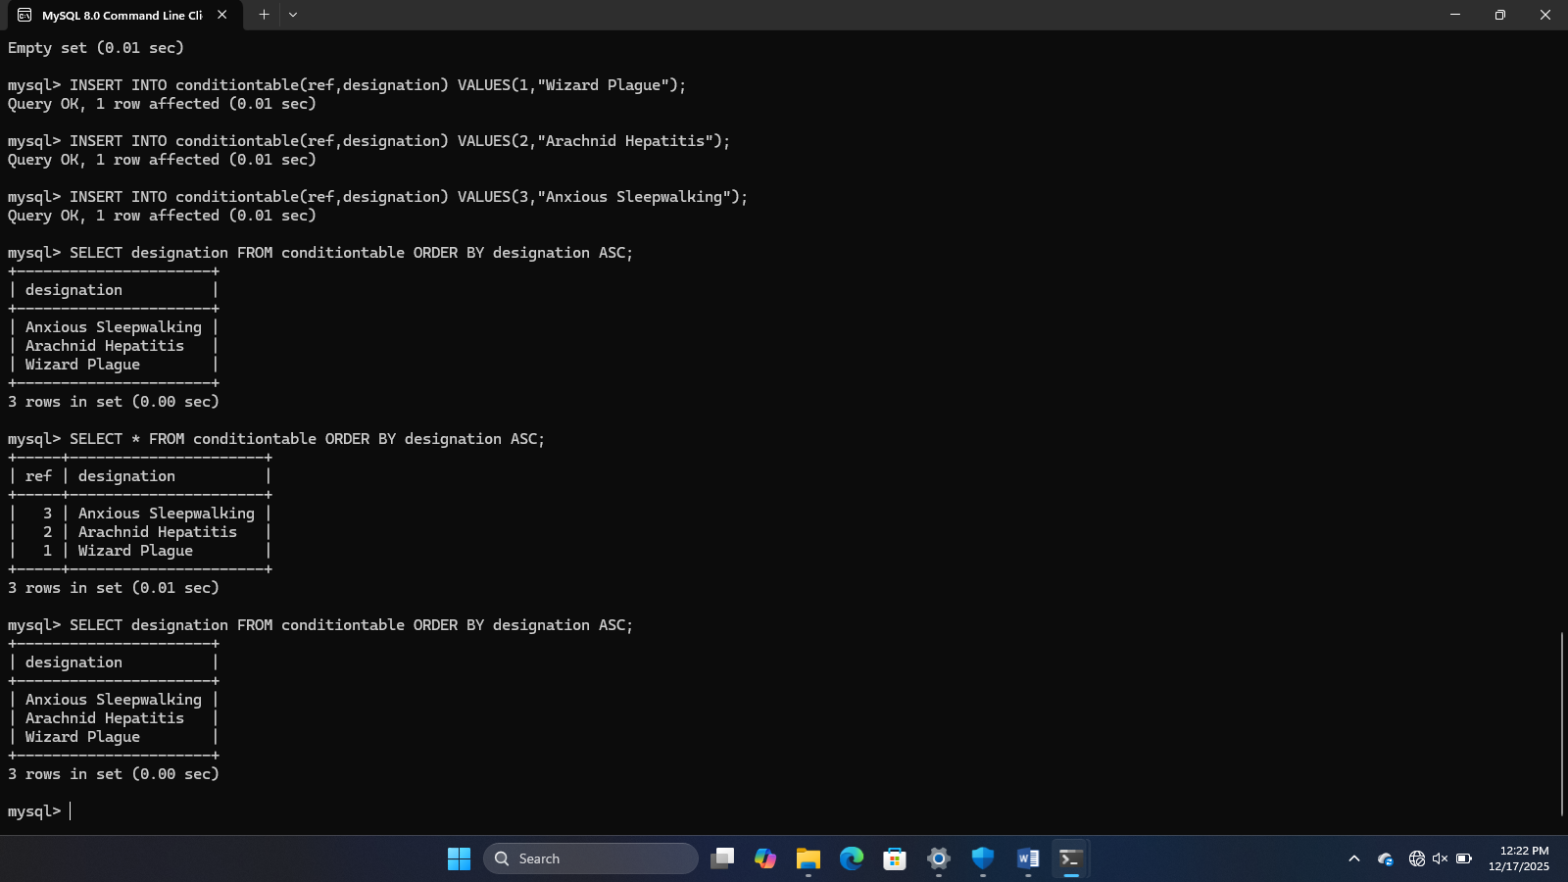
5. What patients were seen on January 1 2007 ? (Number,name)
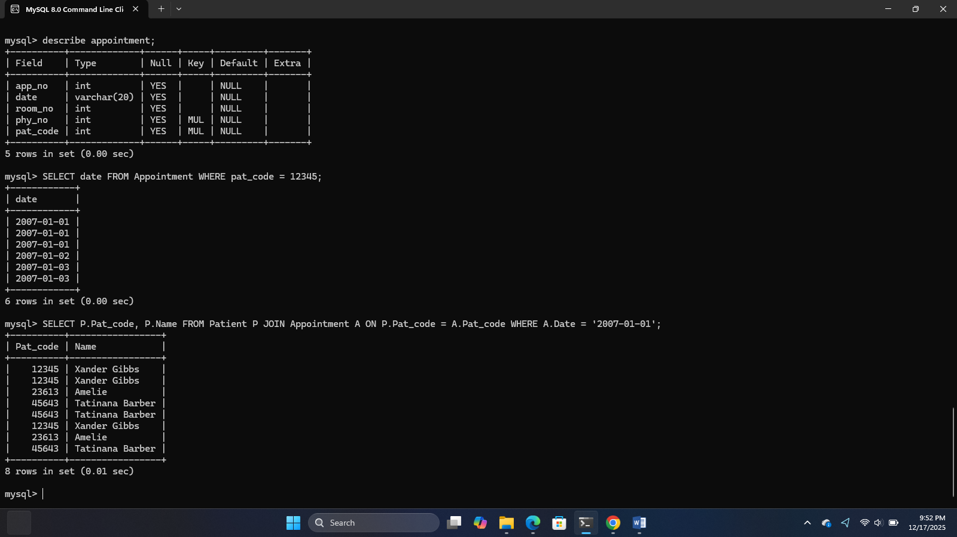

6.

