Mapping (map)

Splitting (antan2)

Reducing (reduce)

Shuffing (map)

**C**

**C1**

**C2**

**C3**

**Ck**

**.**

**.**

**.**

**RRT**

**C1**

**RRT**

**C2**

**RRT**

**C3**

**RRT**

**Ck**

**.**

**.**

**.**

**C1**

**C2**

**Ck**

**X2**

**X3**

**Xk**

**.**

**.**

**.**

**…..**

Xinit

X2

X3

Xi

Xk

X2

X3

X4

Xi+1

Xk+1

X2

X3

X4

Xi+1

Xbut

X1

X2

X3

Xi

Xk

X2

X3

Xi

Xk

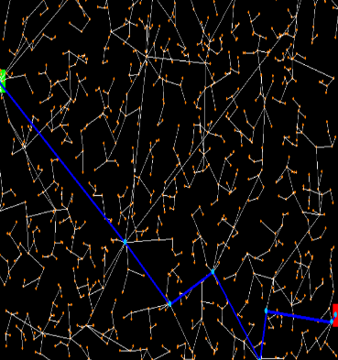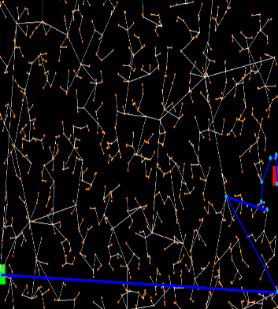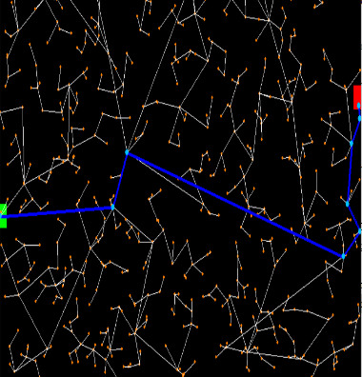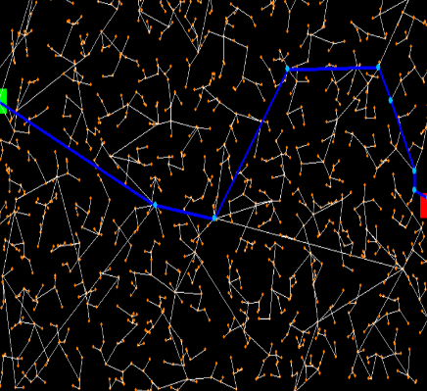

Partie 3 et 4

Partie 7