**Reaction time distributions**

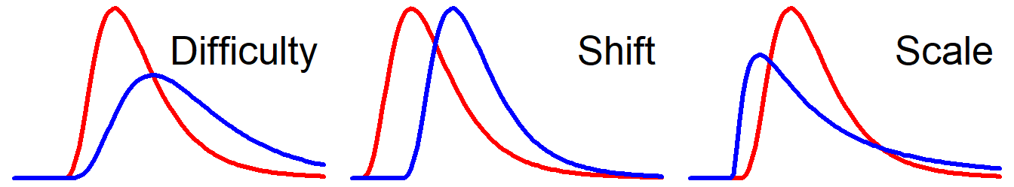

**Difficulty:** Disperses distribution towards longer RTs. [This is very RT-like](http://ejwagenmakers.com/2007/WagenmakersBrown2007.pdf). **Shift:** Moves the whole distribution towards longer RTs.   
**Scale:** Disperses the distribution.  
**Messy:** None or more than one of the above.

****[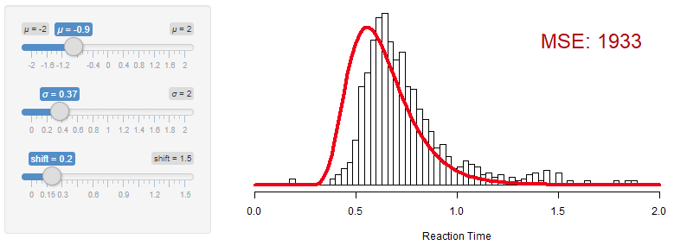](http://lindeloev.github.io/shiny-rt/)KTry the interactive applets and read more at  
<http://lindeloev.github.io/shiny-rt/>.





|  |  |  |  |  |  |  |  |
| --- | --- | --- | --- | --- | --- | --- | --- |
| [C:\Users\jonas\AppData\Local\Microsoft\Windows\INetCache\Content.MSO\5B307664.tmp](http://lindeloev.github.io/shiny-rt/)Distribution | | | Parameters | | | | Code |
| Variant of… | **Name** | **RT fit** | **Shift** | **Scale** | **Difficulty** | **Messy** | **Example brms::brm code** |
| NORMAL Descriptive | Normal (Gaussian) |  | ***μ*** | *σ* |  |  | brm(rt ~ x + (1|id), data, family=gaussian()) |
| Ex-gaussian | ✔✔ | ***μ*** | *σ* |  | *λ* | brm(rt ~ x + (1|id), data, family=exgaussian()) |
| Skew normal |  | ***μ*** | *σ* |  | *α* | brm(rt ~ x + (1|id), data, family=skew_normal()) |
| Log-normal | ✔ |  | *σ* | ***μ*** |  | brm(rt ~ x + (1|id), data, family=lognormal()) |
| Shifted log-normal | ✔✔ | *shift* | *σ* | ***μ*** |  | brm(rt ~ x + (1|id), data, family=shifted_lognormal()) |
| DRIFT … towards response thresholds. | Wald / Inverse Gaussian | ✔ |  | *λ* | ***μ*** |  | brm(rt ~ x + (1|id), data, family=inverse.gaussian()) |
| Shifted Wald / Inverse Gaussian | ✔✔ | *shift* | *λ* | ***μ*** |  | [Custom brms family](https://cran.r-project.org/web/packages/brms/vignettes/brms_customfamilies.html) and [see this post](https://mrunadon.github.io/Shifted-Wald-distribution-for-response-time-data-using-R-and-Stan/). |
| Wiener / Decision Diffusion | ✔✔ | Mechanism: 4 parameters | | | | [See brms tutorial](http://singmann.org/wiener-model-analysis-with-brms-part-i/). |
| Linear Ballistic Accumulator | ✔✔ | Mechanism: 7 parameters | | | | See glba::lba |
| SURVIVAL  Time to event. | Weibull |  |  |  | ***λ*** | *k* | brm(rt ~ x + (1|id), data, family=weibull) |
| Shifted Weibull | ✔ | *shift* |  | ***λ*** | *k* | [Custom brms family](https://cran.r-project.org/web/packages/brms/vignettes/brms_customfamilies.html). |
| Gamma | ✔ |  |  |  | ***α, β*** | brm(rt ~ x + (1|id), data, family=gamma()) |

.  
This is an overview of distributions that are commonly used to model   
reaction times. Read the arguments for this way of organizing and eval-  
uating the distributions at <http://lindeloev.github.io/shiny-rt/>. This link also  
contain interactive applets as well as a more extensive code example on  
distributional regression.  
.  
CC-BY, Jonas Kristoffer Lindeløv, <http://lindeloev.net>. Last updated 10 September, 2019.

Red parameter: It is hard to interpret any given value in isolation.

**Bold parameter:** Default predictor in regression. Control this using e.g., formula = bf(rt ~ 1, **ndt** ~ x + (1|id), **sigma** ~ x).