**Phase 1 Project**

**Github link of the application:** [**https://github.com/JoswinDsouza99/SimplilearnPhase1**](https://github.com/JoswinDsouza99/SimplilearnPhase1)

This is the eclipse IDE where I have made the LockedMe Application.

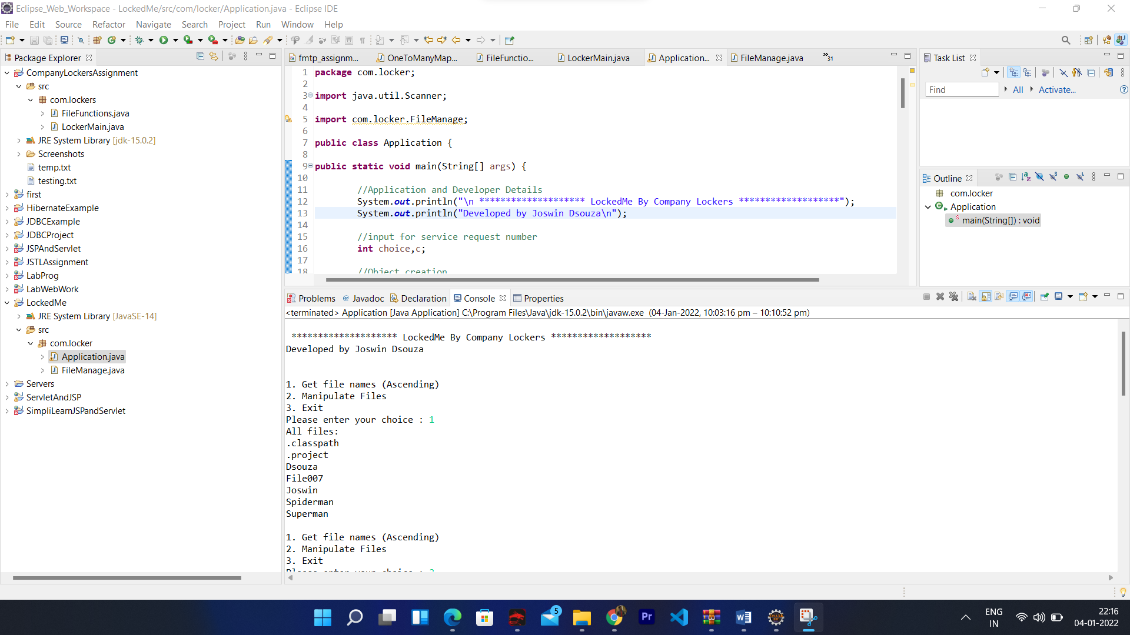

1. When the application is launched the name of the application and the developer’s name is visible.

We get to see the user interface option and we can select any one of the option.

Here when we select (1) we get to see the current file names in ascending order.

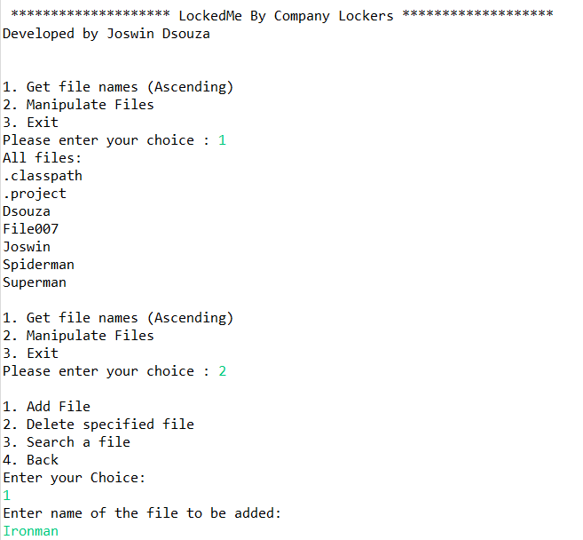

1. Then when we press the (2) option we return the User interface where he/she can return the detail.

Further we select (1) to add a file in the existing directory and we give the name as ‘Ironman’

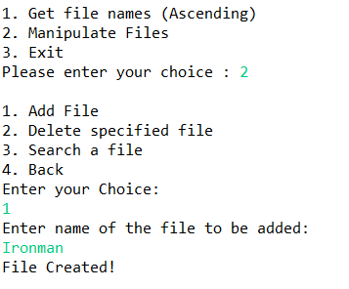

1. Then the option 2->2 is Deleting a user specified file.

And we enter the name as ‘Spiderman’ and the file is deleted.

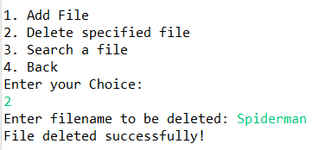

1. The option 2->3 is searching for a file.

If we give a file name that does not exist then File not Found error is thrown.

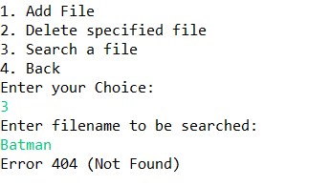

1. If we search for a existing file name then we get the message like the file exists.

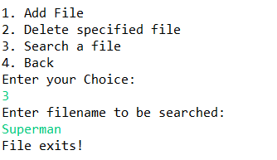

1. Then finally we can go back using the back and the exit option available in the user interface.

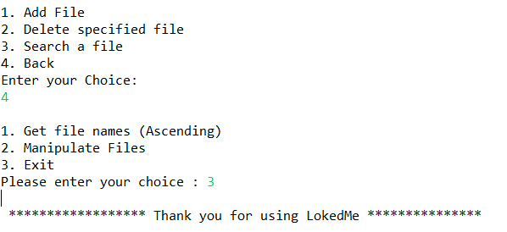

Inference:

Building this project gave me the feel of building a real world project with various user interaction features.

I could implement concepts such as exceptions, collections, and sorting techniques. Moreover all the concepts that were taught were put to good use using this project.