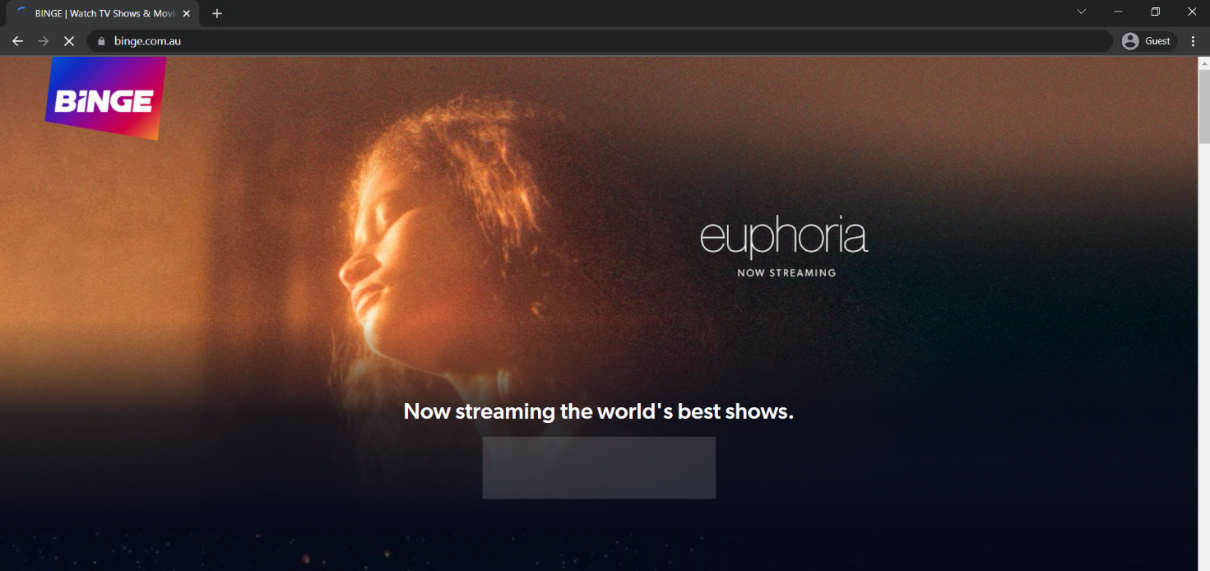

**PROJECT NAME : BINGE WATCH**

Overview :

Want to make your moment memorable then just BINGE WATCH ! It’s a subscription video streaming platform by StreamMotion. BINGE wants to connect people to the content they love watching.

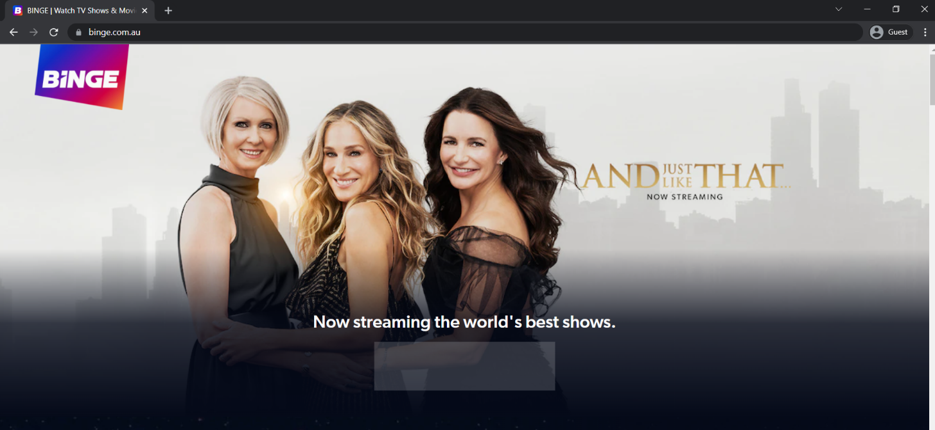

FEATURES OF BINGE

1. Home page
2. Login page
3. Subscription page
4. Payment Gateway
5. Streaming page

**AVAILABLE ON GOOGLE PLAY STORE AND APPLE PLAY STORE**



TECHNOLOGIES USED IN BINGE :

Front- End -

1. HTML
2. CSS
3. BOOTSTRAP
4. REACT

Dynamic –

1. Javascript

Database –

1. MongoDb
2. Json Data

Compilers –

1. Visual Studio
2. Git Bash