**ENGG100 LAB 3 REPORT**

**INSTRUCTIONS BEFORE SUBMISSION**

* Rename this report to Lab3_StudentID
* Make sure you add all the required screenshots/evidence for all the tasks
* Fill in the header information with your name, student ID & date
* Make sure to add one line to each task explaining what you have done for that task and what you have learnt

**TASK 1**

Create a new script with the below code, debug and fix the errors. Make sure you add comments in your code to explain how you fixed the errors.

a = [1 2 3];

b = [1 2];

c = a+b;

disp(c);

|  |
| --- |
| **Screenshot evidence of code & results:** |
| **Explanation of task:** |

**TASK 2**

Create a new script with the below code, debug and fix the errors. Make sure you add comments in your code to explain how you fixed the errors.

d=[0,pi/4,pi/2];

g = sin(d, d);

disp(g);

|  |
| --- |
| **Screenshot evidence of code & results:** |
| **Explanation of task:** |

**TASK 3**

Use MATLAB help & documentation to figure out how to create an identity matrix and create one of size 4x4 and multiply all the values by 6. Make sure you include comments in your code at every step.

|  |
| --- |
| **Screenshot evidence of code & results:** |
| **Explanation of task:** |

__________________________________________________________

**TASK 4**

In the command window, create a 6x6 matrix using the magic() function

* Update the value of (4,6) to 30 using the command window
* Update the value of (1,3) to 12 using the workspace browser
* Verify the matrix has been updated using the disp() function in the command window

|  |
| --- |
| **Screenshot evidence of code & results:** |
| **Explanation of task:** |

**TASK 5**

Create a new script to create a timetable template and fill it in with your own weekly timetable. Make sure to add the screenshot of the code, workspace array and command window results below.

|  |
| --- |
| **Screenshot evidence of code & results:** |
| **Explanation of task:** |

**TASK 6**

Write a script that asks the user for 2 points in a 3D space, and returns the distance between them using the formula below, and displays the final value to the user:

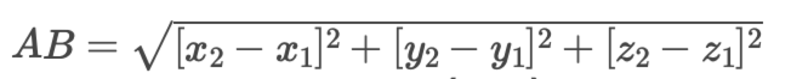

Make sure to test the values with your script A=[2,3,4] and B=[5,6,7] with the answer returned as 5.1962.

|  |
| --- |
| **Screenshot evidence of code & results:** |
| **Explanation of task:** |