**ENGG100 LAB 6 REPORT**

**INSTRUCTIONS BEFORE SUBMISSION**

* Rename this report to Lab6_StudentID
* Make sure you add all the required screenshots/evidence for all the tasks
* Fill in the header information with your name, student ID & date
* Make sure to add one line to each task explaining what you have done for that task and what you have learnt

**TASK 1 – 2 marks**

Create a 2D graph by plotting multiple data series on the same axes:

y = sin(x)

y = cos(x)

y= tan(x)

* Make sure to add x and y axis labels, figure title, legend, and all 3 functions should be a different marker, style and color
* Use x range from 0 to 4*pi, with iterations of pi/12
* Use plotting axis range for x-axis from 0 to pi*2 and y-axis from -2*pi to 2*pi
* Make sure your code is commented properly to explain your code

|  |
| --- |
| **Screenshot evidence of code & results:** |
| **Explanation of task:** |

**TASK 2 – 3 marks**

A car starts at rest, and follows the following pattern:

* Constant acceleration 2 m/s^2 until the velocity reaches 40 m/s
* Then, constant velocity until the displacement reaches 800 m
* Then, constant deceleration of -4 m/s^2 until rest

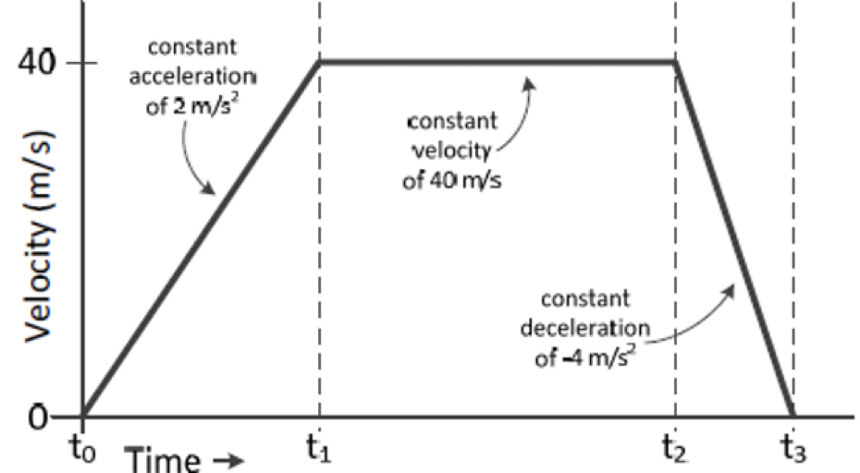

In MATLAB:

* Create arrays of displacement, velocity, acceleration, and time using a time step of 0.1 seconds
* Once the arrays are created, use the plot function to draw graphs of displacement, velocity and acceleration over time.
* Formulas to use:
  + Final velocity = Initial velocity + acceleration * time
  + Displacement = velocity * time

Your Code:

* Define variables to be used within the code
* Initialize 3 arrays for displacement, velocity and acceleration
* 3 while loops (one for each part of the graph), each loop should calculate velocity, displacement, acceleration and time as needed and save the values to their respective arrays
* Each of the arrays (velocity, displacement & acceleration) should be plotted against the time array and displayed in 1 figure window (use subplot to create a 2x2 or 3x1 figure window)
* Make sure your code is **commented**

|  |
| --- |
| **Screenshot evidence of code & results:** |
| **Explanation of task:** |

**TASK 3 – 2 marks**

Create a function called **trapArea** that estimates the area under a curve bounded by two points (x1,y1) and (x2, y2). Estimate the area by computing the area of the trapezium as shown below:

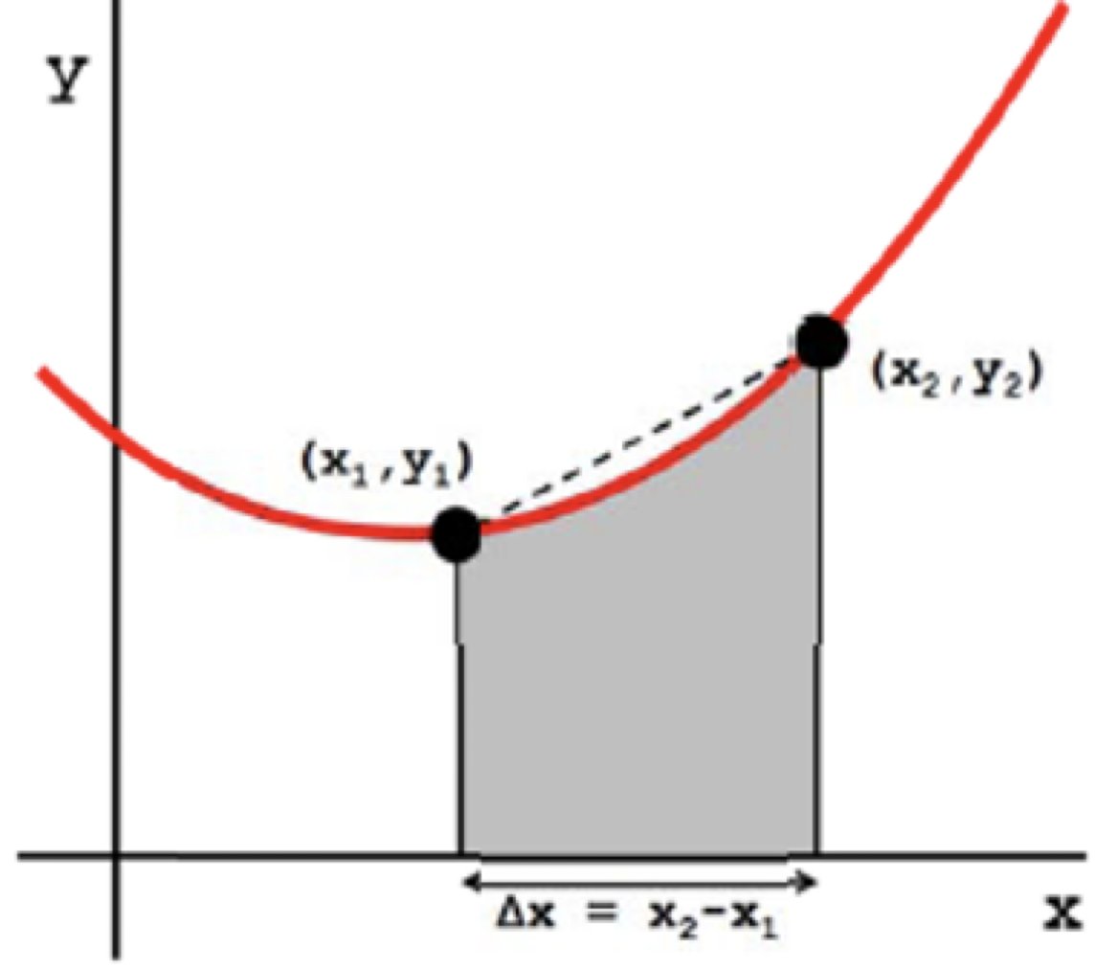

* The function should have four inputs **(x1, y1, x2, y2)** and one output called **area**. Make sure you test your function to ensure it works as expected
* Call the function inside your script with the test values below
* Formula to use for area of trapezoid: **area = height/2 * (side A + side B)** or in this case **area = (x2-x1)/2 * (y1+y2)**
* **Test Values: (1,3,4,7)**

|  |
| --- |
| **Screenshot evidence of code & results:** |
| **Explanation of task:** |

__________________________________________________________

**TASK 4 (BONUS) – 3 marks**

Create a second function called **areaUnderCurve** that will call your **trapArea** function created in Task 3 several times in a loop

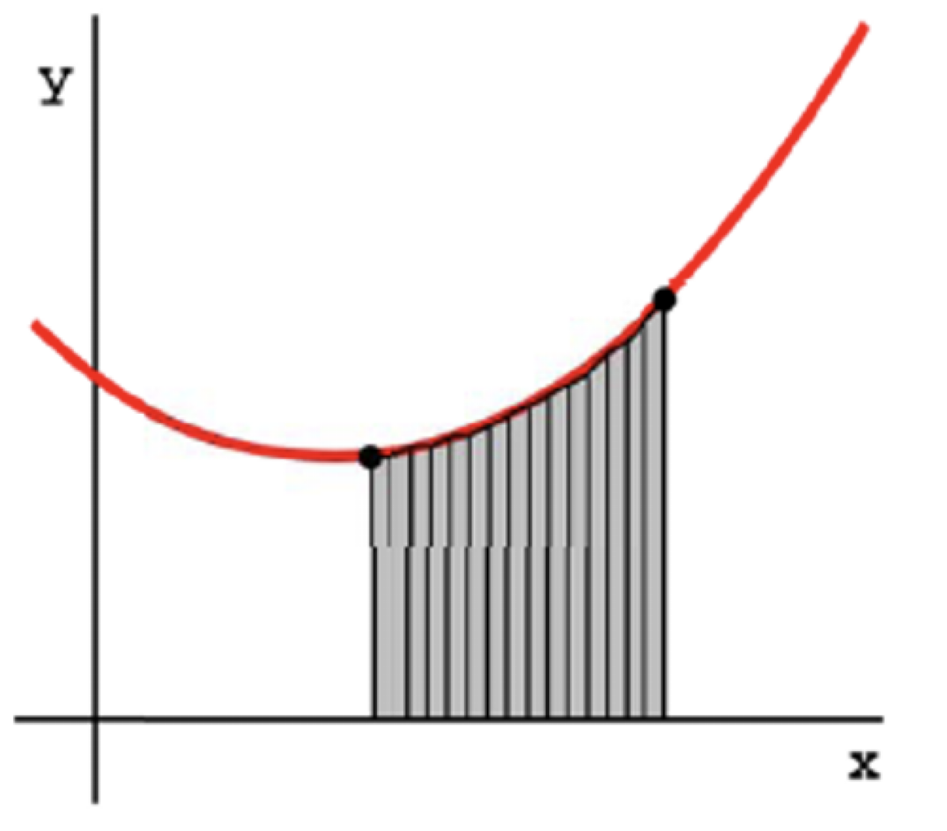

* Your new function should have two inputs **(x,y)** which are both 1D arrays representing the x-axis and y-axis points on a curve.
* There should be one output called **totalArea**
* **Test Values: Use your new function to compute the below integrals:**

￼

|  |
| --- |
| **Screenshot evidence of code & results:** |
| **Explanation of task:** |