**ENGG100 LAB 7 REPORT**

**INSTRUCTIONS BEFORE SUBMISSION**

* Rename this report to Lab7_StudentID
* Make sure you add all the required screenshots/evidence for all the tasks
* Fill in the header information with your name, student ID & date
* Make sure to add one line to each task explaining what you have done for that task and what you have learnt

**TASK 1 – 3 marks**

Using the surface plot approach for plotting functions in two variables, plot the below two functions:

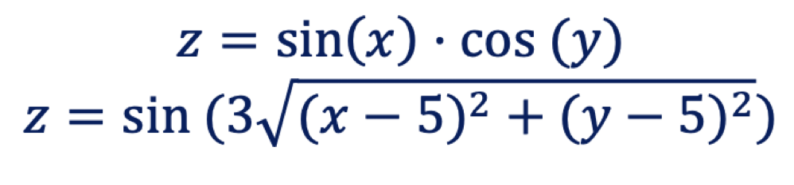

* Use a resolution of at least 0.1 between points, from 0 to 10 for x and y coordinates
* Plot both functions side by side using subplots on the same figure window
* Ensure all your axes (x, y & z) are labelled and each figure has a title
* Use element-wise operators (.* or .^) when multiplying and squaring vectors
* Make sure your code is **commented** properly

|  |
| --- |
| **Screenshot evidence of code & results:** |
| **Explanation of task:** |

**TASK 2 – 3 marks**

Create 2 multidimensional arrays:

* array_A = 10x10x10 numerical array (3D)
* array_B = 5x5x5x5 numerical array (4D)
* Each value inside each array should correspond to the multiplication of its indices (use nested for loops)
* E.g. for the array_A, the number at location (1,2,3) should be 1x2x3 = 6
* Make sure your code is **commented** properly
* For your report: Show a screenshot of your code, along with the below location values:
* **Test values to show for array_A** —> array_A (1,4,5) = 20, array_A (4,7,9) = 252, array _A (9,10,3) = 270
* **Test values to show for array_B** —> array_B(3,3,4,1) = 36, array_B(4,1,2,3) = 24, array_B(1,5,3,2) = 30

|  |
| --- |
| **Screenshot evidence of code & results:** |
| **Explanation of task:** |

**TASK 3 – 4 marks**

Create an array of structures corresponding to a list of students in a class. Each student structure must contain the below fields:

* First Name (first_name)
* Last Name (last_name)
* Student Number (student_no)
* Engineering Major (eng_major)
* Test Mark (marks)

Finally, show how you would output just the test marks for all the students (hint: use a for loop)

|  |  |  |  |  |
| --- | --- | --- | --- | --- |
| **First Name** | **Last Name** | **Student Number** | **Engineering Major** | **Test Mark** |
| Jane | Adams | 1234567 | Computer | 89 |
| Philip | Spencer | 8910111 | Mechatronics | 87 |
| Thomas | Evans | 2131415 | Chemical | 94 |
| James | Irwin | 1617181 | Civil | 77 |
| Rose | Baker | 9202122 | Mechanical | 96 |

|  |
| --- |
| **Screenshot evidence of code & results:** |
| **Explanation of task:** |