**ENGG100 REVISION LAB REPORT**

**INSTRUCTIONS BEFORE SUBMISSION**

* Rename this report to RevisionLab_StudentID
* Make sure you add all the required screenshots/evidence for all the tasks
* Fill in the header information with your name, student ID & date
* Make sure to add one line to each task explaining what you have done for that task and what you have learnt

**TASK 1 – 1 mark**

Write a script that asks the user the below questions:

* “What is your name?” (String)
* “How old are you?” (Whole number)
* “What is your GPA?” (Floating point number formatted to 2 decimal place)

Then, display the information back to the user

|  |
| --- |
| **Screenshot evidence of code & results:** |
| **Explanation of task:** |

**TASK 2 – 1 mark**

Create a cell array of the below information:

|  |  |  |  |
| --- | --- | --- | --- |
| Harry | Janet | Philip | June |
| 34 | 37 | 23 | 12 |

Update the marks for June by adding 10 marks (Note: You need to use arithmetic functions to add values to cell arrays)

|  |
| --- |
| **Screenshot evidence of code & results:** |
| **Explanation of task:** |

**TASK 3 – 1 mark**

Create a numerical array of the below information:

|  |  |  |  |  |  |  |  |
| --- | --- | --- | --- | --- | --- | --- | --- |
| 2 | 3 | 6 | 7 | 9 | 8 | 2 | 1 |

Multiply all the values of the array by 6 and then find the square root of each value.

|  |
| --- |
| **Screenshot evidence of code & results:** |
| **Explanation of task:** |

**TASK 4 – 2 marks**

Write a script that keeps adding values entered by the user until the user types “stop”.

|  |
| --- |
| **Screenshot evidence of code & results:** |
| **Explanation of task:** |

**TASK 5 – 1 mark**

Write a script that takes 2 numbers (min and max value) from a user and calculates the sum of all the even numbers between that range and displays it back to the user.

|  |
| --- |
| **Screenshot evidence of code & results:** |
| **Explanation of task:** |

**TASK 6 – 1 mark**

Create a function **my_max** that takes 5 numbers as an input (**n1, n2, n3, n4, n5**), calculates the largest value out of the 5 numbers (use if and else) statements and returns it as an output (**max_num**)

* Test values for the report: **my_max(4,0,9,2,3)**

|  |
| --- |
| **Screenshot evidence of code & results:** |
| **Explanation of task:** |

**TASK 7 – 1 mark**

On your PC, create a notepad file with the below information and save it as task_7_example.txt:

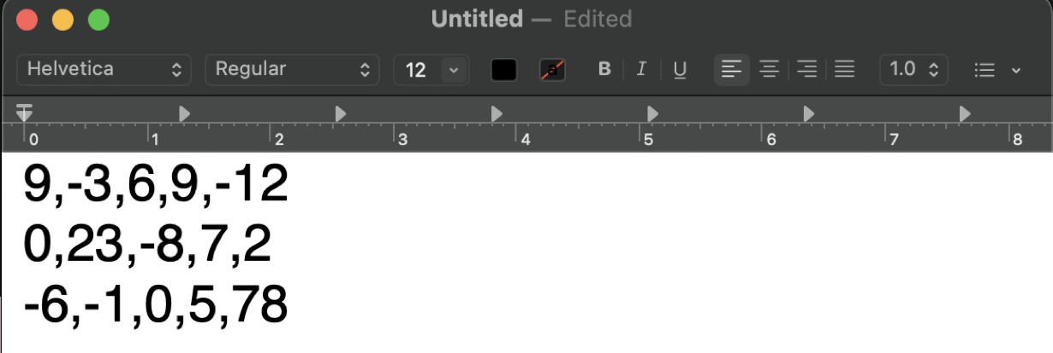

* In MATLAB, retrieve this file in a variable called textfile using the readmatrix function
* Once imported, change the following values: textfile(1,2) = 45, textfile(1,4) = -7
* Update all the values of the last row of the matrix to 3

**For your report:**

* Screenshot of the code/script, with comments
* Screenshot of the original imported matrix from the workspace
* Screenshot of the updated matrix from the workspace

|  |
| --- |
| **Screenshot evidence of code & results:** |
| **Explanation of task:** |

**TASK 8 – 2 marks**

* **GRAPH 1: 2D SUBPLOT**
  + Define x1 and y1 coordinates from -pi to pi, with a resolution of 0.01
  + Calculate the z1 value as **sin(x) - cos(y)**
  + Plot a 2D graph of x and z1 using plot
  + Format your plot: marker ‘o’, color ‘b’ & line style ‘-‘
* **GRAPH 2: 3D SUBPLOT**
  + Define x2 and y2 coordinates from -7 to 7, with a resolution of 0.1
  + Calculate the meshgrid for x2 and y2
  + Calculate the z2 value as **cos(sqrt(x^2 + y^2))**
  + Plot a 3D graph of x2, y2 and z2 using surf

**For your report:** Make sure you comment your code, add titles to each plot & axes labels. The subplots should be (2,1,x)

|  |
| --- |
| **Screenshot evidence of code & results:** |
| **Explanation of task:** |