INTEGRATION PROCESS WEBSERVICES

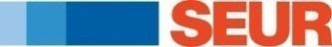
31-07-2013

SHIPPING FLOW
Step 1
SEUR labels printing and shipment integration service

If ok

All parcels with label s and shipment data at SEUR system

If error

Labels are printed with data in the call and must be reprinted at SEUR’s facilities.

Step 2
Manifest Printed

--------------------------------------------------------------------------------------------------------------------------

SEUR labels printing and shipment integration service
A number of methods can be used in the SEUR labels printing service:

Technical specification of the service
http://cit.seur.com/CIT-war/services/ImprimirECBWebService?wsdl

Input/output parameters
The call under the impresionIntegracionConECBWS method is made with the following input/output parameters:
- Input parameters:
  - imp:in0: User, Mandatory
  - imp:in1: Password, Mandatory
  - imp:in2: Brand of printer, Mandatory. ie ‘ZEBRA’
  - imp:in3: Printer model, Mandatory. ie ‘LP2844-Z’
  - imp:in4: Type of label to be printed: Mandatory, may be 1 body (“1C”), 2 bodies (“2C”) or 2D (“2D”).
  - imp:in5: Data to be printed in XML format. Attached are the xsd of the format of data based on the type of label. Mandatory
  - imp:in6: File name. Mandatory
  - imp:in7: Tax identification number (NIF) of the Integrated Client. If this value is not known, the integration code can be used. It can be fixed. Mandatory
  - imp:in8: Franchise code. Customer’s code would be ‘28. It can be fixed. Mandatory
  - imp:in9: Account code: If this value is not known, -1 should be used. It can be fixed. Mandatory
  - imp:in10: System called by the service: optional. If not used, this value should be left blank (“”). It can be fixed. Mandatory

- Output parameters:
  - Result of the operation: The “OK” string, if the data has been processed correctly,
    - 14-digit number corresponding to the barcode of the label and string with the printer configuration, or any of the error messages listed in the table below (placed in <ECB>)
    - or any of the error messages listed in the table below (placed in <traza>)
  - or any of the errors in the table below, with:

Error | Description
ERROR – INCORRECT USER/PASSWORD | Log-in error: invalid user and/or password
VALIDATION ERROR | Error that occurs when the data sent to the web service for printing does not comply with any of the validation rules
ERROR – COULD NOT OBTAIN THE PLATFORM | Error that occurs when the data does not make it possible to obtain a valid platform
ERROR – COULD NOT OBTAIN THE TRANSPORT LINE | Error that occurs when the data does not make it possible to obtain a valid transport line
ERROR | Error

Method | Shipment Creation and Label printing
URL (production environment) | http://cit.seur.com/CIT-war/services/ImprimirECBWebService
SOAP Call | 

Sometimes, printers get discongifurated. In SEUR we prefer to send a configuration file just before sending the data to be printed.
You can use the web service call to get the file o simply hard code it in your system.
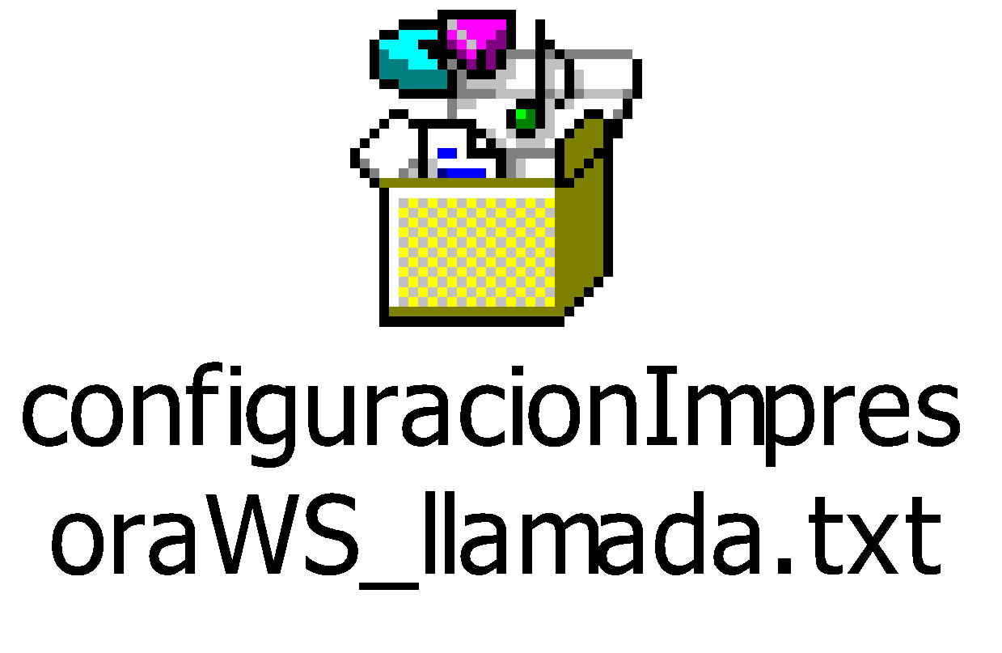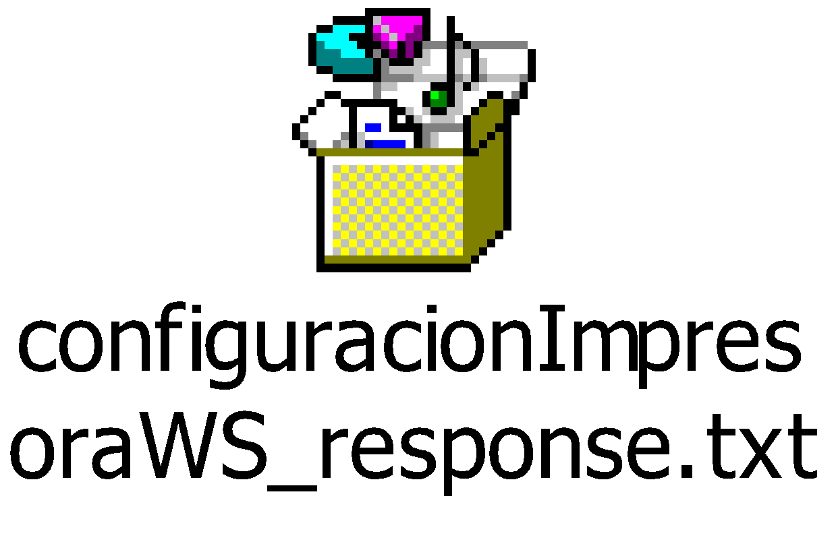

---------------------------------------------------------
imp:in5: Data to be printed in XML format. If the following fields do not have the expected format, the KO string in the web service response will be ‘VALIDATION ERROR’.
If postal code and location (<poblacion_consignatario> and <codPostal_consignatario>) of the consignee are not validated we can work with this algorithm

or simply response with a non-valid label, that will be reprinted at SEUR’s facilities.

<ci> is the customer integration code
<nif> is the customer Tax Identification Code
<ccc>> is the customer Seur’s Code
Values for <servicio>
CODE | NAME | SHORT NAME
001 | SEUR - 24 | S-24
003 | SEUR - 10 | S-10
005 | MISMO DIA | S-MD
007 | COURIER | COUR
009 | SEUR 13:30 | S-13
013 | SEUR - 72 | S-72
015 | S-48 | S-48
017 | MARITIMO | *MAR
019 | NETEXPRESS | NTEX
077 | CLASSIC | CLSC
083 | SEUR 8:30 | S830

Values for <producto>
CODE | NAME | SHORT NAME
002 | ESTANDARD (STANDARD) | ESTD (STD)
004 | MULTIPACK | MPAC
006 | MULTI BOX | MBOX
018 | FRIO (COLD) | FRIO (COLD)
052 | MULTI DOC | MDOC
054 | DOCUMENTS | DOCS
070 | INTERNATIONAL T | INTE
072 | INTERNATIONAL A | INAE
076 | CLASSIC | CLAS
002 | ESTANDARD (STANDARD) | ESTD (STD)
004 | MULTIPACK | MPAC

Normally, servicio=1, product=2
<total_bultos> is for the total number of packages that make up the delivery.
<total_kilos> is the total weight of delivery.
The values of this field are whole numbers (without decimals).
<pesoBulto> is the total weight of a parcel, with 2 decimals (ie 5,35 kilos)
<observaciones> is an open text for comments from the delivery notes. No longer than 150 positions.
< referencia_expedicion > and <referencia_bulto> are Customer’s identifiers for shipments and parcels. Shipment reference (referencia_expedicion) cannot be informed twice a day. They must no be longer than 45 positions.
<clavePortes> is the label type check for cold stores
“F” | Invoice (F= Factura)  Transport charges paid (Portes Pagados)
“D” | Due (D=Debido)

<clavePod></clavePod> is the type of proof of delivery used.

“ “ | Without CDE | Without Comprobante de entrega (Proof of delivery).
“S” | Seur | Return of SEUR delivery note signed.
“I” | Immediate | Return of signed sender documents

<claveReembolso> states who pays the refund payment.
This field is obligatory if we fill out the field “valor del reembolso” (repayment value under valorReembolso. It must be defined like 12,26 ).

“F” | Factura (Invoice) | The sender pays refund costs.
“D” | Debido (Owed) | The addressee pays the refund costs.
“ ” | No refund | There is no refund to be made.

Consignee detalis:
<nombre_consignatario> is the name of the Consignee. No longer than 40 positions.
<direccion_consignatario>is the name of the Consignee’s address. No longer than 70 positions.
This field should only contain the name of the street, motorway, avenue, square etc., without type and number. In the case where the consignee wishes to collect the goods from the SEUR destination agency, this field should contain only the following text: TO BE COLLECTED”. Any other additional information (for example: the name of the consignee) can be inputted into the comments field.

<tipoVia_consignatario> is the type of route. No longer than 3 positions.
Most normal values are AUT - AUTOVIA ; AVD – AVENIDA, CL – CALLE, CRT – CARRETERA, CTO - CENTRO COMERCIAL, EDF – EDIFICIO, ENS – ENSANCHE, GTA – GLORIETA¸ GRV - GRAN VIA, PSO – PASEO, PZA – PLAZA, POL - POLIGONO INDUSTRIAL, RAM – RAMBLA; RDA - RONDA ; ROT – ROTONDA, TRV – TRAVESIA, URB - URBANIZACION

<tNumVia_consignatario> is the type of number of the route. Normally takes N. – Número, but sometimes BL - Bloque ; IN - Indefinido ; KM - Kilómetro ; LT - Lote ; NV - Nave . No longer than 2 positions.
<numVia_consignatario> is the number of the Street.
<escalera_consignatario>, <piso_consignatario>, <puerta_consignatario> are the MAIN DOOR/FLOOR/DOOR for the Consignee.
<poblacion_consignatario> and <codPostal_consignatario> must be validated in web service infoPoblacionesCortoStr or with the next master data.
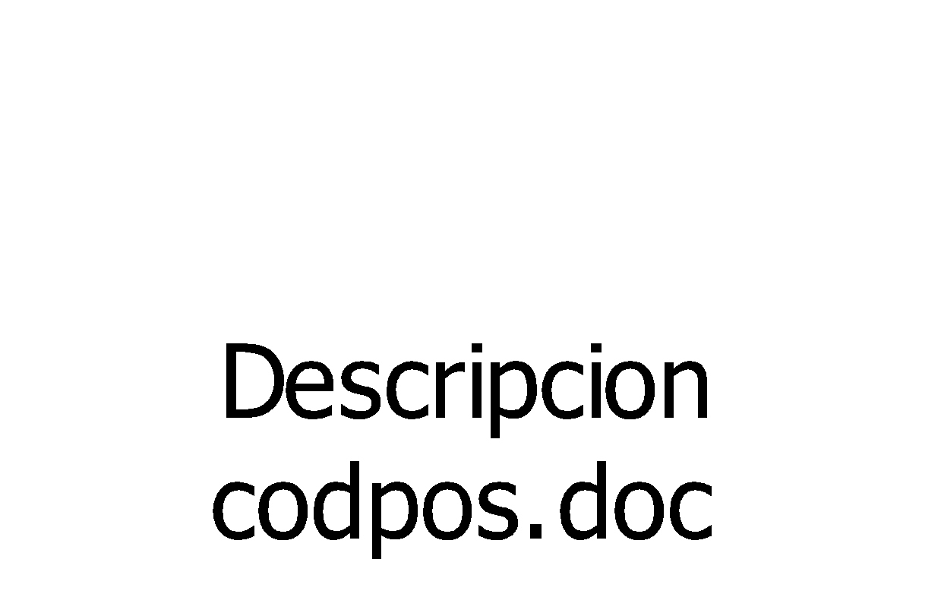
<email_consignatario>, <telefono_consignatario> and <atencion_de> are the mail, tel and contact person for the consignee.

SEUR manifest printing service

Technical specification of the service
http://cit.seur.com/CIT-war/services/DetalleBultoPDFWebService?wsdl

Input/output parameters
The call under the generacionPDFDetalleNoFecha method is made with the following input/output parameters:
- Input parameters:
  - imp:in0: Tax identification number (NIF) of the Integrated Client. If this value is not known, the integration code can be used. It can be fixed. Mandatory
  - imp:in1: Franchise code. Customer’s code would be ‘28. It can be fixed. Mandatory
  - imp:in2: User, Mandatory
  - imp:in3: Password, Mandatory

- Output parameters:
  - Result of the operation: a decode base64 string with all the outstanding shipments to be picked up by SEUR
Method | Manifest Creation and printing
URL (production environment) | http://cit.seur.com/CIT-war/services/DetalleBultoPDFWebService
SOAP Call | 

