Term Project

Significant Earthquakes

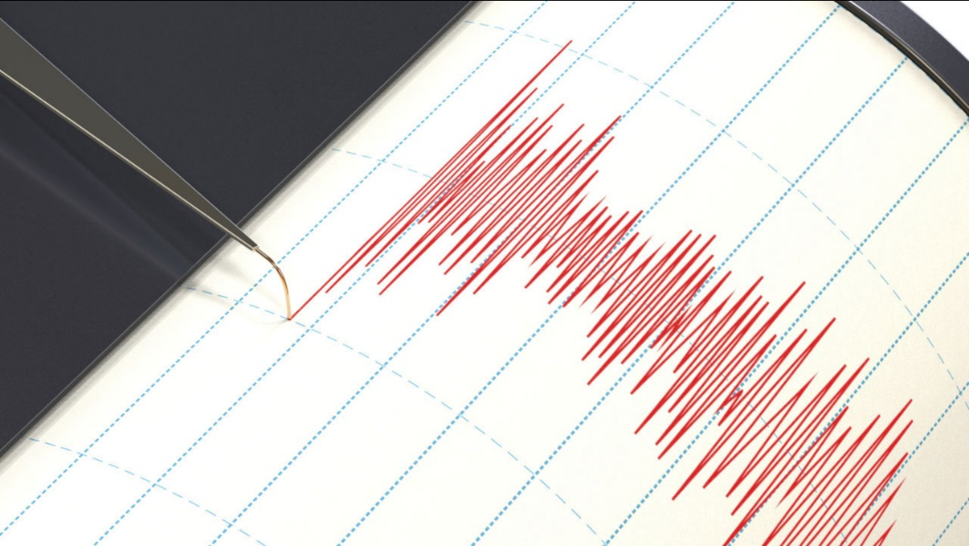

José Luiz Mattos Gomes

CSIS 3860-070 - Data Visualization

William Tan

Significant Earthquakes

Study Subject

The study is about earthquakes and the loss of lives and damage they cause. The story created in tableau gives a first glimpse of all the significant events recorded since 1971 and then points to the loss of life and money. The last slide draws the reader's attention to the Tsunamis consequences that an earthquake can generate.

The data was extracted from The USA *National Centers for Environmental Information (NCEI)* <https://www.ngdc.noaa.gov/nndc/struts/form?t=101650&s=1&d=1>

Choice of Visualization Tool

The tool used in this project was Tableau®. It is in the leader’s quadrant at *Gartner Magic Quadrant for Analytics and Business Intelligence Platforms*, and it was used in most classes, so I felt comfortable working with it.

Gallery

The Story “*Earthquake Study*” contains four slides:

* *Earthquakes since 1971*

The first slide gives an overview of all significant earthquakes since 1971 to 1th March 2019 by year. The range of colors gives the idea of intensity and the size of the bar the number of earthquakes.

Components: *Count by Year* (Sheet), *Earthquakes* (Dashboard).

* *Loss of lives*

The second slide shows on the map earthquakes with a total of deaths greater than 10,000. Here the range of colors gives the idea of quantity and the numbers emphasize the main data. The big number on the right details the deadliest recorded earthquake.

Components: *Deaths by Country* (Sheet), *Deadliest* (Sheet) *Lives Lost* (Dashboard).

* *Loss of values*

The third slide is a top 10 of the countries with major damage in US$MM. The big number on the right details the highest damage earthquake.

Components: *Total Damage US$MM* (Sheet), *Highest Damage* (Sheet), *Value Lost* (Dashboard).

* *Tsunami after earthquake*

Earthquakes can generate tsunamis, and they can be devastating. This slide shows a map with these events and draws attention to the three main occurrences.

Components: *Top 3 Worst Tsunami* (Sheet), *Tsunami* (Sheet), *Tsunami Map* (Sheet), *Tsunami Values* (Dashboard).

Files

1. *Jose_Luiz_Mattos_Gomes_TermProject.twb*

Tableau file with Worksheets, Dashboards and the Story.

1. *SignificantEarthquakes.xlsx*  
   Excel file with the source data and data dictionary.