**Exp: An LED Pendant**

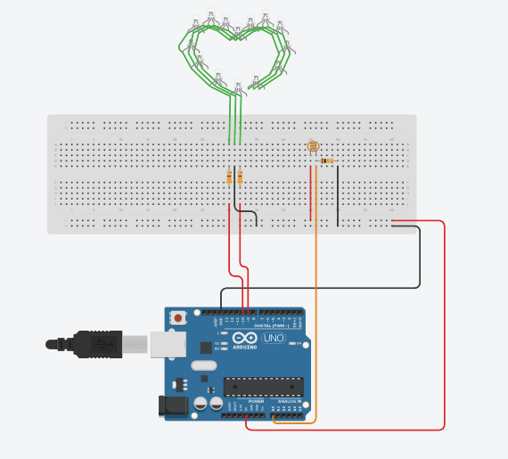

**Theory:**

When the Pendant is wore in bright sunlight it will blink red in colour and when pendant is in darkness it will glow blue without blinking. When the pendant is blinking in red colour it will blink 60 times in a minute.

**Concept used:**

When the pendant is exposed in bright light the photoresistor or LDR in it will be exposed to the light as well. Therefore there will be change in resistance of LDR and Arduino will read that value. If the value received by Arduino from the LDR is more than the value set in program the pendant will blink red 60 times in a minute. But if the value given to Arduino by LDR is less than the value in program, i.e the pendant is in darkness, then the pendant will glow blue in colour.

**Learning & Observations:**

In this experiment I have learned:

1. How to properly setup a LDR.
2. To keep the circuit safe.
3. Multi-functioning of Arduino.

**Problems and Troubleshooting:**

The problems that I had to deal with were:

1. Not being able to properly install the LDR in circuit, which led to hardware failure.
2. Making some of the improperly, which again led to hardware failure.
3. Minor errors in the program caused software malfunction or led to different results than expected.

The problems were a little hard to detect but were taken over as soon as possible.

**Precautions:**

1. Check that the connections in the circuit are made properly.
2. Make sure that the value of resistances is not very low as it might lead to circuit damage.
3. The program must be correct in order for the hardware to work properly.
4. The hardware must be calibrated properly.
5. Make sure that the components used are not faulty.

**Learning Outcomes:**

1. Calibrating the circuit properly.
2. Complex difference between LED and RGB LED.
3. Installing an LDR properly.
4. Different uses of Arduino.