INSTITUTE OF ACCOUNTANCY ARUSHA

DEPARTMENT OF INFORMATICS
FIELD ATTACHMENT REPORT

STUDENT NAME : Mohamedi, Shakrani
REGISTRATION NUMBER : ODIT/0006/2020
PROGRAMME : Ordinary Diploma in Information Technology
YEAR OF STUDY : First Year
NAME OF THE ORGANIZATION : Institute of Accountancy Arusha
FIELD ATTACHMENT PERIOD : July 2021- August2021
MARKER’S/SUPERVISER’S NAME : Mr. Daud, Joseph

October 2020

ACKNOWLEDGEMENT
I would like to extend my sincerely Thanks to almighty God who grated me this prospect of being alive, good health and able to prepare and writing this report and successfully. I really appreciate and thanks the Institute of Accountancy Arusha for introducing and maintaining the field practical training as a part of and percel of studies. As a student this course enable me to apply what I was thought in class and put it into practical which make it easier for student to work more effectively and improve their knowledge.
My most sincerely thanks should be going direct to my supervisor Mr. JOSEPH DAUDI who devoted his valuable time in providing advice, support guidance the productive commenting and suggestion the best ways on how to make a report more presentable and understandable.
It’s my pleasure to extend my sincerely regard and gratitude to the Institute of Accountancy Arusha IAA for allowing me to conduct the practical training in their departments within the organization. Also, much thanks to my onsite supervisor Mr. Evodi Mushi & nelson mduma for giving me more support to accomplished this practical training at IAA and all member of ICT department for their support, love moral and material which support to prepare this report may God blessed them.
Also, it will unfair if I will not take it into account the potential support from my further Mr. HAMISI MOHAMEDI and my mother Ms. AMINA ALPHOCE , friends and other individual who took concern in making this field report successfully. It’s not easy to acknowledge every one by name but I send a greater thanks for them.
Lastly, I would like a thanks my precious family for their support and encouragement throughout the whole period of my stay at field practical training much thanks God will be with them.

ABSTRCTS/SUMMARY
This report is the results of the field practical training that carried at Institute of Accountancy Arusha that did form 12th July 2021 to 20th August 2021. This report it comprised into three chapter, in which a chapter one is Introductions, Historical background of the institute of Accountancy Arusha, description of activities undertaken and challenges, conclusion and recommendation and its mission and vision as well as objective respectively of organization.
In chapter two describe its experience in my field practical training, duties and responsibilities, objective of field attachment, things enjoyed mostly and least,challenges faced in my field practical training and their ways to handles its and lesson learned from different tasks.
In chapter three, it describes the conclusion and its recommendation part. Practical training it enhance program to design to student to learn and understand the challenges necessary for their career. The strength of this practical training is that many things I known theoretically but in practically it’s my big problem for me. Hence, I recommend to the Institute of accountancy Arusha to teach their students more practical rather than theory to increase the performance and knowledge of the students also I recommend that the Institute of Accountancy Arusha should be improve services and material for learning more like computer especially for informatics studies so as to produce more professional students.

Contents
ACKNOWLEDGEMENT i
ABSTRCTS/SUMMARY ii
LIST OF FIGURES iv
List of acronyms; v
CHAPTER ONE 1
1.0 INTRODUCTION 1
Organizational historical backgrounds 1
1.1Objectives of the field attachment 2
1.2 Organization structure 3
ORGANISATIONAL STUCTURE OF IAA 4
1.4 Major product/ service 5
1.5 Activities 5
1.7 CUSTOMERS 6
CHAPTER TWO 7
2.0 EXPERIENCES 7
2.1 DUTIES AND TASKS PERFORMED 7
Boot from DVD 10
Before making bootingyou need to do: 10
Prepare to install Ubuntu 10
Allocate drive space 10
In this step you can choose something else option to sllocate the drive space you want to use it. After that press back to start installation now. 10
Select your location 11
Login details 12
In this step you should enter your name and the installaer will automatically suggest a computer name and username. Next enter a strong password for more secure and confirm your password. After doing it click continue option to processed.changed if you prefer. The computer name is how your computer will appear on the network, while your username will be your login and account name. 12
Background installation 12
The instalkation will be completed, in this background installation window teaches you a little about how Ubuntu is. 12
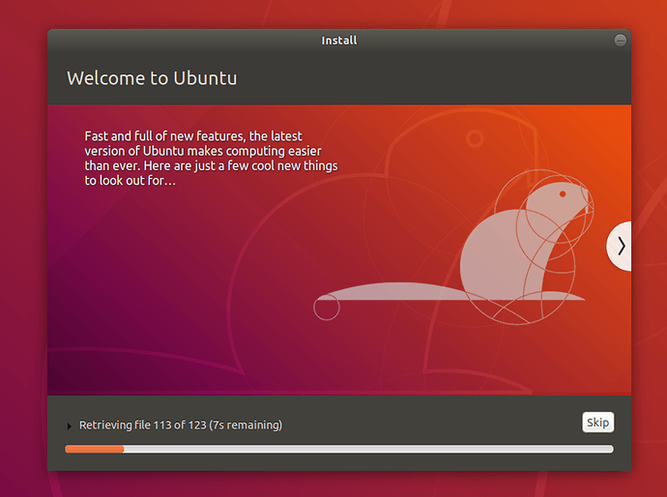 12
After everything has been installed and configured a small window will appear and then click to restart now and remove a DVD or bootable flash when prompted. Hence Ubuntu installation successfully so its time to enjoy t.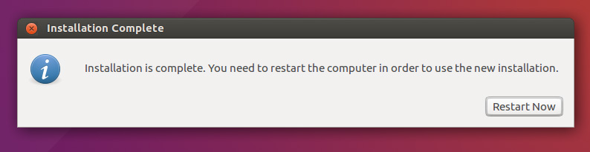 13
2.3 Things enjoyed most during the practical training 13
The things I enjoyed in my field practical training are good working environment, co-operation of staff Also, I appreciated when I was recognized when I did my duties and tasks well. And there is free internet that make me to enjoy and refresh my mind through this I play games, check movie and to learn more through online learning. 13
2.4 Things enjoyed least during practical training 14
2.5 Problems experienced/faced during practical training 14
2.6 Solutions to the problems faced 14
CHAPTER THREE 15
3.0CONCLUSION AND RECOMMENDATIONS 15
3.1 Conclusion 15
3.2 Recommendations 17
REFERENCE 18
Appendices; 19
Arrival Note 19
Log book 19

LIST OF FIGURES
Figure 1: Organizational structure……………………………………………1

List of acronyms;
- IAA Institute of accountancy Arusha
- ICT Information Communication Technology.
- TCP Transition Control Protocol
- IP Internet Protocol
- RJ45 Registered Jack 45
- IT Information Technology
- DRD Domestic revenue department
- DCO Deputy Commissioner operation
- DICT Director for information communication technology
- DF Director for finance
- DDHR Deputy Director for human resources
- HDMI. High definition multimedia interface
- RAM. Random Access Memory
- HDD. Hard disk drives
- MMC. Microsoft Management Consol

CHAPTER ONE

1.0 INTRODUCTION
The practical training is an important component for any students since we learn theoretical and by doing field work students get more experience on what they are learning in the institute. This is because it provides opportunity for students to integrate theory and practical. The students will obtain training valuable experience in a really life situation which are not be simulated and practiced in classes. Through this institution hosting the students will get new ideas, enjoy up to date information, obtain a good analytical skill in solving the problem, capable and adaptable to change and who are eager to work well in a team.
My practical training took place at Institute of Accountancy Arusha in a rush a region. Also, the purpose of this practical training is to give chance to the students to practice what they have been taught in the class session theory into practical performance(practically) so as to relate the teaching between theory and practical. Through it students will be enhance with skills, work abilities, positive attitude toward their area of professional and being exposed successfully to the employment markets.

Organizational historical backgrounds
The Institute of Accountancy Arusha (IAA) is a parasternal Educational Institution established by the Institute of Accountancy Arusha Act of 1990. The overall control and supervision of the Institute is vested in its Governing Council.
The Institute has over time developed a total number of thirty seven academic programmers from Basic Technician Certificate, Ordinary Diploma, Bachelor Degree, Post graduate Diploma and Master’s Degree.
The Institute also conducts short- term Courses and Seminars, many of them tailored to client needs. In addition, it undertakes consultancy and research activities as part of its Mission. Through these interventions, IAA aspires to develop lasting partnerships with Industry, the Government, and non-Governmental Organizations. (Arusha, 2020)

1.1Objectives of the field attachment
- To increase knowledge and skills in area consistent with career goals and philosophy.
- To enables students to get an opportunity to practice what they are learnt in a class so as to tackle different situations during the field work.

- To enhances and sustain student to get enough experience on how to conduct a work, to be effective and efficient to their responsibility, terms of employment and ethics.

- Leads to the opportunity chance to infuse agencies with new and updated concepts for delivery of services, and to aid in providing for more knowledgeable professionals

- To apply the skills and knowledge that they got from the college to deal or solve different technical problem in the working site and life in general.

- To develop working skills and co-ordinates the system for implementation of learning by observing, and participating directly to the site which may lead to direct integration of theoretically learning.

- To enhance and strengthen linkages between Institute of Accountancy Arusha and various stakeholders.

- To provide an opportunity for students to apply the principles and techniques theoretically learnt into real-life problem solving situations.

- To develop student understanding of work ethics, employment demands, responsibilities and opportunities.

- To provide an opportunity for students and academic staffs to interact with the stakeholders and potential employers and thus appreciate field situations that will also generate information for curricula review and improvement.
- To help student to determine the professional strengths and weakness.
- To help student to acquire new concept of delivery of service and to aid in providing for more knowledgeable professionals.
- To understand and appreciate professional duties and responsibilities of personnel.

1.2 Organization structure
The Organization Structure is the means by which Institute of Accountancy Arusha (IAA) discharges its mandated functions and mission. Institute of Accountancy Arusha (IAA) is made up of different departments where by each department have its own activities to perform and they are not interacting to each other in their functions but in all it performs it so as to fulfill their goals withing the organization. The first layer of this organization chart is Government Council who is responsible for performance of Institute of Accountancy Arusha (IAA) functions as a whole. After board it follows by four major layers which are Audit Committee, Finance and Administration Committee, Rector and Academic Affairs Committee. Followed by other Department as shown in the figure below.

ORGANISATIONAL STUCTURE OF IAA
Governing Council

Audit Committee
Finance & Administration Committee
Academics Affairs Committee
Rector

Legal Service Secretary (LO)
Public Relations (PRO)
ICT Unit (ICTM)
Academic Administration (Registrar)
Internal Audit Unit (IAM)
Directorate Undergraduate Studies (DUS)
HR & Admin Department (HRAM)
Directorate Postgraduate Studies (DPS)
HR Section
Finance and Planning (PFM)
Library Services (LSM)
Student Welfare (DEAN)
Students Loan Desk
Planning & Budgeting Dept.
Estate Section
Business Mg Dept.
Accounts Dept.
Reader Support Services Dept.
Library Research Dept.
Technical Services Dept.
Informatics Dept.
Examination Dept
Admission Dept.
Accounting & Finance Dept.
Postgraduate Studies Dept.

Division of Academics, Research and Consultancy (DR ARC)
Division of Planning, Finance & Administration (DR PFA)

Research & Publication Dept.

Consultancy & Executive Development Dept.

TPDF Academic Collaboration Manager
General Studies DPT
1.3 Type of business/ organization
The Institute of Accountancy Arusha (IAA) is a parasternal educational institution established by the Institute of Accountancy Arusha Act of 1990. The overall control and supervision of the Institute is vested in its Governing Council.

1.4 Major product/ service
- Provide facilities for the study of and training in the principles, Procedures and techniques of accountancy and related subjects as the Governing Council may from time to time decide.
- Conduct courses leading to professional qualifications in Accountancy and related Disciplines.
- Sponsor, arrange and provide facilities for Conferences and Seminars for discussion of matters related to Accountancy, Finance, Business, Economics, Information Technology, and other Management Sciences.
- Conduct research, and offer consultancies to business organizations, government, non-governmental organizations, and arrange for publication and general dissemination of study materials in connection with the work activities of the institute.

1.5 Activities
Activity starts with the mission as well as the vision statement of Institute of Accountancy Arusha (IAA)
MISSION STATEMENT: The mission Institute of Accountancy Arusha (IAA) is to provide high quality competence-based training and offer research and consultancy services through applied technology.
VISSION STATEMENT: The vision of the Institute of Accountancy Arusha IAA is to be an exemplary center of excellence in modern business management training, research and consultancy services.
the activities include the followings, Education service, ICT service, Library service. To ensure that IAA students to be more professional in future.
1.6 NUMBER OF EMPLOYEE
Currently, the Institute has the total number of 264 employees Distributed as 246 are permanent staff and the remaining 18 are Contracted staff so that to ensure they provide services needed by the customer as soon as possible. The numbers of employees in the department are population comprises people for different section these will probably stimulate services, diagnostic services, support services.

1.7 CUSTOMERS
Institute of Accountancy Arusha (IAA), receiving different customers both employed and non- employed people who visit every time coming from defend continent, region and district so that to receive the best education provided by the Institute.

CHAPTER TWO

2.0 EXPERIENCES
When I arrived at the organization, I went direct to the Human Resources Office for being directed to the respective department, where I was placed in ICTM for introduce myself and I was go to ICT department for introducing me more about all tasks that shall be done during practical training and other activities was started, then followed by an introduction about the department on how it functions and the activities responsible. This is the department where by my practical training was conducted, thus I went to this department to learn different knowledge in practice through different activities performed by this department and the organization as the whole.

2.1 DUTIES AND TASKS PERFORMED

TO MAKE Installation of window both window 7 and window 10.
First of all we had the things mentioned below:
- CD/DVD
- Bootable Flash
- Internet
- Hardawre and software like window.
And these steps helped us to complete the task given;
STEP 1
I open a command prompt window as administrator in order to start then I press CMD to run as administrator.
STEP 2
Insert the USB flash
STEP 3
After insert I will type the disk part to continue.
STEP 4
I press list disk to know how many files on this PC, with its status, size and free storage space. Also, I make sure that what disk is USB, its size that is not highlighted as GPT disk partition.
STEP 5
I select disk 2 to ensure the process is progress.
STEP 6
After select disk 2 in a command prompt then I press clean this disk.
STEP 7
Then I press to create partition primary so as to make creating of the specified partition then I press enter.
STEP 8
I press format fn=ntfs quick to format all files on this PC.
STEP 9
I press active to marked the current partition.
STEP 10
Select list volume so as to know the volume of those lost of disk.
STEP 11
Finally, I press exit to leave it on the MCD command.
New ideas gained from installation of window
I learn more and more on how to install a window by using cmd command through both bootable flash and CD/DVD. Also, I learn how to format and how to make partition.
TROBLESHOOTING PROBLEM RELATED ON THE PC.
In my practical training one among of the duties is to troubleshoot the problem that are related with PC problem and fix it, connect device that are not connected to the PC such as Mouse keyboard, and ethernet cable. Also make rebuilding of computer components and make exchanging of those components such as RAM and HDD and make sure the cable is be connected to motherboard and power supply are work properly.
NEW IDEAS GAINED IN TROUBLESHOOTING
Through making troubleshooting I learn many things on how to troubleshoot the related problem and how to fix it and how rebuild computer components.
INSTALLATION OF UBUNTU OPERATING SYSTEM
There are several steps that I used to install this operating system.
FIRST STEPS
I insert the bootable flash on the machine,then I restart the machine to processed after that I select the bootable device then I select next option to continue.
STEP 2
Requirements
before starting the installation the following requirements should be considered.
- Connect your laptop to a power source.
- Ensure you have at least 25 GB of free storage space, or 5 GB for a minimal installation.
- Have access to either a DVD or a USB flash drive containing the version of Ubuntu you want to install.
- Make sure you have a recent backup of your data. While it’s unlikely that anything will go wrong, you can never be too prepared.

STEP 3

Boot from DVD

Before making bootingyou need to do:
- Put the Ubuntu DVD into your optical/DVD drive.
- Restart your computer.
- As soon as your computer boots, Simply insert the USB flash drive and either power on your computer or restart it. You should see the same welcome window we saw in the previous ‘Install from DVD’ step, prompting you to choose your language to continue.

Prepare to install Ubuntu
Normally I select continue option after window opened,click next to continue then I select the second option 'normal installation/minimal installation then click back to choose another option.
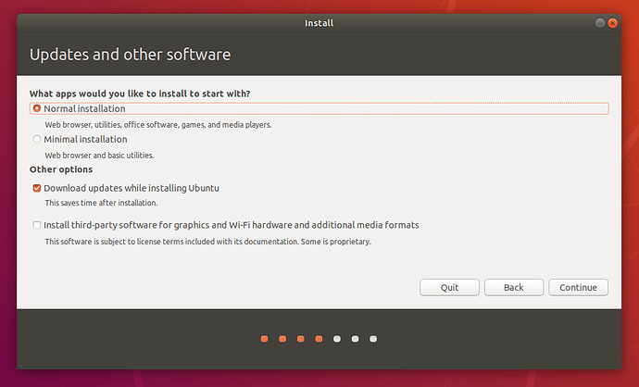

Allocate drive space

In this step you can choose something else option to sllocate the drive space you want to use it. After that press back to start installation now.
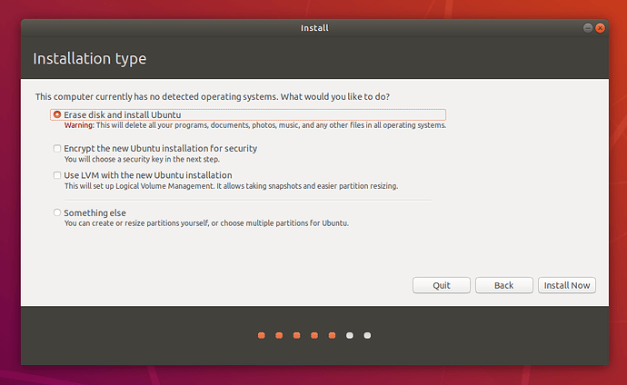
Begin installation
After configuration storage space you can click install now button,the small panel will appear with an overview of the storage option you will choose then you can select continue to fix those changes in place and start the installation process.
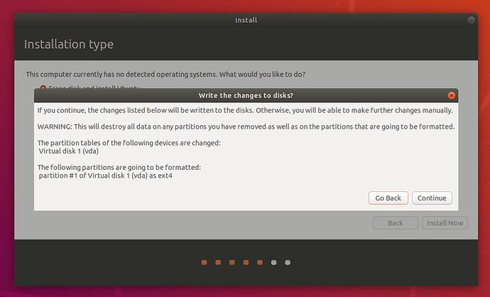

Select your location
If you are connected to the internet, your location will be detected automatically. Check your location is correct and click ’Forward’ to proceed.If you’re unsure of your time zone, type the name of a local town or city or use the map to select your location.
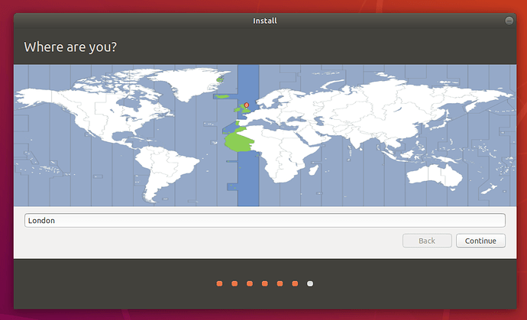

Login details

In this step you should enter your name and the installaer will automatically suggest a computer name and username. Next enter a strong password for more secure and confirm your password. After doing it click continue option to processed.changed if you prefer. The computer name is how your computer will appear on the network, while your username will be your login and account name.

Background installation

The instalkation will be completed, in this background installation window teaches you a little about how Ubuntu is.

After everything has been installed and configured a small window will appear and then click to restart now and remove a DVD or bootable flash when prompted. Hence Ubuntu installation successfully so its time to enjoy t.
2.2 New knowledge and skills gained/learned
In the organization I learned a lot of good new things for me I was know how to make installation of window and operating system, rebuilding of computer components and troubleshooting of networking, and the user assisting to be access in organization. Also, I gained knowledge on how to create an Ethernet cable and make sure that it work properly, also I learn on how to create a folder/file through command line interface CMD, to add a new user to the computer through Microsoft management console MMC.
Team Working.
In my field practical training I also learned on working as a team with other students together with the staffs employed by the organization. I learned that through team work the duties were completed on time and the output was more efficient and more underatandble compared to work personally or on individual basis.
Due to the presence of team work I have got a great exposure of leaning different ideas from others like exchanging different technical staffs concerning with ICT.

2.3 Things enjoyed most during the practical training

The things I enjoyed in my field practical training are good working environment, co-operation of staff Also, I appreciated when I was recognized when I did my duties and tasks well. And there is free internet that make me to enjoy and refresh my mind through this I play games, check movie and to learn more through online learning.

2.4 Things enjoyed least during practical training
The thing that I enjoyed Least in my practical training Is when my tasks /duties is not successed well it makes me boade and it make me difficult time to thinks more so as to solve the problem.

2.5 Problems experienced/faced during practical training
- The computer fails to install an operating system.
The particular computer could not boot from the CD or external DVD-ROM what I decided to do is to create a bootable flash and install the operating system by booting the USB devices through a command prompt.
ii. The computer components failure to work properly especially RAM and HDD its difficult to me to know which RAM is perfect to work properly and which one is not, so by checking this I will make it easy to analyze the RAM that are function and not. Also, some of computer are not turn on immediately so I will solve it.

2.6 Solutions to the problems faced
Most of the time, I fixed problems using simple troubleshooting techniques, like closing and opening the program. It was important for me to try these simple solutions before resorting to more extreme measures. If the problem still isn't fixed, I tried other troubleshooting techniques

CHAPTER THREE

3.0CONCLUSION AND RECOMMENDATIONS

3.1 Conclusion
Generally, I can say that my field attachment was very good indeed and really appreciated as I gained new knowledge and skills in ICT that previously I had learned theoretically. I also developed different skills on how to handle duties and tasks that I was assigned through hardworking and creativity. Then I gained new attitudes of working as a team and to take up my responsibilities Likewise, how to maintain the relationship.
Even though the time was too short to learn a lot of things but through the help of my on-site supervisor I managed to plan and cover what I was supposed to learn during my practical training in this organization, there was effective supervision from both supervisors that helped me to gain spirit of hard working and management of time effectively.
On the other hand, the field attachment program was too short in terms of time comparing to the things that I had to learn and be expert with them. Since we only had 6 weeks of practical trainings and things that we have to learn need more time, efforts and continuously practices. The following are the strength of field attachment.
• It enables students to meet different challenges in their carrier when working with people
of different levels of education. When in the organization there are young people having
various qualifications and responsibilities, most of them being fresh graduates from other
university and they are successful in their careers. This is a motivation to plan for future
career development.
• Practical training program is an essential tool in widening students’ skills and
understanding in what they have been taught theoretically in class. It enables students to
experience different working environments prior to completion of their degree programs.
• It helps in building confidence and understanding to students in various fields other than
only the understanding within the carrier. For example, widening knowledge on
Information Technology and its application to various sector, while in class it’s not easy
for such things to be full covered
On another side practical training has its weaknesses like the following explained below
• Limited time, the period of two months is very limited since some organization are so big
so it is not easy for an intern to fully learn about different operations in such limited time.
• Little attention to interns since most of the staffs claims to be busy with their duties hence
they have no spare time to teach the interns.
3.1 Recommendation
In this part I would like to advice on both institute of accountncy arusha.
3.1.1 Recommendation to the Institute of Accountancy Arusha
❖ I recommend that, Institute of Accountnacy Arusha should ensure that there is regular
physical visit and follow up to ensure that the students or trainees are assigned with relevant
tasks during the whole field duration. Since some of trainees were assigned irrelevant
duties in such a way that no room to implement theoretical knowledge into practice.
❖ I recommend that, The Institute of Accountnacy Arusha should improve modality of
teaching computer knowledge and skills to students who studying non-computers
programs. Computer studies should be taught in deeply to computer programs in order to
produce best students in procurement and related issues.
❖ I recommend that, Institute of Accountnacy Arusha should improve modality of arranging
duration of practical training. The duration of practical training should not be done only
once during the attainment of diploma program it should be done at least twice in a first
year and second year of the studies to make a students’ knowledgeable enough on working
environment.

3.2 Recommendations
The following are recommendations concerning this field practical training which can be elaborated as follows to Institute of Accountancy Arusha (IAA);
- I recommend that, the training period should be reviewed in order to enable students to acquire more knowledge on what he/she leant in the class and the actual work done. The time of field practical trainings to be extended to the maximum time that will enable students to learn more practically due enough time given for their trainings.
- I recommend the Institute of Accountancy Arusha to find on behalf of their students centers/organization where they can undertake their field practical training despite leaving them to find on their own which is troublesome since some of the students fail to get centers while others delay to get centers for practical training.
.

REFERENCE
Arusha, I. o. A., 2020. Institute of Accountancy Arusha.
Available at: https://iaa.ac.tz/about-us-2/background/
Mueller's, S., 2012. UPGRADING AND REPAIRING PCs. 20th. United States of America: Pearson Education.
Andrew J. (2012). A+ Guide to Managing and Maintain your pc. (8th ED). California
Wikipedia, 2021. Wikipedia.
Available at: https://en.wikipedia.org/wiki/Network_switch

Appendices;

Arrival Note

Log book

