**ARUSHA TECHNICAL COLLEGE**

Tel.: 027-2970056 Junction of Moshi-Arusha and Nairobi

Fax No: +255 27 254 8337 Email:rector@atc.ac.tz P. O. Box 296, P.O.Box296,Arusha, Tanzania Website:http://www.atc.ac.tz

30/07/2021

Estate manager,

ATC,

P.O. Box 296, ARUSHA. Dear Sir/Madam

Re: Introduction Letter-Industrial Practical Training Placement

This is to introduce and certify that: -

|  |  |  |  |
| --- | --- | --- | --- |
| S/No. | Student Name | Program | NTA level |
| 1. | Samwel Mwitumba | Electrical Engineering | NTA 5 |
| 2. | Kennedy Makoi | Civil and Irrigation Engineering | NTA 4 |
| 3. | Evance Ngasakwa | Electrical and Hydropower Engineering | NTA 5 |

Are full time student at Arusha Technical College undergoing a three years Diploma course in different courses as mentioned above. They completed the second semester of their second and first academic year in July this year. During the training they gained professional experience by working in the College workshops/laboratories, one full day per week during the two semesters (thirty weeks).

They are expected to undergo the Industrial Practical Training for ten weeks from 2nd August, 2021 to  October, 2021.

The College has provided the student with a Logbook where they are supposed to record their activities during the practical training. Kindly ask your training supervisor to check and initial the logbook each week. They have also been provided with Industrial Supervisor's Report form.

The College staff shall visit your enterprise at least once during the training period to check the student' s progress and assess them.

With this said, I am humbly and kindly requesting you to accept them for training in your company for the above mentioned period.

Yours faithfully, 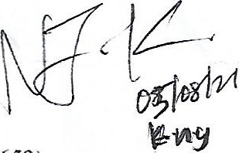

Dr. Mwanza, J.S. (0767025652) Industrial Liaison Officer, for Rector, Arusha Technical College

