CNATOOLS - COMPLEX NETWORK ANALYSIS TOOLS

COMMAND REFERENCE

05/01/2012
SNETDENS

Create a network from a sentence database.

Usage: snetdens option1 value1 [option1 value1]
-h --help show the options sumary
-i input file
-o output file
-l log file
--mode sentence insertion mode(default=clique)*
--pg population growing mode
--rg relationship growing mode
--noadj ignore adjectives
--noadv ignore adverbs
--nonoun ignore nouns
--nonotfound ignore unknown words
--nosigl ignore symbols
--noverbs ignore verbs

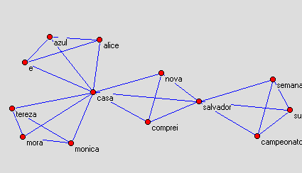
Semantic network created from test01.txt file.

* Sentence insertion mode can be:
clique – each sentence will be inserted creating cliques;
cicle – each sentence will be inserted creating cicles;
chain – each sentence will be inserted creating chains.
CNACALC

Calculate properties given a Pajek file.

Usage: cnacalc option1 value1 [option1 value1]
-h --help show the options sumary
-i input file
-o output file
-t output file type(default=edges)
-l log file
--all calculate all network parameters
--title print a title for each parameter on the log file
--colnames print the column names for each table on the log file
--stat calculate statistics
--density calculate the network density
--degrees calculate vertices degrees
--degdist calculatet the degree distriution
--avgdeg calculate the average vertex degree
--clustering calculate the clustering coefficient matrix
--avgclustering calculate the average clustering coefficient
--diameter calculate the network diameter
--geodesics calculate the geodesics matrix
--centrality calculate the centrality matrix
--nodeefficiency calculate the node efficiency matrix
--avgglobaleff calculate the average global efficiency
--localefficiency calculate the local efficiency matrix
--avglocaleff calculate the average local efficiency
--adj print the adjacency matrix on the log file
--directed it is a directed graph

CNTRANS

Do transformations to a network, described using the Pajek file format.

Usage: cntrans option1 value1 [option1 value1]
-h --help show the options sumary
-i input file
-o output file
-t output file type(default=edges)
--rml remove multiple lines
--arcs2edges converts arcs to edges
--transpose calculate the matrix transpose

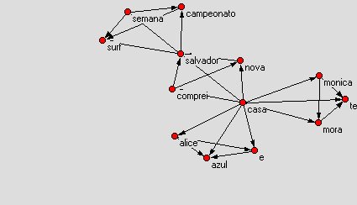
Network after remove multiple lines.

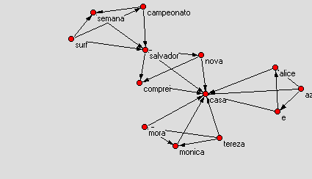
Previous network after transposition.

CNDISCO

Create unconnected networks.

Usage: cndisco option1 value1 [option1 value1]
-h --help show the options sumary
-i input file
-o output file
-l log file
--hubs hubs deletion
--random random node/link deletion
--tax tax for random node/link deletion
--pd population decrease mode
--rd relationship decrease mode

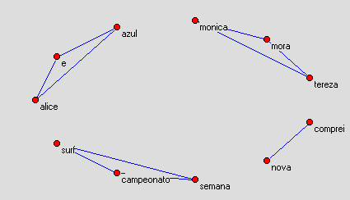
First network after hubs deletion.
COUNTSENTENCES

Count sentences in a sentence database.

Usage: countsentences option1 value1 [option1 value1]
-h --help show the options sumary
-i input file
RMSENTENCES

Usage: rmsentences option1 value1 [option1 value1]
-h --help show the options sumary
-i input file
-o output file
-l log file
-n remove the specified number of sentences
--rmtax remove tax(default=10)
--letn let only the specified number of sentences in the file
NETEXTRACT

Extract a network mode from a bimodal network.

Usage: netextract option1 value1 [option1 value1]
-h --help show the options sumary
-i input file
-o output file
-t output file type(default=edges)
--mode mode to extract(default=1)
ER2NETCSV

Create a NetCSV file, given to csv tables and the relationship between then.

Usage: er2netcsv option1 value1 [option1 value1]
-h --help show the options sumary
--i1 first input file
--i2 second input file
-o output file
--file1c1 table 1 relationship column number(default=0)
--file1c2 table 1 data column number(default=1)
--file2c1 table 2 relationship column number(default=0)
--file2c2 table 2 data column number(default=1)
--file1sep first file field separator(default=",")
--file2sep second file field separator(default=",")
--file3sep output file field separator(default=",")
CSV2NETCSV

Create a NetCSV given a csv file(self-relationship).

Usage: csv2netcsv option1 value1 [option1 value1]
-h --help show the options sumary
-i input file
-o output file
--c1 first column number(default=0)
--c2 second column number(default=1)
--s1 record field separator(default=",")
--s2 internal column field separator(default=";")
--s3 new record field separator(default=",")
CSV2NET

Create a network Pajek given a NetCSV network file.

Usage: csv2net option1 value1 [option1 value1]
-h --help show the options sumary
-i input file
-o output file
--modes selects one or two modes network(default=1)
--separator column separator(default=",")
--ignore ignore fields with the specified patern(default=NULL)
--addsufix add a mode sufix to each vertex
CSVSTAT

Calculate statistics from a NetCSV network file.

Usage: csvstat option1 value1 [option1 value1]
-h --help show the options sumary
-i input file
-o output file
--column column number(default=0)
--separator field separator(default=",")
--firstline first line to include in calculations
--printfirst print first line
PDB2NETCSV

Create a NetCSV network file from a PDB(Protein Data Base).

Usage: pdb2netcsv option1 value1 [option1 value1]
-h --help show the options sumary
-i input file
-o output file
-s column separator(default=",")
-d minimum distance between two atoms to conect them
--ca only measure distance from CA atoms
EVOLNET

Simulate evolution of a network, based in affinity properties.

Usage: evolnet option1 value1 [option1 value1]
-h --help show the options sumary
-i input file
-o output file
-l log file
--mtax mutation tax(default = 1)
--ngen number of generations(default = 10)
--atax affinity tax(default = 30)
--method method for natural selection(default = centrality)
--snapshots take snapshots
--prefix snapshot prefix(default = "snapshot")
--interval snapshots interval(default = 1)
EXAMPLES

LINUX

./snetdens.gua -i test01.txt -o test01.net -l test01-density.log

./cntrans.gua -i test01.net -o test01-arcs.net -t arcs

./cntrans.gua -i test01-arcs.net -o test01-arcs2edges.net --arcs2edges

./cntrans.gua -i test01.net -o test01-arcs.mat -t matrix

./cntrans.gua -i test01.net -o test01-rml.net --rml

./cntrans.gua -i test01.net -o test01-rml.mat --rml -t matrix

./cntrans.gua -i test01-rml.mat --transpose -o test01-transpose.mat -t matrix

./cntrans.gua -i test01-rml.mat --transpose -o test01-transpose.net

./cndisco.gua -i test01.net -o test01-hubs.net -l test01-hubs.log --hubs

./cndisco.gua -i test01.net -o test01-random.net -l test01-random.log --random --tax 30

WINDOWS

guash.exe snetdens.gua -i test01.txt -o test01-win32.net -l test01-density-win32.log

guash.exe cntrans.gua -i test01-win32.net -o test01-arcs-win32.net -t arcs

guash.exe cntrans.gua -i test01-arcs-win32.net -o test01-arcs2edges-win32.net --arcs2edges

guash.exe cntrans.gua -i test01-win32.net -o test01-arcs-win32.mat -t matrix

guash.exe cntrans.gua -i test01-win32.net -o test01-rml-win32.net --rml

guash.exe cntrans.gua -i test01-win32.net -o test01-rml-win32.mat --rml -t matrix

guash.exe cntrans.gua -i test01-rml-win32.mat --transpose -o test01-transpose-win32.mat -t matrix

guash.exe cntrans.gua -i test01-rml-win32.mat --transpose -o test01-transpose-win32.net

guash.exe cndisco.gua -i test01-win32.net -o test01-hubs-win32.net -l test01-hubs-win32.log --hubs

guash.exe cndisco.gua -i test01-win32.net -o test01-random-win32.net -l test01-random-win32.log --random --tax 30

