Game Design Document

Fill up the following document

1. Write the title of your project.

Basketball shooter

1. What is the goal of the game?

Shoot the basketball thru’ the hoop

1. Write a brief story of your game.

Oliver is a great fan of basketball. Due to the lockdown he isn’t able to go to a basketball match . So he decides create a virtual experience in his computer .

1. Which are the playing characters of this game?

* Playing characters are the ones who respond to the user based on the input from the user.
* Cars, monkeys, dinos, wizards, etc., are the playing characters in the game.

|  |  |  |
| --- | --- | --- |
| Number | Character Name | What can this character do? |
| 1 | Oliver | Throw basket balls |

1. Which are the Non-Playing Characters of this game?

* Non-Playing characters are the ones that don't have an action or behavior when the user interacts with the game.
* Hurdles, stones, bananas, coins, etc., are non-playing characters in the game.

|  |  |  |
| --- | --- | --- |
| Number | Character Name | What can this character do? |
| 1 | Hoop | The goal of the game |
| 2 | Basketball | Oliver’s ball |

Draw your imagination of this game. What does this game look like?

* Draw the game either on your computer or on paper.
* Add images of the game scenes to show each of the playing and non-playing characters at least once.

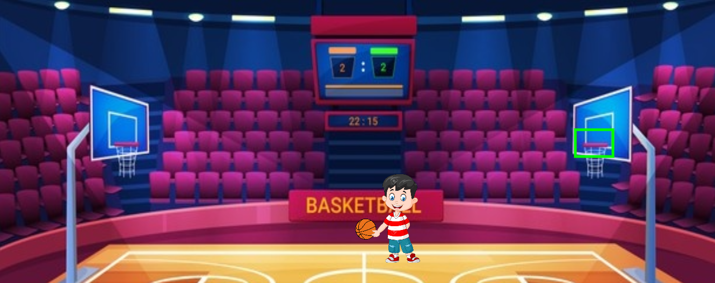

How do you plan to make your game engaging?

By adding arrow key functionality.