Scripting Language Lab

Submitted by:

Jotham N. Wanniang

Registration no: 201900343

Sec: C

**Question:**

## Create a calculator app using Angular which is capable of performing following operations:

1. Addition of two numbers
2. Subtraction of two numbers
3. Multiplication of two numbers
4. Division of two numbers
5. Factorial of a number
6. Checking if a given number is Prime or not

SOLUTION:

**Calculator component.css**

*{

margin: 0;

padding: 0;

font-family:"Times New Roman", Times, serif;

}

body{

display: flex;

justify-content: center;

align-items: center;

}

.calculator{

position:relative;

display: grid;

}

.calculator .val{

grid-column: span 4; height: 100px; width: 320px;

background-color: #a1a1a1f1; border: none;

border-radius: 10px; text-align: right; font-size: 35px; padding: 10px;

color: rgb(107, 100, 100);

font-family: "Times New Roman", Times, serif; outline: none;

}

.calculator span{

display: grid;

width: 80px;

height: 80px;

place-items: center;

background-color: rgb(99, 89, 89);

color: rgb(20, 20, 20); font-size: 25px; margin: 2px;

border-radius : 90px;

}

.calculator span.clear{

grid-column: span 3;

width: 250px;

background-color: #1d5553;

}

.calculator span:hover{

background: #1d5553;

box-shadow: -5px 2px 2px rgba(0, 0, 0, 0.2);

}

.calculator span:active{

background: rgb(68, 124, 126);

}

.calculator span.btm{

grid-column: span 2;

width: 160px;

background-color: #1d5553;

align-self: center;

}

.btm{

display: grid;

width: 80px;

height: 80px;

place-items: center;

background-color: rgb(233, 233, 233);

color: rgba(0, 0, 0, 0.363);

font-size: 25px;

margin: 2px;

border-radius : 90px;

grid-column: span 2;

width: 160px;

background-color: #1d5553;

align-self: center;

border: none;

}

.btm:active{

background: rgb(25, 50, 51);

}

.btm:hover{

background: #1d5553;

box-shadow: -5px 2px 2px rgba(0, 0, 0, 0.2);

}

p{

display: grid;

place-items: center;

background-color: rgb(178, 203, 209);

color: rgba(0, 0, 0, 0); font-size: 25px; margin: 2px;

grid-column: span 4;

}

# Calculator component.html

<body>

<div class="wrapper">

<form class="calculator" name="calc">

<input type="text" class="val" name="txt" readonly="" />

<span class="clear" onclick="document.calc.txt.value =''">AC</span>

<span class="num" onclick="document.calc.txt.value += '/'">/</span>

<span class="num" onclick="document.calc.txt.value += '7'">7</span>

<span class="num" onclick="document.calc.txt.value += '8'">8</span>

<span class="num" onclick="document.calc.txt.value += '9'">9</span>

<span class="num" onclick="document.calc.txt.value += '*'">x</span>

<span class="num" onclick="document.calc.txt.value += '4'">4</span>

<span class="num" onclick="document.calc.txt.value += '5'">5</span>

<span class="num" onclick="document.calc.txt.value += '6'">6</span>

<span class="num" onclick="document.calc.txt.value += '-'">-</span>

<span class="num" onclick="document.calc.txt.value += '1'">1</span>

<span class="num" onclick="document.calc.txt.value += '2'">2</span>

<span class="num" onclick="document.calc.txt.value += '3'">3</span>

<span class="num" onclick="document.calc.txt.value += '+'">+</span>

<span class="num" onclick="document.calc.txt.value += '.'">.</span>

<span class="num" onclick="document.calc.txt.value += '0'">0</span>

<span class="num" onclick="document.calc.txt.value += '00'">00</span>

<span class="equal" onclick="document.calc.txt.value = eval(calc.txt.value)">=</span>

<span class="btm" onclick="document.calc.txt.value = eval(calc.txt.value)">Factorial</span>

<button class="btm" (Click)="isPrime()">Prime</button><br>

<p>{{prime}} is {{result}}</p>

</form>

</div>

</body>

# Calculator component.ts

import { Component } from '@angular/core';

@Component({

selector: 'app-calculator',

templateUrl: './calculator.component.html', styleUrls: ['./calculator.component.css'],

})

export class CalculatorComponent { result = ' not a prime number'; prime = 0;

count = 0;

i = 1;

title = 'Calculator'; isPrime() { this.prime = 1; this.result = ' is a prime';

}

}

# OUTPUT:

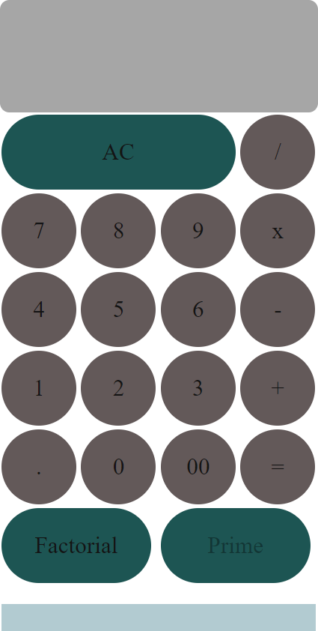

# Program output 1:

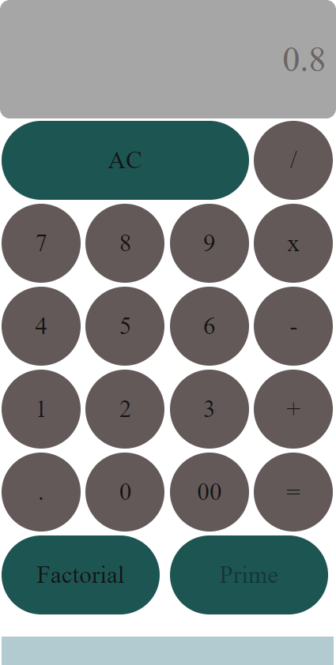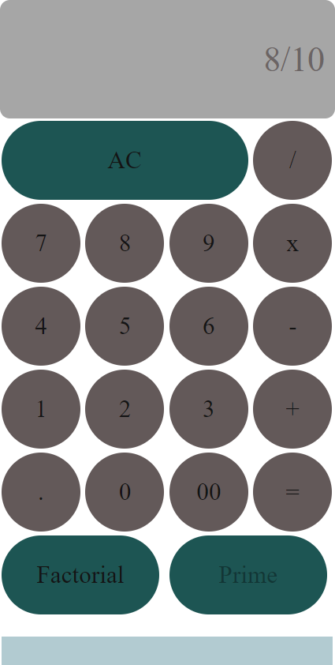

# Program output 2:

