HOLIDAY PROGRAMME FOR SENIOR 5 AND SENIOR 6 STUDENTS
Machine Learning Track
Eight weeks - twenty-four sessions - seventy-two hours
What your child will be able to do on the last day
Open a data file they have never seen, clean it, find something true in it, teach a computer to make a prediction from it, check honestly whether the prediction is any good, and stand up for five minutes and explain the whole thing to a room.
They will have built that themselves, on their own laptop, from a starting point of never having written a line of code. It takes seventy-two hours and it is genuinely within reach of an S.5 student.
The work is published to a portfolio they keep, and the certificate carries a mark earned from that work rather than from attendance.

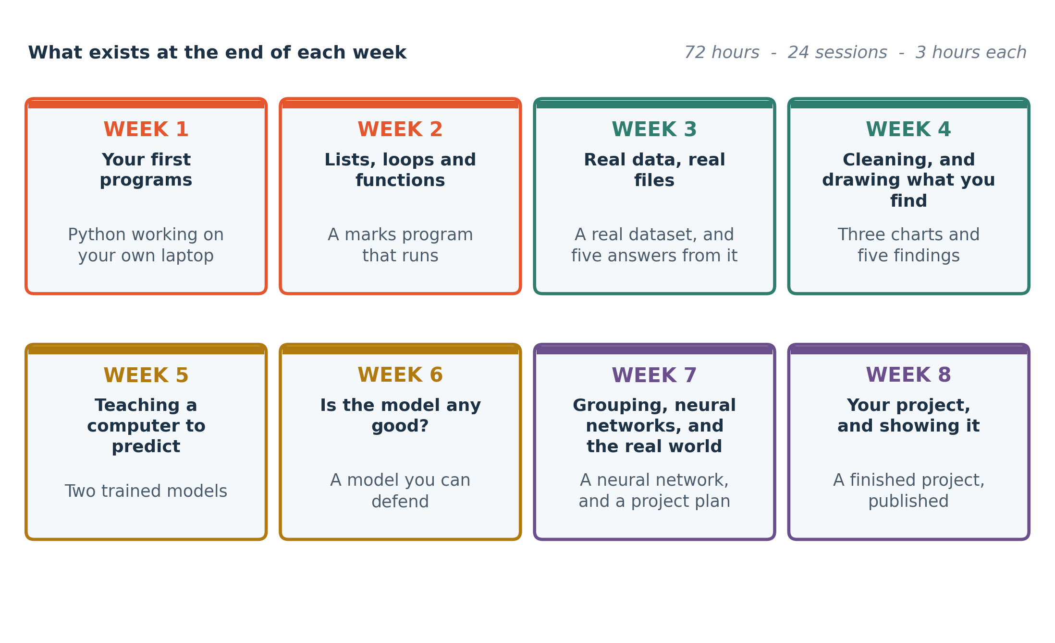
The eight weeks, and what exists on their laptop at the end of each one.

1 · The roadmap
Machine learning has a published learning path that professionals use, at roadmap.sh. The picture below is that path, with this track's eight weeks mapped onto it. It is here because a student deserves to see where they are going, and where this stops.
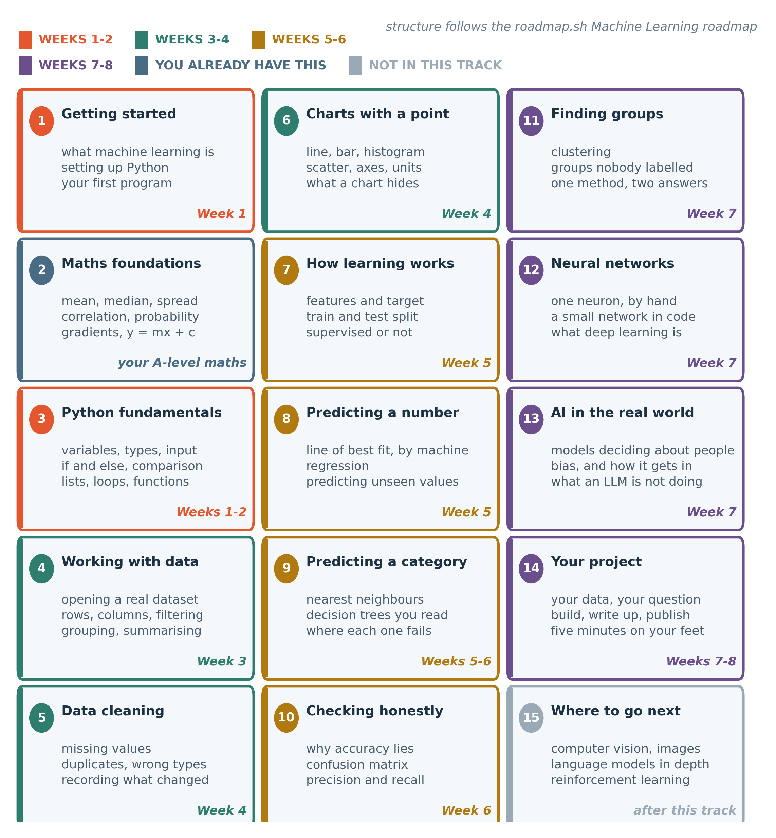
Fifteen stages. The colour says which fortnight covers it. Stage 2 is the mathematics they already have from A-level. Stage 15 is what comes after this track, and it is grey because this track does not teach it.
Two of the fifteen cards are not taught here, and both are deliberate.
Stage 2, the mathematics, is marked as something they already have. The mean, the median, spread, correlation, the line of best fit, probability and gradients are all on the A-level syllabus. This is the most encouraging fact in the whole document: a student who is doing Subsidiary or Principal Mathematics is already holding half of what machine learning is built on, and has never been shown that it is the same thing.
Stage 15 is what comes next. Image recognition, language models and reinforcement learning all need the foundations this track builds. Section 7 says where to learn them.

2 · Week by week
Twenty-four sessions of three hours. Each week below says what is taught, which A-level mathematics it leans on, and what exists at the end of the week. That last column is the one to read if you are short of time.

Week 1 · Your first programs
Roadmap stages 1, 3
# | Session | What happens
1 | What machine learning actually is, and your first program | Three live demonstrations: a model that reads handwriting, one that separates spam from real messages, one that guesses a price. Then how each of them is only arithmetic on a table of numbers. Set up Python on your own laptop, and write and run a program before you leave.
2 | Variables, numbers and text | Storing a value under a name and using it again. The four types you need: whole numbers, decimals, text and true/false. Reading input from the keyboard and printing an answer. Your first error message, on purpose, and how to read it.
3 | Making decisions: if, else and comparison | A program that behaves differently depending on its input. Comparison and the words and, or and not. By the end you have written a program that grades a mark out of 100 into a letter.

The maths behind it | Nothing new. You are using arithmetic you have had since P.7.
What you have at the end | Four small programs that run, and Python working on your own laptop.
Before the next session | Rewrite the grading program from memory, without notes. Fifteen minutes, and it is worth more than an hour of reading.

Week 2 · Lists, loops and functions
Roadmap stage 3
# | Session | What happens
1 | Lists: holding many values at once | One name holding thirty marks. Getting one item out, adding, removing, counting, sorting. Counting from zero, which is the one real surprise in this week.
2 | Loops: doing the same thing to every item | Repeating an instruction for every value in a list without writing it thirty times. Adding a list up, finding the largest, counting how many pass.
3 | Functions, and your first real program | Giving a name to a piece of work so you can use it again. Inputs, a result, and why this is the same idea as a formula in Excel. Then you build a marks program: it takes a class list, computes the mean and the highest, and says who passed.

The maths behind it | Mean and highest value. You are writing the formulas you already use in Excel, in a language that can also do the rest of this course.
What you have at the end | A working marks program, and your code saved online where you can show it.
Before the next session | Add the median to your marks program. You know what a median is; the work is getting the computer to find it.

Week 3 · Real data, real files
Roadmap stage 4
# | Session | What happens
1 | From spreadsheet to pandas | Opening a real data file in Python. Rows, columns and the words the field uses for them. Six commands that tell you what any new file contains, in the same order every time.
2 | Choosing rows and columns | Filtering to the rows you care about and picking the columns you need. This is the autofilter you already use, written down so it runs again tomorrow on a bigger file.
3 | Grouping and summarising | One number per group: the average mark per subject, the total sales per month. This is a pivot table, written down.

The maths behind it | Mean, median, mode and range, applied to a file with thousands of rows rather than the twenty in a textbook exercise.
What you have at the end | A notebook that opens a real dataset and answers five questions about it.
Before the next session | Find a dataset that interests you, from the list we give you, and write down three questions you would like it to answer.

Week 4 · Cleaning, and drawing what you find
Roadmap stages 5, 6
# | Session | What happens
1 | Data is never clean when it arrives | Missing values, the same thing spelled three ways, numbers stored as text, and rows recorded twice. Each one found in two lines and fixed in two more. Writing down what you changed, so somebody else can get your number back.
2 | Charts that answer a question | Four charts and the question each one answers: a line for change over time, a bar to compare groups, a histogram for the shape of one column, a scatter for whether two things move together. Titles, axis labels and units.
3 | Checkpoint 1: your first data investigation | Take a dataset you have not seen, clean it, draw three charts and write five findings with a number attached to each. Marked, and it counts towards your certificate.

The maths behind it | Correlation and the scatter diagram, straight out of the statistics you are taught for A-level. You will draw one and then compute the correlation coefficient.
What you have at the end | A cleaned dataset, three labelled charts and five written findings. The first thing in your portfolio.
Before the next session | Finish and submit the investigation.

Week 5 · Teaching a computer to predict
Roadmap stages 7, 8, 9
# | Session | What happens
1 | What learning from data means | Features and a target. Showing a computer examples and letting it find the pattern instead of writing the rule yourself. Splitting your data into a part to learn from and a part to be tested on, and why that split is the whole game.
2 | Predicting a number: the line of best fit, by machine | You have drawn a line of best fit by eye. Today the computer finds the one that fits best, and you see that y = mx + c is exactly what a first machine learning model is. Then you use it to predict a value it has never seen.
3 | Predicting a category: nearest neighbours | Deciding which group something belongs to by looking at the examples it most resembles. No equations. Then the same idea made to fail on purpose, so you see what it cannot do.

The maths behind it | y = mx + c, gradient and intercept, and the line of best fit. This is the week where A-level algebra turns into a working model.
What you have at the end | Two trained models on your laptop, one predicting a number and one predicting a category.
Before the next session | Retrain your line-of-best-fit model on a different pair of columns and write one sentence on whether it got better or worse.

Week 6 · Is the model any good?
Roadmap stages 9, 10
# | Session | What happens
1 | Decision trees, which you can read | A model that makes a decision by asking a series of yes-or-no questions, drawn as a diagram you can follow with your finger. Then you print the tree your data produced and explain it out loud.
2 | Accuracy lies: how to actually check a model | Ninety-nine per cent accurate and completely useless. The confusion matrix, and what it costs to be wrong in each direction. Precision and recall, in plain words, on an example where the difference matters.
3 | Checkpoint 2: build, test and defend a model | Train two different models on the same data, compare them honestly, choose one and write down why. Marked, and it counts towards your certificate.

The maths behind it | Probability, percentages and rates: the difference between a count and a proportion, which is where most wrong claims about models come from.
What you have at the end | Two compared models, a confusion matrix you can read, and a written justification for the one you chose.
Before the next session | Finish and submit the checkpoint.

Week 7 · Grouping, neural networks, and the real world
Roadmap stages 11, 12, 13
# | Session | What happens
1 | Finding groups nobody labelled | Letting a computer sort things into groups when you have not told it what the groups are. Run on a dataset of your class, and then on songs, and you see the same method behave differently on each.
2 | What a neural network is, and where ChatGPT fits | One artificial neuron, worked by hand on paper, then the same thing with thirty of them in three lines of code. What deep learning is, what a large language model is doing when it answers you, and what it is not doing. The honest limits.
3 | Machine learning in the world, and choosing your project | Where these methods are already deciding things about people: loans, admissions, policing, medical triage. What bias in a model means and how it gets there. Then you choose your project dataset and question, and write the plan.

The maths behind it | Weighted sums and the gradient of a curve. For Principal Maths students, the derivative you learned last term is exactly how a neural network improves itself.
What you have at the end | A clustering notebook, a small neural network that runs, and a one-page project plan.
Before the next session | Collect or download your project dataset and profile it with the six commands from Week 3.

Week 8 · Your project, and showing it
Roadmap stage 14
# | Session | What happens
1 | Build, with help at your elbow | Three hours on your own project. The instructor moves between students; anything asked twice is answered to the whole room. By the end of the session your model trains and produces a number.
2 | Finish it, write it up, publish it | The last fixes, then the write-up: your question, your answer with its number, how you know, and what would change your answer. Push the whole thing to your public portfolio.
3 | Showcase, and certificates | Five minutes each, in front of the room, with parents invited. The question, the answer, one chart, and what you would do next. Then certificates.

The maths behind it | Everything above, used at once, on data you chose.
What you have at the end | A finished project: a working model, a written page, a public portfolio link and a five-minute presentation.
Before the next session | None. Show somebody at home what you built.

3 · A session, hour by hour
Every session has the same shape, so nobody has to wonder what is coming. These are teenagers on holiday, so no teaching block runs longer than twenty-five minutes and more than half of the time is spent at the keyboard rather than listening.
Minutes | What | Why it is built this way
15 | Warm-up | A short puzzle on the screen as they arrive, and last session's homework answered. Starts on time even if the room does not.
25 | Teach one idea | One idea, typed live on the projector while they follow on their own machines. Twenty-five minutes is the ceiling.
35 | Do it yourself | They build the same thing without being led, working in pairs. The instructor circulates rather than presents.
15 | Break | Off screens. Eat something.
25 | Teach the second idea | The half that only makes sense once the first half is in their fingers.
45 | Build something that runs | Every session ends with a file that does something. Nothing is left half-finished on the screen.
20 | Show and tell | Two or three students put their screen on the projector. This is the part they come back for.

Every session ends with something that runs
A student never leaves with a half-finished screen. The last forty five minutes of each session exists so that there is a file on their laptop that does something, however small, before they go home.
The twenty minutes after that is show and tell: two or three students put their own screen on the projector. It is the part they come back for.

4 · Marks, and what the certificate means
A certificate with real marks was asked for, so the marks come from work rather than from turning up. Attendance is expected and is not a grade.
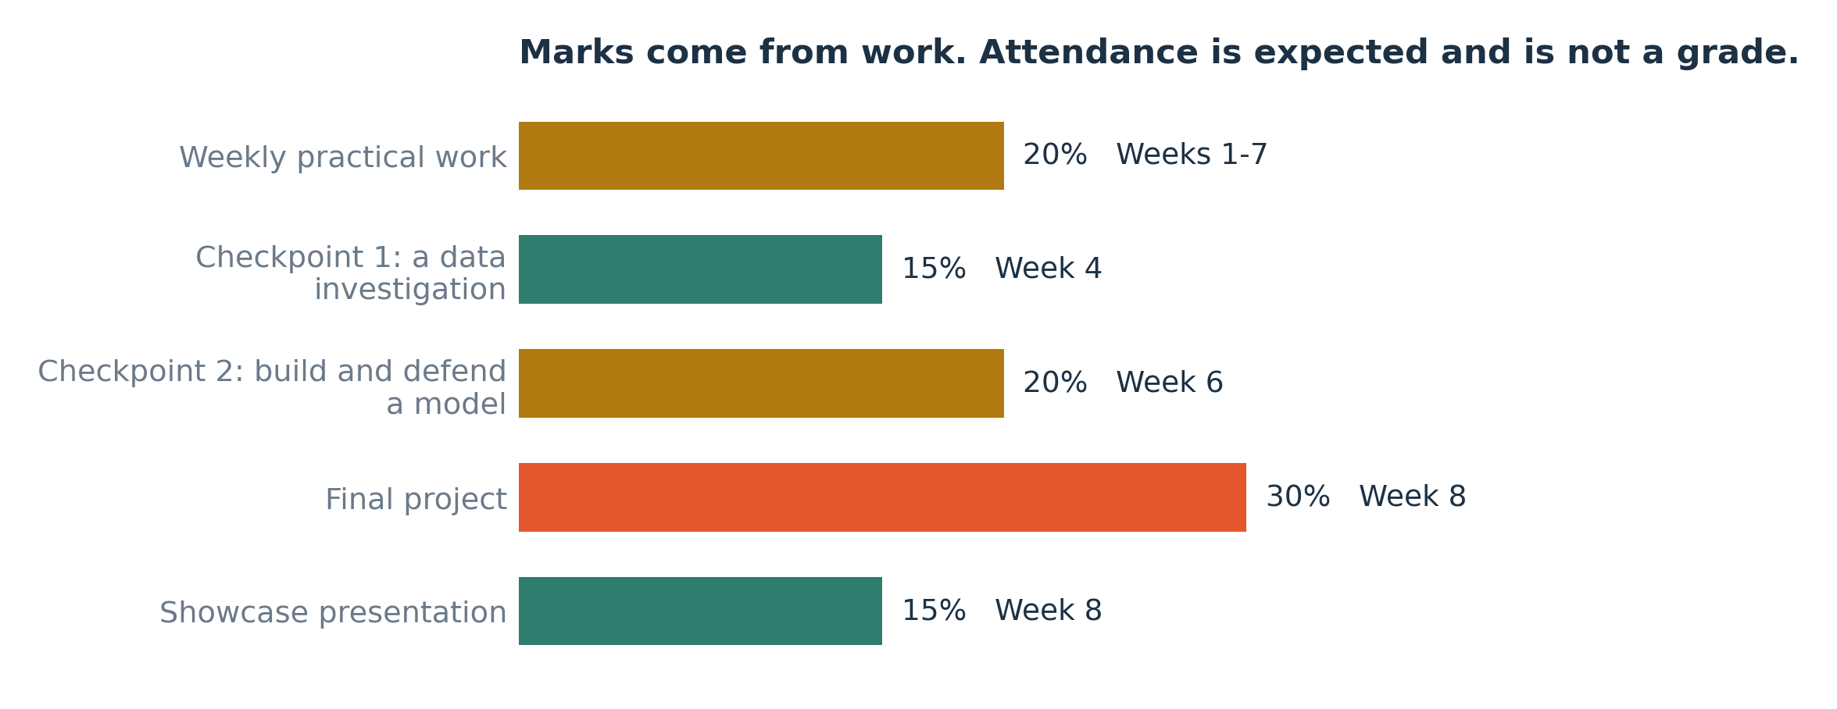
Where the hundred marks come from, and when each piece is due.
What | Weight | When | How it is marked
Weekly practical work | 20% | Weeks 1-7 | Seven short pieces, one a week, marked out of 10. These are the programs and notebooks built in the sessions themselves, so a student who attends and works collects most of this.
Checkpoint 1: a data investigation | 15% | Week 4 | Clean an unfamiliar dataset, draw three charts and write five findings with a number attached to each. Marked on the findings and the labels on the charts.
Checkpoint 2: build and defend a model | 20% | Week 6 | Train two models on the same data, compare them honestly and justify the one you chose. Marked on the reasoning as much as on the accuracy.
Final project | 30% | Week 8 | A working model on a dataset the student chose, with a written page: the question, the answer with its number, how they know, and what would change the answer.
Showcase presentation | 15% | Week 8 | Five minutes in front of the room with parents present. Marked on whether somebody outside the room could follow it.
What the certificate says
Band | Mark | What it claims the student can do
Distinction | 70% and above | Can start a new dataset unaided and finish it.
Merit | 60% and above | Can do the whole workflow with the notes open.
Pass | 50% and above | Can follow the workflow and explain what each step does.
Certificate of attendance | below 50% | Below 50. Attended and took part; the certificate says so and does not claim a skill that is not there.

A student below 50 still receives a certificate, and it does not overstate
It states that they attended and took part, and it does not claim a skill that is not there. We would rather a certificate from this track meant something to the person reading it, including to an admissions officer who has seen a hundred of them.

5 · What to bring, and what it costs to get ready
Students bring their own laptops, which means a mixture of Windows and Mac of different ages. Everything below is planned around that.
A laptop they bring themselves | Windows 10 or newer, or any Mac from 2017 onward. 4 GB of memory is enough; 8 GB is comfortable. About 6 GB of free disk space. A student without a laptop should tell us before Week 1 so we can pair them and arrange lab access, rather than discovering it on the first morning.
Python, installed in Week 1 Session 1 | We install it together, in the room, on their own machine. Windows and Mac instructions are both in the setup sheet, and a USB stick with the installers travels with the instructor so a slow connection cannot stop the first session.
A browser, as the fallback | If a laptop cannot take the install, the same work runs in Google Colab in a browser with nothing to set up. A student needs a Google account for this, and for the portfolio.
A notebook and a pen | Several things in this track are worked on paper first, including the neuron in Week 7. That is deliberate.
The data, on a USB stick | Every dataset is handed out on the first day as well as being downloadable. The internet in the room is not a dependency for any session.

No laptop? Tell us before Week 1, not on the first morning
A student without a laptop can still take the track: they pair with somebody for the session work and use a lab machine for the homework. That has to be arranged in advance, and a student who says nothing and arrives with no machine loses the first session.
Everything also runs in a browser with nothing installed, which is the fallback for a laptop too old or too locked down for the install.

6 · Questions parents ask
Attendance
Twenty-four sessions, and the work is cumulative: Week 5 assumes Week 2. A student who misses a session gets the notes and the recording of the live coding, and should expect to spend an hour catching up before the next one. Missing more than four sessions makes the certificate marks difficult to award honestly.
Using AI tools such as ChatGPT
Allowed, and taught, with one rule: a student must be able to explain every line they submit. We ask in the showcase and at the checkpoints. Code a student cannot explain scores nothing, which is the same rule any university will apply to them next year. Week 7 covers what these tools are actually doing and where they are wrong.
Safety online
Students create a public portfolio, so the setup session covers what goes in it and what does not: no full date of birth, no home address, no school ID numbers, no photographs of other students without asking. Datasets are public and contain no personal information about anybody in the room.
Screens and breaks
Every session has a fifteen-minute break away from screens, and no teaching block runs longer than twenty-five minutes.
What parents are invited to
The showcase on the final session, where each student presents for five minutes. Parents are welcome to the first fifteen minutes of Week 1 Session 1 as well, to see the room and meet the instructor.
Marks, and what the certificate says
Marks come from work rather than attendance. The certificate states the band and the hours, and a student below 50 receives a certificate of attendance that does not claim a skill they do not have. We would rather a certificate meant something.

7 · What this track does not do
Written down because a family deciding how to spend a holiday and a fee deserves the edges as well as the promises.
It does not make your child a professional in eight weeks
Seventy-two hours makes a confident beginner who can finish a small project without help. A working data scientist has years behind them. What this track does is remove the barrier: after it, the online courses and university modules are readable rather than baffling.
It is not a substitute for A-level revision
It is a holiday track and it is scheduled three days a week for that reason. The maths it uses is A-level maths, so it reinforces statistics and algebra, and several students find their Paper 2 statistics easier afterwards. It does not teach the syllabus.
There is no deep learning beyond a first look
Image recognition, language models and reinforcement learning need foundations this track is building. Week 7 shows what they are and Stage 15 of the roadmap says where to learn them. A track that promised them in eight weeks from zero would be selling something.
Nobody is promised a job or a scholarship
Students leave with a public portfolio and a certificate with marks on it, which is a real thing to show an admissions officer. It is an advantage rather than a guarantee, and we will not describe it as more than that.

Where to go after this track
If they want more machine learning | Stage 15 of the roadmap: computer vision, language models, reinforcement learning. The public roadmap.sh Machine Learning path lists them in order and is free.
If they are heading for university computing | This track covers roughly the practical half of a first-year introduction to programming and data. Keep the portfolio and keep adding to it.
If they are heading for engineering, medicine or economics | Every one of those fields now uses these methods on its own data. The data handling in Weeks 3 and 4 is the part they will use first, whatever they study.
If they want to keep practising for free | Kaggle has thousands of public datasets and beginner competitions. The final week shows them how to enter one.

8 · Practical details
The teaching content of this syllabus is settled. The arrangements below are for the school to confirm, and they are left blank rather than guessed, because a syllabus that goes home with a date in it that turns out to be wrong is worse than one with a gap.
To confirm | Details
Start date and end date
Which three days of the week, and the time of day
Venue and room
Fee, what it includes, and how to pay
Instructor name and one line of background
A phone number and an email for questions
Maximum number of students in the group
Registration deadline and how to register

One request of parents, and it is the one that matters most
Ask your child to show you what they built, once a week. Not to check it, and you do not need to understand the code. Explaining it to somebody who does not already know is the single thing that turns a holiday course into a skill that stays, and ten minutes at the kitchen table does more for them than any extra session we could add.

