INTERNATIONAL UNIVERSITY OF EAST AFRICA · FACULTY OF ENGINEERING
Benchmarked Against the Field
The two-semester course mapped node by node onto the roadmap.sh Machine Learning roadmap
WHAT WE TEACH · WHAT WE DEFER · WHAT WE DO NOT TEACH AT ALL

Source: roadmap.sh/machine-learning · Machine Learning Roadmap, retrieved September 2026
Version 1.0 · September 2026

Contents
[To generate the contents list: open in Word, click here, then press F9 — or use References ▸ Update Table.]

1. Why benchmark against a public roadmap
A syllabus written in isolation is impossible for a student to place. They cannot tell whether what they are being taught is the whole field, a sensible subset of it, or an idiosyncratic selection. Benchmarking the course against roadmap.sh answers that question honestly and in public.
It does three useful things. It shows students where they are on a map the profession actually uses, rather than one their lecturer invented. It makes the gaps explicit, so nobody finishes the year believing they have covered reinforcement learning or MLOps when they have not. And it gives the self-directed students a route onwards, because roadmap.sh publishes separate roadmaps for the AI engineer, the data scientist, MLOps and AI agents.
The finding that matters most for this cohort
The roadmap places mathematical foundations — calculus, linear algebra, statistics, probability — as a major early stage, and for people entering machine learning from computing it is the hardest one. These students completed it in Years 1 and 2 of an engineering degree. They are not beginning at the start of the roadmap; they are beginning at stage 3 with stage 2 already behind them. That is worth telling them in Week 1, because it inverts the assumption that this field belongs to computer scientists.

2. The roadmap, and where the course sits on it
The figure below is issued to students in Week 1 as part of the opening session. Orange is Semester 1, green is Semester 2, dark blue is the stage they already hold from their degree, and grey is what the course does not teach.
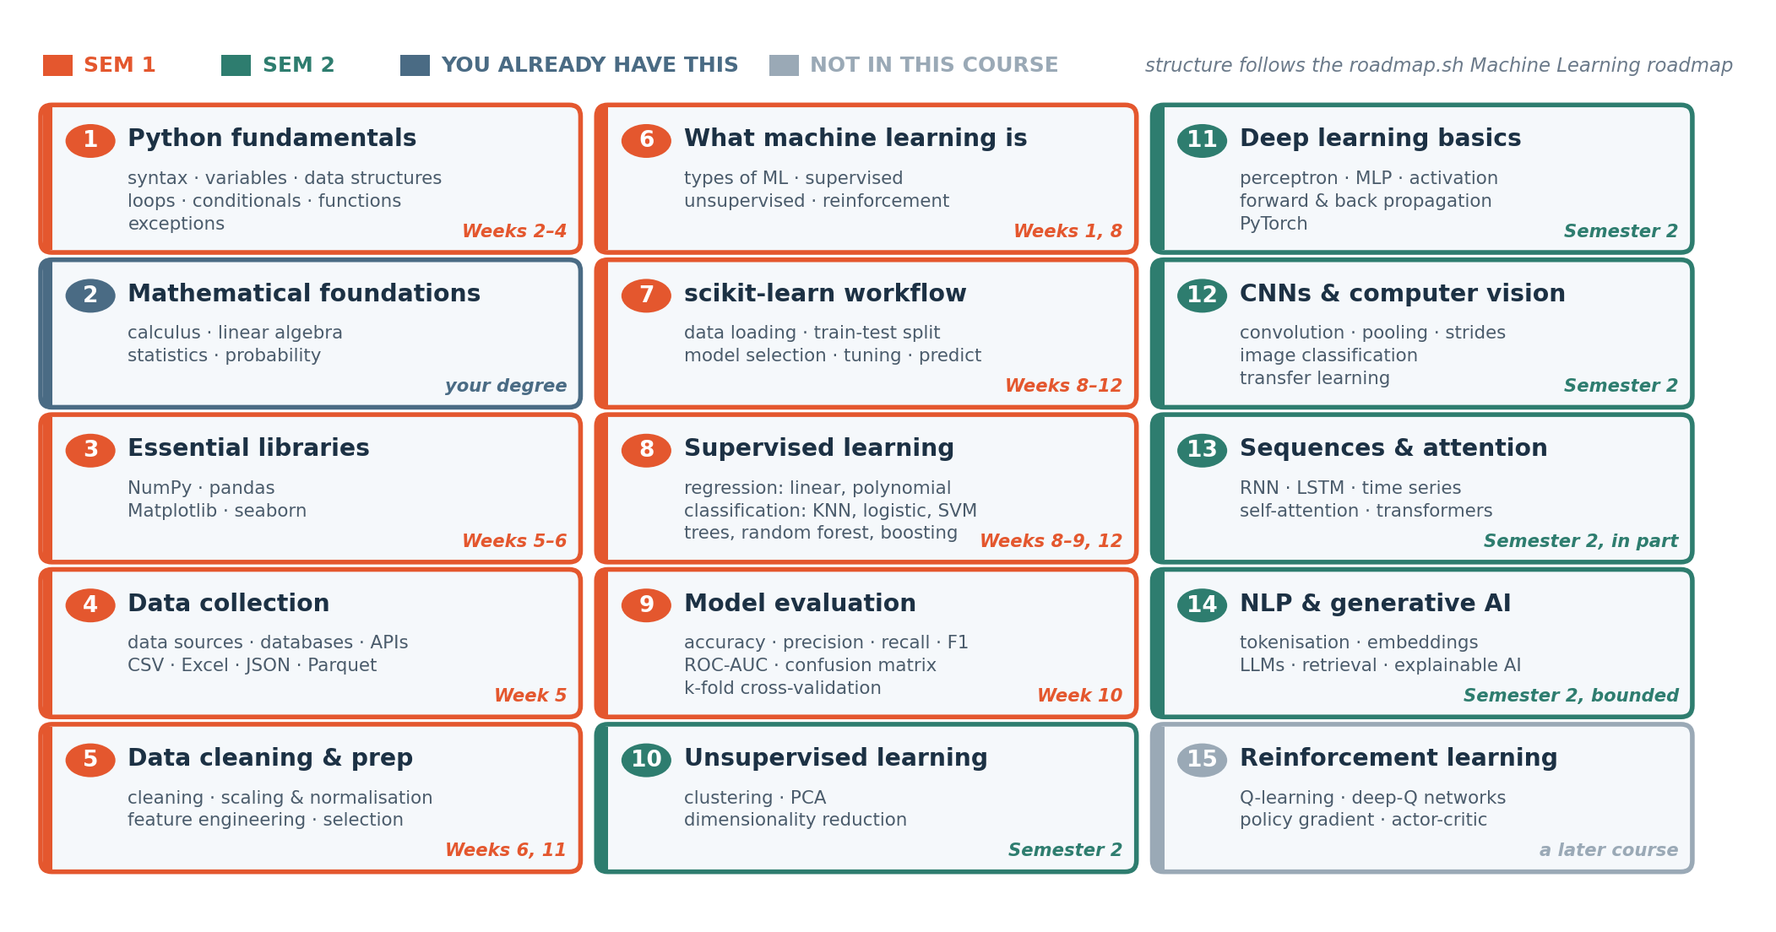

Figure 1 — the fifteen teaching stages, grouped from the roadmap.sh Machine Learning roadmap and colour-coded by when this course reaches them.

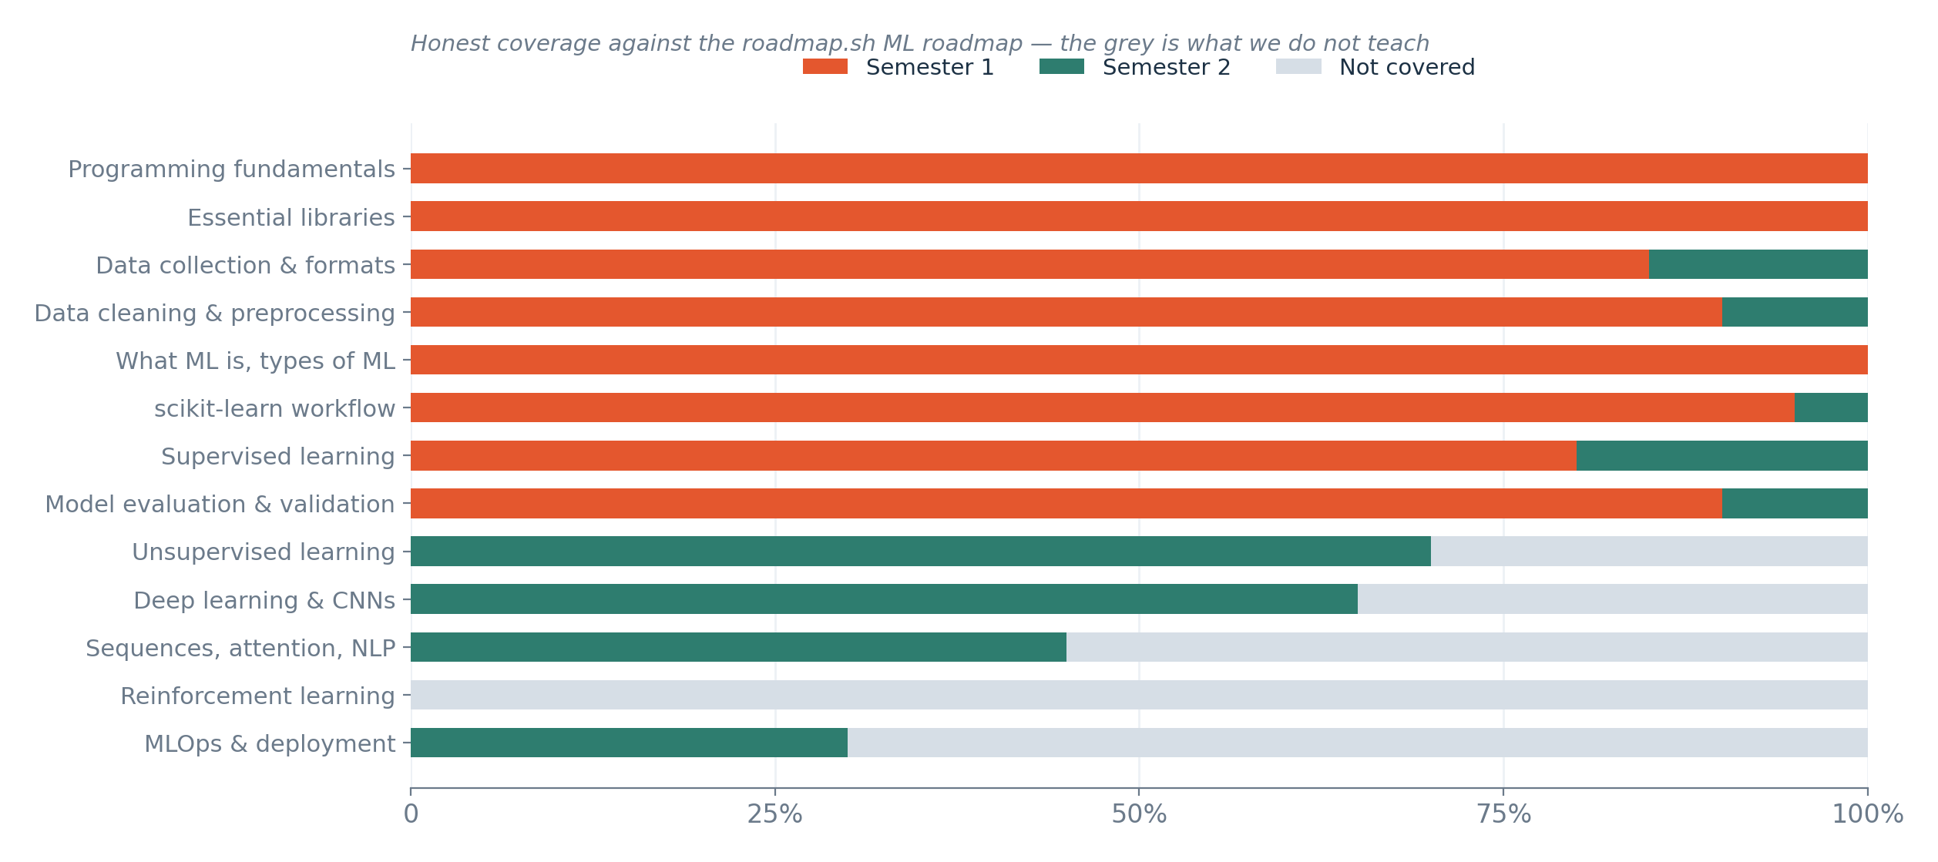

Figure 2 — proportional coverage by roadmap section. The grey is the honest gap.

3. Node-by-node mapping
The roadmap's own headings are used verbatim in the left column so the mapping can be checked against the source. Where a node is covered only in part, the part we cover is named.

Prerequisites and introduction
roadmap.sh node | Status | Where, and what we actually do
Python Roadmap (prerequisite) | SEMESTER 1 | Weeks 2–4 build Python from zero using engineering formulas the students already know. We do not attempt the full Python roadmap — no decorators, generators, async or packaging.
What is an ML Engineer? · ML vs AI Engineer · Skills and responsibilities | SEMESTER 1 | Week 1, the new roadmap segment. All four career tracks are shown and the course's position is stated explicitly: ML applied inside your own engineering discipline.

Mathematical foundations
This whole section is the students' existing strength rather than a gap, which is the single most important observation in this benchmark. We do not re-teach it; we use it and name it when it appears.
roadmap.sh node | Status | Where, and what we actually do
Calculus — derivatives, partial derivatives, chain rule, gradient, Jacobian, Hessian | ALREADY HAVE | Held from Years 1–2. Referenced in Semester 2 when gradient descent and back-propagation appear. We never derive it from scratch.
Linear algebra — matrices and operations, scalars/vectors/tensors, SVD, determinants, eigenvalues | ALREADY HAVE | Held from Years 1–2. Matrix shape is used constantly from Week 5 onwards. SVD and eigen-decomposition are used implicitly inside PCA in Semester 2 but not derived.
Statistics — descriptive, inferential, graphs and charts | ALREADY HAVE | Held, and reinforced practically in Week 6 (distributions, outliers, correlation) rather than taught as theory.
Probability — basics, Bayes theorem, random variables, PDFs, distributions | ALREADY HAVE | Held. Used when class imbalance and probability outputs appear in Week 9. Bayes is not taught as a topic and no naive Bayes classifier is covered.
Discrete mathematics | NOT COVERED | Not needed for anything in this course.

Programming fundamentals and libraries
roadmap.sh node | Status | Where, and what we actually do
Basic syntax · variables and data types · data structures · loops · conditionals · exceptions · functions | SEMESTER 1 | Weeks 3 and 4, in that order, each introduced through an engineering calculation rather than an abstract exercise.
Object-oriented programming | NOT COVERED | Deliberately excluded from Semester 1. Beginners do not need classes to do data work, and the time is better spent on data handling. Students meet objects only as things they use, never as things they define.
NumPy · pandas | SEMESTER 1 | Week 5. pandas is the single most heavily weighted tool in the semester.
Matplotlib · seaborn | SEMESTER 1 | Week 6, taught as instruments of detection rather than decoration — every chart must answer a stated question.

Data collection and preprocessing
roadmap.sh node | Status | Where, and what we actually do
Data sources — databases (SQL, NoSQL), internet, APIs, mobile apps, IoT | PART · SEMESTER 1 | Week 5 covers finding and judging a dataset on Kaggle and the UCI repository, and reading a dataset card for provenance and licence. SQL, APIs and IoT ingestion are NOT taught — a real gap, and the most defensible candidate for adding to Semester 2.
Data formats — CSV, Excel, JSON, Parquet | PART · SEMESTER 1 | CSV throughout, Excel in passing. JSON and Parquet are not covered.
Data cleaning | SEMESTER 1 | Week 6 in depth: missingness, duplicates, impossible values, dtype repair, outlier judgement, with marks awarded for the justification rather than the fix.
Feature engineering · feature selection | SEMESTER 1 | Week 11, framed as the place where the students' domain knowledge beats a better programmer.
Feature scaling and normalisation | SEMESTER 1 | Week 11, always inside a scikit-learn Pipeline so that leakage is structurally prevented.
Dimensionality reduction | SEMESTER 2 | With PCA in Semester 2.

Machine learning core
roadmap.sh node | Status | Where, and what we actually do
What is machine learning? · types of machine learning | SEMESTER 1 | Week 1 for the framing, Week 8 for the formal treatment. Supervised, unsupervised and reinforcement are all NAMED in Week 1 so the vocabulary exists early.
Semi-supervised · self-supervised learning | NOT COVERED | Named in passing only. Neither is teachable at this level in the time available.
scikit-learn — data loading, train-test split, data preparation, model selection, tuning, prediction | SEMESTER 1 | Weeks 8 to 12. The fit / predict / score pattern is named explicitly in Week 8 as the pattern every later model reuses.
Supervised learning — regression: linear, polynomial | SEMESTER 1 | Week 8 for linear regression. Polynomial is demonstrated but not examined.
Regularisation — Lasso, Ridge, ElasticNet | PART · SEMESTER 2 | Not in Semester 1. Introduced in Semester 2 alongside overfitting control. A genuine gap in the first semester and stated as such.
Classification — logistic regression, decision trees, random forest | SEMESTER 1 | Week 9.
Classification — K-nearest neighbours, support vector machines | PART · SEMESTER 2 | Not in Semester 1. KNN is a good teaching algorithm and its omission is a deliberate time trade, not an oversight.
Gradient boosting machines | SEMESTER 2 | Demonstrated for sixty seconds in Week 12 and then explicitly deferred, with the students told why: the tool is not the lesson.
Unsupervised learning — clustering (exclusive, overlapping, hierarchical, probabilistic) | SEMESTER 2 | Semester 2. Only k-means and hierarchical clustering are realistically reachable.
Unsupervised learning — PCA, autoencoders | SEMESTER 2 | PCA in Semester 2. Autoencoders only if the deep learning block runs ahead of schedule.
Reinforcement learning — Q-learning, deep-Q networks, policy gradient, actor-critic | NOT COVERED | Not covered anywhere in either semester. It needs a simulator and a different mental model, and there is no honest way to fit it. Students are told this in Week 1.

Model evaluation — the course's centre of gravity
This is the section where the course goes deeper than the roadmap implies, deliberately. Engineering students will be asked to sign their name under a prediction, so 'how do I know I can trust this' carries more weight here than in a general course.
roadmap.sh node | Status | Where, and what we actually do
What is model evaluation? Why is it important? | SEMESTER 1 | Week 10, an entire three-hour session, plus the concept is seeded in Week 1 through the hand-prediction exercise where students measure their own error.
Metrics — accuracy, precision, recall, F1, ROC-AUC, log loss, confusion matrix | SEMESTER 1 | Week 9 and Week 10. Accuracy, precision, recall, F1 and the confusion matrix in full. ROC-AUC is introduced; log loss is named but not examined.
Validation techniques — k-fold cross-validation | SEMESTER 1 | Week 10, reported as a mean with a spread rather than a single number.
Leave-one-out cross-validation | NOT COVERED | Mentioned only. Rarely the right choice at these dataset sizes.
Data leakage | S1 — BEYOND THE ROADMAP | The roadmap does not list leakage as a node. We give it half of Week 10, because it is the defect most likely to appear in a student project and in professional practice, and it produces a model that looks excellent and is useless.

Deep learning and beyond — Semester 2
roadmap.sh node | Status | Where, and what we actually do
Neural network basics — perceptron, MLP, forward and back propagation, activation and loss functions | SEMESTER 2 | Semester 2. The engineering cohort's calculus makes back-propagation teachable rather than hand-waved.
Deep learning libraries — TensorFlow, Keras, PyTorch | PART · SEMESTER 2 | PyTorch only. Teaching two frameworks to beginners halves the depth in both.
Convolutional neural networks — convolution, pooling, padding, strides | SEMESTER 2 | Semester 2, with transfer learning, because training from scratch is not realistic on the available hardware.
Applications of CNNs — image classification, segmentation, recommendation systems | PART · SEMESTER 2 | Image classification yes; segmentation and recommenders no.
Recurrent neural networks — RNN, GRU, LSTM | PART · SEMESTER 2 | Semester 2 time-series block. Classical time-series methods come first because they are more often the right answer on engineering sensor data.
Attention mechanisms — self-attention, transformers, multi-head attention | PART · SEMESTER 2 | Conceptually only, in the generative AI block. Students will use transformers; they will not implement one.
Autoencoders · generative adversarial networks | NOT COVERED | Neither is reachable in the time.
Explainable AI | SEMESTER 2 | Semester 2, and treated as a professional requirement rather than a curiosity — a model that cannot be explained often cannot be used, whatever its accuracy.
NLP — tokenisation, stemming, lemmatisation, embeddings, attention models | PART · SEMESTER 2 | Tokenisation and embeddings conceptually, in service of retrieval over engineering documentation. Stemming and lemmatisation are not covered.
MLOps | PART · SEMESTER 2 | Reproducibility, environment capture and a simple deployed interface. Not CI/CD, monitoring, registries or serving infrastructure — roadmap.sh has a separate MLOps roadmap and that is the honest answer.

4. The four gaps I would defend, and the two I would not
Every course omits things. The distinction worth drawing is between an omission that is a considered trade and one that is simply a shortfall.

Defensible
Reinforcement learning is absent because it needs a simulator, a different mental model and a term of its own. Object-oriented programming is absent because beginners do not need to define classes to do data work. TensorFlow and Keras are absent because teaching two frameworks halves the depth in both. Generative adversarial networks and autoencoders are absent because they would displace something the students will actually use.

Harder to defend, and worth revisiting
The first is data ingestion. The roadmap lists databases, APIs and IoT as data sources; we teach CSV files from a course share. Real engineering data lives in historians, SCADA systems and databases, and a graduate who can only read a CSV will be stuck on their first day. A single session on SQL and one API call would close most of this, and Semester 2 is the place for it.
The second is regularisation, and K-nearest neighbours and support vector machines alongside it. Semester 1 teaches linear regression, logistic regression, trees and forests, which is enough to work with — but Ridge and Lasso are the natural companions to the overfitting session in Week 10, and leaving them out means the students meet the problem without one of its standard answers.

5. How this is used with students
When | How the roadmap is used
Week 1, segment 2 | Fifteen minutes walking the whole field, start to finish, so that every later topic has somewhere to sit. Students are pointed at roadmap.sh/machine-learning to explore the interactive version themselves.
Week 1, same segment | The stage-2 observation: they already hold the mathematics. This is the most motivating thing they hear all week and it is true.
Week 1, coverage figure | The gaps are shown deliberately. Being honest about what is not taught buys credibility for everything that is.
Start of each block | One slide re-showing the roadmap with the current stage highlighted, so progress is visible rather than assumed.
Week 15 | The roadmap returns beside the capability ladder. Students see how far along a public professional map they have travelled in fifteen weeks, and where to go next.
Semester 2, final session | The related roadmaps — AI engineer, data scientist, MLOps, AI agents — are issued as the route onwards for anyone who wants to continue.

One caution on using any roadmap with beginners
A roadmap shows the territory; it does not teach it, and a student who mistakes reading the map for walking it will feel productive and learn nothing. Show it, let them see the shape of the field, then close it and go back to the twelve rows of data on the desk. The roadmap is orientation at the start of a session, never the substance of one.

Benchmark version 1.0 · September 2026 · roadmap.sh content retrieved September 2026 and worth re-checking each year, as the roadmap is actively maintained.

