Jotham Masila
SCT211-0016/2020
Project

JUJA RIVER DIGITAL TWIN MODEL

DATA COLLECTION
The images used for this project were acqiuired from Juja River usig a digital camera.

DATA PREPROCESSING
The images were processed using the scikit-image package which is Python based.
The color images were first converted to gray images.
The noise type in the image was identified, which was Gaussian Noise. This was identified by computing the histogram and computing the pixel frquency against the pixel intensities.
The sigma value for the noise was found to be:0.5455
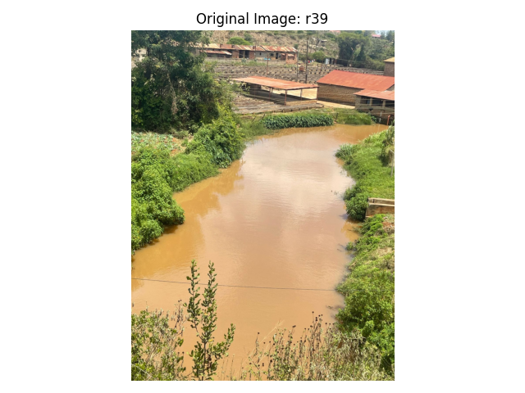

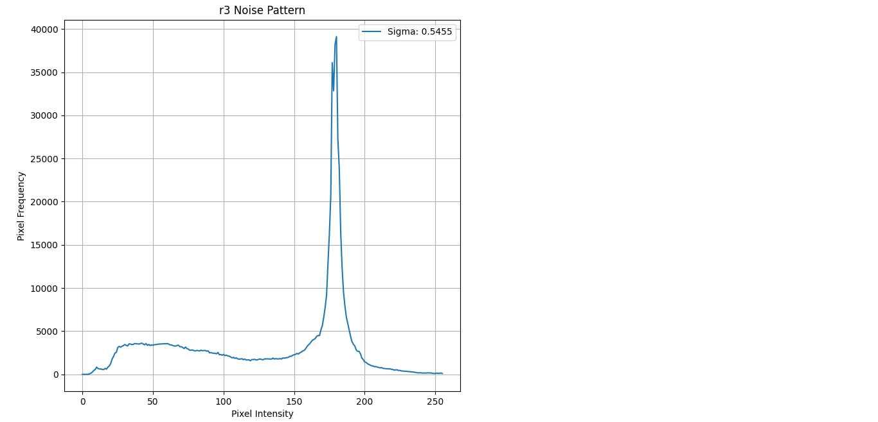

The image was denoised using Total Variation Algorithm called denoise_tv_chambolle( )

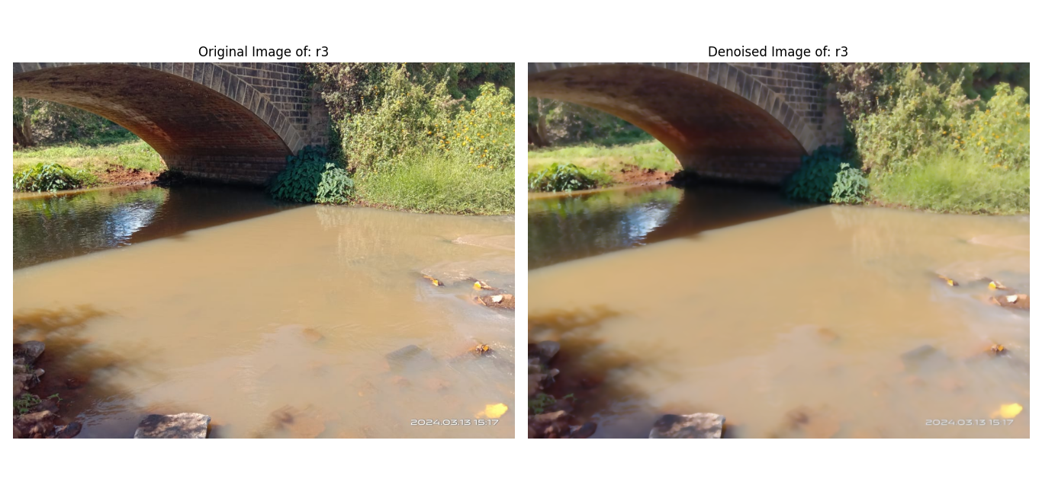

The contrast-enhancement was done enhance the the quality of the image. A clip_limit of 0.1 was used.
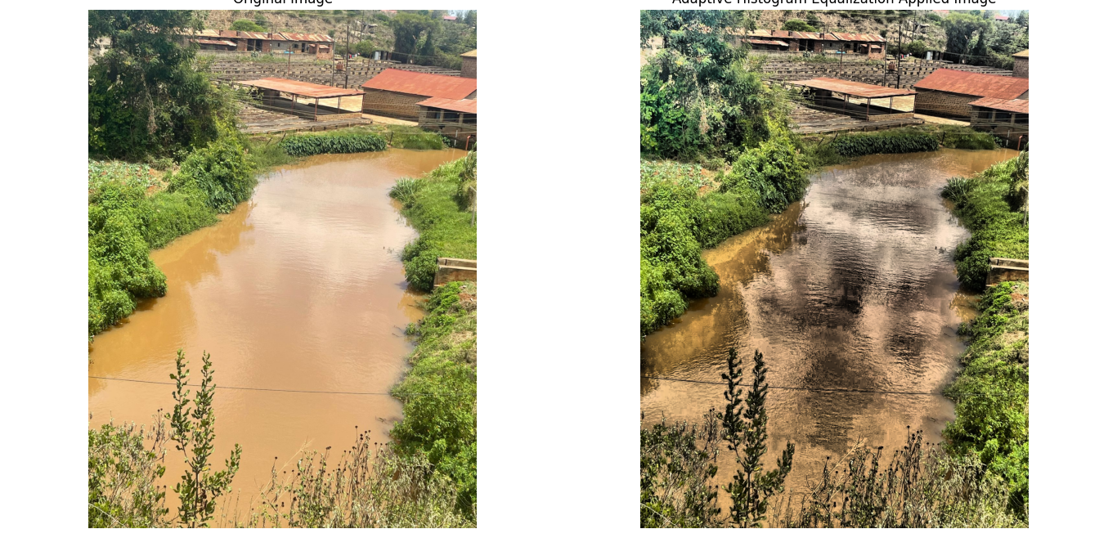

Then the contrast graphs of the two were compared.
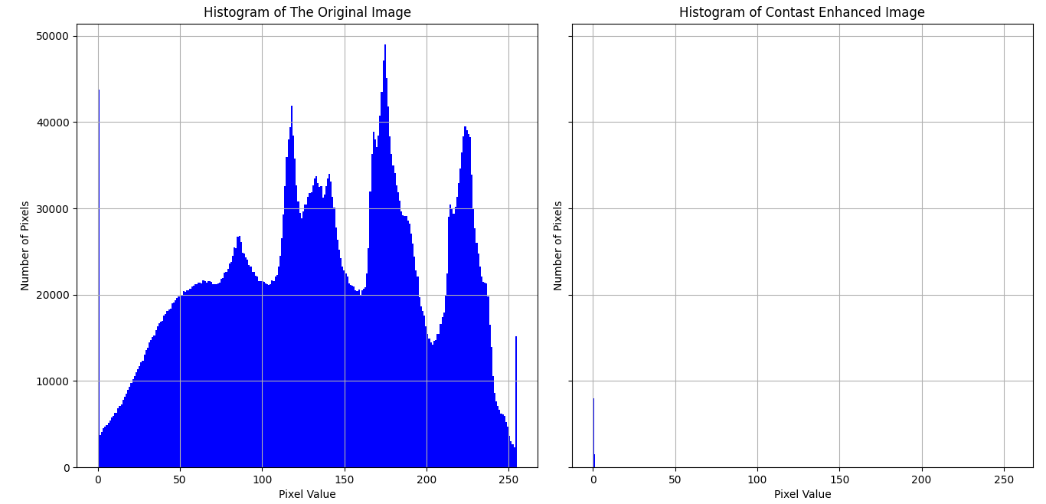

Feature Extraction
In order to get the best threshold, try_all_threshold( ) was used. The image was first converted to binary image using entropy filter rank. Of the six thresholds, threshold_otsu( ) gave the best result.

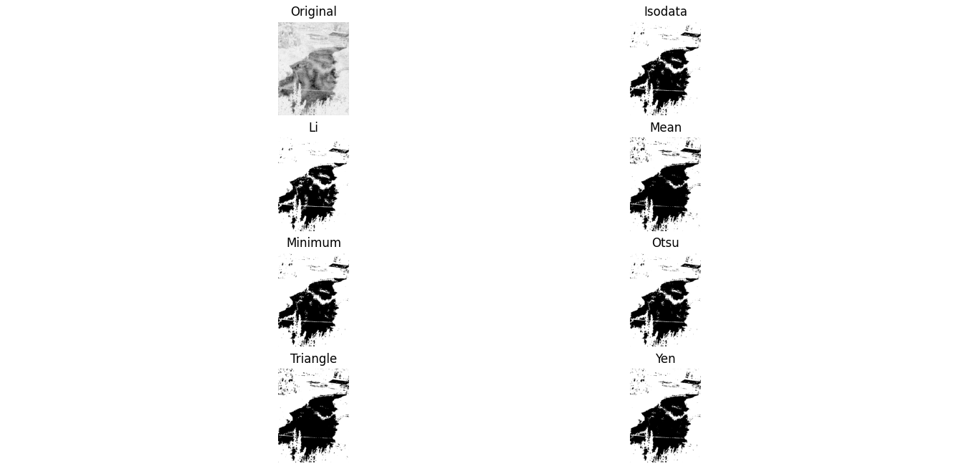

To extract the edges of river and vegetation cover, threshold_otsu was used.

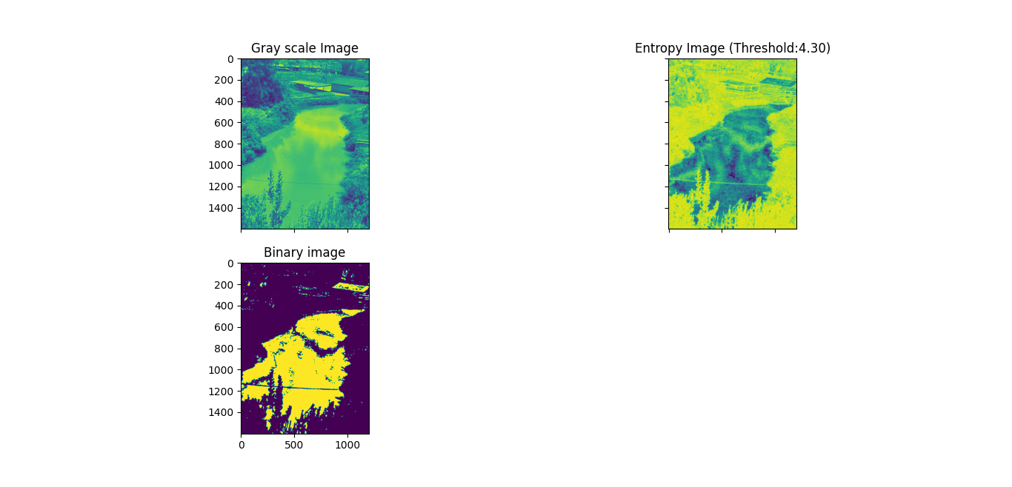

Different Edge filters were used to filter the image, for edge detection.
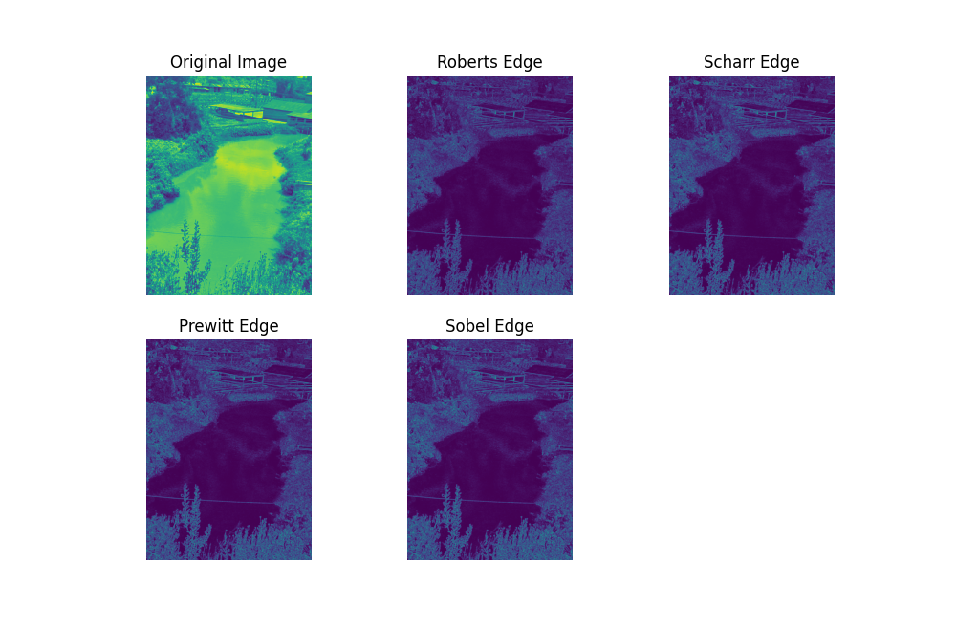

After the filtering, the necessary edges were detected.

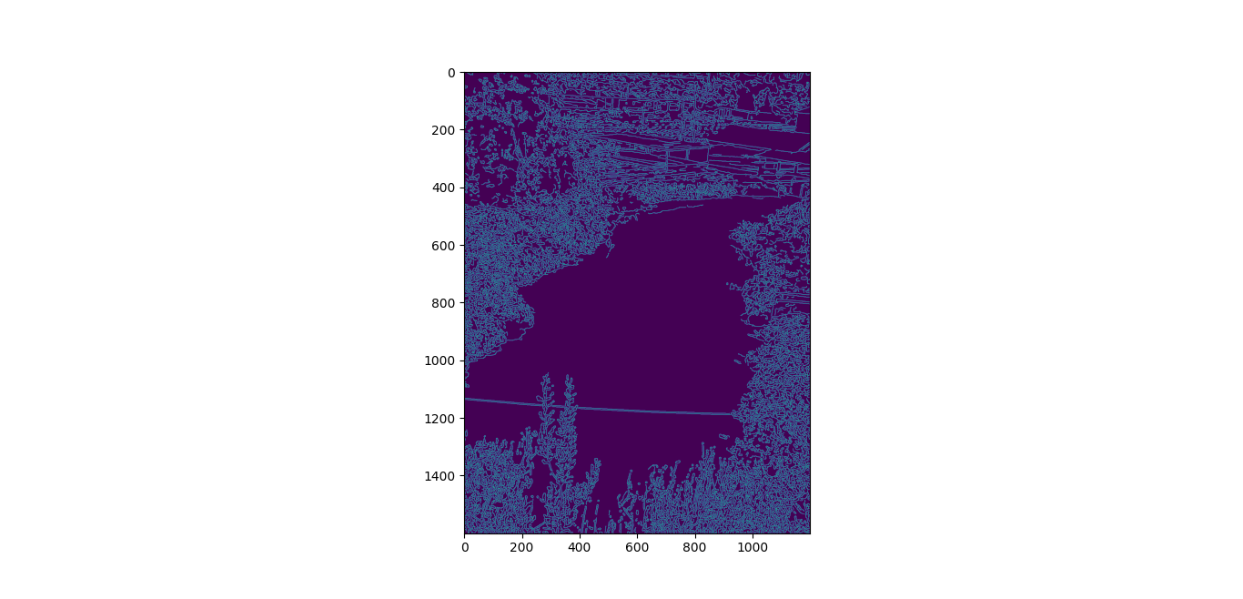

Digital Twin Model development
The model accepted the the features extracted. The features such as vegeation cover, waterflow and river banks can be seen.

Analysis
- The findings us that the water is mostly dirty, hence giving a sense of pollution by human activities.
- The vegetation cover upon the river is also alot along the river bank.

Potential Environmental Concerns
- The settlements alont the river bank could have contributed to the water pollution.
- The economic activities like mining near the river could have contributed to the pollution of the water.

Proposed Sustainable Management Strategies.
- Eliminate human economic activities near the river to reduce the water pollution.

