JUnit
Exercise 1: Setting Up Junit
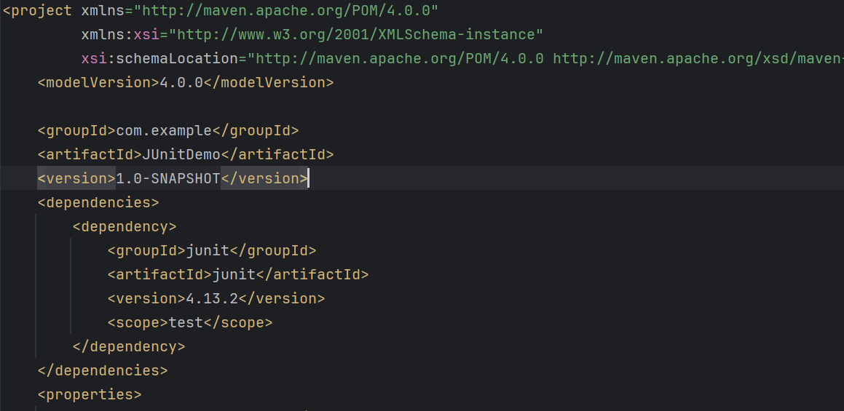
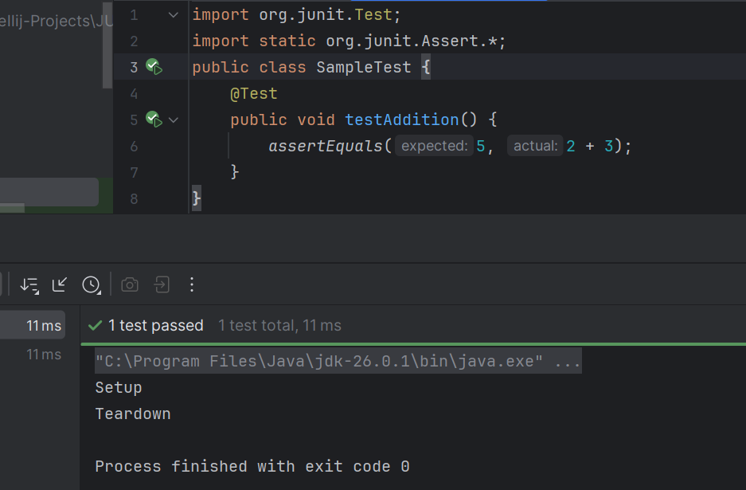
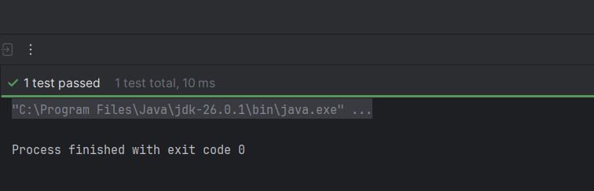

Exercise 3: Assertions in Junit
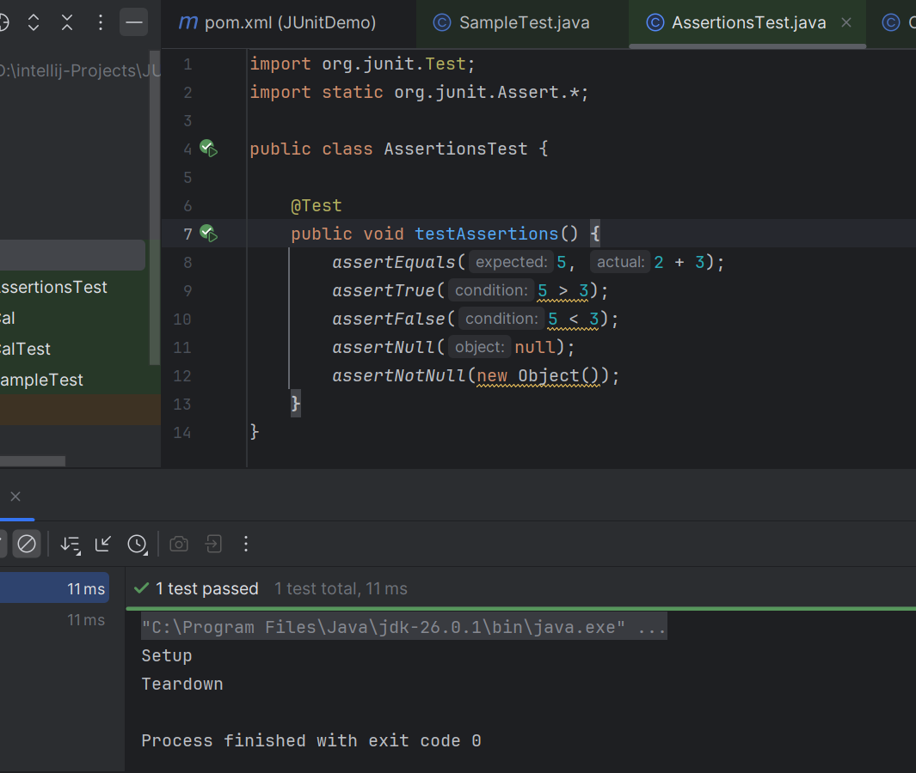
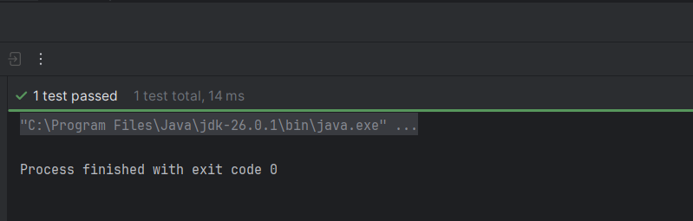

Exercise 4: Arrange-Act-Assert (AAA) Pattern, Test Fixtures, Setup and Teardown methods in Junit
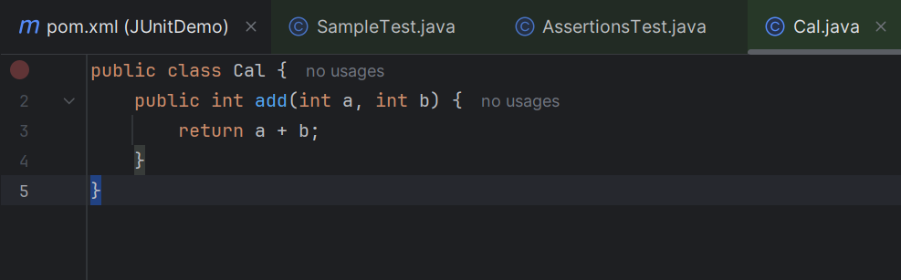

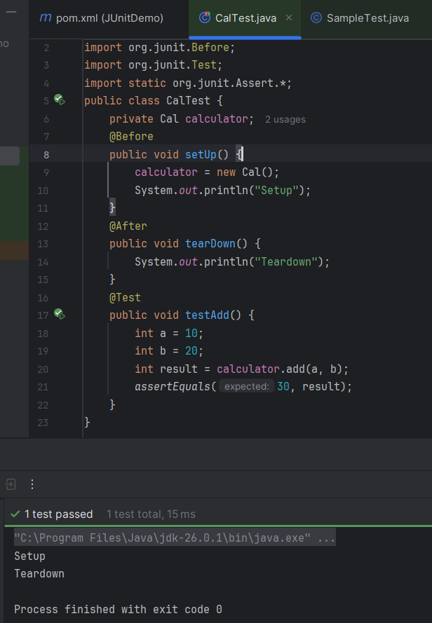

Mockito
Exercise 1: Mocking and Stubbing

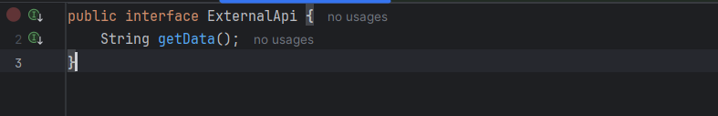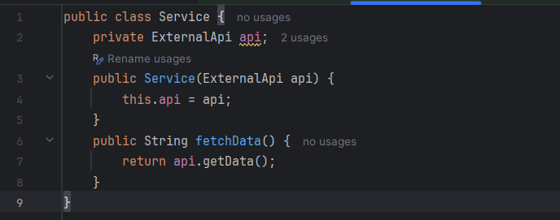
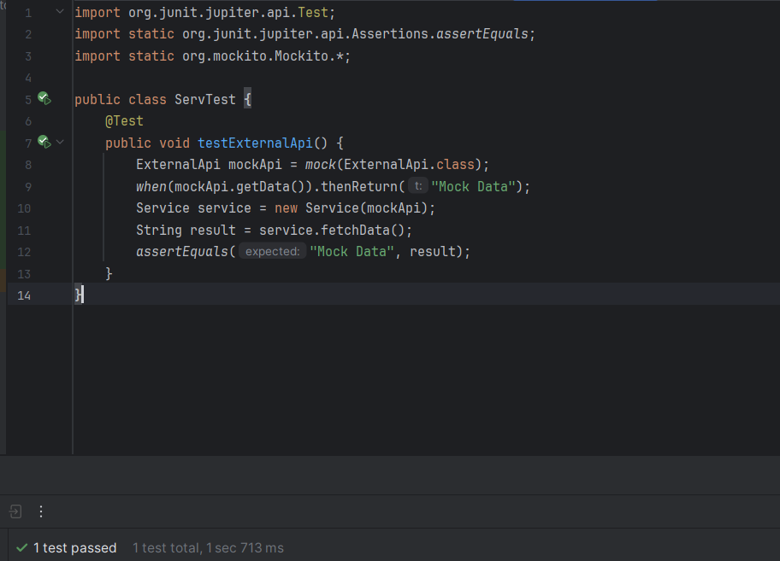

Exercise 2: Verifying Interactions


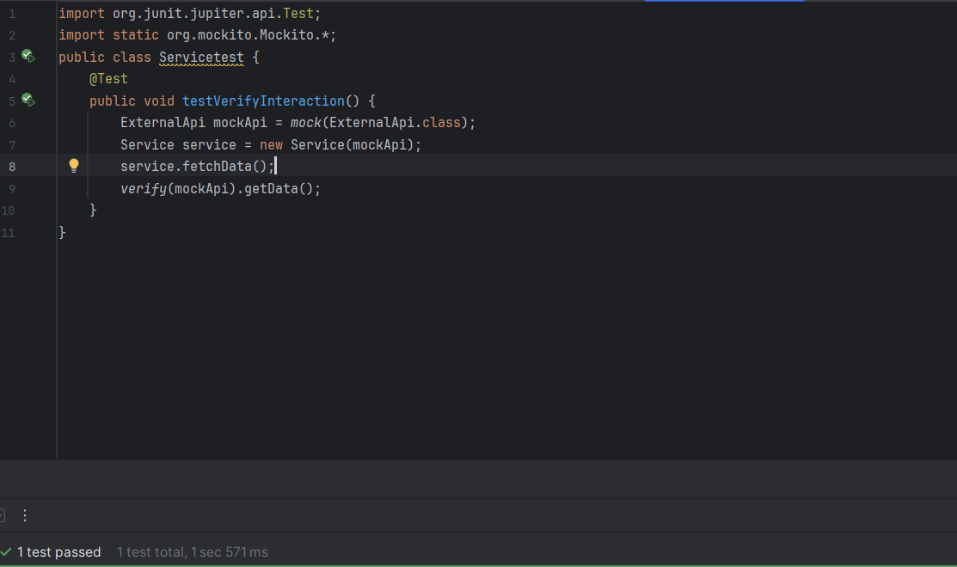

SLF4J
Exercise 1: Logging Error Messages and Warning Levels
