JOTHEESWARAN S

DA&DS

FEB-25

REINFORCEMENT PROJECT-4

CAR PRICE PERDICTION – POWER BI

INSIGHTS

**INTRODUCTION**

This is an dataset of various car along with their name, brand, engine type and price over the years, which appears to be used for predicting car prices based on various attributes. Here's a quick overview of the dataset's structure:

**AVAILABLE COLUMNS**

**Car ID** – A unique identifier for each car.

**Brand** – The manufacturer of the car (e.g., Tesla, BMW, Audi).

**Year** – The year the car was manufactured.

**Engine Size** – The engine capacity in liters.

**Fuel Type** – The type of fuel the car uses (e.g., Petrol, Diesel, Electric).

**Transmission** – Indicates whether the car is Manual or Automatic.

**Mileage** – The number of kilometers the car has traveled.

**Condition** – The overall condition of the car (e.g., New, Used, Like New).

**Price** – The price of the car (target variable for prediction).

**Model** – Specific model name of the car

**ADDED COLUMNS**

**Vehicle type –Categorize the Vehicle type as SUV , Sedan ,…etc**

**Brand & model –Concatenate the Brand and Model Columns**

**Engine Category –Categorize the Engine type Based on Litres**

**Luxury Category – Separate them as luxury and non-luxury category**

**Year Order – Grouped the year as Four-year format**

**Year Group – Named the grouped Four years as 1,2,3,……6**

**DATA PREPARATION**

**DAX FUNCTION**

By using DAX functions in Power BI,I created various new columns and new measures that helps me to get more insights.

**USED DAX FUNCTIONS**

**1.VEHICLE TYPE:**

Vehicle Type =

SWITCH(TRUE(),

    CONTAINSSTRING([brand & model], "Q5") || CONTAINSSTRING([brand & model], "Q7") ||

    CONTAINSSTRING([brand & model], "X3") || CONTAINSSTRING([brand & model], "X5") ||

    CONTAINSSTRING([brand & model], "Explorer") || CONTAINSSTRING([brand & model], "CR-V") ||

    CONTAINSSTRING([brand & model], "GLA") || CONTAINSSTRING([brand & model], "GLC") ||

    CONTAINSSTRING([brand & model], "Model X") || CONTAINSSTRING([brand & model], "Model Y") ||

    CONTAINSSTRING([brand & model], "RAV4"), "SUV",

    CONTAINSSTRING([brand & model], "Fiesta") || CONTAINSSTRING([brand & model], "Fit") ||

    CONTAINSSTRING([brand & model], "Prius"), "Hatchback",

    CONTAINSSTRING([brand & model], "Mustang") || CONTAINSSTRING([brand & model], "Model S"), "Sports Car",

    CONTAINSSTRING([brand & model], "3 Series") || CONTAINSSTRING([brand & model], "5 Series") ||

    CONTAINSSTRING([brand & model], "A3") || CONTAINSSTRING([brand & model], "A4") ||

    CONTAINSSTRING([brand & model], "Focus") || CONTAINSSTRING([brand & model], "Accord") ||

    CONTAINSSTRING([brand & model], "Civic") || CONTAINSSTRING([brand & model], "C-Class") ||

    CONTAINSSTRING([brand & model], "E-Class") || CONTAINSSTRING([brand & model], "Camry") ||

    CONTAINSSTRING([brand & model], "Corolla") || CONTAINSSTRING([brand & model], "Model 3"), "Sedan",

"Other"

)

**2.BRAND & MODEL:**

brand & model =

car_price_prediction_[Brand] & "-" & car_price_prediction_[Model]

**3.ENGINE CATEGORY:**

EngineCategory =

SWITCH(TRUE(),

    [Engine Size] <= 1.9, "Small Engine",

    [Engine Size] <= 3.0, "Medium Engine",

    [Engine Size] <= 4.0, "Large Engine",

    [Engine Size] <= 6.0, "High Performance",

    "Unknown"

)

**4.LUXURY CATEGORY**

LuxuryCategory =

SWITCH(TRUE(),

    [brand] = "BMW" ||

    [brand] = "Audi" ||

    [brand] = "Mercedes" ||

    [brand] = "Tesla", "Luxury",

[brand] = "Ford" ||

    [brand] = "Honda" ||

    [brand] = "Toyota", "Non-Luxury",

"Unknown"

**)**

**5.YEAR GROUP:**

Year_Group =

VAR YearValue = car_price_prediction_[Year]

RETURN

SWITCH(

    TRUE(),

    YearValue >= 2000 && YearValue <= 2003, "2000-2003",

    YearValue >= 2004 && YearValue <= 2007, "2004-2007",

    YearValue >= 2008 && YearValue <= 2011, "2008-2011",

    YearValue >= 2012 && YearValue <= 2015, "2012-2015",

**YearValue >= 2016 && YearValue <= 2019, "2016-2019",**

YearValue >= 2020 && YearValue <= 2023, "2020-2023"

)

**6.YEAR ORDER**

YEARORDER =

SWITCH(

    TRUE(),

    car_price_prediction_[Year_Group] = "2000-2003", 1,

    car_price_prediction_[Year_Group] = "2004-2007", 2,

    car_price_prediction_[Year_Group] = "2008-2011", 3,

    car_price_prediction_[Year_Group] = "2012-2015", 4,

    car_price_prediction_[Year_Group] = "2016-2019", 5,

    car_price_prediction_[Year_Group] = "2020-2023", 6,

    BLANK()

)

**7.AVERAGE OF PRICE**

Average_Price = AVERAGE(car_price_prediction_[Price])

**8.AVERAGE OF MILEAGE**

Average_Mileage = AVERAGE(car_price_prediction_[Mileage])

**DASHBOARD**

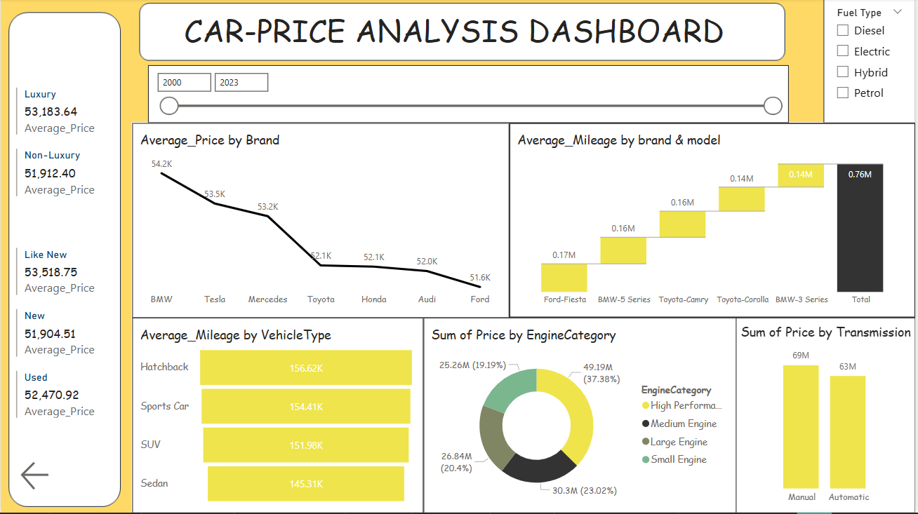

**INSIGHTS FROM DASHBOARD**

**🏷️ Category-Based Price Insights**

**➤ Luxury vs Non-Luxury**

* Luxury Cars have an average price of $53,183.64.
* Non-Luxury Cars have an average price of $51,912.40.
* Insight: Luxury vehicles cost slightly more on average, but the gap is narrow (~$1,270), suggesting strong price competitiveness among top non-luxury brands.

**➤ Condition-Based Price Averages**

* Like New: $53,518.75
* New: $51,904.51
* Used: $52,470.92
* **Insight:**
  + Surprisingly, "Like New" cars have a higher average price than "New" cars, likely due to better models or luxury brands being listed as "Like New".
  + "Used" vehicles are priced between new and like-new, showing model/brand impacts more than just condition.

**📈 Brand Analysis: Average Price**

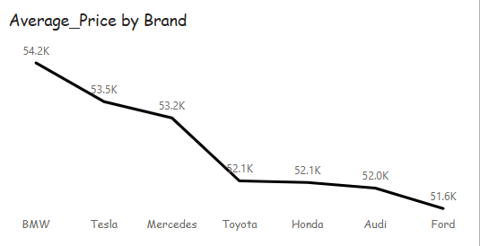

| Brand | Average Price (USD) |
| --- | --- |
| BMW | 54.2K |
| Tesla | 53.5K |
| Mercedes | 53.2K |
| Toyota | 52.1K |
| Honda | 52.1K |
| Audi | 52.0K |
| Ford | 51.6K |

* **Insight:**
  + BMW leads in average price, reflecting a premium positioning.
  + Tesla and Mercedes follow closely, supporting their luxury status.
  + Ford is the most affordable, indicating a value-focused brand.

**Brand & Model-Based Mileage Analysis**

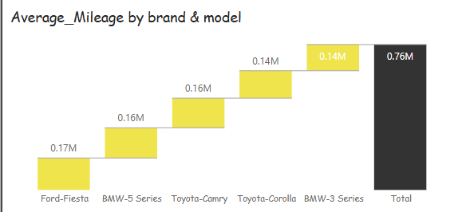

| Brand-Model | Average Mileage |
| --- | --- |
| Ford-Fiesta | 0.17M (170,000) |
| BMW-5 Series | 0.16M |
| Toyota-Camry | 0.16M |
| Toyota-Corolla | 0.14M |
| BMW-3 Series | 0.14M |
| Total | 0.76M |

* **Insight:**
  + Ford-Fiesta cars tend to have the highest mileage, often used more extensively.
  + BMW's 5 Series and Toyota’s mid-size sedans show consistent usage.
  + Suggests BMW vehicles hold value despite high mileage.

🚘 **Vehicle Type vs Mileage**

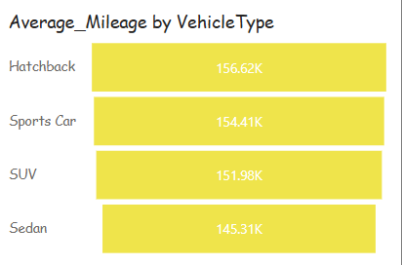

| Vehicle Type | Avg Mileage |
| --- | --- |
| Hatchback | 156.62K |
| Sports Car | 154.41K |
| SUV | 151.98K |
| Sedan | 145.31K |

* **Insight:**
  + Hatchbacks are driven the most, likely for utility/daily use.
  + Sedans have the least average mileage, possibly indicating more luxury or formal use.
  + Sports cars have high mileage, suggesting long ownership periods or highway use.

**🧩 Engine Category – Sum of Price**

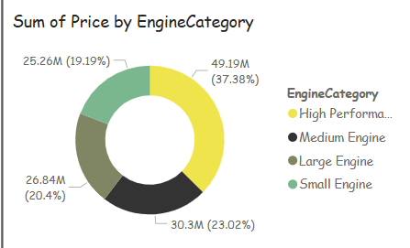

| Category | Price ($M) | % of Total |
| --- | --- | --- |
| High Performance | 49.19 | 37.38% |
| Large Engine | 30.3 | 23.02% |
| Medium Engine | 26.84 | 20.4% |
| Small Engine | 25.26 | 19.19% |

* **Insight:**
  + High-performance engines contribute the most to overall price, despite likely lower volume.
  + Small and medium engines together make up ~40%, showing balance in economy vs power demand.

**⚙️ Transmission – Sum of Price**

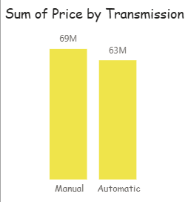

| Transmission | Total Price ($M) |
| --- | --- |
| Manual | 69 |
| Automatic | 63 |

* **Insight:**
  + Manual cars have a slightly higher total price, possibly due to popularity in performance or fuel-efficient vehicles.
  + Gap is not huge, suggesting broad adoption of automatic transmissions as well.

**INSIGHTS**

**BASED ON FUEL TYPE**

**1.ELECTRIC**

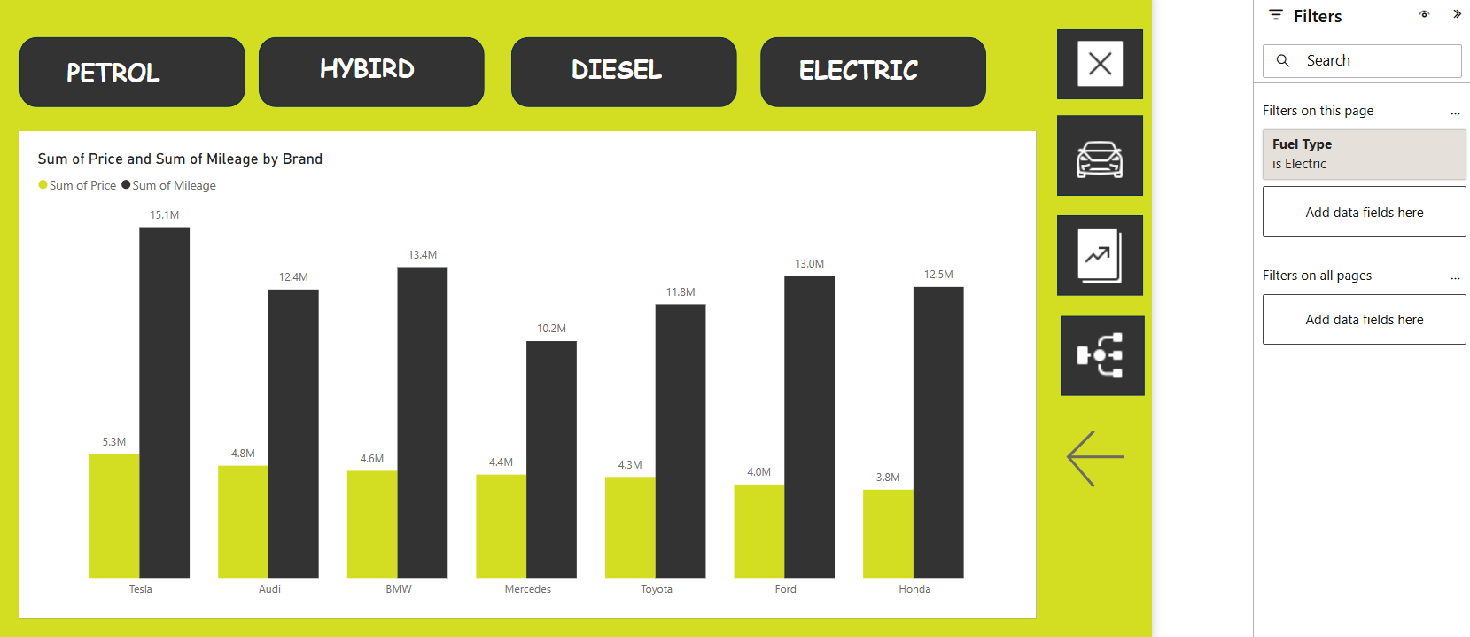

1. **Tesla** has the **highest mileage** (15.1M) but is **mid-range** in price (5.3M).
2. **Ford** offers **great mileage (13M)** at a **low price (4M)** – excellent value.
3. **Honda** is the **cheapest** (3.8M) with **good mileage** (12.5M).
4. **Mercedes** has the **lowest mileage** (10.2M) but isn’t the cheapest – less efficient.
5. **BMW, Audi, and Toyota** are well-balanced in **price and performance**.

**2.DIESEL**

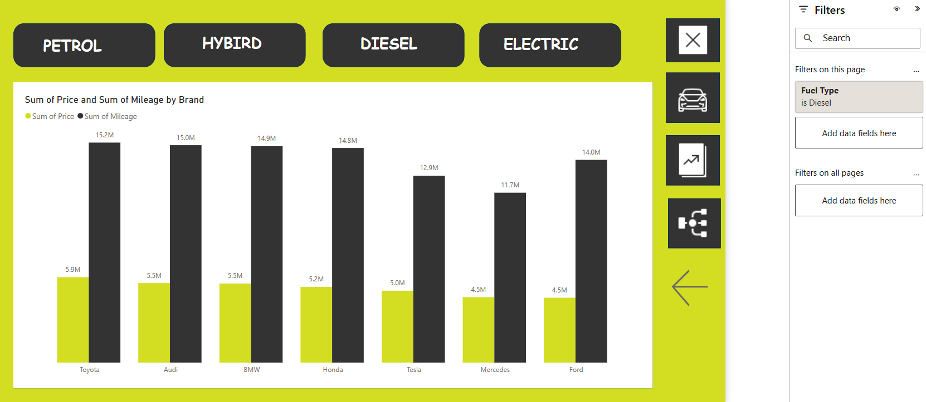

1. **Toyota** has the **highest mileage** (15.2M) and **highest price** (5.9M).
2. **Ford** and **Mercedes** are **most affordable** (4.5M) but offer **lower mileage** (14M and 11.7M).
3. **Audi, BMW, and Honda** show a **good balance** of price (~5.2M–5.5M) and **high mileage** (14.8M–15M).
4. **Tesla (Diesel variant)** has **moderate performance** (5M price, 12.9M mileage).

**3.HYBIRD**

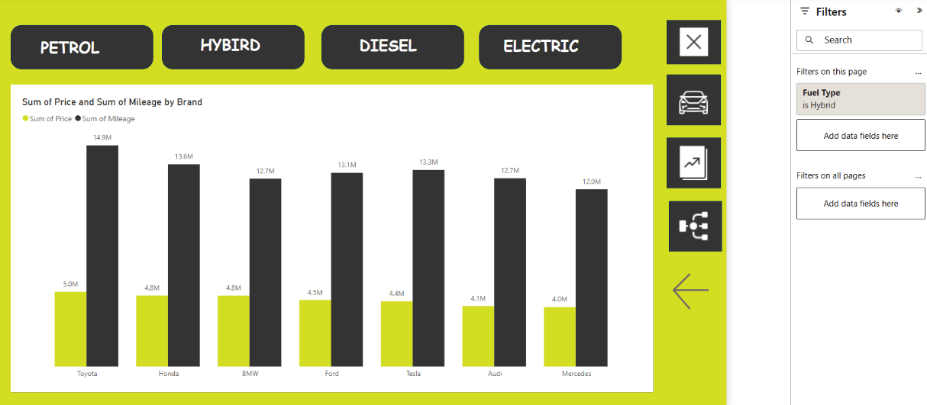

1. **Toyota** leads with the **highest mileage** (14.9M) and a moderate price (5.0M).
2. **Honda** offers a good **mileage-to-price ratio** (13.6M mileage, 4.8M price).
3. **Tesla and Ford** have **similar mileage** (~13M) with **competitive prices** (4.4M–4.5M).
4. **Mercedes** is the **most affordable** (4.0M) but has the **lowest mileage** (12.0M).

**4.PETROL**

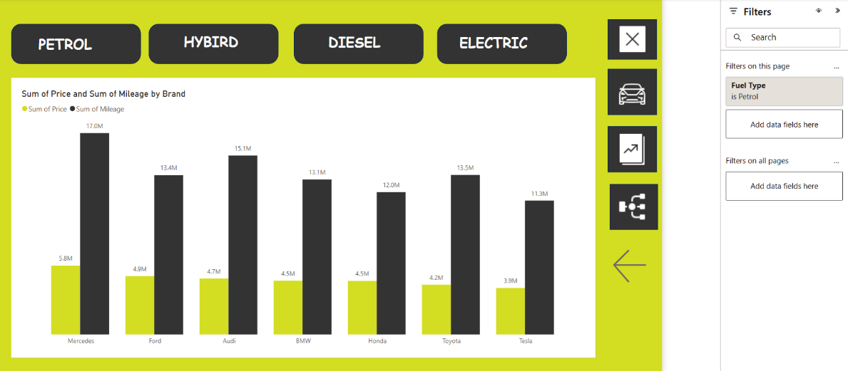

1. Mercedes: Highest price (~5.8M) and mileage (~17.6M) — premium option.
2. Toyota: Best value — low price (~4.2M) with high mileage (~11.5M).
3. Tesla: Lowest price (~3.9M), decent mileage (~11.3M).
4. Audi & BMW: High mileage (~15.1M, ~12.2M) with mid-to-high pricing.
5. Ford & Honda: Balanced price and mileage options.

**TRENDS OVER TIME**

1.2000-2003

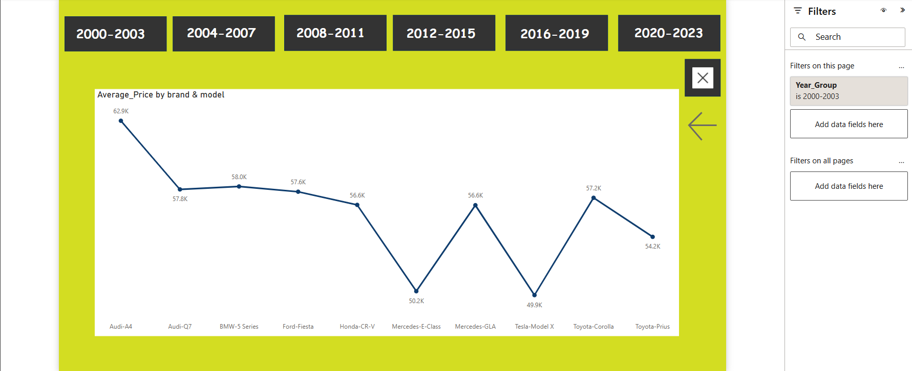

1. **Audi A4** has the highest average resale price at **62.9K**, indicating strong brand retention in this period.
2. **Tesla Model X** shows the lowest price at **49.9K**, which is likely a data inconsistency as this model wasn’t available during these years.
3. The price spread among all models is relatively narrow (**49.9K to 62.9K**), suggesting **moderate depreciation** and **consistent value retention** across both luxury and non-luxury brands.
4. **Mid-range performers** like the **BMW 5 Series (58K)** and **Toyota Corolla (57.2K)** indicate a balanced blend of brand value and depreciation.
5. Luxury models like **Mercedes E-Class (50.2K)** and **Mercedes GLA (56.6K)** show similar average prices to non-luxury models, pointing to potential undervaluation or higher depreciation.

2.2004-2007

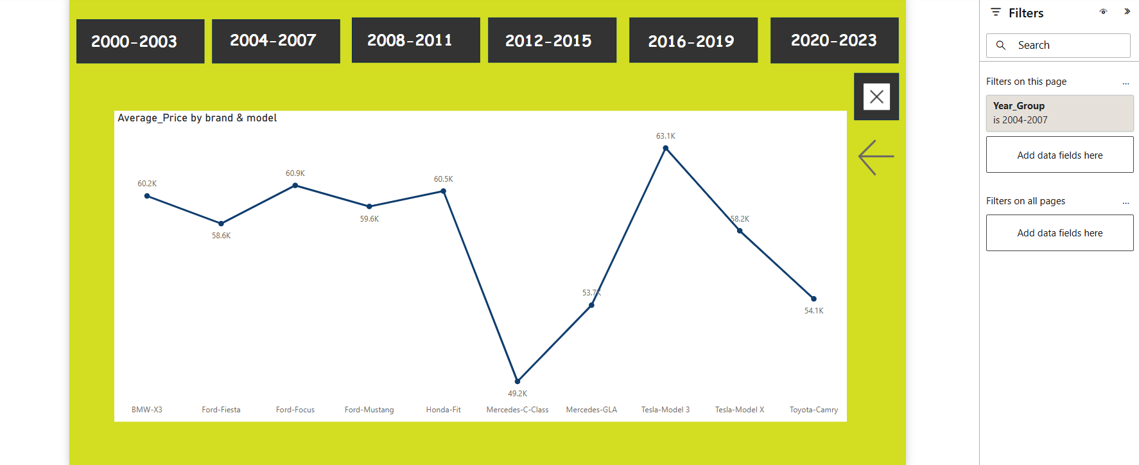

1. **Tesla Model 3** leads with the highest average price of **63.1K**, though this may reflect a data issue since this model was released later (post-2017).
2. **Mercedes C-Class** shows the lowest average price at **49.2K**, indicating **higher depreciation** or **lower resale value** compared to peers.
3. Multiple vehicles including **BMW X3 (60.2K)**, **Ford Focus (60.9K)**, and **Honda Fit (60.5K)** are closely priced, suggesting **strong value retention** across brands in this group.
4. The **price range is moderate** (49.2K–63.1K), with most models clustered in the 58K–61K zone, showing **stable depreciation trends**.
5. **Ford models** (Fiesta, Focus, Mustang) show consistent pricing between **58.6K and 59.6K**, reflecting **balanced performance and value**.

3.2008-2011

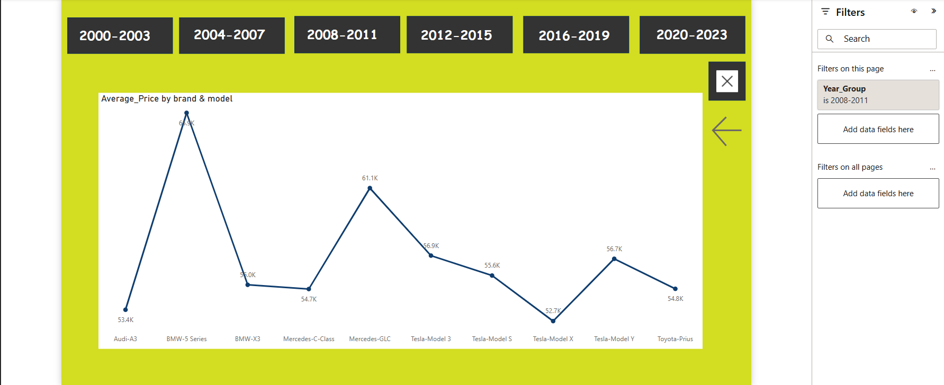

1. **BMW 5 Series** stands out with the **highest average price of 69.4K**, suggesting **strong luxury value retention** for this period.
2. **Tesla Model X** has the **lowest average price at 52.7K**, likely due to **model-year mismatch**, as it was released after 2015.
3. **Mercedes GLC** also holds a strong position at **61.1K**, showing **premium price stability**.
4. **Most other models**, like **BMW X3 (55.0K)**, **Audi A3 (53.4K)**, and **Toyota Prius (54.8K)** fall in a **moderate pricing range**, suggesting **consistent depreciation**.
5. **Tesla models** (3, S, X, Y) show **mixed pricing** between 52.7K and 56.9K, again likely skewed by **model-year inconsistencies** in the dataset.

4.2012-2015

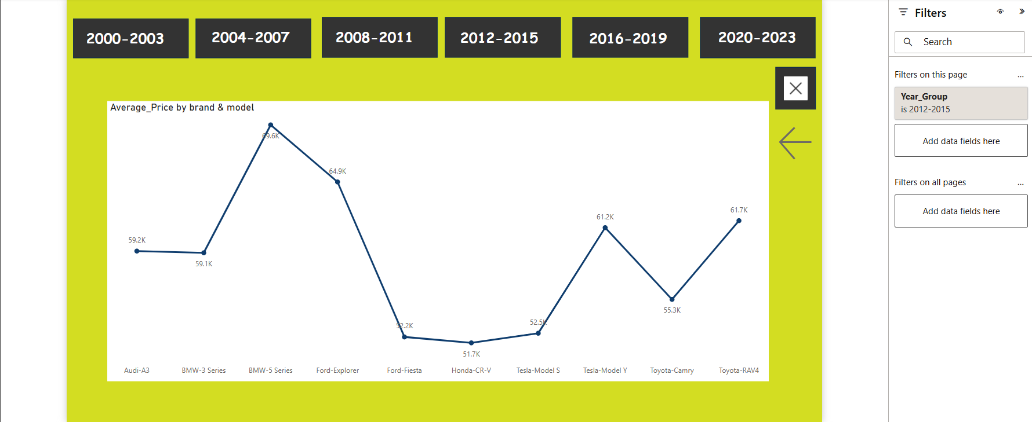

The **BMW-5 Series** has the **highest average price** among the models, peaking at **79.6K**.

* The **Ford-Fiesta** has a significantly lower price of **32.2K**, making it one of the most affordable options.
* **Audi-A3** and **BMW-3 Series** have **similar pricing** at around **59K**, suggesting comparable market positioning.
* **Tesla-Model S and Model Y** show price variations, with the **Model Y** at **61.2K**, slightly higher than the **Model S (52.5K)**.
* The **Toyota-Camry** and **Toyota-RAV4** fall into the mid-range category, priced at **55.3K** and **61.7K**, respectively.
* Regional and economic factors from **2012 to 2015** may have influenced these price differences.

5.2016-2019

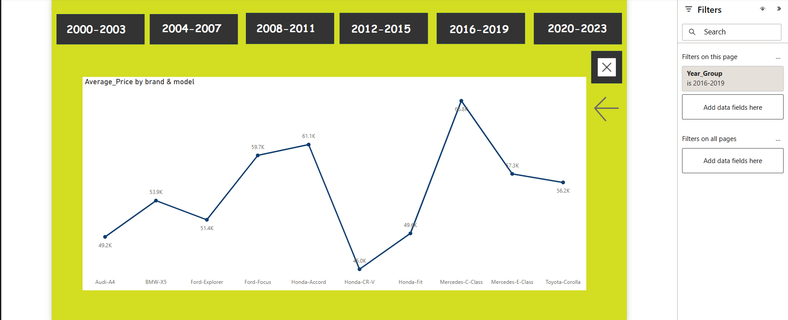

**Mercedes-E-Class** had the **highest average price** at **73.3K**, reinforcing its premium positioning.

* **Honda-CR-V** was the most affordable model, priced at **45.0K**, making it a strong choice for budget-conscious buyers.
* **Ford-Focus** saw a relatively high average price of **59.7K**, surpassing both the **Ford-Explorer (51.4K)** and **Honda-Fit (49.6K)**.
* **Audi-A4** and **BMW-X5** remained in a mid-range price bracket, with values close to **49.2K and 53.9K**, respectively.
* **Toyota-Corolla (56.2K)** maintained competitive pricing compared to other models in its segment.
* Price fluctuations between **2016 and 2019** indicate potential shifts in market demand, technological advancements, and brand positioning.

6.2020-2023

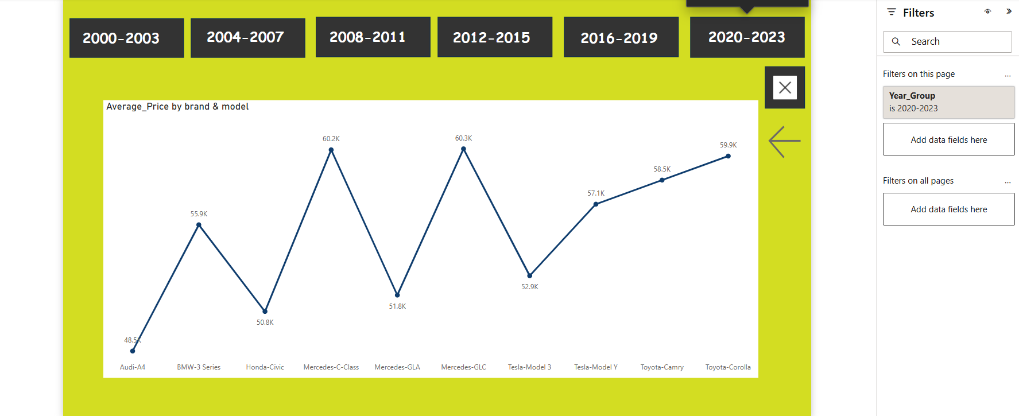

**Mercedes-C-Class** had the highest average price at **$60.3K**, maintaining its premium market position.

* **Audi-A4** had the lowest price at **$48.5K**, making it a more affordable luxury sedan compared to others.
* **Tesla-Model Y ($57.1K)** and **Tesla-Model 3 ($52.9K)** continued to be competitively priced, indicating sustained demand for electric vehicles.
* **Toyota-Camry ($59.9K)** and **Toyota-Corolla ($58.5K)** remained in the mid-range pricing category, showing stability in their value.
* **Honda-Civic ($50.8K)** had a moderate price compared to other compact sedans.
* **Mercedes-GLC ($60.2K)** and **Mercedes-GLA ($51.8K)** showed that SUVs in the luxury category maintained strong pricing power.

**TRENDS OVER 2000-2023**

**Luxury vs. Non-Luxury Price Trends**

* Luxury brands like BMW, Mercedes, and Audi consistently retain strong resale values, with models such as the BMW 5 Series and Mercedes-E-Class reaching high average prices across multiple years.
* Depreciation is visible in some luxury models (e.g., Mercedes C-Class in 2004-2007), indicating variability in resale value based on specific model performance.

**Electric Vehicles & Data Anomalies**

* Tesla models appear in earlier time periods where they were not available (e.g., Model X in 2000-2003), suggesting possible inconsistencies in the dataset.
* Tesla vehicles (Model 3, Model Y) gain traction from 2016 onwards, reflecting increased demand for EVs in the market.

**Price Stability Across Mid-Range Vehicles**

* Models like the Toyota Corolla, Camry, and Honda Civic maintain relatively stable pricing over the years.
* Consistent depreciation trends are observed, especially from 2012 onward, as mid-range models hold their competitive pricing without drastic increases.

**Market Positioning & Consumer Preferences**

* SUVs, especially Mercedes GLC and Toyota RAV4, hold strong pricing power, showing a steady preference shift toward SUVs over sedans.
* Ford models maintain balanced pricing over multiple periods, suggesting steady consumer demand.

**Key Takeaways**

* Luxury models tend to start strong but may depreciate depending on market conditions.
* Tesla’s emergence in later years reflects a rising trend toward EV adoption.
* Mid-range models like Toyota and Honda remain steady, showing reliable value retention.
* SUVs continue to gain popularity, holding stronger pricing over time**.**

**CONCLUSION**

* Luxury vehicles maintain strong resale value but are increasingly competing with high-end non-luxury models.
* Electric vehicles (EVs) are gaining traction, with Tesla models showing steady growth in price retention and consumer interest.
* SUVs continue to dominate the market, holding higher resale prices and proving to be preferred over sedans.
* Mid-range brands like Toyota, Honda, and Ford remain stable, showing consistent price retention without drastic fluctuations.
* Mileage plays a crucial role in price determination, with hatchbacks seeing the highest usage and luxury sedans having lower mileage but maintaining value.
* Fuel type impacts pricing trends, with EVs and hybrids expected to see continued appreciation, while diesel and petrol models may decline in market demand.
* Manual transmissions still hold value, though automatic transmissions are steadily overtaking them in overall sales.
* Future pricing trends indicate a shift toward EV adoption, luxury expansion into mid-range markets, and continuous growth in SUV popularity.

**RECOMMENDATIONS**

1. Investment in EVs: With Tesla models showing strong price retention and growing demand, investing in EV infrastructure and newer models will likely yield long-term benefits.
2. Luxury Segment Strategies: Given the narrowing price gap between luxury and non-luxury cars, manufacturers should enhance brand differentiation through premium features and after-sales services.
3. SUV Market Optimization: Since SUVs remain strong in pricing, manufacturers should focus on fuel-efficient SUVs and hybrid models to meet demand trends.
4. Manual vs. Automatic Considerations: While manual cars have a slightly higher total price, the gap is narrow, signaling that automatic transmissions will continue to dominate the market in future vehicle designs.
5. Mid-Range Vehicle Stability: Given Toyota, Honda, and Ford's steady pricing, targeting affordable financing options will maintain market share among budget-conscious consumers.

**Price Trend Prediction for Future (2025–2030)**

1. EV Growth Acceleration: Tesla, Toyota, and BMW will see continued demand for electric and hybrid models, making EVs one of the highest-valued segments in pricing.
2. SUV Domination Continues: Expect SUV models to remain the preferred choice, with demand increasing for fuel-efficient and electric SUVs.
3. Sedan Prices Might Decline: Traditional sedans will gradually lose market share to SUVs and EVs, leading to potential depreciation in sedan pricing.
4. Luxury Brands Expanding to Mid-Range: With luxury cars becoming more accessible, brands like BMW and Mercedes may introduce budget-friendly variants to compete with mid-tier brands.
5. Fuel Economy and Smart Features Will Drive Pricing: Expect higher prices for models with advanced AI-based features and fuel efficiency enhancements, with hybrid vehicles holding steady pricing as a bridge between traditional fuel models and EVs.