**EMPLOYEES SALARY ANALYSIS USING EXCEl**

STUDENT NAME ; JEEVAJOTHI M   
REGISTER NO ; 312217870   
DEPARTMENT ; B.COM(GENERAL)   
COLLEGE ; PURATCHI THALAIVAR DR.M.G.R GOVT ARTS AND SCIENCE   
COLLEGE,UTHIRAMETUR- 603 406.

**AGENDA**

|  |  |
| --- | --- |
|  | 1.Problem Statement 2.End  users 3.project overview  4.Our Solutions And Proposition 5.Modelling Approach  6.Dataset Description  7.Results And Discussion  8.Conclusion |



**PROBLEM STATEMENT**

The Salary Statement In Management Plays Important

|  |  |  |  |  |  |  |  |
| --- | --- | --- | --- | --- | --- | --- | --- |
| role, | pay | Employees | The | Correct | Amount | On | Time, |

Common Payroll Problems Include Issuing Salary Slips To Their Employees Even Though Employers Must Issue Salary Slips To Their Employees, It Is Not Mandatory To

|  |  |  |  |  |  |  |  |
| --- | --- | --- | --- | --- | --- | --- | --- |
| Provide | Printed | Slips. | For | Employees, | A | Salary | Slip |
| Works As Proof Of Income. | | | |  | | | |

**OUR SOLUTION AND ITS VALUE**  **PROPOSITION**

|  |  |
| --- | --- |
|  | CONDITIONAL FORMATTING – MISSING VALUES FILTER-FILTER OUT MISSING VALUES  PIVOT TABLE- SUMMARY OF DATA GRAPH- DATA VISUALISATION |



**Salary process**

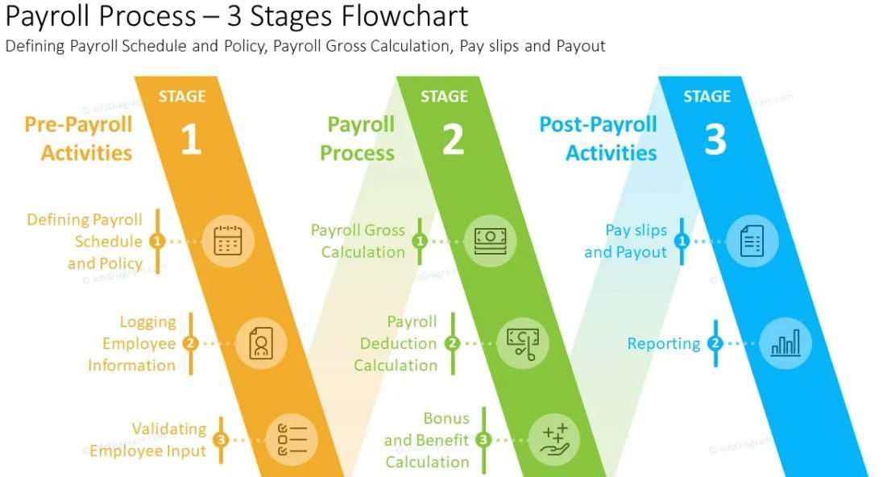

**MODELLING**

|  |  |
| --- | --- |
|  | DATA COOLLECTION |

Download kaggle   
Edunet dashboard- file

download

FEATURES COLLECTION

1.Employees name   
2.Basic salary   
3.Dearness allowance   
4.Travelling allowance   
5.Gross salary   
6.Provident fund   
7.Net salary

|  |  |
| --- | --- |
|  | USING PIVOT TABLE GRAPH FOR SUMMARY |

**DATA SET DESCRIPTION**

|  |  |
| --- | --- |
|  | Employee Data Set – Kaggle |

|  |  |  |  |  |
| --- | --- | --- | --- | --- |
|  | Features- | 21 | Considered-7 | |
| Name- Te xt Provident Fund- | | | |
| numerical | D.A- | | Numerica l |
| Gross Salary- Numerical Net Salary- Numerical | | | |





**THE “ WOW ” IN OUR SOLUTION**

=SALARY IFS(G2>=47140, “ VERY

HIGH”,G10>=3, “HIGH”,G10>=8, “LOW”)

**RESULTS**

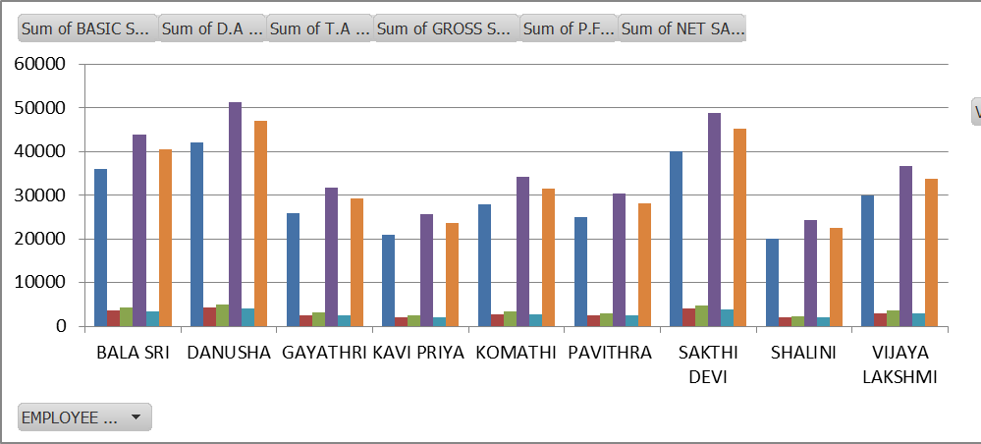

**CONCLUSION**

|  |  |
| --- | --- |
|  | The Salary Statement Provides A Clear |

Breakdown Of The Employee’s Total Earnings, Including Basic Pay,   
Allowances And Bonuses, Along Side Statutory And Other Deduction.

The Net Salary Payable Is Calculated

After On Applicable Deductions.

This Statement Ensures Transparency And Accuracy In Salary Disbursement

|  |  |
| --- | --- |
|  | Supporting Both The Employee And |

Employer In Finacial Planning.