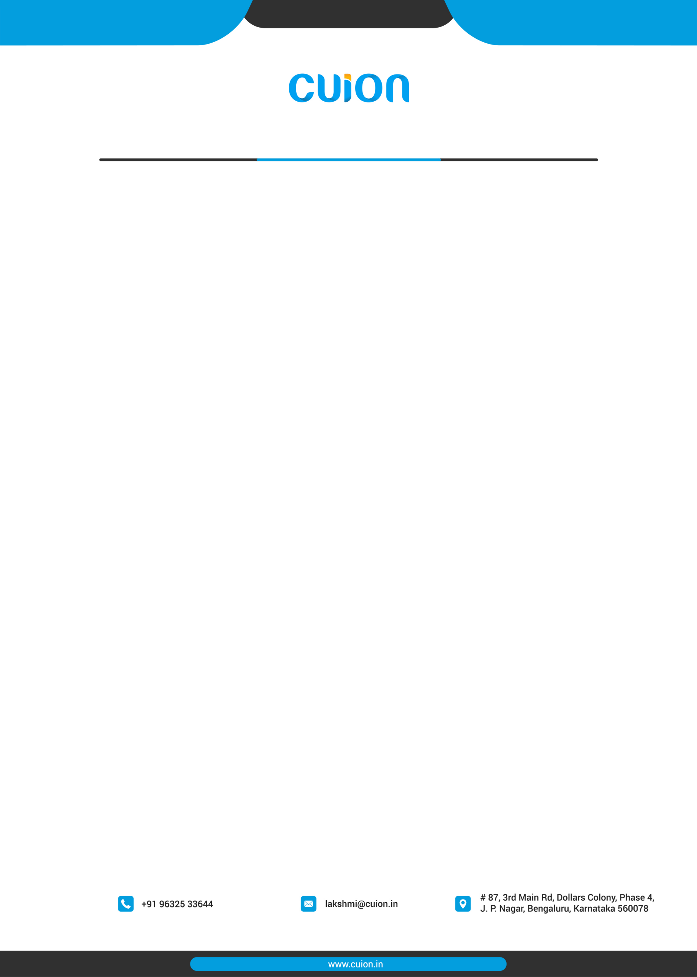

To 03.10.2022

M/s. Shreesha Greentech Pvt Limited

No 157, KIADB IT Park

Jala

North Bangalore - 560063

Dear Mr.Prasanna

Kindly find attached the quote for development of new website as discussed

**QUOTATION FOR  Development of a New website - ShreeshaGreentech**

New site will be designed with the following elements

1) Single page  - Have all the information about the Company and the type pf blocks , Contact information, Why Choose , Plant information, AND two CTAs ( One on top and one at the bottom for the user to fill in and give the information )

**Inclusions in the development of the website.**

a) Complete design and development of website with the page.

b) Design of the page.

c) Content to be presented. - Content will be given by the client and also added by the client and us.

d) Images to be present on the website to be given by the client

e) Mobile Optimization / Desktop Optimization

f) Call to Action buttons and Forms for lead generation on  the website.

g) Email to be received to the mail id configured

**Approach**

1) Working on the wireframes - approval

2) Design , Development on staging server

    - Will also include the content

3) Testing , production on desktops and mobile versions

4) Hosting on the clients server and maintenance.

**Out of Scope**

1) Social Media marketing

2) Videos to be made for the website

3) Dynamic functionalities as like Login

4) Ratings / Reviews or similar kind of functionality.

Cost for the development of the website will be Rs.12000/-

Domain charges - Rs.2000/-

Hosting Charges + SSL charges : Rs.5000/-

Email charges - Rs.1000/ - for one mail id per year

Total cost of the project is Rs.20000/- exclusive GST

**Terms and Conditions**

**1. Advance - 50% - Rs 10000/-**

**2. Final Payment - 50% - Rs.10000/- ( after completion and hosting and going live )**

Cost mentioned is exclusive of GST.

**Bank Details**

Name of the Account : Cuion Technologies

Bank : ICICI

Branch : JP Nagar 4th Phase

Account number : 344105500095

IFS Code :ICIC0003441

# Best Regards

( Lakshmi Swaminathan )

Proprietor – Cuion Technology