1. 8 Puzzle Problem
Aim:
To solve the 8-puzzle problem using the A* search algorithm and find the shortest path from the initial state to the goal state.
Procedure:
- Read the initial and goal states.
- Calculate the heuristic value.
- Apply the A* search algorithm.
- Expand the node with the lowest cost.
- Continue until the goal state is reached.
- Display the solution path.
Output:
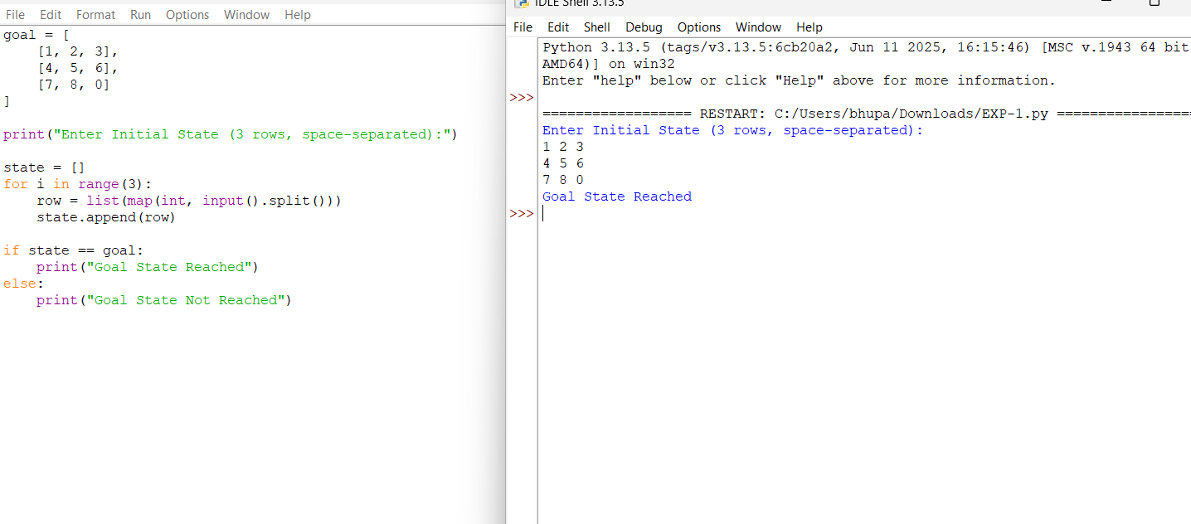Result:
The 8-puzzle problem was solved successfully using the A* search algorithm.

