**2. FM modulation and Demodulation using Discrete Components**

**Aim**

To design and construct frequency modulation and demodulation using discrete components and perform the demodulation

To observe the spectral components in Spectrum analyzer

|  |  |
| --- | --- |
| **Component Required** | **Equipment Required** |
| IC : NE 555 Timer  Resistors :  Capacitors : | Function Generator – 2 Nos  CRO – 1  Regulated Power supply 0-12 V  Spectrum Analyzer |

**Theory**

Frequency modulation is an analog modulation technique in which the frequency of carrier wave is varied in accordance with the instantaneous value amplitude of the modulating signal. In Frequency modulation the modulation index is given by

$$m=\frac{δf}{f_{m}}$$

$$m=\frac{f_{max}-f_{min}}{f_{m}}$$

Here, $δf$ is the peak frequency deviation and $f_{m}$ is the maximum frequency of the message signal

555 is an IC which can be used to set up an astable multivibrator whose frequency is determined by externally connected R and C. The standard design equation for an astable multivibrator using 555 IC is defined by the equation

$$T=1.38RC$$

Hence the frequency of oscillation to generate unmodulated carrier signal is

$$f_{0}=\frac{1}{1.38RC}$$

From the circuit given in figure 1

$$R_{1}=R_{2}=R$$

And $C_{1}=C$ to be used in the calculation after considering an unmodulated carrier signal to a specific value

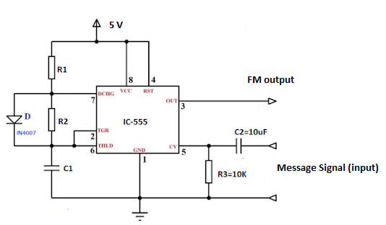

Figure 1. FM Modulator using 555 Timer

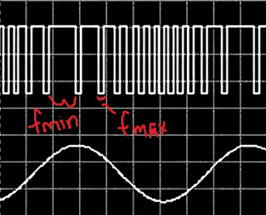

Figure 2. Model graph

The FM demodulation can be done by a differentiator cascaded with an envelope detector as shown in figure 3.

The design for FM demodulator is given by the following principles

The capacitor $C_{d}$ and the resistor $R_{d}$ must have the same value used in the modulator as C and R.

The envelope detector resistor and capacitor can be designed depending on the frequency of modulating signal (message signal) taken as given by the equation

$$f_{m}=\frac{1}{2πR_{e}C_{e}}$$

Here, $f_{m}$ is the maximum frequency of the message signal. The diode OA79 can be used as D1 of the envelope detector.

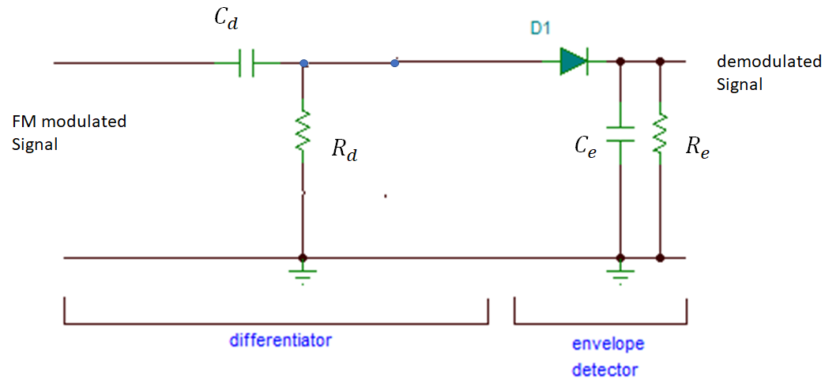

Figure 3. FM demodulator

FM spectrum has sidebands along with carrier signal. The number of sidebands generated depends on the modulation index. The modulation index is depending on the modulating signal’s frequency and the amplitude.

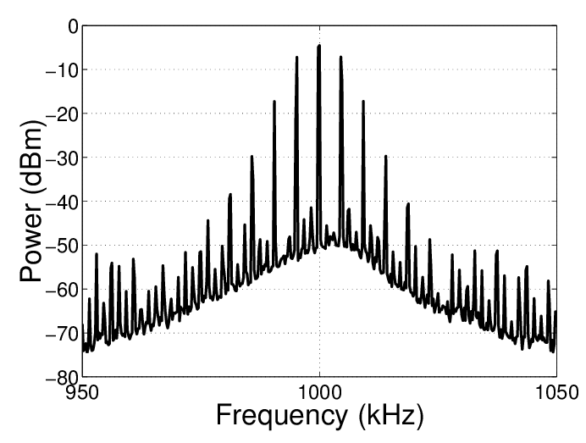

Figure 4. Wideband FM spectrum

Based on the number of sidebands, the FM is classified as narrowband FM and wideband FM. The narrowband FM has only one set of sidebands and wideband FM has several sidebands decided by the modulation index. For some specific values of modulation index the carrier vanishes in the spectrum called as carrier null. This is used in FM broadcasting in order to save the power wastage in broadcasting the FM. The wideband FM can be viewed in spectrum analyzer by connecting the FM modulated signal to the RF input port of spectrum analyzer. A wideband FM spectrum is shown in figure 4.

**Tabulation**

|  |  |  |  |
| --- | --- | --- | --- |
| **Waveforms** | **Amplitude (V)** | **Time (ms)** | **Frequency (Hz)** |
| **Message Signal** |  |  |  |
| **Unmodulated Carrier Signal** |  |  |  |
| **FM modulated signal** | **Vmax =**  **Vmin =** |  |  |
| **De-modulated signal** |  |  |  |

**Spectrum Analyzer Readings**

Number of significant sidebands:

|  |  |  |
| --- | --- | --- |
| **Waveforms** | **Amplitude (V)** | **Frequency (Hz)** |
| **Carrier Signal** |  |  |
| **Upper side bands** |  |  |
| **Lower side bands** |  |  |

**Result:**