1. Write a C Program to implement following operations

a) traverse

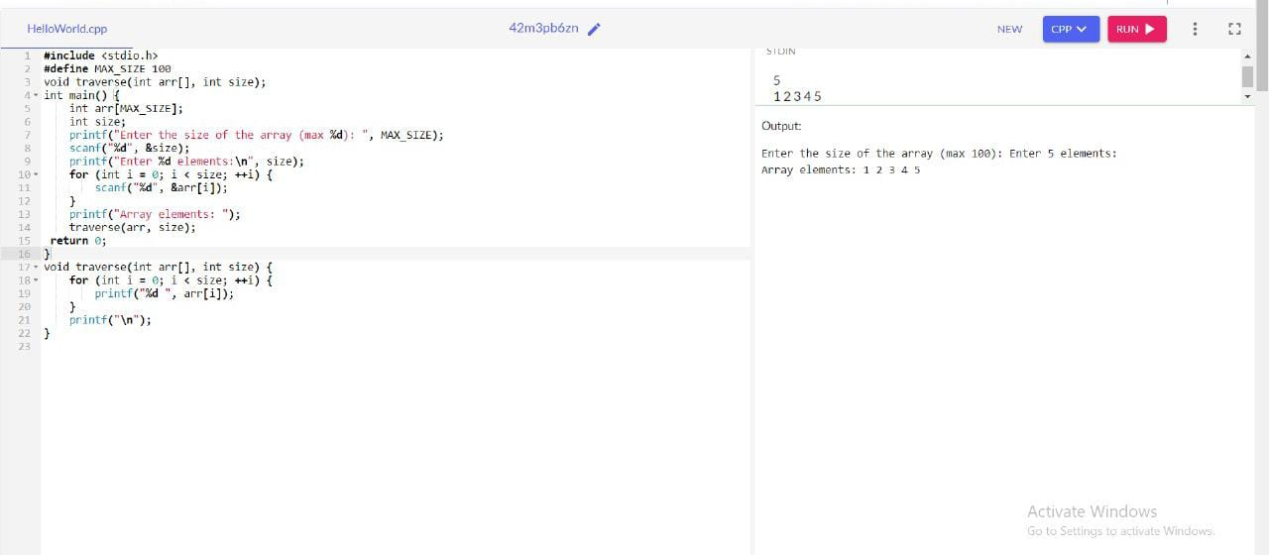

b) search

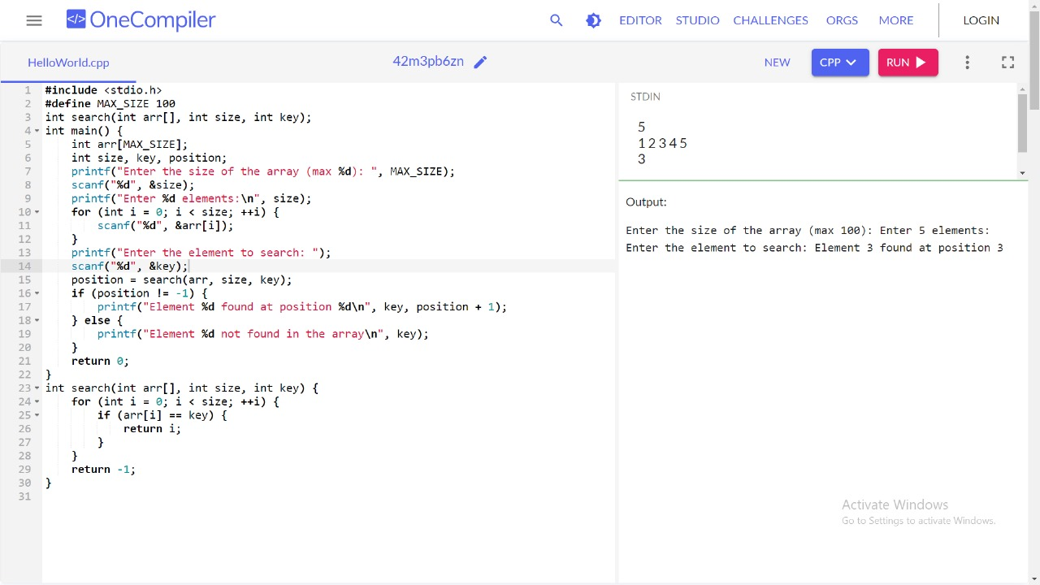

c) insert

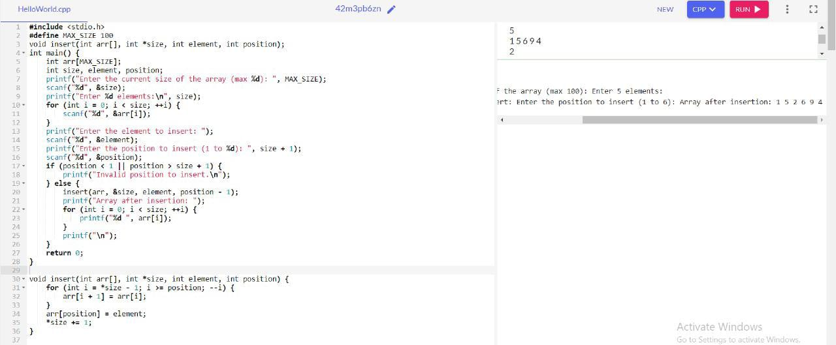

d) delete

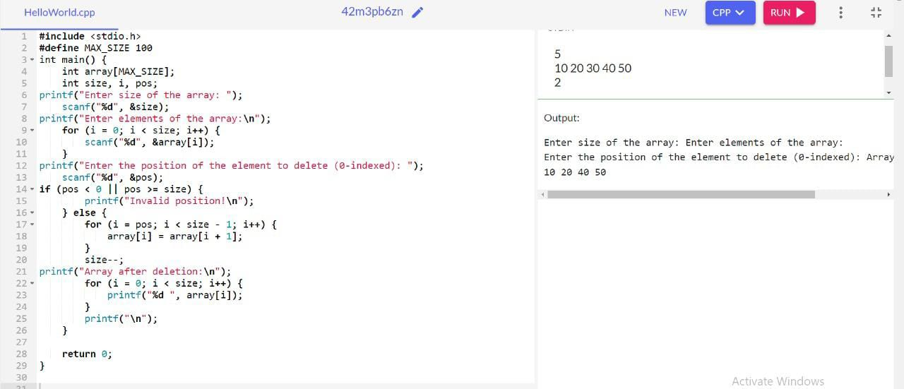

e)update

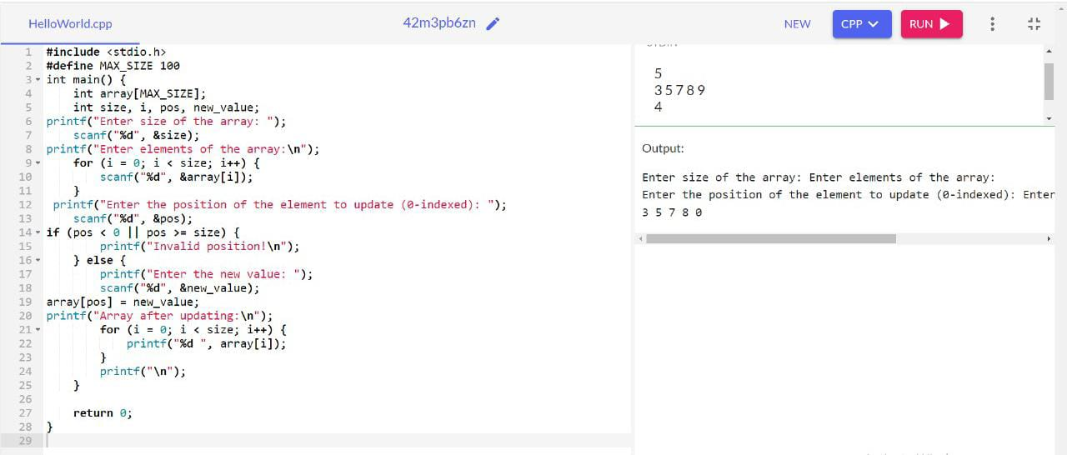

2. Writing a recursive function to calculate the factorial of a number.

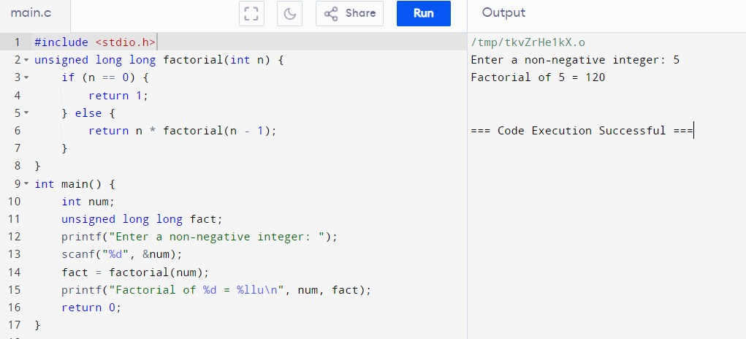

3. Write a C Program to find duplicate element in an array

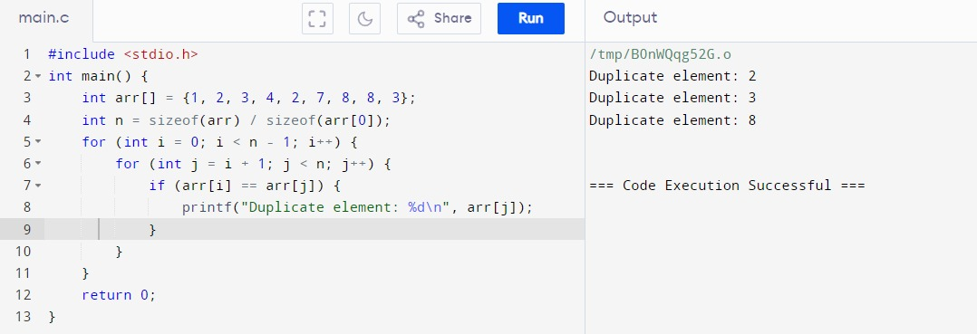

4. Write a C Program to find Max and Min from an array elements

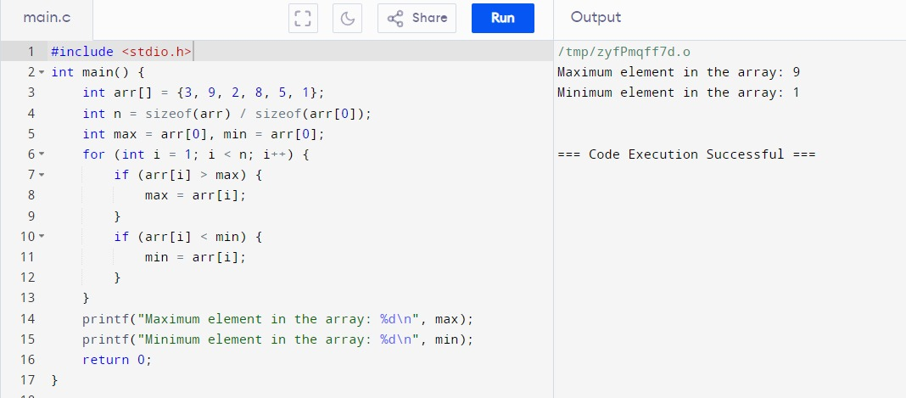

5. Given a number n. the task is to print the Fibonacci series and the sum of the series using

recursion.

input: n=10

output: Fibonacci series

0, 1, 1, 2, 3, 5, 8, 13, 21, 34

Sum: 88

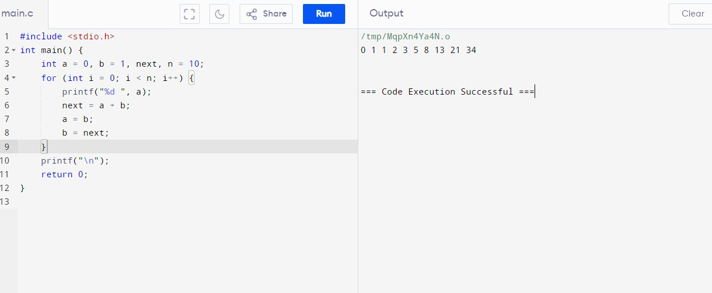

6. You are given an array arr in increasing order. Find the element x from arr using binary

search.

Example 1: arr={ 1,5,6,7,9,10},X=6

Output : Element found at location 2

Example 2: arr={ 1,5,6,7,9,10},X=11

Output : Element not found at location 2

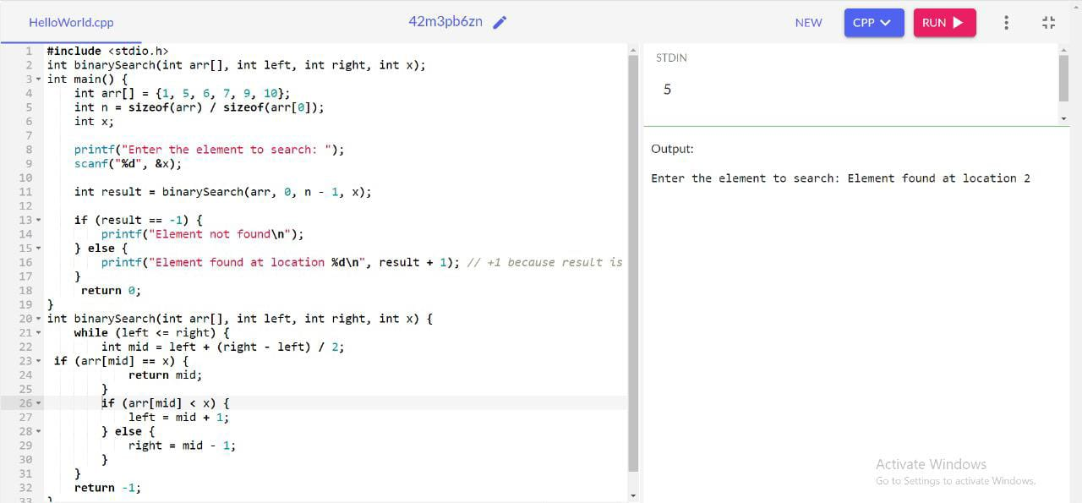

7. You are given an array arr in increasing order. Find the element x from arr using linear search.

Example 1: arr={ 1,5,6,7,9,10},X=6

Output : Element found at location 2

Example 2: arr={ 1,5,6,7,9,10},X=11

Output : Element not found at location 2

