Overview :SMS Template :

**Left side :**

Message : New Homepage released with better design and improved performance after beta testing.

**Right side :**

New Homepage released with better design and improved performance after beta testing.

**-Done**

Overview : Email Template :

**Left side :**

Subject : Latest news

Headline : Release Notes

Message : The Homepage New Homepage released with better design and improved performance after beta testing.

Button text : Shop Now

Button url :[www.google.com](http://www.google.com)

**Right Side :**

Shop Now

Release Notes

<img>

The Homepage New Homepage released with better design and improved performance after beta testing.

**-Done**

**Scheduler Page :**

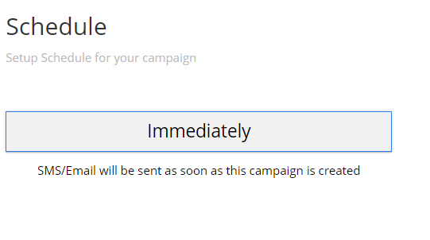

* Move the text inside the box with same font size. -**Done**

SMS /Email :

* Remove <hr> in between SMS and Preview **- Done**
* Remove laptop image and use the preview used in overview section. -**Done**

Overview Page: Label, edit buttons as discussed with Viji -**Done**

Audience list

* Table column sizing and text remove - **Done**

Create audience group:

<https://panamon.tech/campaign_system/audience_group.php>

* Brands dropdown should be shown only when the specific brand is chosen **- Done**
* Brands dropdown must allow multiselection **- Done**
* Label : all caps , size smaller than existing size **- Done**
* Age Group : make 13-17 active **- Done**
* Regulated contentAge restriction required – add * **- Done**
* Show timeline always **- Done**
* If Frequent selected : show timeline and start and end date **- Done**
* Save button **- Done**

Templates:

1. “Layout” rename to “Templates” **- Done**
2. Remove “view in iphone” button **- Done**
3. Use Campaign overview email template  **- Done**
4. Add three dot buttons inside sms/email template box **- Done**
5. Three dot menu : Edit, Copy, Delete **- Done**
6. Hide Filter icon **- Done**

Create sms template

1. Heading “ Templates” to “SMS Templates”- **Done**
2. Remove “SMS”, “Message details”- **Done**
3. Button – all caps small, reduce button size- **Done**
4. Change text “create” to “Save”- **Done**

Create Email Template

1. Heading “ Templates” to “Email Templates”- **Done**
2. “TEMPLATE” to “LAYOUT”- **Done**
3. Label : all caps small size - **Done**

ALL PAGES:

Label : all caps small size- **Done**

Button : all caps small size- **Done**

Button Size : rectangle, reduce size no curved edge- **Done**

* “Create” to “SAVE”- **Done**
* “Submit” to “SAVE”- **Done**