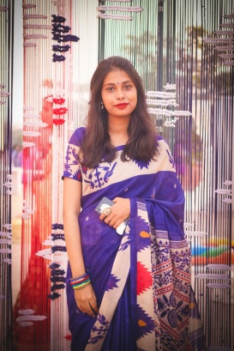

Public Speaking

Solidworks

C Programming

Python

Microsoft Office

**SKILLS**

**PERSONAL EXPERIENCE**

Sub-Executive (2014-2015)

**Viqarunnisa Noon Science Club**

______________________________

Executive (2013-2015)

**Viqarunnisa Noon Debate Club**

______________________________

**Assistant Secretary**

**MIST Debate Scociety**

______________________________

**EXTRA CURRICULAR ACTIVITIES**



**2016**

Participated in **ROBOLUTION as a volunteer**

______________________________

**2016**

Organizer of ‘’Bioscope”

______________________________

**2017**

Organizer of ‘’Cinemascope”

______________________________

**2017**

Volunteer at Icchhepuron (A dream of life)

______________________________

**2017**

**HULT PRIZE**

1st Runner-up (on campus)

______________________________

**2017**

**IEEE R10 HTC 2017 WIE TRACK**

Champion (best idea presenter)

______________________________

**ADDITIONAL COURSES**



**Design & Development of Prototype using Computer Integrated Manufacturing (CIM) Process**

______________________________

**Short Course on Python**

______________________________

EMAIL: [joytunnisajoti@gmail.com](mailto:joytunnisajoti@gmail.com)

**JOYTUN NISA**

**JOTI**

**AWARDS**

House No: 03, Abdullabag Mosque Road no: 07, North Badda, Dhaka-1212

**EDUCATION**

**2013**

**SSC (GPA- 5.00)**

Viqarunnisa Noon School & College

______________________________

**2015**

**HSC (GPA- 5.00)**

Viqarunnisa Noon School& College

______________________________

**2016-2019 (in roll)**

**B. Sc. Engineering (Industrial & Production Engineering)**

Military Institute of Science & Technology

___________________________

MOBILE – +8801700871547

HOME – +8801720021023