|  |  |  |  |  |
| --- | --- | --- | --- | --- |
| Onlin(e) | | | | |
|  |  | | |  |
| Health  Project Link: https://github.com/JotunMichael/Java/Spring | | | | |
|  | | e-Health Web APP |  | |

TABLE OF CONTENTS

agenda 4

1. Brief 4

2. Description Scope 5

3. Financial Scope 6

4. Focused on Delivery 6

5. Project Execution 8

6. Technologic Approach 9

1. DESIGN 10

1.1. PERSONA 10

1.2. Requirement Analysis (non/functional) 11

1.3. UML Representation Analysis 14

1.4. Use Case 18

1.5. Class Diagrams 19

1.6. State Machine/State Chart Diagram 20

1.7. ER Diagram 21

1.8. Storyboards & Wireframes (low fidelity) 22

1.9. User Flows 29

1.10. Web Site Map Design & Planning 30

1.11. Heat Map/Mockup 32

2. Project Management 33

2.1. Task/Time Schedule PERT 33

2.2. Work Breakdown Structure (WBS) 34

2.3. Sprint Canvas 35

2.4. Scrum Cabinet Reports 36

2.5. Project Participants 36

2.5.1. Stakeholder List 36

2.5.2. Product Owner 37

2.5.3. Scrum Master 38

2.5.4. Scrum Team Members 38

2.6. Project Initiation 39

2.6.1. Project Vision 39

2.6.2. Project Charter 40

2.6.3. Use Case Diagram 41

2.6.4. Prioritized Use Cases 42

2.6.5. Epics 43

2.6.6. Product Backlog - Features 45

2.6.7. Project Deliverables – Release Planning 51

2.7. Sprint Planning Meeting Agenda 51

2.7.4. Sprint Planning Meeting Minutes 52

2.7.5. Sprint Backlog 55

2.7.6. Sprint Deliverables 58

2.8. Burnout Chart/Line 59

# agenda

## Brief

**e-Health – Product Design (UI/UX back-end) Project end-to-end**

* Project Name:
  + e-Health
* Project Description:
  + A client wishes to develop and test a platform to enable online Health system for Hospitals, to host their own content on their own domain.
* Who is this for?
  + Everyone – this product is for everyone who wishes to have an easy way about Health System or/and monitor their history record and Doctor Appointments.
* Feature List (product requirements)
  + Easy onboarding
  + Health Monitor, History
  + No monthly fees
  + Personalization screen
  + Health Appointments
  + Find Doctor
* Competitors & Product Inspiration
  + Gov.gr/aule-suntagographese
  + Idika
* Deliverables
  + Wireframes for client approval
  + High fidelity prototype of the product
  + User Testing
  + Usability Report
  + UI Assets for developers
* Cost
  + $4000 total with $93 p/hour for any additional work outside the brief
  + 50% payment required to begin work
* Timeline/Deadline
  + The duration is described below as subtasks

## Description Scope

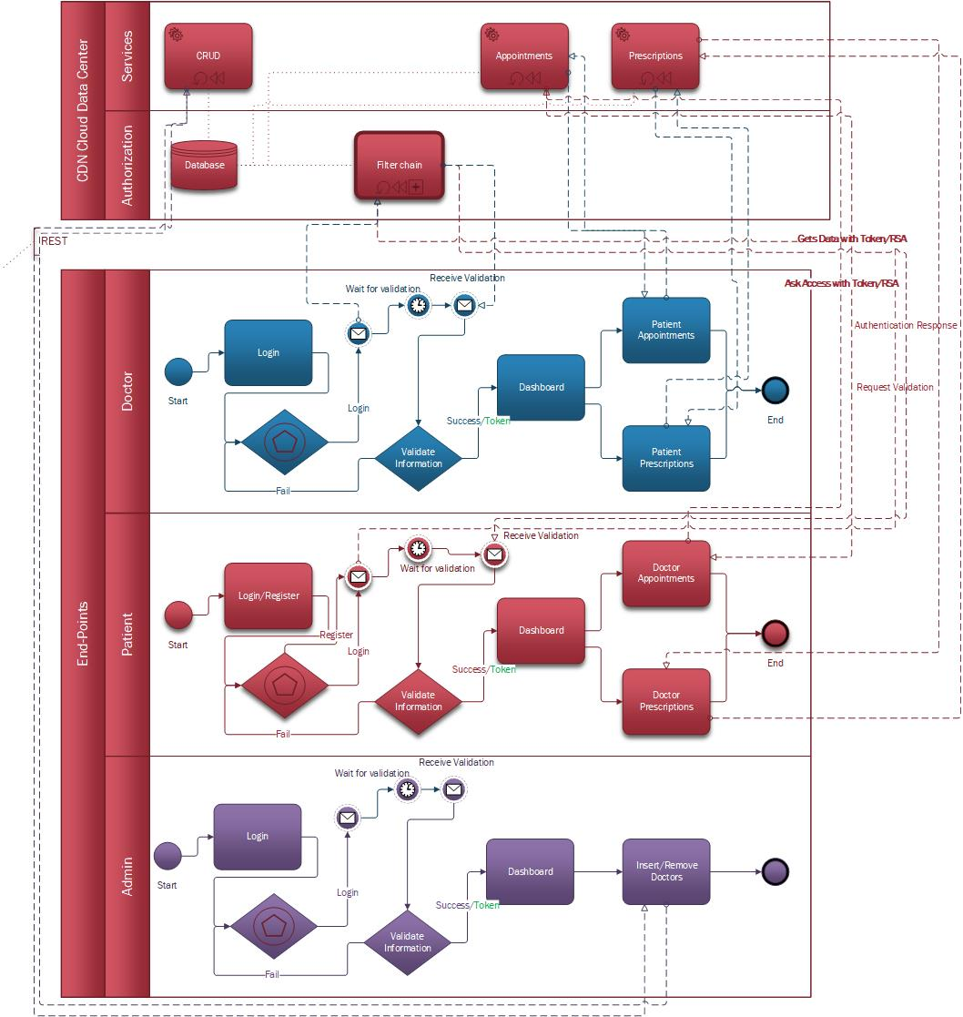

BPMN 2.0 Visual Process Representation of Description Below(**activity-like**)

The purpose of this document is to provide valid information for its members including Low level Design and High-Level design in a concise application of the Business Health Content application.

The application will consist of front & back-end interfaces functionality. It will allow the Patient to check Appointment list, make new ones, monitor their health and have a Complete Suite of Health Checking events. The application will be a subset of an information system that will interact with users and other database systems.

## Financial Scope

The project will observe deadlines, Budget, vision of stakeholders.

* Investment decision
* Working Capital decision
* Financing decision
* Dividend decision
* Ensures liquidity
* Profit management

## Focused on Delivery

**Subtasks/activities.**

1) Requirements analysis

2) Database/Business Entities design

3) Interface design

4) Database/ Business Entities development and data entry

5) Interface development

6) System completion

7) Application installation and control (integration)

8) Training and acceptance/support

## Project Execution

Approaches available: procedural/waterfall, agile, Dev ops

A base of staff specialization and available infrastructure is selected agile scrum team approach. The main course recording and management will become a means of collaboration & agile platform JIRA with tracking and problem recording system/tickets source & version control DVCS GIT.

**Product BACKLOG**

Below is an initial estimate which will change dynamically (updated / passage of time) with more information as the priorities will change as well as the requirements of the project may change.

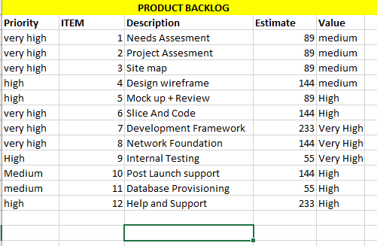

*from the above section Agenda everything is abstracted including the Gantt and Product backlog these are not in any means any close to actual requirements but a close generalized estimate of what to be expected. Latter will be introduced actual implementations in this document.

## Technologic Approach

The application will be web based

1. Web tech & frameworks: Spring boot(back-end) + Angular(front-end) + thymeleaf.
2. Spring Security
3. ORM: JPA Hibernate
4. Database System: MySQL
5. Third-Party libraries:
   * + - 1. spring-boot-starter-thymeleaf
         2. spring-boot-starter-web
         3. spring-boot-starter-test
         4. spring-boot-starter-jdbc
         5. spring-boot-starter-data-jpa
         6. mysql-connector-java
         7. spring-boot-starter-security
         8. commons-lang3
         9. CSS

Bootstrap

DateTimePicker

Datatables,JQuery-UI,UIkit,themeroller

* + - * 1. Javascript

BootBox

Bootsrap

DateTimePicker

Datatables,JQuery-UI,UIkit,easing

The corresponding progress will be on GitHub: <https://github.com/JotunMichael/PHP>

**This documentation will be changing to keep up with the updates

# DESIGN

## PERSONA

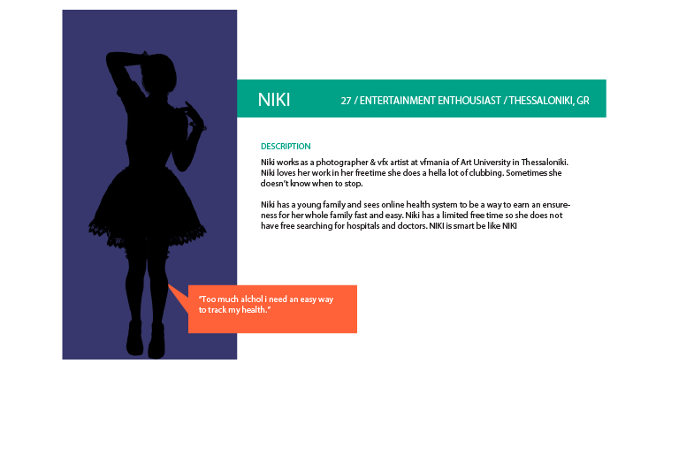

The project will expand as what NIKI wants.

## Requirement Analysis (non/functional)

**indicative specification functional requirements**

**Function Name:** Account login

**Description**: Patient, Doctor, Admin login end-point portals

**INPUTS**: Front-end portal authenticated in back-end.

**System behavior**: The system takes Data comparing each unique user individually based on their input fields. The “user” asks for a token in Spring security if they provided correct a JWT comes back in order to access RESTful API to-do functionality.

**OUTPUT**: logged in profiles on site.

**Function Name:** Patient Appointments

**Description**: User Makes Appointments based on doctor set of availability.

**INPUTS**: Date, Doctor Category.

**System behavior**: The system search and logs available Doctor Dates in order for a patient to reserve one.

**OUTPUT**: User Scheduled Appointments.

**Function Name:** Medical Account

**Description**: Patient has its own medical account information review.

**INPUTS**: User Id generates a medical account based on a custom seed number.

**PROCESS**: The system creates a one-to-one medical account relationship. So, the user can review his/her medical instruction and history.

**OUTPUT**: Review any medical advice from the doctor.

**Function Name:** Patient Information Update

**Description**: User can update its own medical information if something changes.

**INPUTS**: Form post data fields.

**PROCESS**: The user gives valid information based on constraint check and sees his/her updated information output Live.

**OUTPUT**: Updated User Information.

**Function Name:** Admin CRUD’s Database.

**Description**: Admin insert or removes a doctor entry from the system.

**INPUTS**: Front-end page admin account.

**PROCESS**: The system is capable of removing or add a new entry based on Admin operation actions.

**OUTPUT**: Doctor Business entity database update.

**Function Name:** Doctor Prescribes

**Description**: Doctor prescribes medical instruction for a patient.

**INPUTS**: Form post data fields from the doctor

**PROCESS**: This system behaviour accepts inputs from corresponding any medical instruction made by doctor for a patient to follow.

**OUTPUT**: Patient medication account updated.

**indicative specification non-functional requirements**

**Function Name:** Portal differences on login

**Function Name:** Fast and responsive Database logging system

**Function Name:** Realtime updates

**Function Name:** ssl(https), pki connections

**Function Name:** Load balancing network server offload

**Function Name:** Data center private cloud setup

**Function Name:** Esxi Vmotion enabled

**Function Name:** CIA (Confidentiality, integrity and availability) triad

## 1.3. UML Representation Analysis

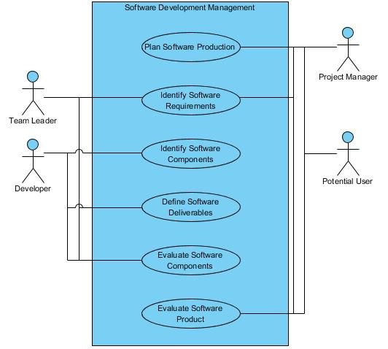

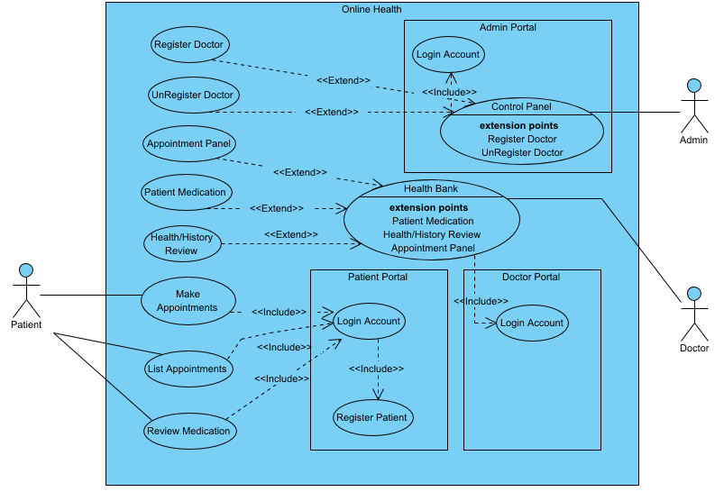

## 1.4. Use Case

**Use Case**: Login portal

**Main user**: admin, user

**Short Description**: User or admin enter credentials and gets checked against database queries. The abstraction layer here is Spring Security that provides token data to the valid user as session cookies. The inputs fields apply security rules backend & front-end.

**Conditions:** only registered users can use the system with Health Services.

**Exit status**: Successful health Appointment system for patients.

**Main Flow**:

1. User registers
2. System checks input integrity [Alternative Flow A]
3. User Logins
4. System Checks input integrity [Alternative Flow B]
5. Enjoy e-health

**Alternative flows**

Alternative flow A: Field checking

If not valid input check jumps on Step 1

Alternative flow B: Field checking

If not valid input check jumps on Step 3

## 1.5. Class Diagrams

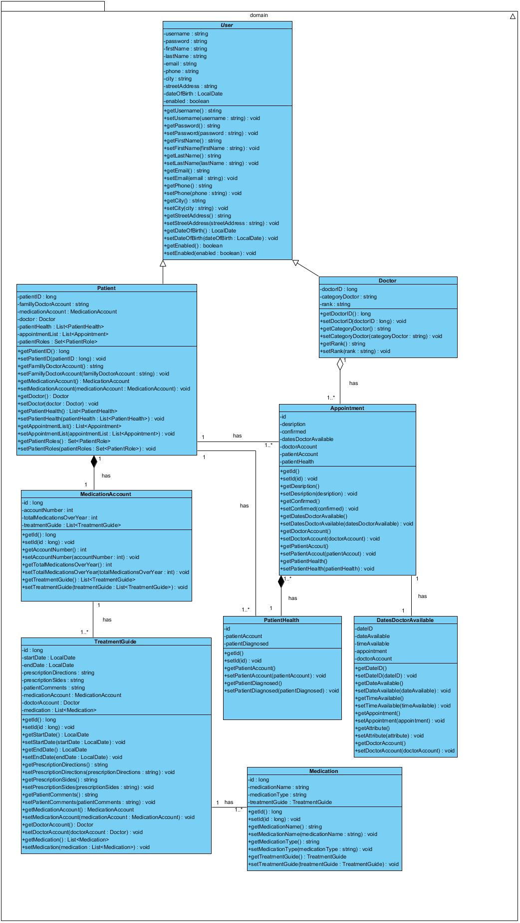

## 1.6. State Machine/State Chart Diagram

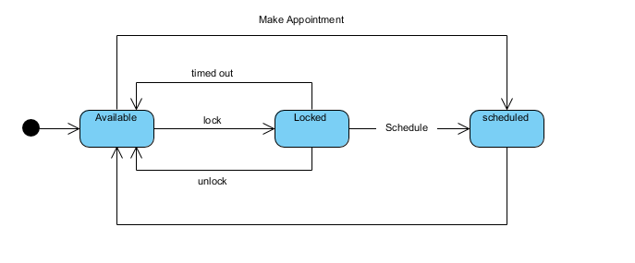

## 1.7. ER Diagram

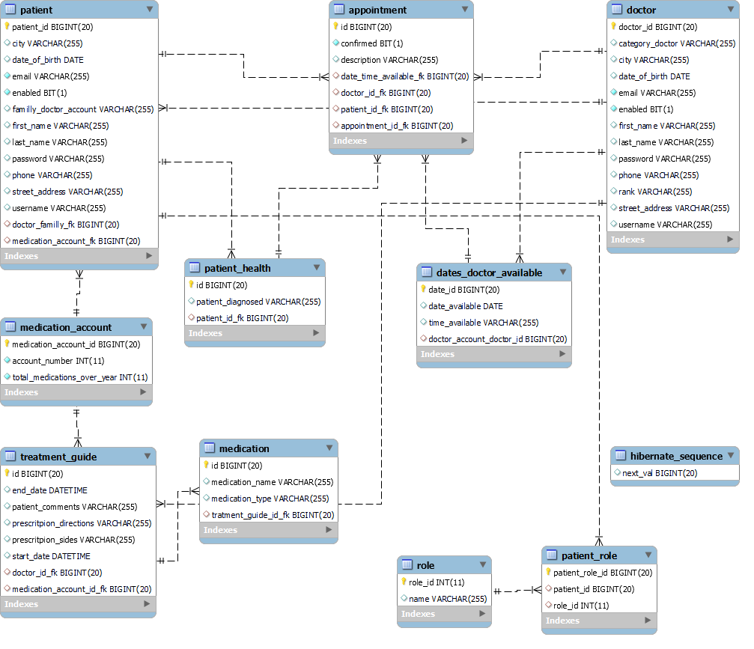

## 1.8. Storyboards & Wireframes (low fidelity)

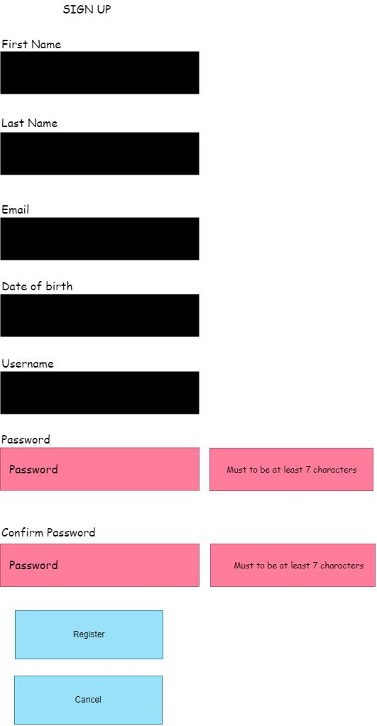

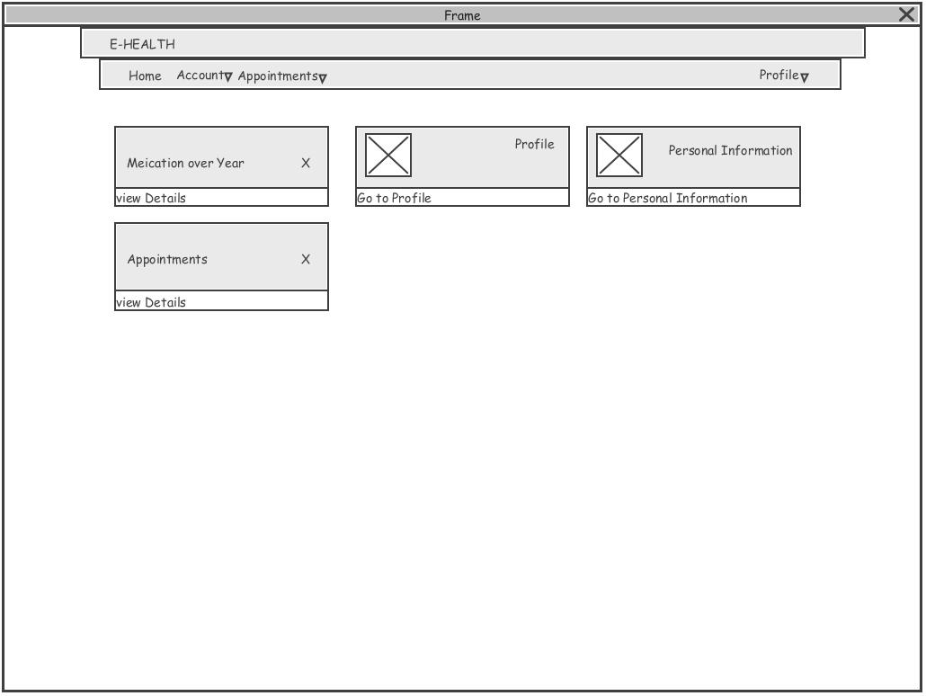

## 1.9. User Flows

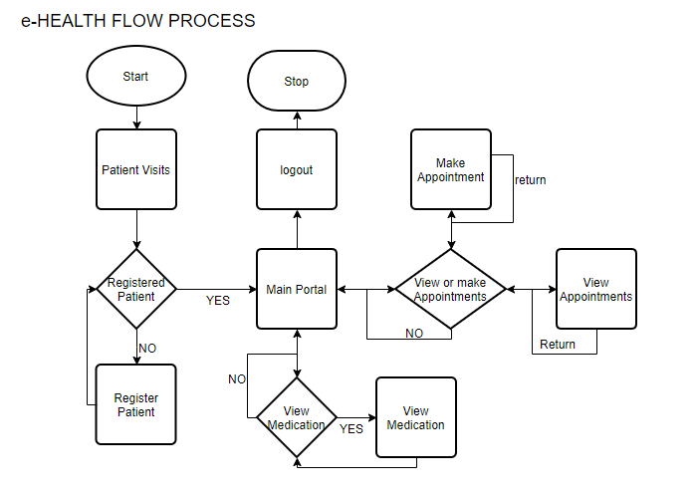

## 1.10. Web Site Map Design & Planning

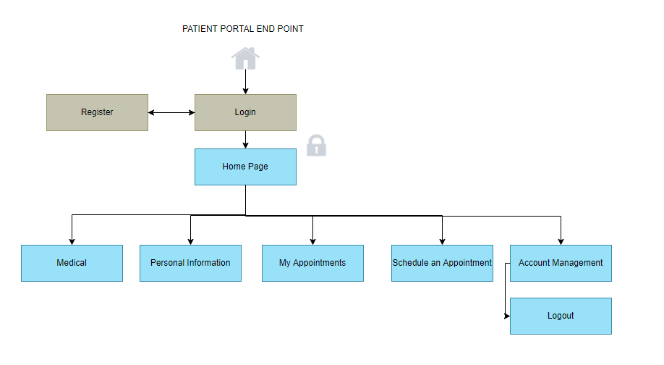

## 1.11. Heat Map/Mockup

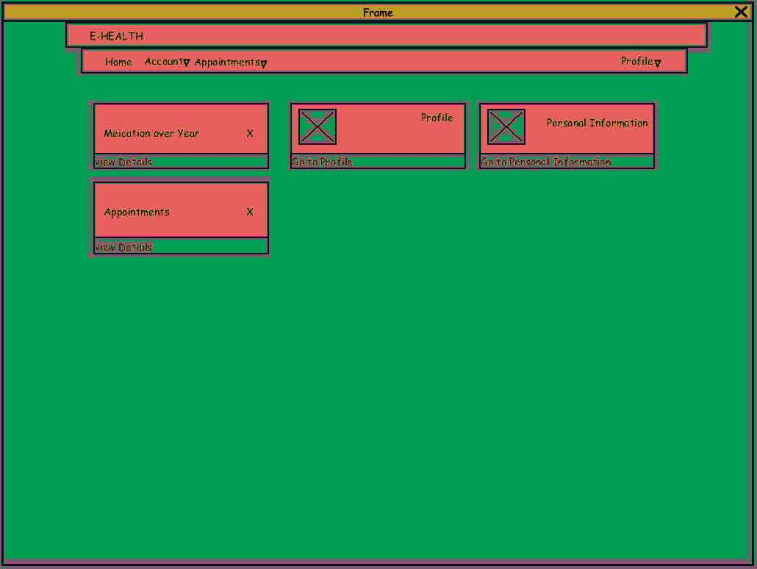

Various testing and design patterns should be deployed for measure user accesibility and preference.

Bounce Rate, Sex, Age, Device, Interests, A/B Testing + real case users though Analytics

# Project Management

## 2.1. Task/Time Schedule PERT

Upcoming features

Critical path method in red lines (CPM)

## 2.2. Work Breakdown Structure (WBS)

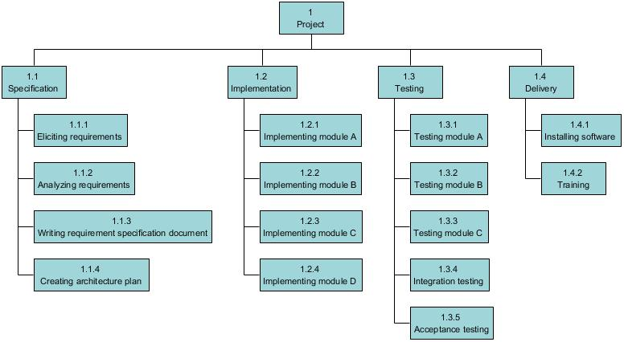

## 2.3. Sprint Canvas

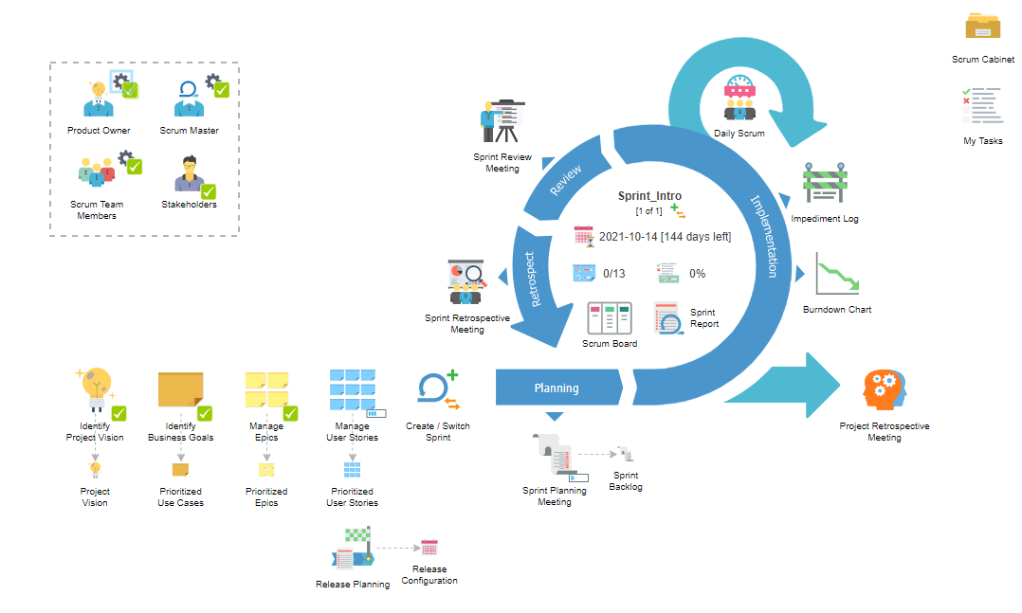

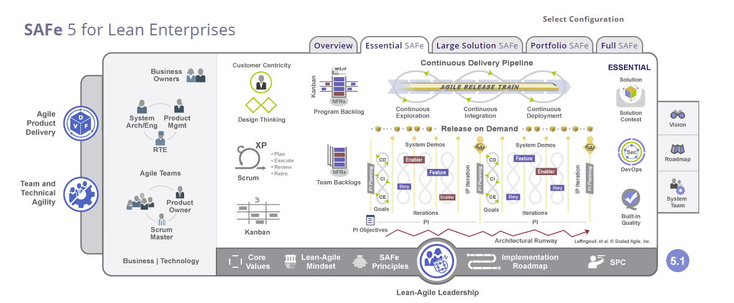

## 2.4. Scrum Cabinet Reports

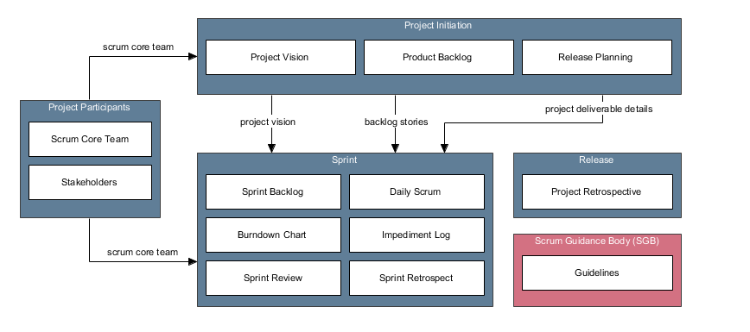

## 2.5. Project Participants

2.5.1. Stakeholder List

| Name | Role | Responsibilities | Contact |
| --- | --- | --- | --- |
| Michail Markou | Sponsor, Customer, User | Vision Leader | backtrackpower@gmail.com |

2.5.2. Product Owner

| Member | Michail Markou |
| --- | --- |
| Responsibilities | Articulating customer/sponsors/users requirements     * Defines the project vision * Helps create the Project Charter * Identifies project stakeholders * Helps determine scrum team members * Create epics * Create, define and prioritize user stories * Create Release Plan and keep it updated * Approve user stories * Explains user stories and clarifies requirements to scrum team in sprint planning meeting * Provides guidance and clarification in estimating effort for tasks * Grooms prioritized product backlog * Accept/reject deliverables * Provide feedback to scrum master and scrum teams * Help deploy product releases and coordinates this with the customer * Participate in sprint retrospective meeting |
| Notes |  |

2.5.3. Scrum Master

| Member | Michail Markou |
| --- | --- |
| Responsibilities | * Helps identify project stakeholders * Facilitates the formation of scrum team * Facilitates the creation of epics * Helps product owner in creating and maintain product backlog * Coordinates the creation of Release Plan * Assists in creating and defining user stories * Facilitates meetings * Facilitates the scrum team in creating tasks for the next sprint * Facilitates the scrum team in effort estimation * Supports the scrum team in creating deliverables * Helps maintain the impediment log * Ensures that issues affecting the development are discovered and resolved |
| Notes |  |

2.5.4. Scrum Team Members

| Member | Responsibilities | Notes |
| --- | --- | --- |
| Michail Markou | * Ensures a clear understanding of epics and user stories * Agrees with the other team members on sprint length * Seeks clarification on new updates in requirements * Provides inputs to the product owner in defining and estimating user stories * Commits user stories to be done in a sprint * Provides inputs in creating and estimate tasks * Develops the product, service or other results * Identifies the risk and implements risk mitigation actions, if required * Provides inputs to update the impediment log * Discusses progress and issues in daily scrum meeting * Demonstrates completed deliverables in sprint review * Suggests improvement opportunities in sprint retrospective meeting * Participates in the project retrospective meeting |  |

## 2.6. Project Initiation

2.6.1. Project Vision

For consumers/patients who need to check their health, e-health is an online health service for appointments while keeping the record for your all-medical conditions and prescriptions. Unlike the other competitors, our system can run on all modern web browsers and provide rapid health solutions

2.6.2. Project Charter

2.6.2.1. Project Vision

For consumers/patients who need to check their health, e-health is an online health service for appointments while keeping the record for your all-medical conditions and prescriptions. Unlike the other competitors, our system can run on all modern web browsers and provide rapid health solutions

2.6.2.2. Project Mission

* Provide an online e-health system to automate and facilitate the whole process of health monitoring.
* Support on modern web browsers.
* Appointments and medical history of prescriptions of your health status

2.6.2.3. Project Success Criteria

Success for the e-health project will be achieved when a fully tested e-health and all technical documentation, are fully deployed within the time and cost constraints defined.

2.6.3. Use Case Diagram



2.6.4. Prioritized Use Cases

| Name | Description | Priority | Size | Complexity |
| --- | --- | --- | --- | --- |
| Register Doctor | Admin Inserts Doctor to the system | Must | Medium | Low |
| Control Panel | Admin Inserts or Removes Doctor from the System | Must | Medium | Medium |
| Login Account | Admin Logins | Must | Small | Medium |
| Login Account | Patient Logins | Must | Small | Medium |
| Register Patient | Patient Register to the System | Must | Small | Medium |
| List Appointments | Patient Make or Unset Appointments | Must | Medium | Medium |
| Patient Medication | Doctor Prescription | Must | Medium | Medium |
| Health/History Review | Doctor Review Patient's history | Must | Medium | Medium |
| Review Medication | Patient follows medication instruction from doctor | Must | Medium | Medium |
| Make Appointments | Patient Make Appointments | Must | Medium | Medium |
| UnRegister Doctor | Remove Doctor from the system | Must | Medium | Medium |
| Login Account | Doctor Logins | Must | Medium | High |
| Health Bank | Doctor main panel for interaction to Patients | Must | Medium | High |
| Appointment Panel | Doctor See upcoming Appointments and sets availability for new ones | Must | Medium | High |

2.6.5. Epics

| Name | Description | Parent Use Case | Priority | Risk |
| --- | --- | --- | --- | --- |
| Admin Removes Doctor | Admin removes Doctor from system | UnRegister Doctor | Should | Low |
| Doctor monitors patient history | Doctor monitors Patient's History record | Health/History Review | Should | Medium |
| Admin Inserts Doctor | Admin Insert Doctor to the System | Register Doctor | Must | Medium |
| Patient Schedules an Appointment | Patient Schedules an Appointment with Doctor | Make Appointments | Must | Medium |
| Doctor Panel for Patient interface | Doctor Health Bank Panel for Patient Interface | Health Bank | Should | Medium |
| Patient Gets Scheduled Appointments | Patients Gets schedules Appointment List | List Appointments | Must | Low |
| General Epic |  | General Activity |  |  |
| Patient Logins | Patient Logins to the System | Login Account | Must | Low |
| Admin Control Panel | Admin Control Panel UI | Control Panel | Must | Medium |
| Patient Registers | Patient Registers to the system | Register Patient | Must | Low |
| Doctor 's prescription for Patient | Doctor's prescription for Patient Medication | Patient Medication | Should | Medium |
| Doctor Appointment Panel | Doctor Appointment Panel depends on health Bank | Appointment Panel | Must | Medium |
| Medication Patient instruction from Doctor | Doctor's Instruction for Patient to a specific medication/cure | Review Medication | Must | High |
| Doctor Login | Doctor Login Portal | Login Account | Must | High |
| Admin Login | Admin Login Portal | Login Account | Must | Medium |

2.6.6. Product Backlog - Features

2.6.6.1. User Story Map - ROADMAP

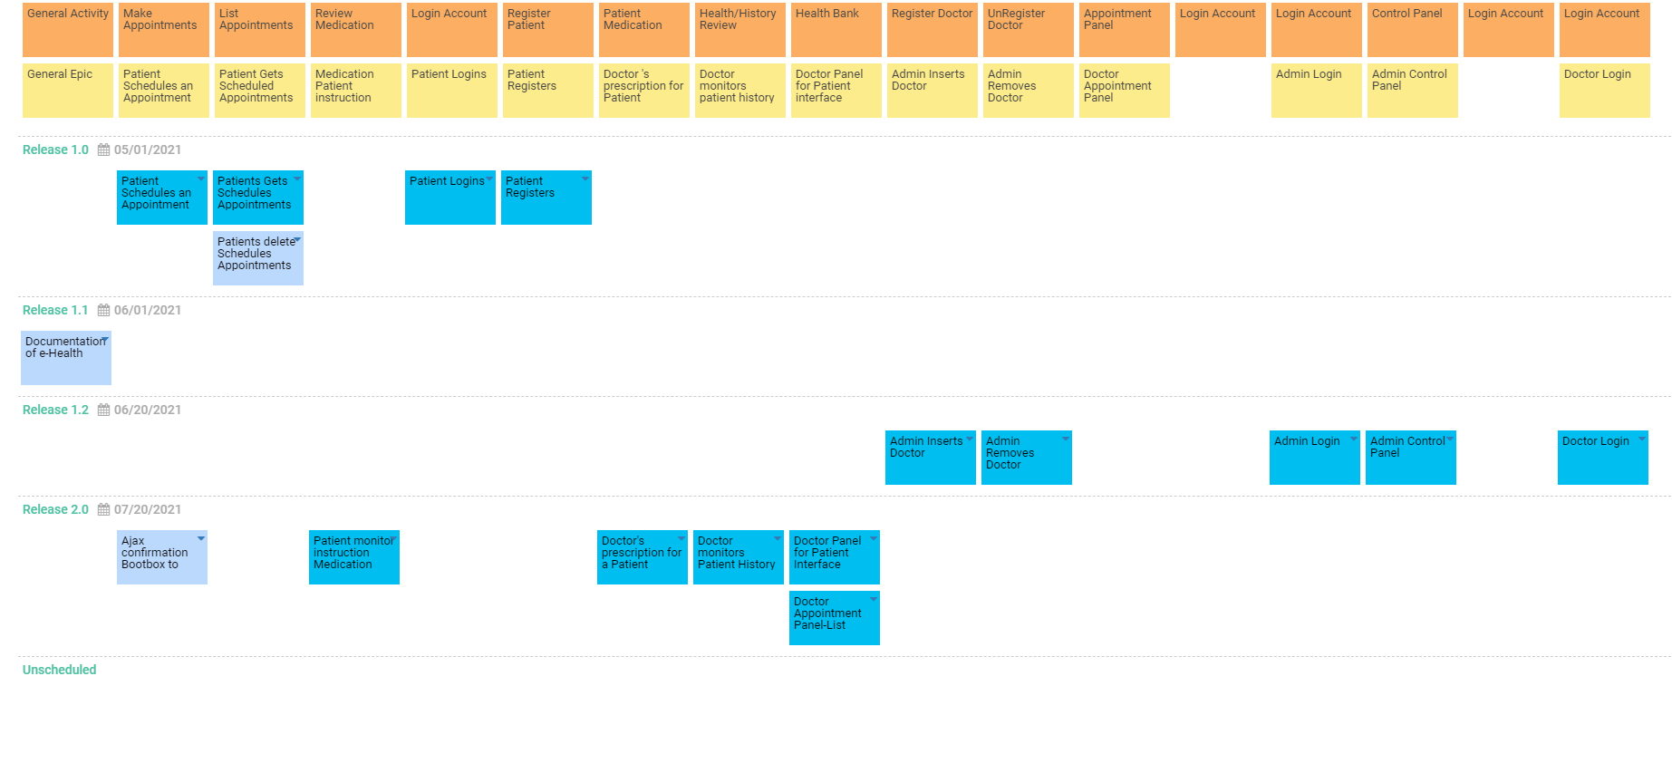

2.6.6.2. Prioritized User Stories - FEATURES of the App

| ID | Name | Description | Epic | Status | Acceptance Criteria | Story Points | Priority | Risk |
| --- | --- | --- | --- | --- | --- | --- | --- | --- |
| US001 | Patient Schedules an Appointment | As a Patient, I want to be able to schedule online appointments | Patient Schedules an Appointment | Approved | Search doctor and pick available appointments, Confirmation | 3 | Must | Low |
| US002 | Patients Gets Schedules Appointments | As a Patient, I want to be able to see my schedule list so to remove or not to forget when an appointment is. | Patient Gets Scheduled Appointments | Approved | remove appointments, review appointments, Confirmation | 1 | Must | Low |
| US003 | Patient monitor instruction Medication from Doctor | As a Patient, I want to see my medication instruction so to know the dosages and timing | Medication Patient instruction from Doctor | Approved | See medication instructions, See who is from, See how long to take them and dosages | 1 | Must | Medium |
| US004 | Patient Logins | As a Patient, I want to sign in to my health services | Patient Logins | Approved | Security check, Patients Logins to main e-health Portal, Another Portal | 2 | Must | Low |
| US005 | Patient Registers | As a Patient, I want to be able to Register to Health Services | Patient Registers | Approved | security checks | 5 | Must | Low |
| US006 | Doctor's prescription for a Patient | As a Doctor, I want to write proper steps for a medication so a patient can follow | Doctor 's prescription for Patient | Approved | For each Patient from the Appointment | 3 | Must | Medium |
| US007 | Doctor monitors Patient History | As a Doctor, I want to review the history of my Patient so to have a clearer understanding | Doctor monitors patient history | Approved | Review previous medications, See Dates information | 3 | Must | Medium |
| US008 | Doctor Panel for Patient Interface | As a Doctor, I want an easy way to interface with my Patients so to keep organized | Doctor Panel for Patient interface | Approved | List area of all patient interactions, Add Appointments, Edit Appointment Dates if not scheduled from patient, Writes prescription to Patient | 3 | Must | Medium |
| US009 | Admin Inserts Doctor | As an Admin, I want to register Doctor to the System | Admin Inserts Doctor | Approved |  | 2 | Must | Low |
| US010 | Admin Removes Doctor | As an Admin, I want to un-register Doctor to the System | Admin Removes Doctor | Approved |  | 2 | Should | Low |
| US011 | Doctor Appointment Panel-List | As a Doctor, I want to set or unset Appointments | Doctor Panel for Patient interface | Approved | Depends on Doctor Health Bank Panel | 3 | Must | Medium |
| US012 | Admin Login | As an Admin, I want to login to Health Service Administration Panel | Admin Login | Approved | Another Portal, 1 admin | 2 | Must | Medium |
| US013 | Admin Control Panel | As an Admin, I want a main area to centralized adjust everything | Admin Control Panel | Approved | Main Panel for Admin interaction to users | 3 | Must | Medium |
| US014 | Doctor Login | As a Doctor, I want to Sign-In to Health Services. | Doctor Login | Approved | After Admin insert, Another Portal | 2 | Must | Medium |
| US015 | Ajax confirmation Bootbox to Controller HTTPreq |  | Patient Schedules an Appointment | New |  |  |  |  |
| US017 | Documentation of e-Health |  | General Epic | New |  |  |  |  |
| US016 | Patients delete Schedules Appointments |  | Patient Gets Scheduled Appointments | New |  |  |  |  |

2.6.7. Project Deliverables – Release Planning

2.6.7.1. Project Deliverables

| Deliverable | Description | Planned Release Date | Priority | Status | Owner |
| --- | --- | --- | --- | --- | --- |
| e-Health (web) | A web-based online Health Services system that automates and facilitates the whole process of Health Monitoring | 2021-07-20 | High | In Progress | Michail |

2.6.7.1. Release Configuration

| Release | Description | Planned Release Date |
| --- | --- | --- |
| Release 1.0 | Support some of major features of the web-based e-Health online system. | 2021-05-01 |
| Release 1.1 | Completion of Documentation of e-Health Services system. | 2021-06-01 |
| Release 1.2 | Support the most of major features of the web-based e-Health online system. | 2021-06-20 |
| Release 2.0 | Completion of the web version of e-health online system. | 2021-07-20 |

## 2.7. Sprint Planning Meeting Agenda

2.7.1. Sprint Planning Meeting Agenda

| Date | 2021-08-01 |
| --- | --- |
| Time | 09:00 |
| Location | Teams |
| Prepared by | Michail |
| Attendees | Michail |

2.7.2. Agenda Topics

| Topic | Presenter | Time Allotted |
| --- | --- | --- |
| Project Initiation and Vision of Business | Michail | 10 mins |
| Select user stories to support in this sprint | Michail | 20 mins |
| Identify tasks involved | Michail | 30 mins |
| Identify sprint deliverable | Michail | 5 mins |

2.7.3. Other Information

| Observers | sylvi, miontragk |
| --- | --- |
| Resources | Internet, Teams |
| Special Notes | Just Keep Watching! |

2.7.4. Sprint Planning Meeting Minutes

| Date | 2021-08-01 |
| --- | --- |
| Time | 09:00 |
| Location | Teams |
| Prepared by | Michail |
| Attendees | Michail |

2.7.4.1. Agenda Topics

| Topic | Project Initiation and Vision of Business |
| --- | --- |
| Presenter | Michail |
| Time Allotted | 10 mins |
| Discussion | The Project Vision summary |
| Conclusions | The assignments that we must make |

| Topic | Select user stories to support in this sprint |
| --- | --- |
| Presenter | Michail |
| Time Allotted | 20 mins |
| Discussion | Which user stories we will give priority and what kind of features to implement |
| Conclusions | * 13 User Stories have been selected * Database and UI first |

| Topic | Identify tasks involved |
| --- | --- |
| Presenter | vpuser |
| Time Allotted | 30 mins |
| Discussion | The tasks required to complete the user stories Identified |
| Conclusions | Tasks are created for the user stories selected. |

| Topic | Identify sprint deliverable |
| --- | --- |
| Presenter | Michail |
| Time Allotted | 5 mins |
| Discussion | Concluded the sprint deliverable to be delivered by the end of this sprint. |
| Conclusions | We(I) concluded that be the end of this sprint, the Login and Change credentials for user and Admin scheduling will be working |

2.7.4.2. Other Information

| Observers | sylvi, miontragk |
| --- | --- |
| Resources | Internet, Teams |
| Special Notes | Just Keep Watching! |

## 

## 2.8. Burnout Chart/Line

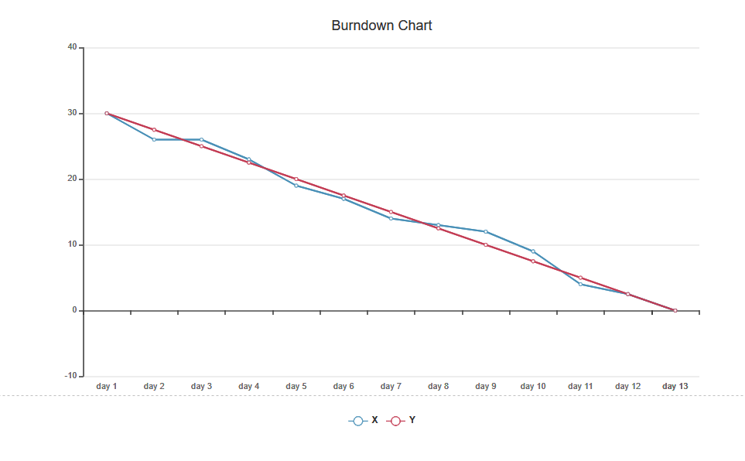

Spring**1 above

Y as Story points of Sprint No.1 == 30 task points