|  |  |  |  |  |
| --- | --- | --- | --- | --- |
| Online | | | | |
|  |  | | |  |
| buy ticket  Project Link: https://github.com/JotunMichael/PHP | | | | |
|  | | CINEMA APP |  | |

TABLE OF CONTENTS

agenda 4

1. Brief 4

2. Description Scope 5

3. Financial Scope 6

4. Focused on Delivery 6

5. Project Execution 8

6. Technologic Approach 9

1. DESIGN 10

1.1. PERSONA 10

1.2. Requirement Analysis (non/functional) 11

1.3. UML Representation Analysis 14

1.4. Use Case 18

1.5. Class Diagrams 19

1.6. State Machine/State Chart Diagram 20

1.7. ER Diagram 21

1.8. Storyboards & Wireframes (low fidelity) 22

1.9. User Flows 29

1.10. Web Site Map Design & Planning 30

1.11. Heat Map/Mockup 32

2. Project Management 33

2.1. Task/Time Schedule PERT 33

2.2. Work Breakdown Structure (WBS) 34

2.3. Sprint Canvas 35

2.4. Scrum Cabinet Reports 36

2.5. Project Participants 36

2.5.1. Stakeholder List 36

2.5.2. Product Owner 37

2.5.3. Scrum Master 38

2.5.4. Scrum Team Members 38

2.6. Project Initiation 40

2.6.1. Project Vision 40

2.6.2. Project Charter 40

2.6.3. Use Case Diagram 41

2.6.4. Prioritized Use Cases 41

2.6.5. Epics 44

2.6.6. Product Backlog - Features 48

2.7. Sprint Planning Meeting Agenda 55

2.7.4. Sprint Planning Meeting Minutes 56

2.7.5. Sprint Backlog 58

2.7.6. Sprint Deliverables 61

2.8. Burnout Chart/Line 62

# agenda

## Brief

**CINESOCIAL – Product Design (UI/UX back-end) Project**

* Project Name:
  + CINESOCIAL
* Project Description:
  + A client whishes to develop and test a platform to enable online ticket booking system for cinemas, to host their own content on their own domain.
* Who is this for?
  + Everyone – this product is for everyone who wishes to learn about cinema or just entertain him/herself by buying premiere tickets to watch fast on demand movies.
* Feature List (product requirements)
  + Easy onboarding
  + Example | Pricing | login | Sign up
  + No monthly fees
  + Personalization screen
  + Ticket booking
  + Friend System like social media
* Competitors & Product Inspiration
  + IMDb
  + Gamato
* Deliverables
  + Wireframes for client approval
  + High fidelity prototype of the product
  + User Testing
  + Usability Report
  + UI Assets for developers
* Cost
  + $4000 total with $93 p/hour for any additional work outside the brief
  + 50% payment required to begin work
* Timeline/Deadline
  + The duration is described below as subtasks

## Description Scope

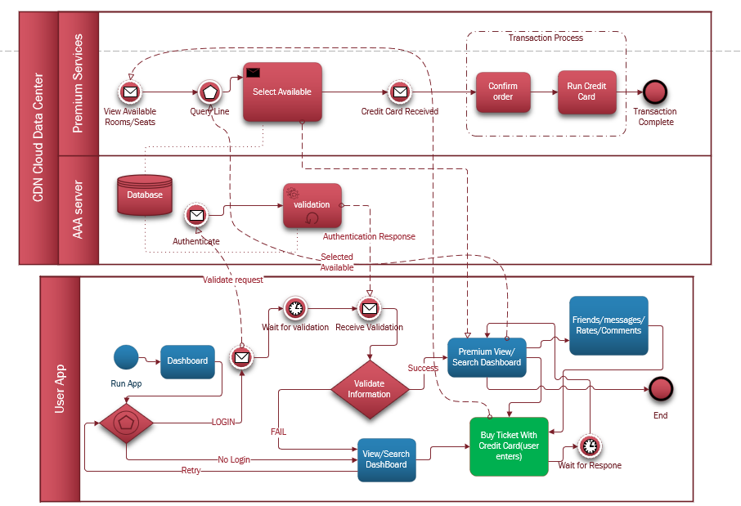

BPMN 2.0 Visual Process Representation of Description Below(**activity-like**)

The purpose of this document is to provide valid information for its members including Low level Design and High-Level design in a concise application of the Business Cinema Content application.

The application will consist of front & back-end interfaces functionality. It will allow the guest user to see list cast actors, premiere trailers, opening hours, days and rooms by making online reservations on-click but will have VIP registered users who can make rating, comments, to have followers, e.g., similar features of a social media limited mode & cinema interactive. The application will be a subset of an information system that will interact with users and other database systems.

## Financial Scope

The project will observe deadlines, Budget, vision of stakeholders.

* Investment decision
* Working Capital decision
* Financing decision
* Dividend decision
* Ensures liquidity
* Profit management

## Focused on Delivery

**Subtasks/activities.**

1) Requirements analysis

2) Database design

3) Interface design

4) Database development and data entry

5) Interface development

6) System completion

7) Application installation and control (integration)

8) Training and acceptance/support

**The duration of the subprojects is analyzed below:**

subtask 1: 1 month/s (sprints)

subtask 2: 1 month/s (sprints)

subtask 3: 0,5 month/s (sprints)

subtask 4: 3 month/s (sprints)

subtask 5: 2 month/s (sprints)

subtask 6: 1 month/s (sprints)

subtask 7: 1 month/s (sprints)

subtask 8: 0,5 month/s (sprints)

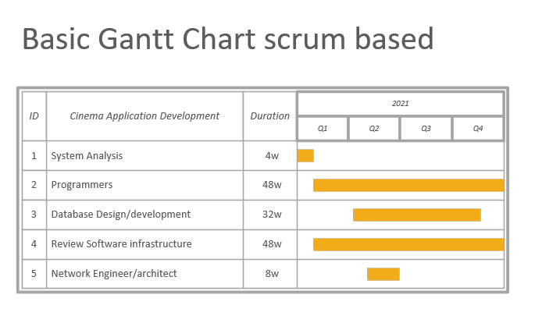

Estimated final plan

## Project Execution

Approaches available: procedural/waterfall, agile, Dev ops

A base of staff specialization and available infrastructure is selected agile scrum team approach. The main course recording and management will become a means of collaboration & agile platform JIRA with tracking and problem recording system/tickets source & version control DVCS GIT.

**Product BACKLOG**

Below is an initial estimate which will change dynamically (updated / passage of time) with more information as the priorities will change as well as the requirements of the project may change.

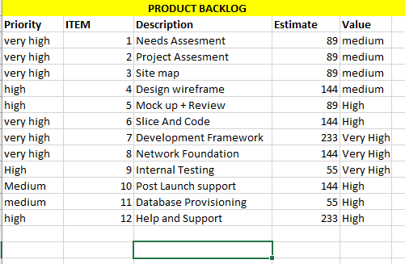

*from the above section Agenda everything is abstracted including the Gantt and Product backlog these are not in any means any close to actual requirements but a close generalized estimate of what to be expected. Latter will be introduced actual implementations in this document.

## Technologic Approach

The application will be Cross platform & web based

1. Web tech & frameworks: PHP Laravel backend(future) + AngularJS(front-end).
2. Database System: MySQL
3. Cross-Platform Solution: React Native(future)
4. Third-Party libraries:
   * + - 1. Chart JS
         2. DataTables
         3. Datetimepicker
         4. PHPMailer
         5. OwlCarousel
         6. Starrr(rates)
         7. Sweet alert
         8. Font-awesome
         9. BootStrap 5
         10. Doctrine

The site will be a mix of Facebook + Netflix social network. The corresponding progress will be on GitHub: <https://github.com/JotunMichael/PHP>

**This documentation will be changing to keep up with the updates

# DESIGN

## PERSONA

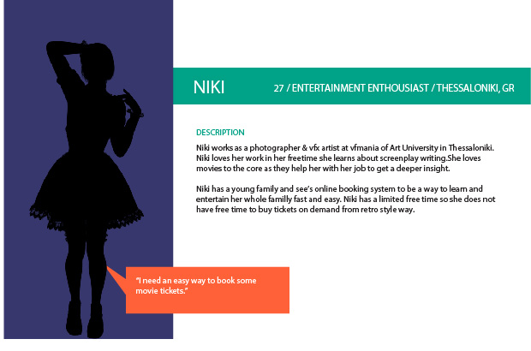

The project will expand as what NIKI wants.

## Requirement Analysis (non/functional)

**indicative specification functional requirements**

**Function Name:** Account login

**Description**: User admin login portals

**INPUTS**: Front-end portal authenticated in back-end.

**System behavior**: The system takes Data comparing each unique user individually based on their input fields.

**OUTPUT**: logged in profiles on site.

**Function Name:** Feedback

**Description**: Experiences and complaints comments.

**INPUTS**: Hand written from the user.

**System behavior**: The system takes complaints, notes or anything related from a textfield and sends it in the Database for further logging.

**OUTPUT**: Admin access logging.

**Function Name:** Scheduled events

**Description**: Available on Season to watch movies.

**INPUTS**: No user inputs just most recommended and demanded movies on cycle.

**PROCESS**: The system represents top watched movies along time and categorizes them on cycle based.

**OUTPUT**: Front-end on-site results.

**Function Name:** Ticket Booking

**Description**: User buys tickets admin handles them based on available Seats.

**INPUTS**: From Front-end source data buying tickets bound to or not to an account.

**PROCESS**: The app checks if a user is logged in or not and keeps buy ticket record accordingly by sending them in the Database storage. The admin is able to setup Theatre, add movies and arrange seats. Accept or deny tickets already bought from customer. The Data stored in Database with requests/fetch Data is being displayed accordingly to panels layout.

**OUTPUT**: Reserved tickets are being fetched from database and been displayed in admin portal for further support/management.

**Function Name:** Movie setup

**Description**: Add on the fly new on demands movies.

**INPUTS**: Front-end page admin account.

**PROCESS**: The system is capable of capturing demanding movies from admin page and inserts them into the database. Real time update with front end users to see.

**OUTPUT**: Front-end User pages.

**Function Name:** Movies Info

**Description**: Information and news about a movie.

**INPUTS**: from admin database

**PROCESS**: This system behaviour accepts inputs from admin and shows information accordingly about information, casting, trailers.

**OUTPUT**: Front-end result page

**indicative specification non-functional requirements**

**Function Name:** Portal differences on login

**Function Name:** Fast and responsive Database logging system

**Function Name:** Realtime updates

**Function Name:** ssl(https), pki connections

**Function Name:** Portal differences on login

**Function Name:** Load balancing network server offload

**Function Name:** Data center private cloud setup

**Function Name:** Esxi Vmotion enabled

**Function Name:** CIA (Confidentiality, integrity and availability) triad

## 1.3. UML Representation Analysis

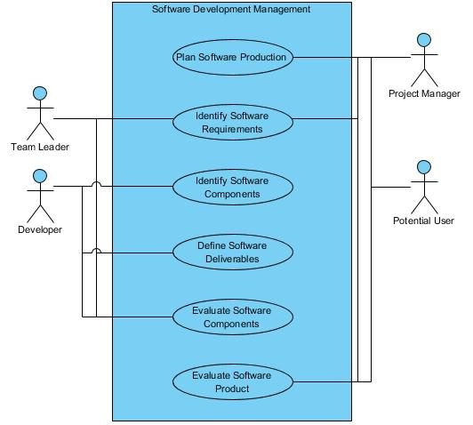

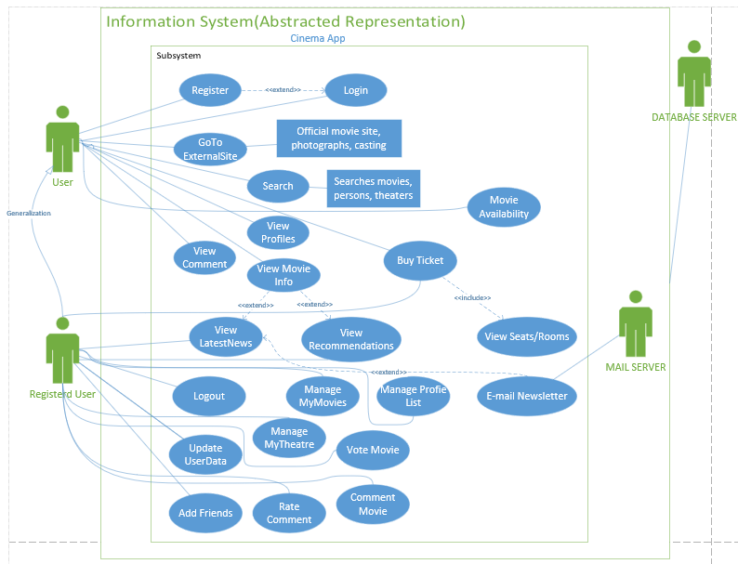

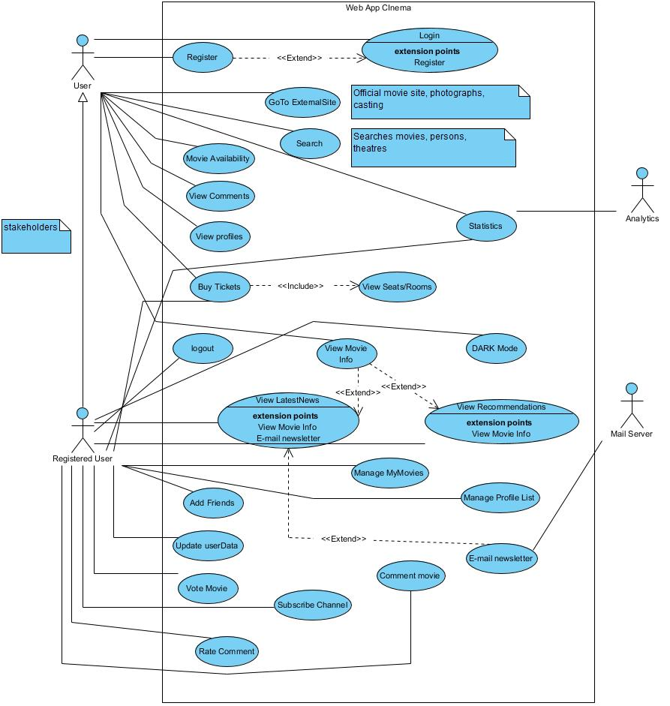

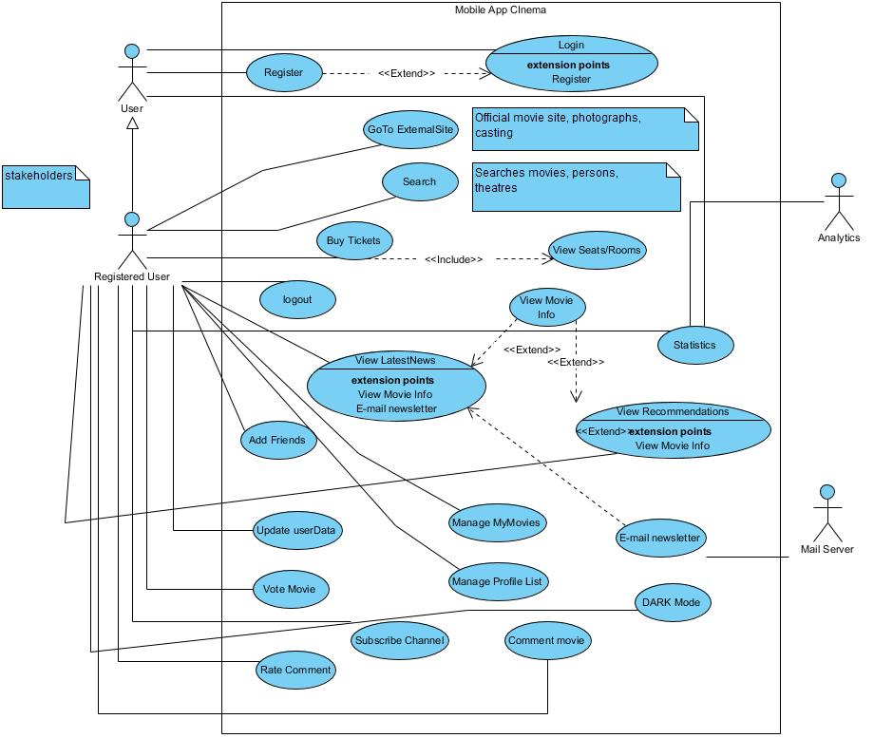

**Theme MODE included DARK/LIGHT

## 1.4. Use Case

**Use Case**: Login portal

**Main user**: admin, user

**Short Description**: User or admin enter credentials and gets checked against database queries. The inputs fields apply security rules.

**Conditions:** only registered users can use the system with Premium Services.

**Exit status**: Successful Cinema Booking system for users.

**Main Flow**:

1. User registers
2. System checks input integrity [Alternative Flow A]
3. User Logins
4. System Checks input integrity [Alternative Flow B]
5. Enjoy movies

**Alternative flows**

Alternative flow A: Field checking

If not valid input check jumps on Step 1

Alternative flow B: Field checking

If not valid input check jumps on Step 3

## 1.5. Class Diagrams

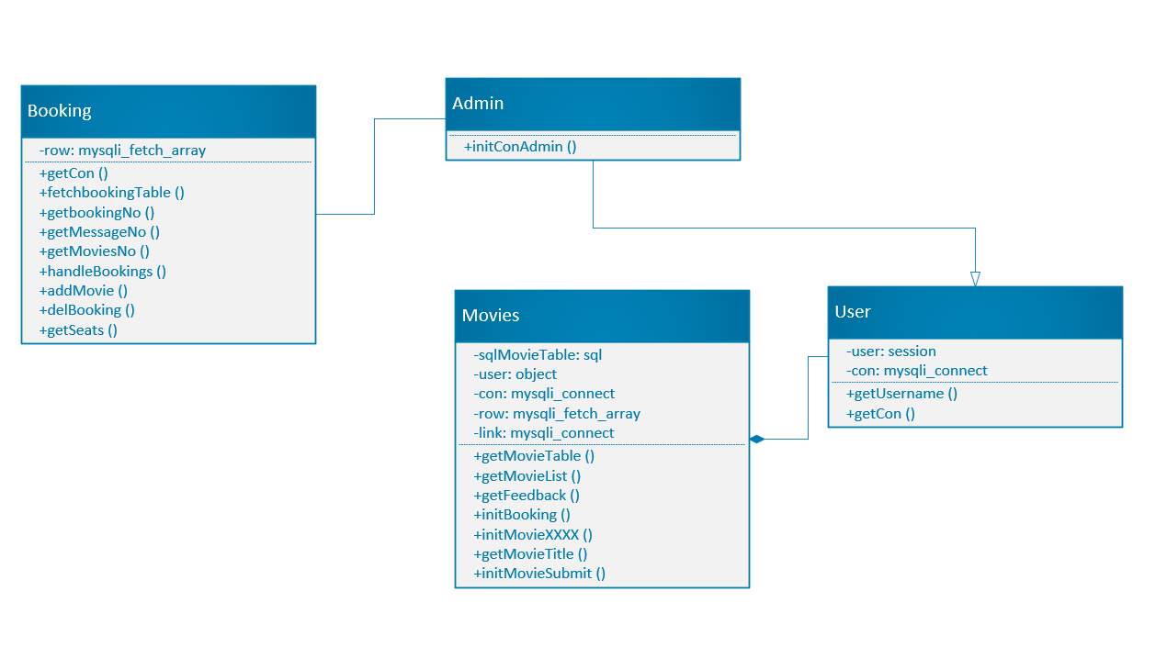

*upschedule redesign

## 1.6. State Machine/State Chart Diagram

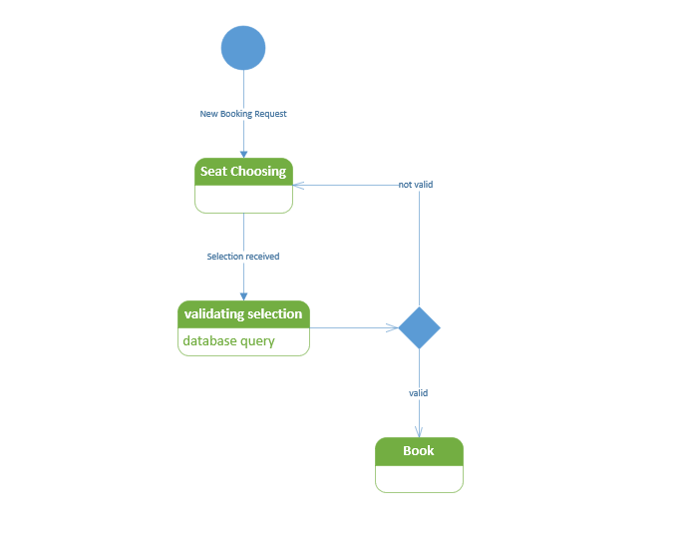

## 1.7. ER Diagram

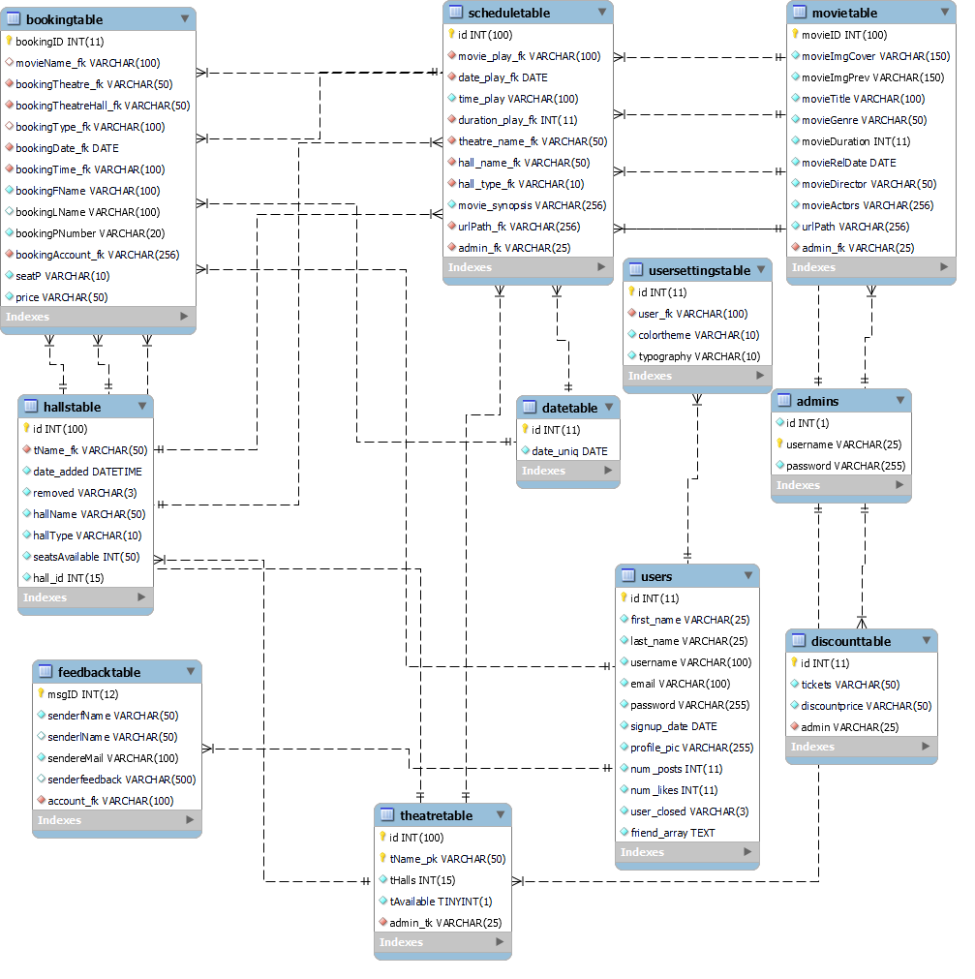

*upschedule redesign

## 1.8. Storyboards & Wireframes (low fidelity)

WEB UI (now implemented **is going to be changed the UI soon)

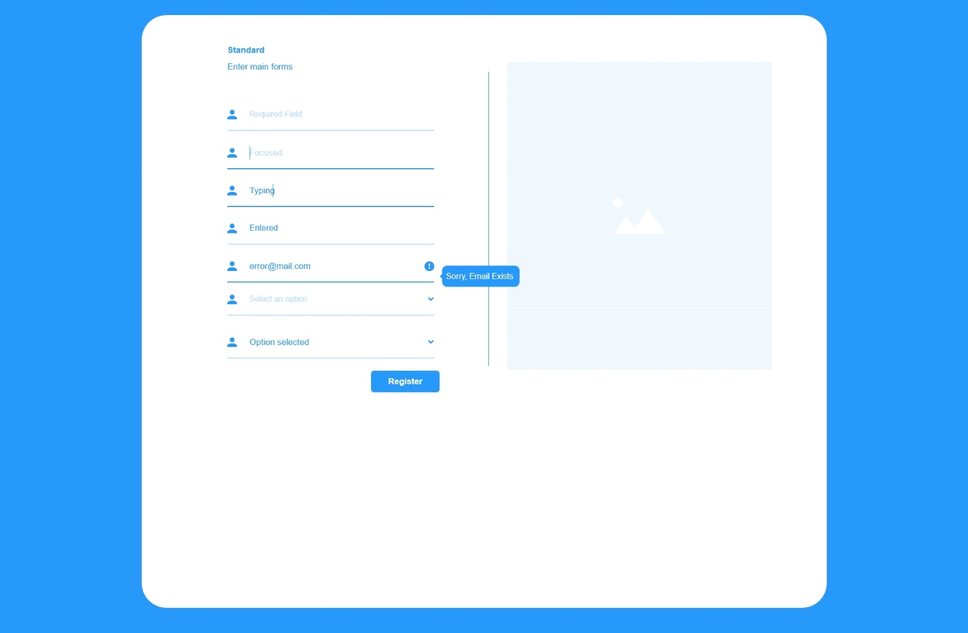

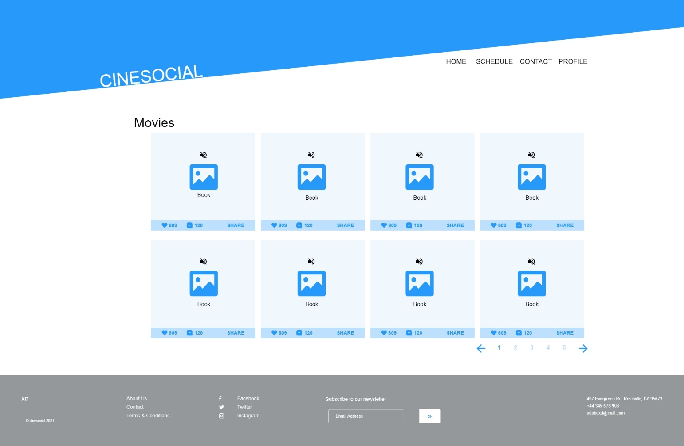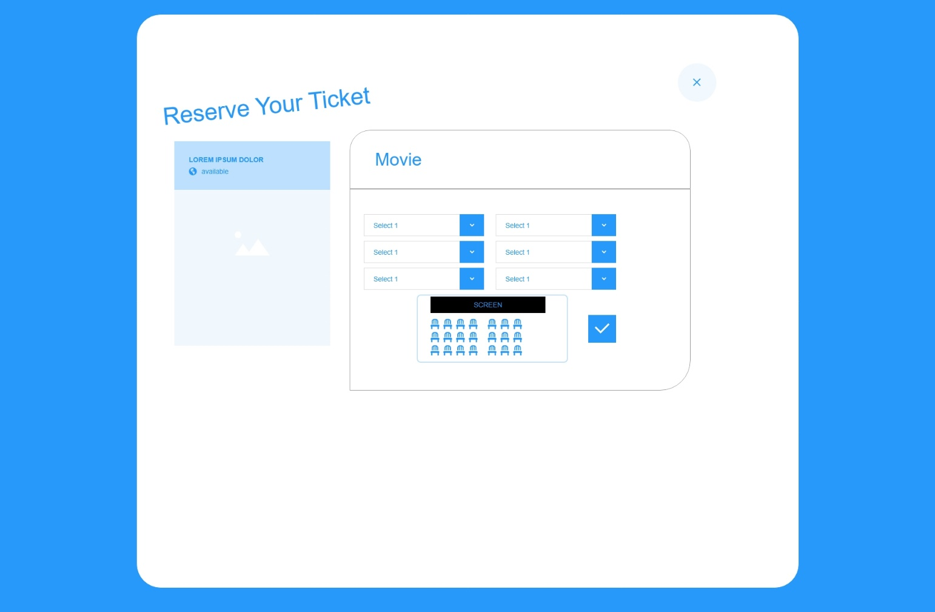

MOBILE UI

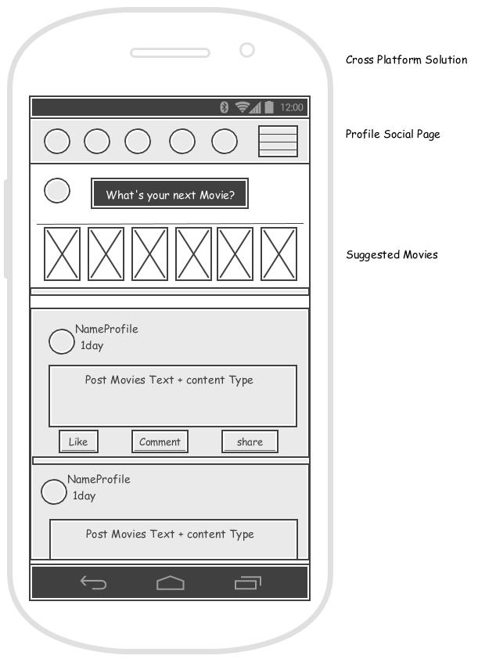

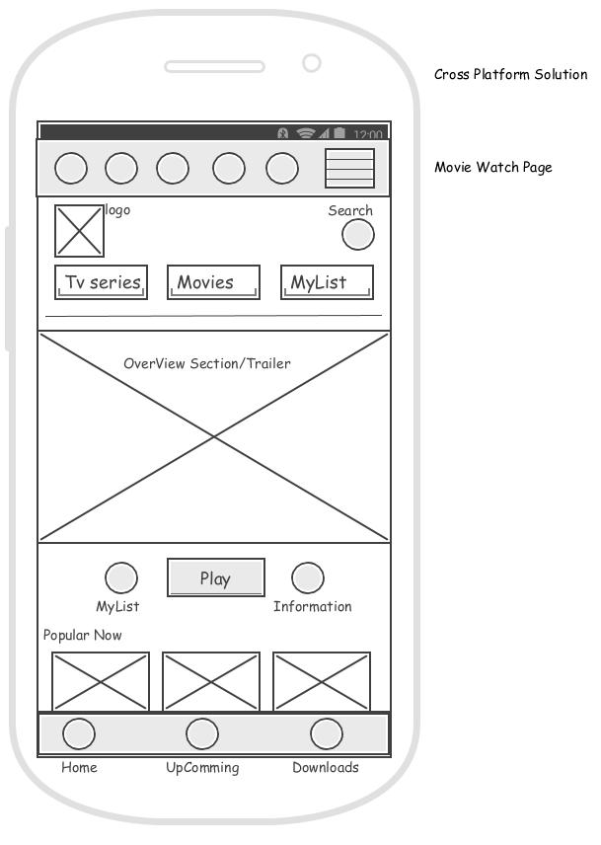

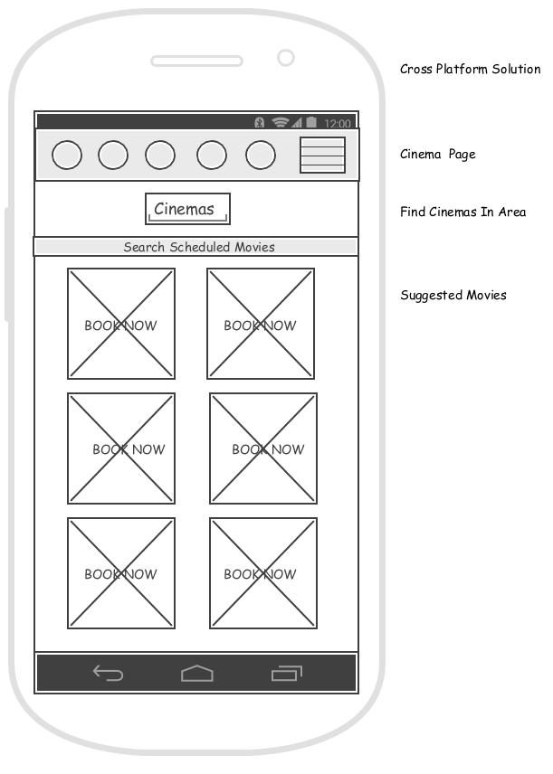

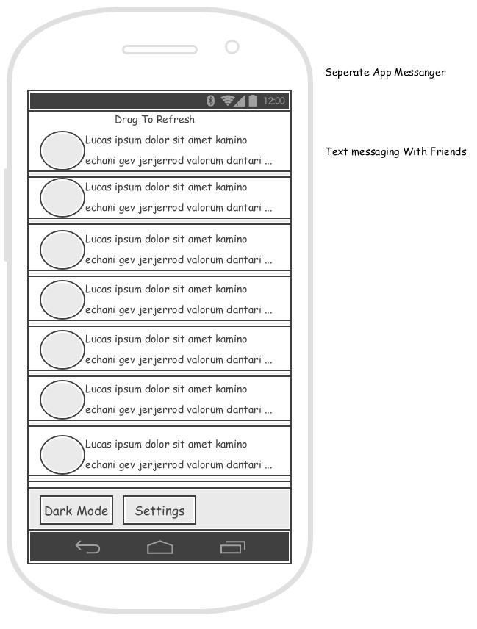

## 1.9. User Flows

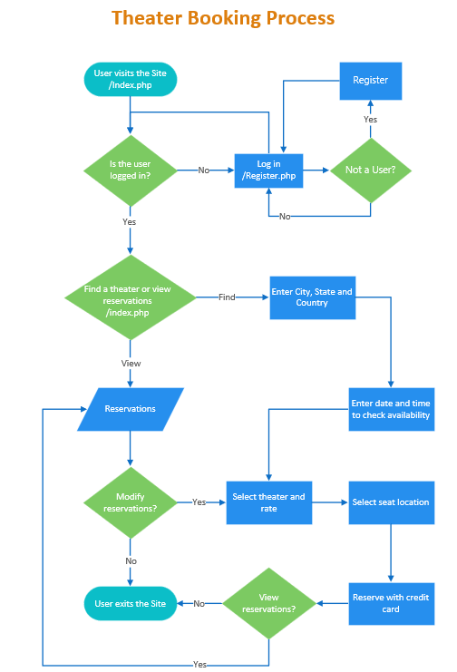

## 1.10. Web Site Map Design & Planning

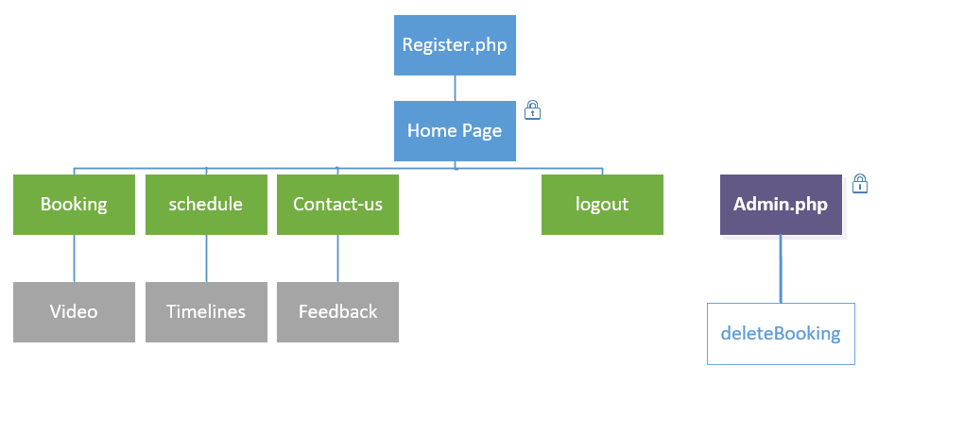

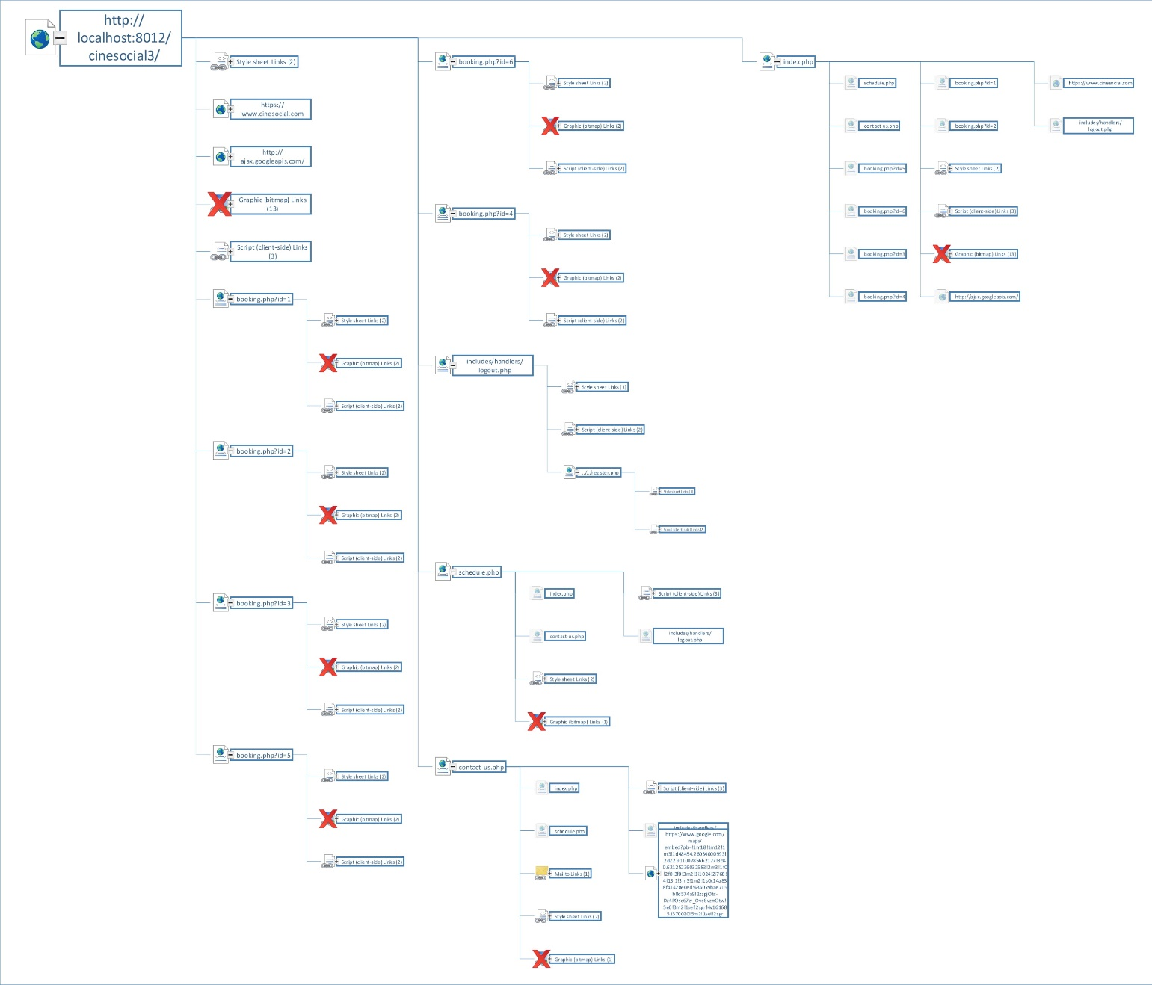

## 1.11. Heat Map/Mockup

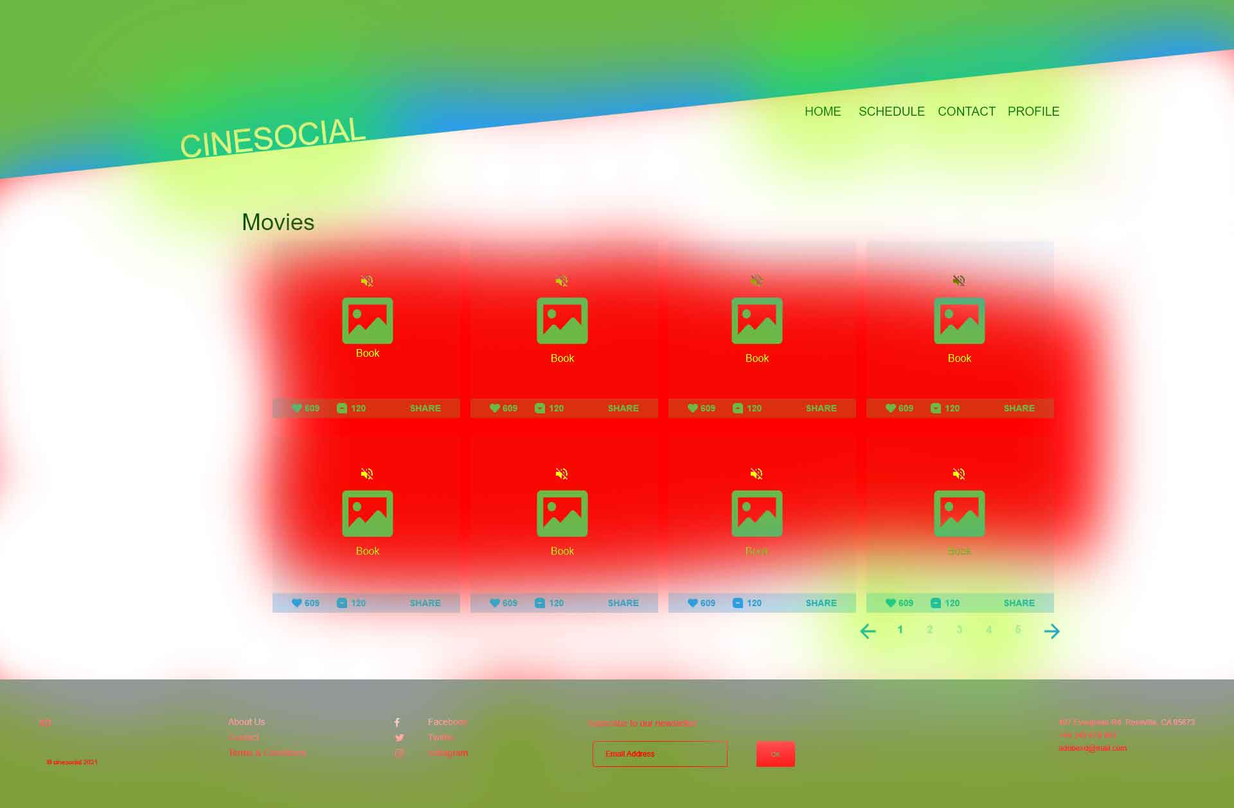

Various testing and design patterns should be deployed for measure user accesibility and preference.

Bounce Rate, Sex, Age, Device, Interests, A/B Testing + real case users though Analytics

# Project Management

## 2.1. Task/Time Schedule PERT

Upcoming features

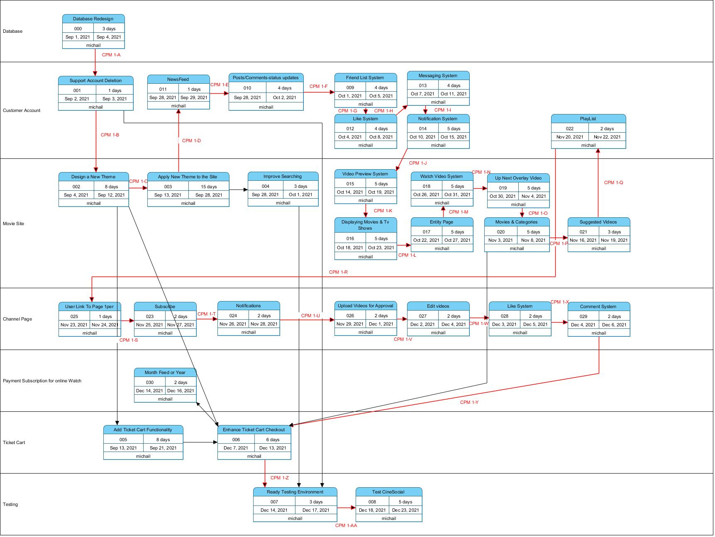

Critical path method in red lines (CPM)

## 2.2. Work Breakdown Structure (WBS)

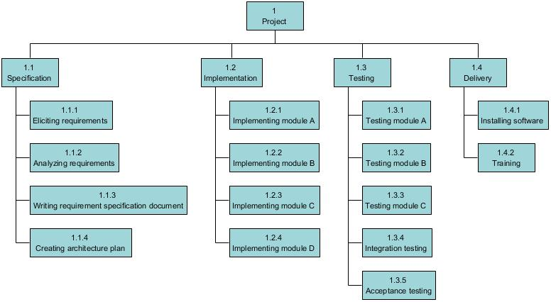

## 2.3. Sprint Canvas

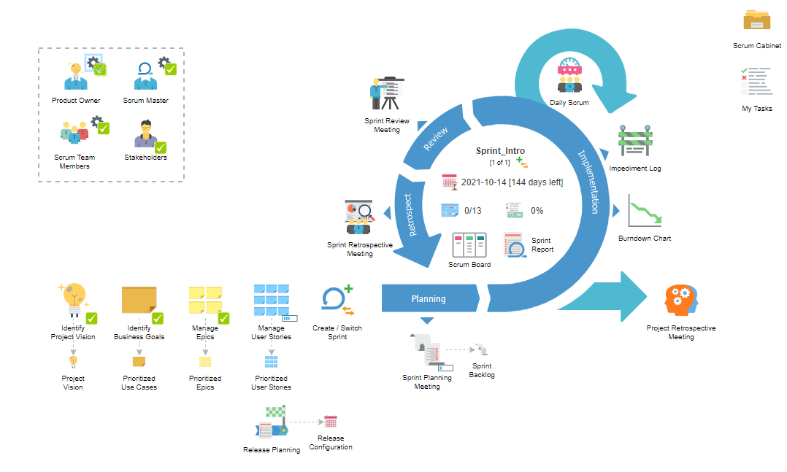

## 2.4. Scrum Cabinet Reports

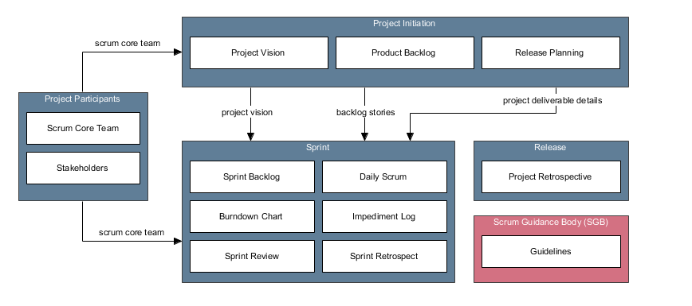

## 2.5. Project Participants

2.5.1. Stakeholder List

| Name | Role | Responsibilities | Contact | Notes |
| --- | --- | --- | --- | --- |
| Michail Markou | Sponsor, Customer, User | Manages the project final output and vision | backtrackpower@gmail.com |  |
| Sylvi Markou | Customer, User | Reflects opinion about usability | sylvimarkou@hotmail.com |  |
| Miontragk Markou | User | Approves the UI additions | miodragmarkou@hotmail.com |  |

2.5.2. Product Owner

| Member | Michail Markou |
| --- | --- |
| Responsibilities | * Defines the project vision * Helps create the Project Charter * Identifies project stakeholders * Helps determine scrum team members * Create epics * Create, define and prioritize user stories * Create Release Plan and Keep it Updated * Approve user stories * Explains user stories and clarifies requirements to scrum team in sprint planning meeting * Provides guidance and clarification in estimating effort for tasks * Grooms prioritized backlog * Accept/reject deliverables * Provide feedback to scrum master and scrum teams * Help deploy product releases and coordinates this with the customer * Participate in print retrospective meeting |
| Notes |  |

2.5.3. Scrum Master

| Member | Michail Markou |
| --- | --- |
| Responsibilities | * Helps identify project stakeholders * Facilitates the formation of scrum team * Facilitates the creation of epics * Helps product owner in creating and maintain product backlog * Coordinates the creation of Release Plan * Assists in creating and defining user stories * Facilitates meetings * Facilitates the scrum team in creating tasks for the next sprint * Facilitates the scrum team in effort estimation * Supports the scrum team in creating deliverables * Helps maintain the impediment log * Ensures that issues affecting the development are discovered and resolved |
| Notes |  |

2.5.4. Scrum Team Members

| Member | Responsibilities | Notes |
| --- | --- | --- |
| Michail Markou | * Ensures a clear understanding of epics and user stories * Agrees with the other team members on sprint length * Seeks clarification on new updates in requirements * Provides inputs to the product owner in defining and estimating user stories * Commits user stories to be done in a sprint * Provides inputs in creating and estimate tasks * Develops the product, service or other results * Identifies the risk and implements risk mitigation actions, if required * Provides inputs to update the impediment log * Discusses progress and issues in daily scrum meeting * Demonstrates completed deliverables in sprint review * Suggests improvement opportunities in sprint retrospective meeting * Participates in the project retrospective meeting |  |

## 2.6. Project Initiation

2.6.1. Project Vision

For consumers who prefer cinema entertainment. CineSocial is an online cinema find booking system and a clone of

Facebook and Netflix will bring all together.

Unlike the other competitors, our system can run on both web browsers and cross-platform

2.6.2. Project Charter

2.6.2.1. Project Vision

For consumers who prefer cinema entertainment. CineSocial is an online cinema find booking system and a clone of

Facebook and Netflix will bring all together.

Unlike the other competitors, our system can run on both web browsers and cross-platform mobile solution.

2.6.2.2. Project Mission

Facilitate ticket booking and social networking and online watch cinema, bring all together via cross-multi platform solution. Keep everyone together with Messanger App included.

2.6.2.3. Project Success Criteria

* The App has a high number of downloads on Google Play and App store
* The App has ratings of 4-5 stars on Google Play and App Store and more than 10 positive reviews on each platform
* The number of CineSocial customers grew by 10%

2.6.3. Use Case Diagram



2.6.4. Prioritized Use Cases

| Name | Description | Priority | Size | Complexity |
| --- | --- | --- | --- | --- |
| Manage Profile List | perfrom profile changes like picture change | Should | Small | Low |
| Login | Access premium services | Must | Medium | Low |
| GoTo ExternalSite | Look extra information sources | Could | Very Small | Low |
| View LatestNews | Top NewsFeeds of movie | Should | Medium | Medium |
| Add Friends | perform add requests | Must | Large | Medium |
| Buy Tickets | do reservations of ticket to nearby cinemas | Must | Large | High |
| View Comments | Look user comments | Should | Medium | Medium |
| Movie Availability | Perform lookup of available movies | Must | Large | High |
| View Seats/Rooms | View available seats | Must | Large | High |
| Search | perform Live Search to Services | Should | Medium | Medium |
| View Recommendations | Based on your movie/tv series most watch categories | Should | Large | Medium |
| View Movie Info | Movie information of the section | Should | Small | Low |
| View profiles | For register users only | Must | Medium | Low |
| Comment movie | Registered users Only | Should | Medium | Medium |
| E-mail newsletter | For Registered users only. News about updates of site changes and Services.(movies included) | Should | Large | Medium |
| Rate Comment | Registered users only | Should | Small | Low |
| DARK Mode | For the Night Owls | Must | Very Small | Low |
| Register | Authentication System | Must | Large | Medium |
| Update userData | CRUD operations on user information | Must | Small | Low |
| Subscribe Channel | to Channel Pages 1 user can have 1 page and upload movies after getting verified by the organization CineSocial like netflix + youtube approach more fluent | Should | Medium | Medium |
| Vote Movie | Vote for movie if its bad or good | Should | Medium | Low |
| logout | Logout registered user from services | Must | Very Small | Low |
| Manage MyMovies | MyList of movies/tv series | Should | Medium | Medium |
| Statistics | Gather User Statistics Bounce Rate mobile Devices, Region etc | Could | Medium | Medium |

2.6.5. Epics

| Name | Description | Parent Use Case | Priority | Risk |
| --- | --- | --- | --- | --- |
| Change profile picture and interests | User can change status information and profile pictures | Manage Profile List | Should | Low |
| Send Request to people | user can send friend requests to other persons so they will keep with him for life updates and events | Add Friends | Must | Medium |
| Link to external sources | User can visit external information from creators of the series/movie | GoTo ExternalSite | Could | Low |
| From specified RDBMS | User depending on platform he is logging in must enter the Business Services that he | Login | Must | Low |
| Read movie information | Read more information about the movie on current page | View Movie Info | Should | Low |
| Search Cinemas | Nearby cinemas that have scheduled this movie | Search | Must | Medium |
| Search Movies/TV series | Search for scheduled or on demand movies/TV series | Search | Should | Medium |
| While buying tickets show availability of seats | Show available free seats where they are located and which of those are reserved | View Seats/Rooms | Must | High |
| Change email password or username | change credentials | Update userData | Must | Low |
| to RDMBS | insert database entry of the user | Register | Must | Medium |
| Rate up or thumbsdown a movie | Rate how good was a movie you saw | Vote Movie | Should | Medium |
| Based on other top rated from users to your most viewed category | User can see recommendations based his/her favorite categories | View Recommendations | Must | High |
| Register to Newsfeed email server | user can be notified for any new movies/series via email or and push notifications | E-mail newsletter | Could | Medium |
| Registered users search Users profile from RDMS | Registered User can see other profiles without friend request been accepted but with limitations of privacy | View profiles | Must | High |
| General Epic |  |  |  |  |
| Color themes | change color theme | DARK Mode | Must | Low |
| View Existing comments but not deleted | view comments that has been made and exists | View Comments | Should | Medium |
| registered user | user can comment movies | Comment movie | Must | Medium |
| Register user voting for most anticipated coment | user can vote up or down a comment | Rate Comment | Could | Low |
| Registered user follow a channel | user can see his favorite Crew release movies and stay up-to-date with them | Subscribe Channel | Should | Medium |
| exit from services on web or mobile | logout service | logout | Must | Low |
| Scheduled from Admin panel | Admin schedules movies to be played on cinema AND online | Movie Availability | Must | High |
| site updates | User can be notified for any site changes | View LatestNews | Could | Low |
| Movies on Demand and casting | information about movies and actors | View LatestNews | Should | Low |
| Pay while in cinema place | User can pay in front the ticket | Buy Tickets | Must | Medium |
| Add to shopping card | user can pay online for ticket | Buy Tickets | Must | Medium |
| Create List of favorites or to watch later MOVIES/TV series | Favorite List or watch later | Manage MyMovies | Should | Medium |
| Gather User Statistics | Gather User Statistics for Usage, Devices, Bounce Rate, country, browsers etc | Statistics | Could | Medium |
|  |  |  |  |  |

2.6.6. Product Backlog - Features

2.6.6.1. User Story Map

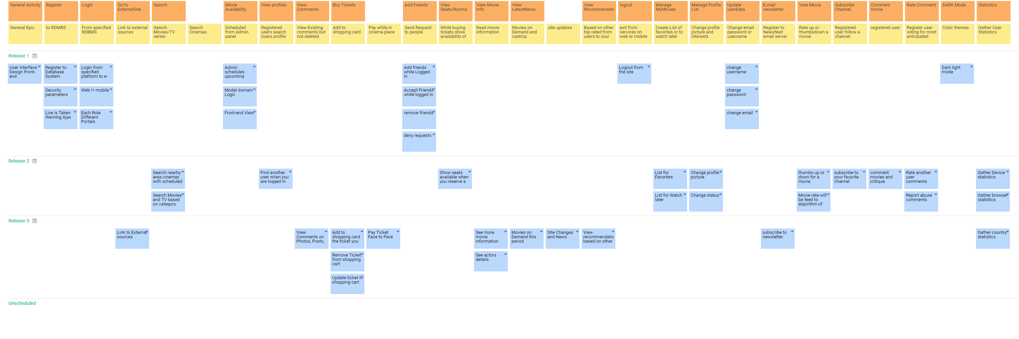

2.6.6.2. Prioritized User Stories - FEATURES of the App

| Name | Description | Epic | Status | Story Points | Priority | Risk |
| --- | --- | --- | --- | --- | --- | --- |
| Search nearby area cinemas with scheduled movies | As a user, I want to find available cinemas nearby of this scheduled movie so that I will enjoy it watching it with my friends | Search Movies/TV series | Approved | 5 | Must | High |
| Admin schedules upcoming Movies for Cinemas | As an Admin, I want to schedule movies for my customers/users so that popularity increases | Scheduled from Admin panel | Approved | 3 | Must | Medium |
| Find another user when you are logged in | As a User, I Wan to be socialized so that I will be famous | Registered users search Users profile from RDMS | Approved | 2 | Must | Low |
| View Comments on Photos, Posts, Videos | As a User, I want to entertain my self with other status updates so that I will know things in the community | View Existing comments but not deleted | Approved | 2 | Should | Low |
| Add to shopping card the ticket you reserved | As a User, I want to have an easy way on buying stuff so that everything will be organized | Add to shopping card | Approved | 3 | Should | Medium |
| Pay Ticket Face to Face | As a Site-Visitor or User, I want to be able to pay in front the check if no money on card is available. | Pay while in cinema place | Approved | 1 | Must | Low |
| Add friends while Logged in | As a User, I want to add people that I know in my Contact list for an easy chatting | Send Request to people | Approved | 2 | Must | Medium |
| Show seats available when you reserve a ticket | As a User/Site-Visitor, I want to know where are seat positions and which of them are available. | While buying tickets show availability of seats | Approved | 3 | Must | Medium |
| See more movie information based on what you choose | As a User/Site-Visitor, I want to know more details about each movie so that I will be informed technically. | Read movie information | Approved | 5 | Could | Low |
| Movies on Demand this period | As a User/Site-Visitor, I want to watch Top most demand movies/TV series every period. | Movies on Demand and casting | Approved | 5 | Should | Medium |
| Site Changes and News | As a User, I want to know every single site improvement. | site updates | Approved | 3 | Could | Low |
| View recommendation based on other users and your preference | As a User, I want to have an easy way to find best Movies/TV based on my vanilla flavor | Based on other top rated from users to your most viewed category | Approved | 5 | Should | Medium |
| Logout from the site | As a User, I want be able to exit from services | exit from services on web or mobile | Approved | 1 | Must | Low |
| List for Watch later | As a User, I want to have a watch later list | Create List of favorites or to watch later MOVIES/TV series | Approved | 3 | Should | Medium |
| Change profile picture | As a User, I want to change my Username so that I would be happy again | Change profile picture and interests | Approved | 2 | Should | Low |
| Change status | As a User, I want to change my Status | Change profile picture and interests | Approved | 1 | Should | Low |
| List for Favorites | As a User, I want to change my Username so that I would be happy again | Create List of favorites or to watch later MOVIES/TV series | Approved | 2 | Should | Medium |
| change username | As a User, I want to change my Username so that I would be happy again | Change email password or username | Approved | 1 | Should | Low |
| change password | As a User, I want to change my password regularly so that my account will not be compromised or any security leaks. | Change email password or username | Approved | 1 | Should | Low |
| change email | As a User, I will like to have the ability to change an e-mail address just in case. | Change email password or username | Approved | 1 | Should | Low |
| subscribe to newsletter | As a User, I want to Keep up with updates in my push or email notification List | Register to Newsfeed email server | Approved | 3 | Could | Medium |
| thumbs up or down for a movie | As a User, I want to Rate a movie so that other to know before watch | Rate up or thumbsdown a movie | Approved | 3 | Should | Medium |
| Movie rate will be feed to algorithm of recommendations | As a Customer, I want to change an easy way of recommending movies/TV if they are good | Rate up or thumbsdown a movie | Approved | 8 | Should | High |
| subscribe to your favorite channel | As a User, I want to change my Username so that I would be happy again | Registered user follow a channel | Approved | 3 | Should | Medium |
| comment movies and critique | As a User, I want to comment and leave a critique if a movie/TV was good | registered user | Approved | 3 | Should | Medium |
| Dark light mode | As a User, I want to allow my eyes to rest or see better on dark areas with different Color theme modes so that I would be happy with my eyes | Color themes | Approved | 1 | Must | Low |
| Rate another user comments | As a User/Customer, I want to distinct most anticipated comments so that others will see | Register user voting for most anticipated coment | Approved | 3 | Should | Medium |
| Report abuse comments | As a Customer/User/Site-Visitor, I want to have abuse FREE site sections because this is inappropriate for my eyes or any children lurking around | Register user voting for most anticipated coment | Approved | 3 | Must | Medium |
| Gather Device statistics | As a Customer, I want to know if my business going well | Gather User Statistics | Approved | 2 | Should | Low |
| Gather browser statistics | As a Customer, I want to know if my business going well | Gather User Statistics | Approved | 2 | Should | Low |
| Gather country statistics | As a Customer, I want to know if my business going well | Gather User Statistics | Approved | 2 | Should | Low |
| User Interface Design Front-end | As a Customer, I want to have a nice representation of Site so more people approach it or recommend it. | General Epic | Approved | 8 | Must | Low |
| Login from specified platform to e-Services | As a Programmer, I want to have distinct separation of portals that a customer/User logs in | From specified RDBMS | Approved | 2 | Must | Low |
| Link to External sources | As a User/Site-Visitor, I want to Have access to third party links for reviews or the creators of movies | Link to external sources | Approved | 1 | Could | Low |
| Search Movies and TV based on category | As a User/Site-Visitor, I want to Search for my Movies/TV's if I don't remember something about it. | Search Movies/TV series | Approved | 3 | Should | Medium |
| Register to Database System | As a Programmer, I want to have an organized status of Users for easy management and Today top tech solutions | to RDMBS | Approved | 1 | Must | Low |
| Security parameters | As a Programmer, I want to have sanity and security checks for Secure and happy clients. | to RDMBS | Approved | 1 | Must | Low |
| Live is Taken Warning Ajax | As a Programmer, I want to show to the User a message before he submits and not lose Precious time. | to RDMBS | Approved | 1 | Could | Low |
| Web != mobile | As a programmer, I want to have distinct portal logins based on device that a customer/User logs in | From specified RDBMS | Approved | 1 | Must | Low |
| Each Role Different Portals | As a programmer, I want to make distinct portal logins for clear and easy separations and future improvement of code. | From specified RDBMS | Approved | 1 | Must | Low |
| Model domain Logic | As an Admin, I want to have an easy way of organizing movies/shows/TV's | Scheduled from Admin panel | Approved | 3 | Must | Medium |
| Front-end View | As an Admin, I want to keep Live updated my Landing Page for any new Show/Movie | Scheduled from Admin panel | Approved | 2 | Must | Medium |
| Accept Friends while logged in | As a User, I want to Accept my Contacts. | Send Request to people | Approved | 2 | Must | Medium |
| remove friends | As a User, I want to be able to remove friends from list for personal reasons. | Send Request to people | Approved | 3 | Must | Medium |
| deny requests | As a User, I want to deny Friend requests that I don't know from unknown people | Send Request to people | Approved | 3 | Must | Medium |
| See actors details | As a User/Site-Visitor, I want to know more about casting and actors of each movie. | Read movie information | Approved | 1 | Could | Low |
| Remove Ticket from shopping cart | As a User, I want to Cancel a ticket if I accidentally or for some other reasons add it to List. | Add to shopping card | Approved | 3 | Should | Low |
| Update ticket in shopping cart | As a User, I want to Change a ticket if I changed my mind. | Add to shopping card | Approved | 3 | Should | Low |

## 2.7. Sprint Planning Meeting Agenda

2.7.1. Sprint Planning Meeting Agenda

| Date | 2021-08-01 |
| --- | --- |
| Time | 09:00 |
| Location | Teams |
| Prepared by | Michail |
| Attendees | Michail |

2.7.2. Agenda Topics

| Topic | Presenter | Time Allotted |
| --- | --- | --- |
| Project Initiation and Vision of Business | Michail | 10 mins |
| Select user stories to support in this sprint | Michail | 20 mins |
| Identify tasks involved | Michail | 30 mins |
| Identify sprint deliverable | Michail | 5 mins |

2.7.3. Other Information

| Observers | sylvi, miontragk |
| --- | --- |
| Resources | Internet, Teams |
| Special Notes | Just Keep Watching! |

2.7.4. Sprint Planning Meeting Minutes

| Date | 2021-08-01 |
| --- | --- |
| Time | 09:00 |
| Location | Teams |
| Prepared by | Michail |
| Attendees | Michail |

2.7.4.1. Agenda Topics

| Topic | Project Initiation and Vision of Business |
| --- | --- |
| Presenter | Michail |
| Time Allotted | 10 mins |
| Discussion | The Project Vision summary |
| Conclusions | The assignments that we must make |

| Topic | Select user stories to support in this sprint |
| --- | --- |
| Presenter | Michail |
| Time Allotted | 20 mins |
| Discussion | Which user stories we will give priority and what kind of features to implement |
| Conclusions | * 13 User Stories have been selected * Database and UI first |

| Topic | Identify tasks involved |
| --- | --- |
| Presenter | vpuser |
| Time Allotted | 30 mins |
| Discussion | The tasks required to complete the user stories Identified |
| Conclusions | Tasks are created for the user stories selected. |

| Topic | Identify sprint deliverable |
| --- | --- |
| Presenter | Michail |
| Time Allotted | 5 mins |
| Discussion | Concluded the sprint deliverable to be delivered by the end of this sprint. |
| Conclusions | We(I) concluded that be the end of this sprint, the Login and Change credentials for user and Admin scheduling will be working |

2.7.4.2. Other Information

| Observers | sylvi, miontragk |
| --- | --- |
| Resources | Internet, Teams |
| Special Notes | Just Keep Watching! |

2.7.5. Sprint Backlog

| User Story | Description | Epic | Owner | Tasks | Story Points | Priority | Risk |
| --- | --- | --- | --- | --- | --- | --- | --- |
| Model domain Logic | As an Admin, I want to have an easy way of organizing movies/shows/TV's | Scheduled from Admin panel | Michail | Update DB schema, Implement Schedule Movies, Test the function | 3 | Must | Medium |
| Register to Database System | As a Programmer, I want to have an organized status of Users for easy management and Today top tech solutions | to RDMBS | Michail | Update DB schema, Design sign-up screen, Implement the sign-up function, Test the sign-up function | 1 | Must | Low |
| Each Role Different Portals | As a programmer, I want to make distinct portal logins for clear and easy separations and future improvement of code. | From specified RDBMS | Michail | Update DB schema, Design each Role API function, Implement API functions, Test API functions | 1 | Must | Low |
| Admin schedules upcoming Movies for Cinemas | As an Admin, I want to schedule movies for my customers/users so that popularity increases | Scheduled from Admin panel | Michail | Update DB Schema, Design the Admin Portal section, Implement the Admin Schedule Portal section, Test the Admin Schedule portal section | 3 | Must | Medium |
| change password | As a User, I want to change my password regularly so that my account will not be compromised or any security leaks. | Change email password or username | Michail | Sql Update operation query | 1 | Should | Low |
| change username | As a User, I want to change my Username so that I would be happy again | Change email password or username | Michail | Sql Update operation query | 1 | Should | Low |
| change email | As a User, I will like to have the ability to change an e-mail address just in case. | Change email password or username | Michail | Sql Update operation query | 1 | Should | Low |
| Live is Taken Warning Ajax | As a Programmer, I want to show to the User a message before he submits and not lose Precious time. | to RDMBS | Michail | Sql Query for matching | 1 | Could | Low |
| Login from specified platform to e-Services | As a Programmer, I want to have distinct separation of portals that a customer/User logs in | From specified RDBMS | Michail | Same table diff devices | 2 | Must | Low |
| Logout from the site | As a User, I want be able to exit from services | exit from services on web or mobile | Michail | Logout User | 1 | Must | Low |
| Security parameters | As a Programmer, I want to have sanity and security checks for Secure and happy clients. | to RDMBS | Michail | Front end HTML checks, Back end models domain logic | 1 | Must | Low |
| User Interface Design Front-end | As a Customer, I want to have a nice representation of Site so more people approach it or recommend it. | General Epic | Michail | Bootrap 5IT (MDB) | 8 | Must | Low |
| Web != mobile | As a programmer, I want to have distinct portal logins based on device that a customer/User logs in | From specified RDBMS | Michail |  | 1 | Must | Low |

2.7.6. Sprint Deliverables

| Deliverable | Description | Owner | Associated User Stories |
| --- | --- | --- | --- |
| Basic check-out feature | The check-out feature is done with the following function ready:  - Security Checks while the below  - Register  - Login | Michail | Logout from the site, Login from specified platform to e-Services, Register to Database System, Security parameters, Live is Taken Warning Ajax |

## 2.8. Burnout Chart/Line

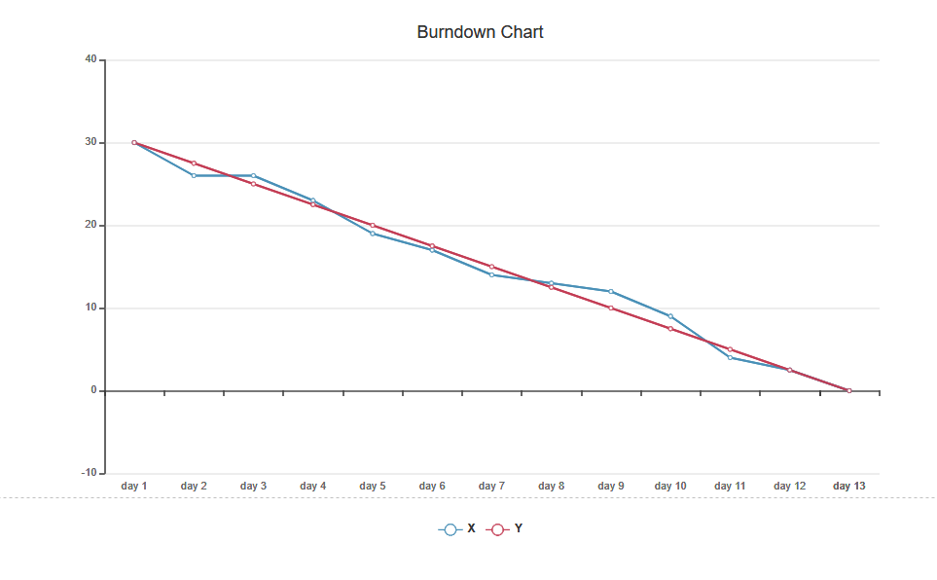

Spring**1 above

Y as Story points of Sprint No.1 == 30 task points