Text adventure

# Story type

### Linear

* One story one direction one ending (easiest)
* Entering a state and executing it and going to a new state if conditions are met
* boring

### Multiple

* Story can be more complex; has multiple paths you can go thru (complex)
* More checking commands to see which direction you will be going
* Can give a sense of vastness compared to the linear version

# What needs

* Engaging story
* Good ending, Bad ending
* Fun combat (Turn based)
* Companions (with personality)
* Punishing helping system? (HP for hints)
* Different locations

# How to make

* Combat can be a class that can be called that gets the current enemy and player and executes a battle according to their stats, can make it turn base you and enemy decide a course of attack or defend and then the class check what each thing has selected and executes accordingly.
* (Multiple) Maybe a method in the state that accepts an int that makes the choice of which state case to choose from after the combat is done, can also work multiple paths for the story knows which state to go to next etc..
* A death state?
* Saving state? Whereby it saves your stats and the story tree you have chosen to follow and if you do you can restart from there instead of playing the game from the start (won’t save if you quit the game)
* Can decide your stats without saying they are your stats when you talk with the prisoner he should ask you questions about yourself and you will answer and they will determine your initial stats
* Your interaction / decision will have either +1, 0, -1 to the total of your (ending score) if it’s below a certain threshold you can do the good ending else you get the bad one
* Player script that holds data like hp dmg mana etc, same for the enemy…
* Chance based attacking system where each attack has its own chance of hitting and missing
* Inventory and crafting?
* (IMPORTANT) add developer command so that you can pass the fights with you winning for play testing

# Game Flow

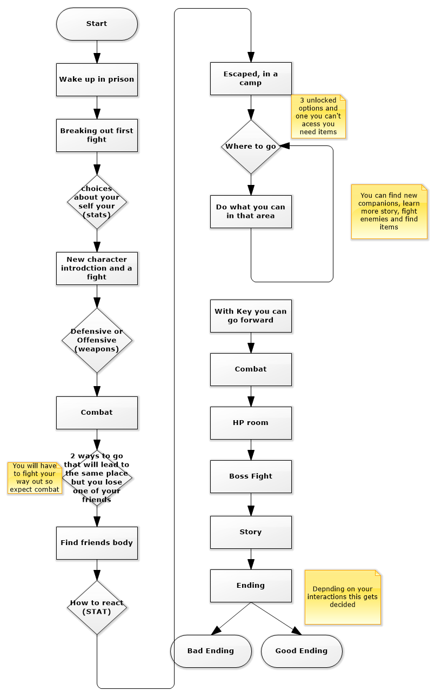

### Game Flow description

In this diagram we see how the game will flow and how it will play out for the player and what choices he has.

# Story

INTRO: You wake up somewhere with a headache you soon realize that it’s dark and you can’t see anything but somehow you make out the shape of few long bars trapping you in a room, you start touching everything around you to get a sense of what’s happening and then you hear a sound….

Prisoner: Hey someone there?

You are confused because you understand what he is saying but cannot reply you force yourself to reply but your headache starts to get worse and you slowly start to lose consciousness.

You wake up after a while without a headache to the sound of someone saying “are you there?” repeatedly.

You get up and asked him what happened and where you are

Prisoner: Laughs, you are in “Name” prison, as to what happened to you, I don’t know

He asks you who you are you say (Your Character name) and then he asks you why are you here?  
you reply with you don’t know (here you can ask him who he is and you get a back story ).

After some time passes, he asks you if you want to try and break out with you agree and he tell you to look around on ways you can escape (puzzle). After you open your cell and his you make your way into the next room which is the guard room, you fight the guard (combat).

After the fight your companion compliments you and you reply (few options to reply with each give you different stats), and he replies with oh I’m a (his class play style)

You hear a commotion (screaming, dragging, struggling), it is heading towards you and your new friend, you both hide expecting guard to arrive.

The guards arrive dragging a woman (combat) after killing the guards the woman thanks you introducing herself and her (class play style), you have 3 things you can do now (loot), (talk with one of your companions “can hint to looting”), (Keep going).

After you keep going you get more combat with stronger enemies the game assume you have looted the guards thus having weapon if not you will die fighting these guards.

Then decision to go left or right (each of your companions will be locked to going one way, basically sacrificing one of them), Fight scene.

Then we see the result of your action your dead companion and, now your other companion will talk with you asking you question depending on how you reply your (ending score will be affected).

You escape the prison and go to the woods and make camp.

Now you have 3 places you can explore and a place you can’t access because you don’t have (gear, key, whatever)

Each new place you explore has combat, new people to meet, puzzles and story.

After getting the thing you need you go to the 4th place and fight some trash mobs, then go to a healing room.

ENDING: Last place is the boss fight the thing that brought you here? Or is guarding a portal? Well it will be what I want it to be once I figure and flesh out the story.

You go back to where you came from, but you either find it:  
Bad ending: destroyed (you did it) and you get story.  
Good ending: everything is as you remember and you are reunited with loved ones.