Problem Description:

The main idea is to study the effect of beta blocker on acute kidney insurey. The issue here is that we want to investigate if the usage of beta blocker usage at the ICU for patients with heart disease are the most causes for acute kidney failure in ICU.

Some research says it's good to use it and others say that it makes the patient's situation worse. Therefore, we want to investigate if beta blocker has protectable effect or if it is harmful for the acute Kidney insurey in the ICU.

Methodolody for extracting the initial cohort for this study:

to achieve our research goal we need to control for other diseases and drugs. for example if the patient is already having a slow heart rate or if he has enough blood presure, etc.

all these can play a role in the predictive analysis.

we will start by defining the people whom are diagnosed with sepsis and to this we followed the Angus method (Angus et al, 2001. Epidemiology of severe sepsis in the United States

-- http://www.ncbi.nlm.nih.gov/pubmed/11445675)

In this method the case selection and definitions to identify cases with severe sepsis, they selected all acute care hospitalizations with ICD-9-CM codes for both:

-- (a) a bacterial or fungal infectious process AND

-- (b) a diagnosis of acute organ dysfunction.

The materialized view defined as of the angus_sepsis methodology and already created within the code contains "**58976**" rows

To confirm that a patient has sepsis_shock from this table we need to specify that the patient has at least two from those

* Infection
* Explicit sepsis
* Organ_dysfunction
* Mech_vent

This is labled in the materialized view in the as ( **angus = 1)**

If we queried people only labled with angus = 1 -- the result is a materialized view with "17420 " rows and 11 columns (**"subject_id"**,**"hadm_id"**,**"icustay_id"**,**"icu_length_of_stay"**,**"age"**,**"gender"**,**"numeric_gender"**,**"language"**, **"religion"**,**"marital_status"**, **"ethnicity"**, **"infection"**,**"explicit_sepsis"**, **"organ_dysfunction"**, **"mech_vent"**, **"angus"**)

Descriptive statistics for this table is as follows:

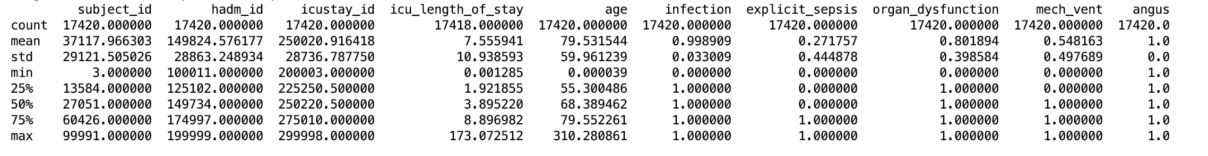

Next:

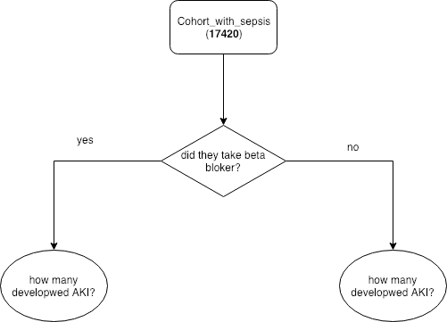

What we need is identify what each of these people has taken as medicine. From here we will obtain two subgroups (one that has taken beta blockers as medicine and others who didn’t took it)

For this purpose an inner join is needed between the previous selected cohort (**17420**) and the prescriptions table ("4156450") rows on subject_id.

The issue here is that there is repletion in the subject_id and for the inner join we need to take only distinct ids (“12612” ids). Taking this into consideration, the result is a view with “2226318” rows

DROP MATERIALIZED VIEW IF EXISTS prescriptions_angus_sepsis_distinct CASCADE;

CREATE MATERIALIZED VIEW prescriptions_angus_sepsis_distinct as

SELECT angDist.subject_id, pres.startdate, pres.enddate, pres.drug_name_generic

FROM angus_sepsis_distinct_subject_id as angDist

Left JOIN Prescriptions as pres

ON angDist.subject_id = pres.subject_id

The query retrieves **2226318 rows**

From the above selection we want to get two subgroups:

People who took beta blocker and whom don’t.

The beta blocker drug is described in the column drug_name_generic from the prescriptions table

The generic names for the beta blockers are:

**Beta Blocker names:**

* Acebutolol (Sectral)
* Atenolol (Tenormin)
* Metoprolol (Lopressor, Toprol-XL)
* Nadolol (Corgard)
* Nebivolol (Bystolic)
* Propranolol (Inderal LA, InnoPran XL)
* Betaxolol (Kerlone)
* Bisoprolol (Zebeta, Ziac)
* Carteolol (Cartrol)
* Carvedilol (Coreg)
* Labetalol (Normodyne, Trandate)
* Nebivolol (Bystolic)
* Penbutolol (Levatol)
* Pindolol (Visken)
* Sotalol (Betapace)
* Timolol (Blocadren)

The query retrieves 137114 rows

select subject_id

From prescriptions_angus_sepsis

where ( drug_name_generic LIKE 'Carvedilol%'

OR drug_name_generic LIKE 'Metoprolol%'

OR drug_name_generic LIKE 'Atenolol%'

OR drug_name_generic LIKE 'Nadolol%'

OR drug_name_generic LIKE 'Nebivolol%'

OR drug_name_generic LIKE 'Propranolol'

OR drug_name_generic LIKE'Betaxolol'

OR drug_name_generic LIKE 'Bisoprolol'

OR drug_name_generic LIKE 'Carteolol'

OR drug_name_generic LIKE 'Carvedilol'

OR drug_name_generic LIKE 'Labetalol'

OR drug_name_generic LIKE 'Nebivolol'

OR drug_name_generic LIKE 'Penbutolol'

OR drug_name_generic LIKE 'Pindolol'

OR drug_name_generic LIKE 'Sotalol'

OR drug_name_generic LIKE 'Timolol');

Appendix:

Code for cohort selection

WITH co AS (

SELECT icu.subject_id,

icu.hadm_id,

icu.icustay_id,

date_part('epoch'::text, icu.outtime - icu.intime) / 60.0::double precision / 60.0::double precision / 24.0::double precision AS icu_length_of_stay,

date_part('epoch'::text, icu.intime - pat.dob) / 60.0::double precision / 60.0::double precision / 24.0::double precision / 365.242::double precision AS age,

pat.gender

FROM mimiciii.icustays icu

JOIN mimiciii.patients pat ON icu.subject_id = pat.subject_id

), serv AS (

SELECT icu.hadm_id,

icu.icustay_id,

ad.language,

ad.religion,

ad.marital_status,

ad.ethnicity

FROM mimiciii.icustays icu

LEFT JOIN mimiciii.admissions ad ON icu.hadm_id = ad.hadm_id

)

SELECT co.subject_id,

co.hadm_id,

co.icustay_id,

co.icu_length_of_stay,

co.age,

co.gender,

serv.language,

serv.religion,

serv.marital_status,

serv.ethnicity

FROM co

LEFT JOIN serv ON co.icustay_id = serv.icustay_id;

Code for cohort with sepsis_angus observations

set search_path to mimiciii;

select count(distinct hadm_id)

from angus_sepsis;

DROP MATERIALIZED VIEW IF EXISTS admissions_According_To_The_Angus_Methodology CASCADE;

CREATE MATERIALIZED VIEW admissions_According_To_The_Angus_Methodology as

WITH co AS

(

SELECT cohort.*, angus.infection, angus.explicit_sepsis, angus.organ_dysfunction, angus.mech_vent, angus

FROM cohort

Inner JOIN angus_sepsis angus

ON angus.hadm_id = cohort.hadm_id

)

select co.*

from co

where co.angus = 1;

COPY (select * from admissions_According_To_The_Angus_Methodology)

TO '/Users/joudsi/Desktop/admissionsAccordingToTheAngusMethodology.csv' DELIMITER ',' CSV;