Reproducible Research Course Project 1

Load the data:

setwd('D:/data')  
data <- read.csv('activity.csv')

Process the data (removing NAs):

data1 <- data[complete.cases(data), ]

What is mean total number of steps taken per day?

Calculate the total number of steps taken per day and make a histogram:

library(ggplot2)

## Warning: package 'ggplot2' was built under R version 3.2.4

ggplot(data1, aes(as.factor(date),steps))+geom_bar(fill="red", stat="identity")+xlab("Day") + ylab("Steps")+ggtitle("Histogram of the total number of steps taken each day")+ theme(axis.text.x = element_text(angle = 90, hjust = 1))

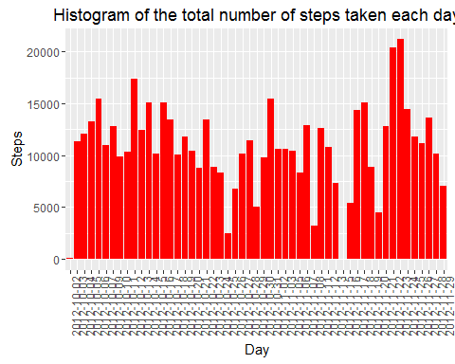

Calculate and report the mean and median of the total number of steps taken per day:

meanFreq <- as.integer(mean(aggregate(steps~date,data1, FUN=sum)$steps))  
medianFreq <- median(aggregate(steps~date,data1, FUN=sum)$steps)

Mean and median of the total number of steps taken per day are r meanFreq steps and r medianFreq steps, respectively.

What is the average daily activity pattern?

data2 <- data1  
data2 <- aggregate(steps~interval, data2, FUN=mean)  
plot(data2$steps ~ data2$interval, type="l", xlab="Date", ylab="Average Steps per Day (5-mins interval")

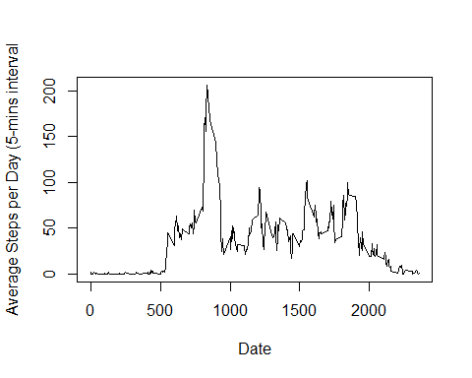 Code to look for the maximum number of steps:

maxSteps <- data2[data2$steps==max(data2$steps), ]  
data2 <- NULL

The 5-minute interval 835, on average across all the days in the dataset, contains the maximum number of steps 206.1698113.

Imputing missing values

Calculate and report the total number of missing values in the dataset:

number <- nrow(data) - nrow(data1)

The total number of rows with NAs in the dataset is 2304.

The simple strategy that I used in imputing the data is that I used the average steps taken for that specific interval in all of the data set and assign it to the missing value(s). The code for this strategy is the following:

imputedData <- data  
#The mean for that 5-minute interval  
meanForNA <- aggregate(steps~interval,imputedData, FUN=mean)  
for(i in 1:nrow(imputedData)){  
 if(is.na(imputedData[i,c("steps")])){  
 imputedData[i,c("steps")] <- meanForNA[meanForNA$interval==imputedData[i,c("interval")], c("steps")]  
 }  
}

Code to Show Histogram of the total number of steps taken each day after missing values are imputed:

ggplot(imputedData,aes(as.factor(date),steps))+geom_bar(fill="red", stat="identity")+xlab("Day") + ylab("Steps")+ggtitle("Histogram of the Total Number of Steps Taken Each Day (Imputed Data)")+ theme(axis.text.x = element_text(angle = 90, hjust = 1))

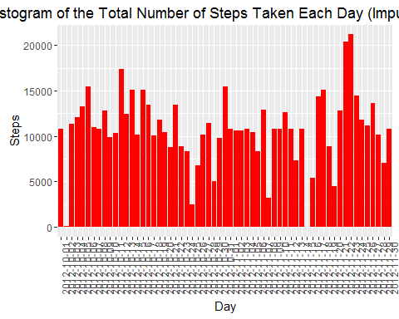

newmeanFreq <- as.integer(mean(aggregate(steps~date,imputedData, FUN=sum)$steps))  
newmedianFreq <- as.integer(median(aggregate(steps~date,imputedData, FUN=sum)$steps))

The new mean of the imputed data is 10766 steps compared to the old mean of 10766 steps. That creates a difference of 0 steps on average per day.

The new median of the imputed data is 10766 steps compared to the old median of 10765 steps. That creates a difference of 1 steps for the median.

This shows that the overall shape of the distribution has not changed after applying the method in imputing the data.

Are there differences in activity patterns between weekdays and weekends? Ans:

Code to Create a new factor variable in the dataset with two levels - 'weekday' and 'weekend' indicating whether a given date is a weekday or weekend day.

weekDayEnd <- data.frame("dayType"=character(0))  
weekDayEnd <- NULL  
  
#Check wether the day is a weekday or weekend (Saturday)  
weekInd <- function(day){  
 if (weekdays(day)=="Saturday") {  
 out <- "Weekend"   
 } else {  
 out <- "Weekday"   
 }  
 out  
}  
  
for (i in 1:nrow(imputedData)){  
 date <- imputedData[i,c("date")]  
 newObs <- data.frame("dayType"= weekInd(as.Date(date)))  
 weekDayEnd <- rbind(weekDayEnd, newObs)  
}  
#------------------------------------------------------------  
  
#Add the day type column in the data set  
imputedData <- cbind(imputedData, weekDayEnd)

Panel plot comparing the average number of steps taken per 5-minute interval across weekdays and weekends.

averageWeekDayEnd<-aggregate(steps~interval + dayType, imputedData, FUN=mean)  
ggplot(averageWeekDayEnd,aes(interval,steps, color=dayType))+geom_line()+facet_grid(. ~ dayType)+xlab("5-min Interval")+ylab("Steps")+guides(fill=FALSE)

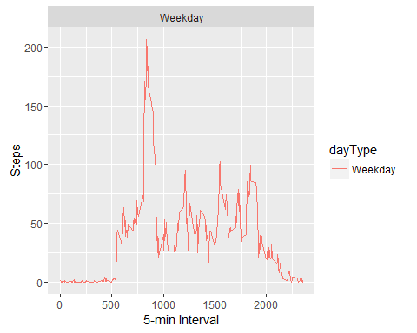 Reference: <https://rpubs.com/skycrater/180134>