Abstract- In this paper, a program is developed which can predict the painter of a painting. By learning from a dataset of painters classified by their relative painter, the program will be able to predict who painted a given painting, or match the style of a painting to a painter from the database. In order to carry out this classification problem, I explore a range of techniques that approach the problem with different algorithms. Firstly, image processing using SIFT feature extraction is used with a Bag of Visual Words approach to classify the paintings, then a range of machine learning algorithms are used and compared on the basis of their accuracy in making predictions.
Keywords: SVM, SIFT, XGBoost, Classification, Bag of Visual Words, Computer Vision, Machine Learning

Link to drive folder: https://drive.google.com/drive/folders/1wO4IaM26WEtCq9YxcMC2d4-MzZzZMKpy?usp=drive_link
Youtube link for demo: https://www.youtube.com/watch?v=IubBm0EbFxc

I. INTRODUCTION
The field of computer vision has been flourishing rapidly, holding great potential to alleviate everything from healthcare disparities to mobility limitations on a global scale. With the use of Artificial Intelligence, and particularly Deep Learning algorithms, significant advancements have been seen in a computer’s ability to complete tasks such as object detection, object recognition, image classification etc. Computer vision uses machine learning and neural networks to teach computers and systems to derive meaningful information from digital images, videos and other visual inputs—and to make recommendations carry out certain actions when they see defects or issues.
Image classification is the task of assigning a label or class to an entire image. Images are expected to have only one class for each image. Image classification models take an image as input and return a prediction about which class the image belongs to. Using image classification can provide very accurate results in image processing, and this is especially relevant to deep learning. However, when it comes to the classification of paintings by the artist who the painting belongs to, it can pose a challenge. Painters can be affected during their life simultaneously from different movements, the same movements or a few different movements. This situation makes the problem of identifying and classifying painters more difficult. When analyzing the paintings that a particular painter has created throughout their lifetime, such as Piet Mondrian who is known for his artistic evolution from realism to abstract cubism, we can see that classification can be difficult when there exist such a wide range of techniques and styles, or styles that are so contrasting to one another.
I decided to explore a range of techniques to classify the painting by their corresponding artists, including image processing (with feature extraction and tree classification), and machine learning (which uses SVM, MLP and XGBoost algorithms. The efficiency and implementation of these methods are explored throughout the paper.
II. LITERATURE REVIEW
The majority of methods used for solving the problem of finding out the painters of the specific paintings are deep learning and CNN based algorithms. To be specific, transfer learning or auto-encoder based deep learning models are mostly preferred. Among almost all of the articles and websites researched related to this topic, there are various methods even though some of them are not as common as the others. Here are some of the approaches followed based on our research:

In [1], various deep learning network structures are applied on the dataset which contains 46 paintins per painter on average. These networks can be found below:
- ResNet: As the networks are made deeper in the progress, it is highly expected that the training becomes more complex. On the other hand, classification accuracy generally increases, then unexpectedly drops. Residual Network steps in to solve this problem. This network has a shortcut mechanism to prevent these from happening.

- DenseNet: This network connects all layers with each other directly and by using matching feature-map sizes. It solves the problem of vanishing gradients or at least alleviates it. Furthermore, it strengthens feature propagation, reduces the number of parameters significantly. The down side of this network is that it takes a long time to train.

- Inception: There is a repetitive block structure that takes the responsibility of a current block’s output to be an input to the next block to it. These blocks are called inception blocks.

In [2], the most significantly mentioned progress is feature selection. Before features, the model is one-vs-all SVM for the multi class classification. The features vary and they are assessed in terms of accuracy of the model. After that, the most promising features are selected. The most used features are color histogram features and pixel features. However, there might occur a problem if the number of these features are only a few. The model may overfit. Hence, this article aimed at finding out much more reliable and advanced features to use. There are many features such as HOG2x2, SSIM, geo texton and Dense SIFT. It turns out each of them are successful in distinct tasks. In general, HOG2x2 features are the ones that provide an accuracy of around 82%. When all the features are mixed into one representation and used in that way, the accuracy went up to 85.3%.

In the Image classification for the painting style with SVM paper [3], a similar Project was carried out using a combination of SIFT and SVM to classify paintings by their style of painting. They used 2 classes in their model: Cubist and Non-cubist paintings. In their study, their methodology consists of the following steps: dense SIFT for local feature detection, Clustering of the feature space into 5 visual words, vector quantization of the visual words to produce histograms of the training images, and finally using an SVM architecture for the classifier.

SIFT extracts local features described by the intensity gradient of the image. It is a local feature descriptor which is invariant to changes in intensity and rotation. By utilizing the weighted histogram of the 8 directions gradient strength produced through the application of the SIFT algorithm, the weighted histograms are concatenated to give the local features. A Visual-Words dictionary was created by accumulation of the local features obtained from the local image patterns that frequent in the image of painting by using a large number of the general image of painting. Visual cluster centers were accumulated as an element of the Visual-Words dictionary, obtained by performing clustering using the k-means algorithm based on the total feature value. Classification of the certain painting was done with SVM using the histogram of the local feature quantities for painting style of the painting.

Their study proposed a new method for image classification, which received a 70% accuracy rate in classification of paintings. In contrast, models which incorporate CNN have a higher average accuracy rate. One example of this is the DeepPainter study [4], where they received an accuracy rate of 96.52% using CNN and autoencoders for classifying paintings by their relative painter. Although CNN models are more computationally complex and expensive, they have proven in multiple studies to be more accurate in a variety of image classification problems.

III. DATASET
The dataset of the project is obtained by the website Kaggle. Its link can be found in [5] There is a page that contains “Collections of Paintings from 50 Artists”. This dataset has 50 folders in the name of each painter. I plan to mixing these folders’ content altogether and make use of them this way. There are 8355 images in total in the whole dataset. All these images are paintings that is made by the specific painter. The format of these is “jpg.”

Another dataset that will be used consists 42195 images for training and 10628 images for testing. These paintings belong to 195 different artists. Its link can be found in [6].

Some examples can be found in Figure 1. These 25 samples belong to Vincent van Gogh.

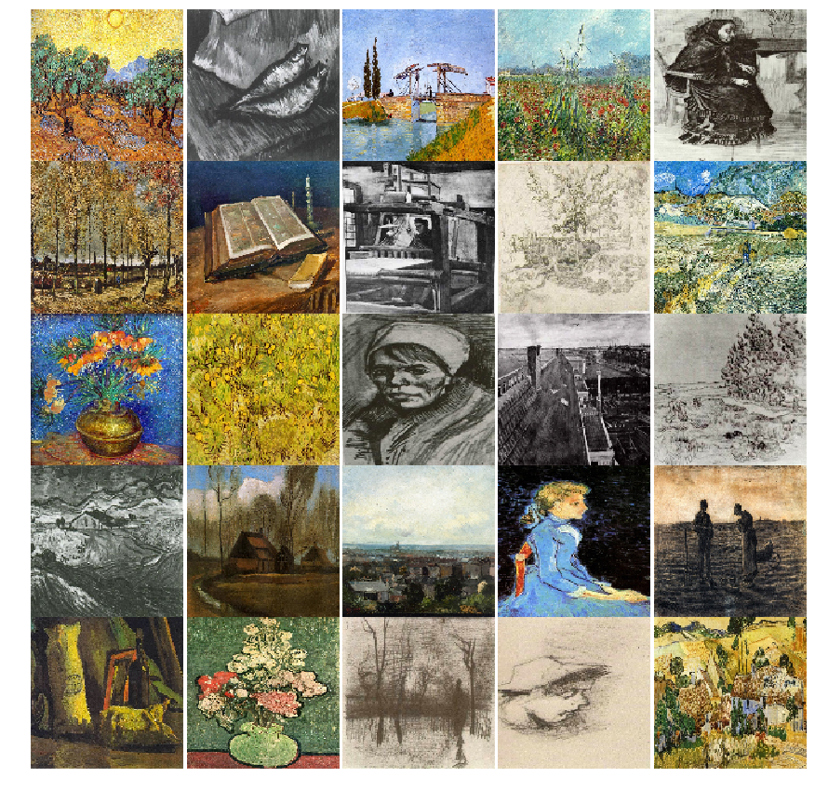
Figure 1
The following table shows the 24 artists with the most number of paintings that belong to them in the dataset, and the corresponding number of paintings of theirs in the dataset.

Name | Paintings
Vincent van Gogh | 877
Edgar Degas | 702
Pablo Picasso | 439
Pierre-Auguste Renoir | 336
Albrecht Dürer | 328
Paul Gauguin | 311
Francisco Goya | 291
Rembrandt | 262
Alfred Sisley | 259
Titian | 255
Marc Chagall | 239
Rene Magritte | 194
Amedeo Modigliani | 193
Paul Klee | 188
Henri Matisse | 186
Andy Warhol | 181
Mikhail Vrubel | 171
Sandro Botticelli | 164
Leonardo da Vinci | 143
Peter Paul Rubens | 141
Salvador Dali | 139
Hieronymus Bosch | 137
Pieter Bruegel | 134
Diego Velazquez | 128
Kazimir Malevich | 126

The total number of classes that exist in the dataset is equivalent to the number of artists in the dataset (=50). This is the list of classes, followed by a graph showing the distribution of the nationality of the artists, which gives insight into the style of artwork and the versatility of the dataset:
['Albrecht_Dürer', 'Alfred_Sisley', 'Amedeo_Modigliani', 'Andrei_Rublev', 'Andy_Warhol', 'Camille_Pissarro', 'Caravaggio', 'Claude_Monet', 'Diego_Rivera', 'Diego_Velazquez', 'Edgar_Degas', 'Edouard_Manet', 'Edvard_Munch', 'El_Greco', 'Eugene_Delacroix', 'Francisco_Goya', 'Frida_Kahlo', 'Georges_Seurat', 'Giotto_di_Bondone', 'Gustav_Klimt', 'Gustave_Courbet', 'Henri_Matisse', 'Henri_Rousseau', 'Henri_de_Toulouse-Lautrec', 'Hieronymus_Bosch', 'Jackson_Pollock', 'Jan_van_Eyck', 'Joan_Miro', 'Kazimir_Malevich', 'Leonardo_da_Vinci', 'Marc_Chagall', 'Michelangelo', 'Mikhail_Vrubel', 'Pablo_Picasso', 'Paul_Cezanne', 'Paul_Gauguin', 'Paul_Klee', 'Peter_Paul_Rubens', 'Pierre-Auguste_Renoir', 'Piet_Mondrian', 'Pieter_Bruegel', 'Raphael', 'Rembrandt', 'Rene_Magritte', 'Salvador_Dali', 'Sandro_Botticelli', 'Titian', 'Vasiliy_Kandinskiy', 'Vincent_van_Gogh', 'William_Turner']

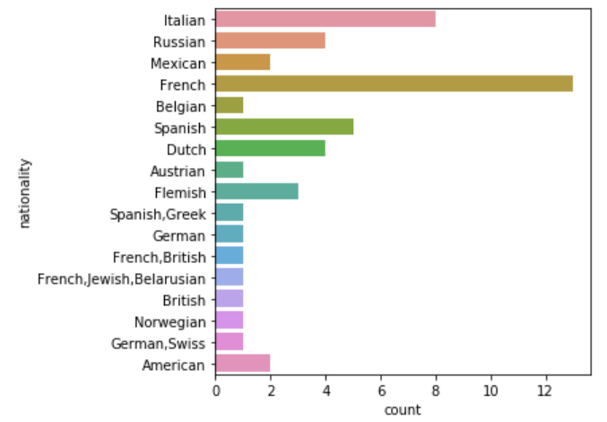
IV. METHODOLOGY
Metrics and Train-Test Adjustment

I will be creating a confusion matrix in order to see the performance of the methods used in the project. As for metrics, varied ones will be mentioned for each scenario as the methods will differ. For instance, F1 score, precision, recall and many other ones are to be considered.

For all of the methods, I used a 80% of train and %20 of test data. There was no validation data except for the simple CNN and Inception model. This data is

Method 1:

For the first method, I will be using Scale- invariant feature transform (SIFT) as a computer algorithm for extraction of local features and image patterns from the paintings in our dataset. The paintings will be randomly selected, and by creating an accumulation of the local features extracted with SIFT, we will obtain a Visual Words dictionary. This will produce words for each image.

SIFT is a feature detection algorithm in computer vision to detect and describe local features in images developed by David Lowe in 1999. Unlike other feature detection algorithms, the features detected by the SIFT algorithm are generally more scattered around the painting, whereas in algorithms like ORB and BRISK, the features detected are more concentrated on corners. SIFT detector is based on Difference-of-Gaussians (DoG) operator which is an approximation of Laplacian-of-Gaussian (LoG). Feature- points are detected by searching local maxima using DoG at various scales of the subject images. SIFT is robustly invariant to image rotations, scale, and limited affine variations but its main drawback is high computational cost.

To produce words for each of the images, I will use a comparative algorithm to produce an optimal bag of words. The algorithm I plan to use for this is the histogram comparison/matching algorithm. Histogram matching is a process where a time series, image, or higher dimension scalar data is modified such that its histogram matches that of another (reference) dataset. The algorithm is as follows: The cumulative histogram is computed for each dataset, for any particular value (xi) in the data to be adjusted has a cumulative histogram value given by G(xi) (cumulative probability distribution). This in turn is the cumulative distribution value in the reference dataset (reference cumulative probability distribution), namely H(xj). The input data value xi is replaced by xj.

Visual cluster centers were accumulated as an element of the Visual-Words dictionary, which obtained by performing clustering using the k-means algorithm based on the total feature value to find center points for the visual words. Henceforth, when analyzing a new image, the program would be able to find a cluster from k clusters which is the most similar to the bag of words extracted from the new image, and upon that basis propose which artist the painting likely belongs to.

The general idea of bag of visual words (BOVW) the representations an image as a set of features each consisting of key points and descriptors. And descriptor is the description of the key point. I use the key points and descriptors to construct vocabularies and represent each image as a frequency histogram of features that are in the image. From the frequency histogram, later, we can find another similar image or predict the class/cluster of an image, or in this case, the painter which the image is likely to belong to.

References for method 1 can be found in [7], [8], [9], [10], [11] and [12].

Method 2:

In this method, main outlines are generated by two steps. First is applying feature extraction on the data of given images using various and representative features. Then concatenating these is essential in order to be able to produce representing results for the images. Second, based on the obtained representations, executing assorted ML models. In the existent case, they are MLP, SVM and XGBoost.

The features are as the following:
1. LBP
2. Gray Image Histogram
3. Edge Histogram
4. B Histogram of RGB Image
5. S Histogram of HSV Image

Each of these has its own advantages and provides characteristics of the images to some extent. LBP is specifically for texture detection and also robust to grayscale variations. Gray image histogram gives a simple insight to the image's pixel intensity distribution. Edge histograms are beneficial in terms of making a distinction between images that have sharp edges and ones that have not. Provides also shape recognition. Even though B histogram is simple when compared to others, it focuses on the color distribution, specifically blue. S histogram is valuable for the images that saturation plays a crucial role.

After grasping the avails of these features, the concatenation of them cannot be underestimated in terms of its power for reflecting an image's significant properties. In this process, not all of them are directly applied on the bare images. The reason for that is the process taking a long time especially when the LBP feature is produced. A less amount of data that can be compensated by the current computer system is more beneficial. Therefore, while utilising LBP, images are resized as (128, 128) since there are even images which have sizes even more than (1000, 1000).

All the processes up until now applies to both train and test data. Hence, feature concatenation is executed in both cases. However, for train data, each image's each feature is saved in txt file which has the name of the specific feature. Also, concatenated versions are saved in the same folder to be able to directly use the model and not waste time on extracting features over and over again. Concatenations will be named as "representation" from now on for this part.

Representations are fed into ML models in order to complete the training process. MLP is configured in a way that it has 100 hidden layers, SVM's kernel type is chosen as linear. XGBoost has also the default parameter settings. The essential aim in this whole method is to see how powerful feature extraction is and how it can be made use of during painter classification.

In order to complete the classification procedure, the 3 machine learning methods I chose are Multilayer Perceptron (MLP), Support Vector Machine (SVM) and Extreme Gradient Boosting (XGBoost). The obtained representations are inputs to these ML models.

MLP model made use of in here has two hidden layers having sizes of 100 and 50 neurons respectively. Maximum number of iterations are decided as 500 to be able to make the learning process effective. The information obtained from the input layer continues to move through hidden layers, then finally arrives at the output layer to produce the result. The classification report is saved in the respective name of text file for this model.

SVM model is the second preferred ML model in this project to be able to have an insight regarding the different models’ performances. It has default parameters such as its kernel being linear.

XGBoost is an ensemble learning method that gives expeditious results since it is a parallelized and optimized version of the gradient boosting algorithm. Thereby, this model is a decent choice to compare to other models which are simple ML models. It also uses the default parameters during the training process.

As it can be noticed, these three models are not optimized since the main motivation in this part is to see the power that feature extraction holds. So that we can compare each model to each other and see how far the process of ‘only feature extraction’ included models can take us in terms of models’ performances.

V. RESULTS AND DISCUSSION
The models mentioned in IV. part has the accuracies that are showed in Table 1. In terms of Method 2’s models, SVM takes the longest time and XGBoost has the highest accuracy as it can be seen. Even though MLP has an accuracy of 0.1 and it may look poorly, there are 50 painters, and the probability of predicting an image’s true painter is 2%. The results in here surpassed that number. This shows that this model can make more than simply predicting based on randomization. Especially SVM and MLP models are far better than that probability. Also, XGBoost has a specifically spectacular result that is even close to the Inception model which has the highest accuracy in here.
Table 1
Model | Accuracy
Method 2: MLP | 0.10
Method 2: SVM | 0.33
Method 2: XGBoost | 0.49
VI. CONCLUSION AND FUTURE WORK
To further improve the performance of each model is possible.
In Method 1 we were able to successfully extract SIFT keypoints and descriptors from the images, and using the extracted SIFT features, the model aims to find viual words that can be used to classify the paintings in the test set to their relevant artists. Below is an example of how the program was able to extract and display the extracted keypoints of an image in a visually comprehensive way. The paintings belong to Jane van Eyck.
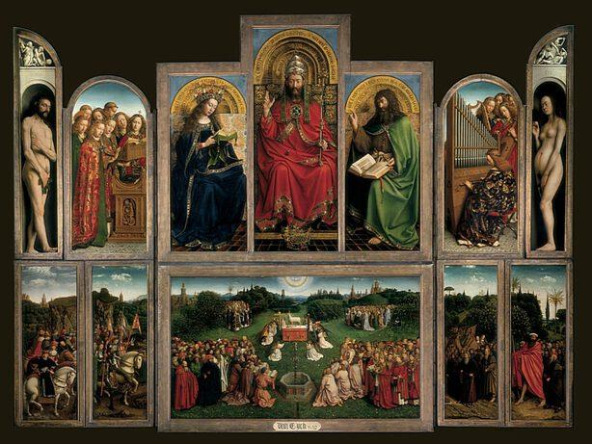
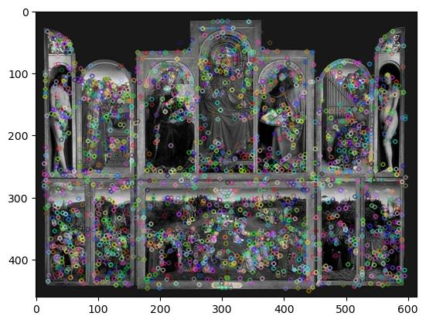
The program was written to use extracted features and find clusters that would relate to the category (in this case the artist) that a painting belongs to, thus when being tested using the testing data set, images would be matched to the artist cluster which the test data’s features are the closest to in the feature space.
Results for method 1 – Image Processing:
From these results we can see that the accuracy changes from artist to artist widely. The blue results are for kNN with 60 clusters and k=1 (nearest neighbour), and the orange results are for k-NN with 200 clusters and k=10. The results with more clusters and neighbours (the second trial) were better overall, with an accuracy of 24.1% compared to 17.3 with the first trial. When looking at the results, we can see that in the first trial the highest accuracy for an artist is observed with Jackson Polllock, with an accuracy of 80%, whereas in the second trial the same artist has an accuracy of 0%, and the overall highest observed accuracy for a single artist is 64.15%.
Results from method 2 – Machine Learning:
MLP:
 | precision | recall | f1-score | support
0 | 0.5 | 0.02 | 0.03 | 66
1 | 0 | 0 | 0 | 52
2 | 0 | 0 | 0 | 39
3 | 0 | 0 | 0 | 20
4 | 0 | 0 | 0 | 37
5 | 0 | 0 | 0 | 19
6 | 1 | 0.18 | 0.31 | 11
7 | 0 | 0 | 0 | 15
8 | 0 | 0 | 0 | 14
9 | 0 | 0 | 0 | 26
10 | 0 | 0 | 0 | 141
11 | 0 | 0 | 0 | 18
12 | 0 | 0 | 0 | 14
13 | 0 | 0 | 0 | 18
14 | 0 | 0 | 0 | 7
15 | 0 | 0 | 0 | 59
16 | 0 | 0 | 0 | 24
17 | 0 | 0 | 0 | 9
18 | 0 | 0 | 0 | 24
19 | 0 | 0 | 0 | 12
20 | 0 | 0 | 0 | 24
21 | 0 | 0 | 0 | 17
22 | 0 | 0 | 0 | 38
23 | 0 | 0 | 0 | 14
24 | 0 | 0 | 0 | 28
25 | 0 | 0 | 0 | 5
26 | 0 | 0 | 0 | 17
27 | 0 | 0 | 0 | 21
28 | 0 | 0 | 0 | 26
29 | 0 | 0 | 0 | 29
30 | 0 | 0 | 0 | 48
31 | 0 | 0 | 0 | 10
32 | 0 | 0 | 0 | 35
33 | 0 | 0 | 0 | 88
34 | 0 | 0 | 0 | 10
35 | 0 | 0 | 0 | 63
36 | 0 | 0 | 0 | 38
37 | 0 | 0 | 0 | 29
38 | 0 | 0 | 0 | 68
39 | 0 | 0 | 0 | 27
40 | 1 | 0.12 | 0.21 | 17
41 | 0 | 0 | 0 | 22
42 | 0 | 0 | 0 | 53
43 | 0 | 0 | 0 | 39
44 | 0 | 0 | 0 | 28
45 | 0 | 0 | 0 | 33
46 | 0 | 0 | 0 | 51
47 | 0 | 0 | 0 | 18
48 | 0.1 | 1 | 0.19 | 176
49 | 0 | 0 | 0 | 14
accuracy | 0.11 | 1711
macro avg | 0.05 | 0.03 | 0.01 | 1711
weighted avg | 0.05 | 0.11 | 0.02 | 1711
Accuracy: | 0.10578609
SVM:
 | precision | recall | f1-score | support
0 | 0.68 | 0.79 | 0.73 | 66
1 | 0.36 | 0.44 | 0.4 | 52
2 | 0.21 | 0.23 | 0.22 | 39
3 | 0.17 | 0.2 | 0.19 | 20
4 | 0.41 | 0.43 | 0.42 | 37
5 | 0 | 0 | 0 | 19
6 | 0.12 | 0.36 | 0.19 | 11
7 | 0.19 | 0.33 | 0.24 | 15
8 | 0.32 | 0.43 | 0.36 | 14
9 | 0.12 | 0.12 | 0.12 | 26
10 | 0.41 | 0.42 | 0.41 | 141
11 | 0.09 | 0.11 | 0.1 | 18
12 | 0 | 0 | 0 | 14
13 | 0.43 | 0.33 | 0.38 | 18
14 | 0 | 0 | 0 | 7
15 | 0.36 | 0.27 | 0.31 | 59
16 | 0.48 | 0.5 | 0.49 | 24
17 | 0.14 | 0.33 | 0.2 | 9
18 | 0.44 | 0.33 | 0.38 | 24
19 | 0.2 | 0.42 | 0.27 | 12
20 | 0.1 | 0.08 | 0.09 | 24
21 | 0.2 | 0.18 | 0.19 | 17
22 | 0.36 | 0.26 | 0.3 | 38
23 | 0.25 | 0.21 | 0.23 | 14
24 | 0.33 | 0.25 | 0.29 | 28
25 | 0.56 | 1 | 0.71 | 5
26 | 0.21 | 0.18 | 0.19 | 17
27 | 0.31 | 0.19 | 0.24 | 21
28 | 0.11 | 0.08 | 0.09 | 26
29 | 0.11 | 0.14 | 0.12 | 29
30 | 0.6 | 0.6 | 0.6 | 48
31 | 0.14 | 0.2 | 0.17 | 10
32 | 0.33 | 0.31 | 0.32 | 35
33 | 0.25 | 0.33 | 0.28 | 88
34 | 0 | 0 | 0 | 10
35 | 0.37 | 0.48 | 0.42 | 63
36 | 0.18 | 0.11 | 0.13 | 38
37 | 0.13 | 0.07 | 0.09 | 29
38 | 0.29 | 0.31 | 0.3 | 68
39 | 0.42 | 0.37 | 0.39 | 27
40 | 0.43 | 0.18 | 0.25 | 17
41 | 0.16 | 0.14 | 0.15 | 22
42 | 0.37 | 0.43 | 0.4 | 53
43 | 0.53 | 0.46 | 0.49 | 39
44 | 0.58 | 0.54 | 0.56 | 28
45 | 0.29 | 0.12 | 0.17 | 33
46 | 0.29 | 0.29 | 0.29 | 51
47 | 0.2 | 0.06 | 0.09 | 18
48 | 0.39 | 0.36 | 0.38 | 176
49 | 0 | 0 | 0 | 14
accuracy | 0.33 | 1711
macro avg | 0.27 | 0.28 | 0.27 | 1711
weighted avg | 0.33 | 0.33 | 0.32 | 1711
Accuracy: | 0.32729398
XGB:
 | precision | recall | f1-score | support
0 | 0.81 | 0.91 | 0.86 | 66
1 | 0.52 | 0.58 | 0.55 | 52
2 | 0.45 | 0.51 | 0.48 | 39
3 | 0.4 | 0.3 | 0.34 | 20
4 | 0.45 | 0.46 | 0.45 | 37
5 | 0.1 | 0.05 | 0.07 | 19
6 | 0.5 | 0.36 | 0.42 | 11
7 | 0.57 | 0.27 | 0.36 | 15
8 | 0.31 | 0.36 | 0.33 | 14
9 | 0.59 | 0.38 | 0.47 | 26
10 | 0.47 | 0.67 | 0.56 | 141
11 | 0.4 | 0.33 | 0.36 | 18
12 | 0.29 | 0.14 | 0.19 | 14
13 | 0.42 | 0.61 | 0.5 | 18
14 | 0 | 0 | 0 | 7
15 | 0.48 | 0.27 | 0.35 | 59
16 | 0.62 | 0.62 | 0.62 | 24
17 | 0.75 | 0.33 | 0.46 | 9
18 | 0.62 | 0.62 | 0.62 | 24
19 | 0.43 | 0.25 | 0.32 | 12
20 | 0.47 | 0.33 | 0.39 | 24
21 | 0.17 | 0.12 | 0.14 | 17
22 | 0.57 | 0.45 | 0.5 | 38
23 | 0.5 | 0.57 | 0.53 | 14
24 | 0.29 | 0.36 | 0.32 | 28
25 | 1 | 1 | 1 | 5
26 | 0.5 | 0.24 | 0.32 | 17
27 | 0.5 | 0.38 | 0.43 | 21
28 | 0.4 | 0.23 | 0.29 | 26
29 | 0.48 | 0.38 | 0.42 | 29
30 | 0.79 | 0.69 | 0.73 | 48
31 | 0.78 | 0.7 | 0.74 | 10
32 | 0.41 | 0.46 | 0.43 | 35
33 | 0.4 | 0.55 | 0.46 | 88
34 | 0 | 0 | 0 | 10
35 | 0.48 | 0.59 | 0.53 | 63
36 | 0.2 | 0.16 | 0.18 | 38
37 | 0.32 | 0.21 | 0.25 | 29
38 | 0.43 | 0.44 | 0.43 | 68
39 | 0.83 | 0.37 | 0.51 | 27
40 | 0.71 | 0.29 | 0.42 | 17
41 | 0.52 | 0.5 | 0.51 | 22
42 | 0.55 | 0.7 | 0.62 | 53
43 | 0.54 | 0.56 | 0.55 | 39
44 | 0.69 | 0.64 | 0.67 | 28
45 | 0.45 | 0.3 | 0.36 | 33
46 | 0.41 | 0.45 | 0.43 | 51
47 | 0.29 | 0.11 | 0.16 | 18
48 | 0.51 | 0.66 | 0.58 | 176
49 | 0.14 | 0.07 | 0.1 | 14
accuracy | 0.49 | 1711
macro avg | 0.47 | 0.41 | 0.43 | 1711
weighted avg | 0.49 | 0.49 | 0.48 | 1711
Accuracy: | 0.491525424
We can see from the results that the most successful model was XGB, both out of the machine learning methods and overall, with an accuracy of 49%. This is followed by SVM with an accuracy of 33%, and lastly MLP with an accuracy of 10.6%, which is the lowest accuracy measure among all of the methods explored in this study. However Due to there being 50 classes, this is still over 5 times better than a random guess.
Method 2 can be improved by using effective and representative features such as HOG and MSER. Using these together with the current ones was one of the aims of this project. However, due to the time limit and computer system’s performance, we had to remove these and continue with the current ones. To reach a better result, these can be added.
Additionally, I ran a hyperparameter fine tuning program on MLP to compare the results with fine tuning against the original method,
To improve accuracy of our models in predicting the artist that a painting belongs to, a larger dataset may be used that provides more examples of artist work. An example of a dataset that could be used to optimize our models is the WikiArt dataset [18] which contains paintings that belong to 195 different artists, with over 42,000 images for training and over 10,000 images for testing.
To improve the results of Method 1, the following could be implemented:
- Increasing the number of visual word clusters: the current model uses 60, this number could be increased to over 100 or 200. Having more clusters allows for having more expressive histograms. But too many could result in overfitting.
- Using TF-IDF weighted histograms could be used to reduce the influence/weight of uninformative features. Currently the histograms used take raw frequency counts which is not optimal.
- The current model uses kNN with k=1. Increasing the number of nearest neighbors (eg. To 3 or 5) and majority voting would very probably improve the models accuracy.
- Normalizing the histograms before feeding them into the k-NN, such as using L2 norm. This would prevent image size or descriptor count from affecting classification unfairly.
- PCA can be used to reduce noise in the BoVW vectors, which could speed up k-NN and possibly boosts generalization.

Due to time constraints (as each time I run the program it takes nearly 2 hours to complete) I was unable to test many optimization techniques and compare their results.
VII. REFERENCES

[1] Mehmet Oguz Kelek, Nurullah Calik, Tulay Yildirim, Painter Classification Over the Novel Art Painting Data Set via The Latest Deep Neural Networks, Procedia Computer Science, Volume 154, 2019, Pages 369-376, ISSN 1877-0509
[2] AlyanNezhadi, Mohammad Mahdi, Hossein Dabbaghan, Samira Moghani and Majid Forghani. “A Painting Artist Recognition System Based on Image Processing and Hierarchical SVM.” 2019 5th Conference on Knowledge Based Engineering and Innovation (KBEI) (2019): 537-541.
[3] Misumi, Makoto, et al. "Image classification for the painting style with SVM." Proceedings of the 4th ⅡAE International Conference on Industrial Application Engineering. Beppu, Japan: The Institute of Industrial Applications Engineers. 2016.
[4] David, Omid E., and Nathan S. Netanyahu. "Deeppainter: Painter classification using deep convolutional autoencoders." Artificial Neural Networks and Machine Learning–ICANN 2016: 25th International Conference on Artificial Neural Networks, Barcelona, Spain, September 6-9, 2016, Proceedings, Part II 25. Springer International Publishing, 2016.
[5]https://www.kaggle.com/code/paultimothymooney/collections-of-paintings-from-50-artists
[6] https://paperswithcode.com/dataset/wikiart
AlyanNezhadi, Mohammad M., et al. "A painting artist recognition system based on image processing and hierarchical SVM." 2019 5th Conference on Knowledge Based Engineering and Innovation (KBEI). IEEE, 2019.
[7] Misumi, Makoto, et al. "Image classification for the painting style with SVM." Proceedings of the 4th ⅡAE International Conference on Industrial Application Engineering. Beppu, Japan: The Institute of Industrial Applications Engineers. 2016.
[8] Tareen, Shaharyar Ahmed Khan, and Zahra Saleem. "A comparative analysis of sift, surf, kaze, akaze, orb, and brisk." 2018 International conference on computing, mathematics and engineering technologies (iCoMET). IEEE, 2018.
[9] Karami, Ebrahim, Siva Prasad, and Mohamed Shehata. "Image matching using SIFT, SURF, BRIEF and ORB: performance comparison for distorted images." arXiv preprint arXiv:1710.02726 (2017).
[10]https://towardsdatascience.com/histogram-matching-ee3a67b4cbc1
[11]https://paulbourke.net/miscellaneous/equalisation
[12] AlyanNezhadi, Mohammad M., et al. "A painting artist recognition system based on image processing and hierarchical SVM." 2019 5th Conference on Knowledge Based Engineering and Innovation (KBEI). IEEE, 2019.
[13] Dhoom, Tanni, and Taufique Sayeed. "Artwork Classification and Recognition System based on Convolutional Neural Network." (2022).
[14] Lagunas, Manuel, and Elena Garces. "Transfer learning for illustration classification." arXiv preprint arXiv:1806.02682 (2018).
[15] David, Omid E., and Nathan S. Netanyahu. "Deeppainter: Painter classification using deep convolutional autoencoders." Artificial Neural Networks and Machine Learning–ICANN 2016: 25th International Conference on Artificial Neural Networks, Barcelona, Spain, September 6-9, 2016, Proceedings, Part II 25. Springer International Publishing, 2016.
[16] He, Kaiming, et al. "Deep residual learning for image recognition." Proceedings of the IEEE conference on computer vision and pattern recognition. 2016.
[17] https://towardsdatascience.com/resnets-why-do-they-perform-better-than-classic-convnets-conceptual-analysis-6a9c82e06e53
[18] https://paperswithcode.com/dataset/wikiart

