JourneyAX Enterprise Cloud Architecture
Business configuration Agent runtime Cloud deployment Customer flows
Team handover for product, architecture, engineering, integration, security, and operations.
This document explains where the business is configured, how a business customer is onboarded, how an end-customer conversation is processed, how context is assembled, how models and connectors are selected dynamically, how the interface renders responses, and where each application and package belongs in the cloud architecture.
Scope baseline: repository commit 9b66fdf. PlaceMakers is the reference Business Pack. Additional customer migrations remain deferred until shared platform development closes.
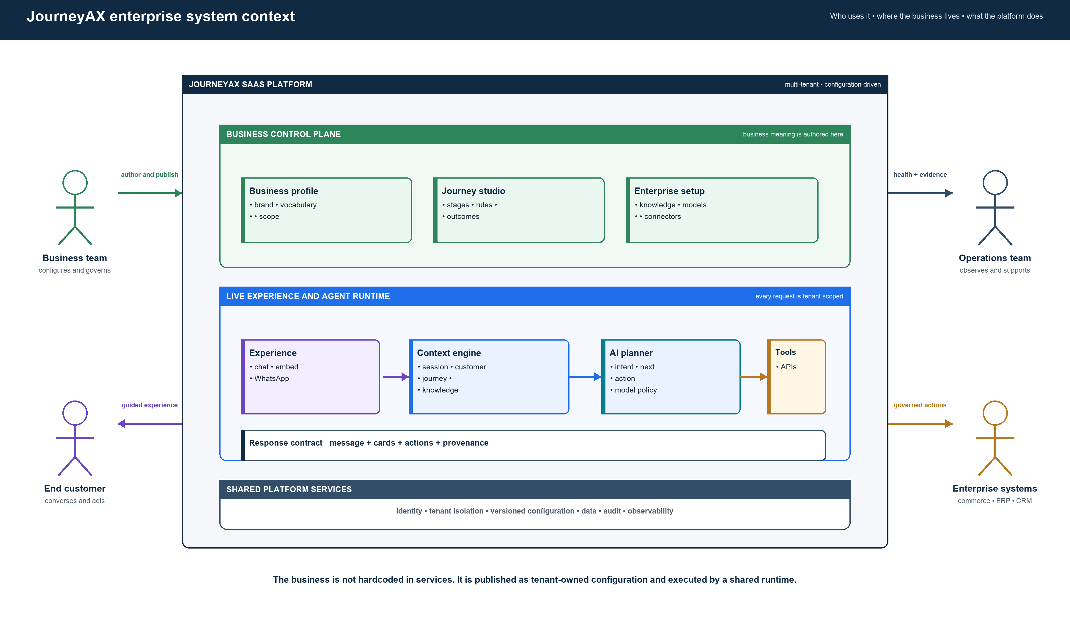
Figure 1 Enterprise system context
Architecture baseline Multi-tenant SaaS: Vercel web tier, Google Cloud Run services, and MongoDB Atlas operational and vector data. Reviewed 28 September 2026.
Status notation Live = implemented; partial = implemented with gaps; target = recommended end state.

Executive architecture decision
JourneyAX is not a collection of customer-specific chatbots. It is a multi-tenant journey platform. A business team defines its brand, vocabulary, journeys, rules, knowledge, model policy, connector bindings, and presentation. The platform compiles that configuration into a versioned Business Pack. A shared runtime then combines the pack with live session, customer, knowledge, and enterprise-system context to decide the next action and return a grounded response plus typed interface instructions.
Where the business lives. Business meaning is authored in the back-office and persisted by the project service. It is published as a Business Pack. It does not belong in API controllers, prompts tied to a brand, or tenant-name branches.
Where AI lives. The journey runtime interprets the event, assembles context, evaluates journey state and policy, selects a model, invokes allowed capabilities, and composes the response. Models advise inside the governed flow; they do not own tenant configuration or credentials.
Where connectors live. Stable capability contracts such as search catalog, validate pricing, create lead, and commit order are bound per tenant to native APIs or workflows. The runtime resolves the binding dynamically and retrieves credentials through secret references.
Where the customer experience lives. The storefront and channel adapters send messages and actions to the same runtime. Responses stream as text, trace events, and validated card instructions. The web client renders tenant-themed cards from the shared UI catalog.

Two meanings of customer
Term | Meaning in this document
Business customer or tenant | The company using JourneyAX, such as PlaceMakers, Workwear Group, Abercrombie and Fitch, or Caroma.
End customer | The shopper, buyer, dealer, installer, employee, or other person interacting with the JourneyAX experience.

Core architectural rule
The shared runtime must remain business-neutral. New business behavior is introduced by publishing configuration or registering a capability implementation. It must not require a new branch based on a customer name.

1 Enterprise system context
Figure 2 Business ownership and platform boundary
The upper control-plane area is where a tenant defines its business. The lower runtime area is the shared product that executes those definitions for every channel. Enterprise systems remain outside JourneyAX and are accessed only through governed capability contracts.

2 Cloud deployment architecture
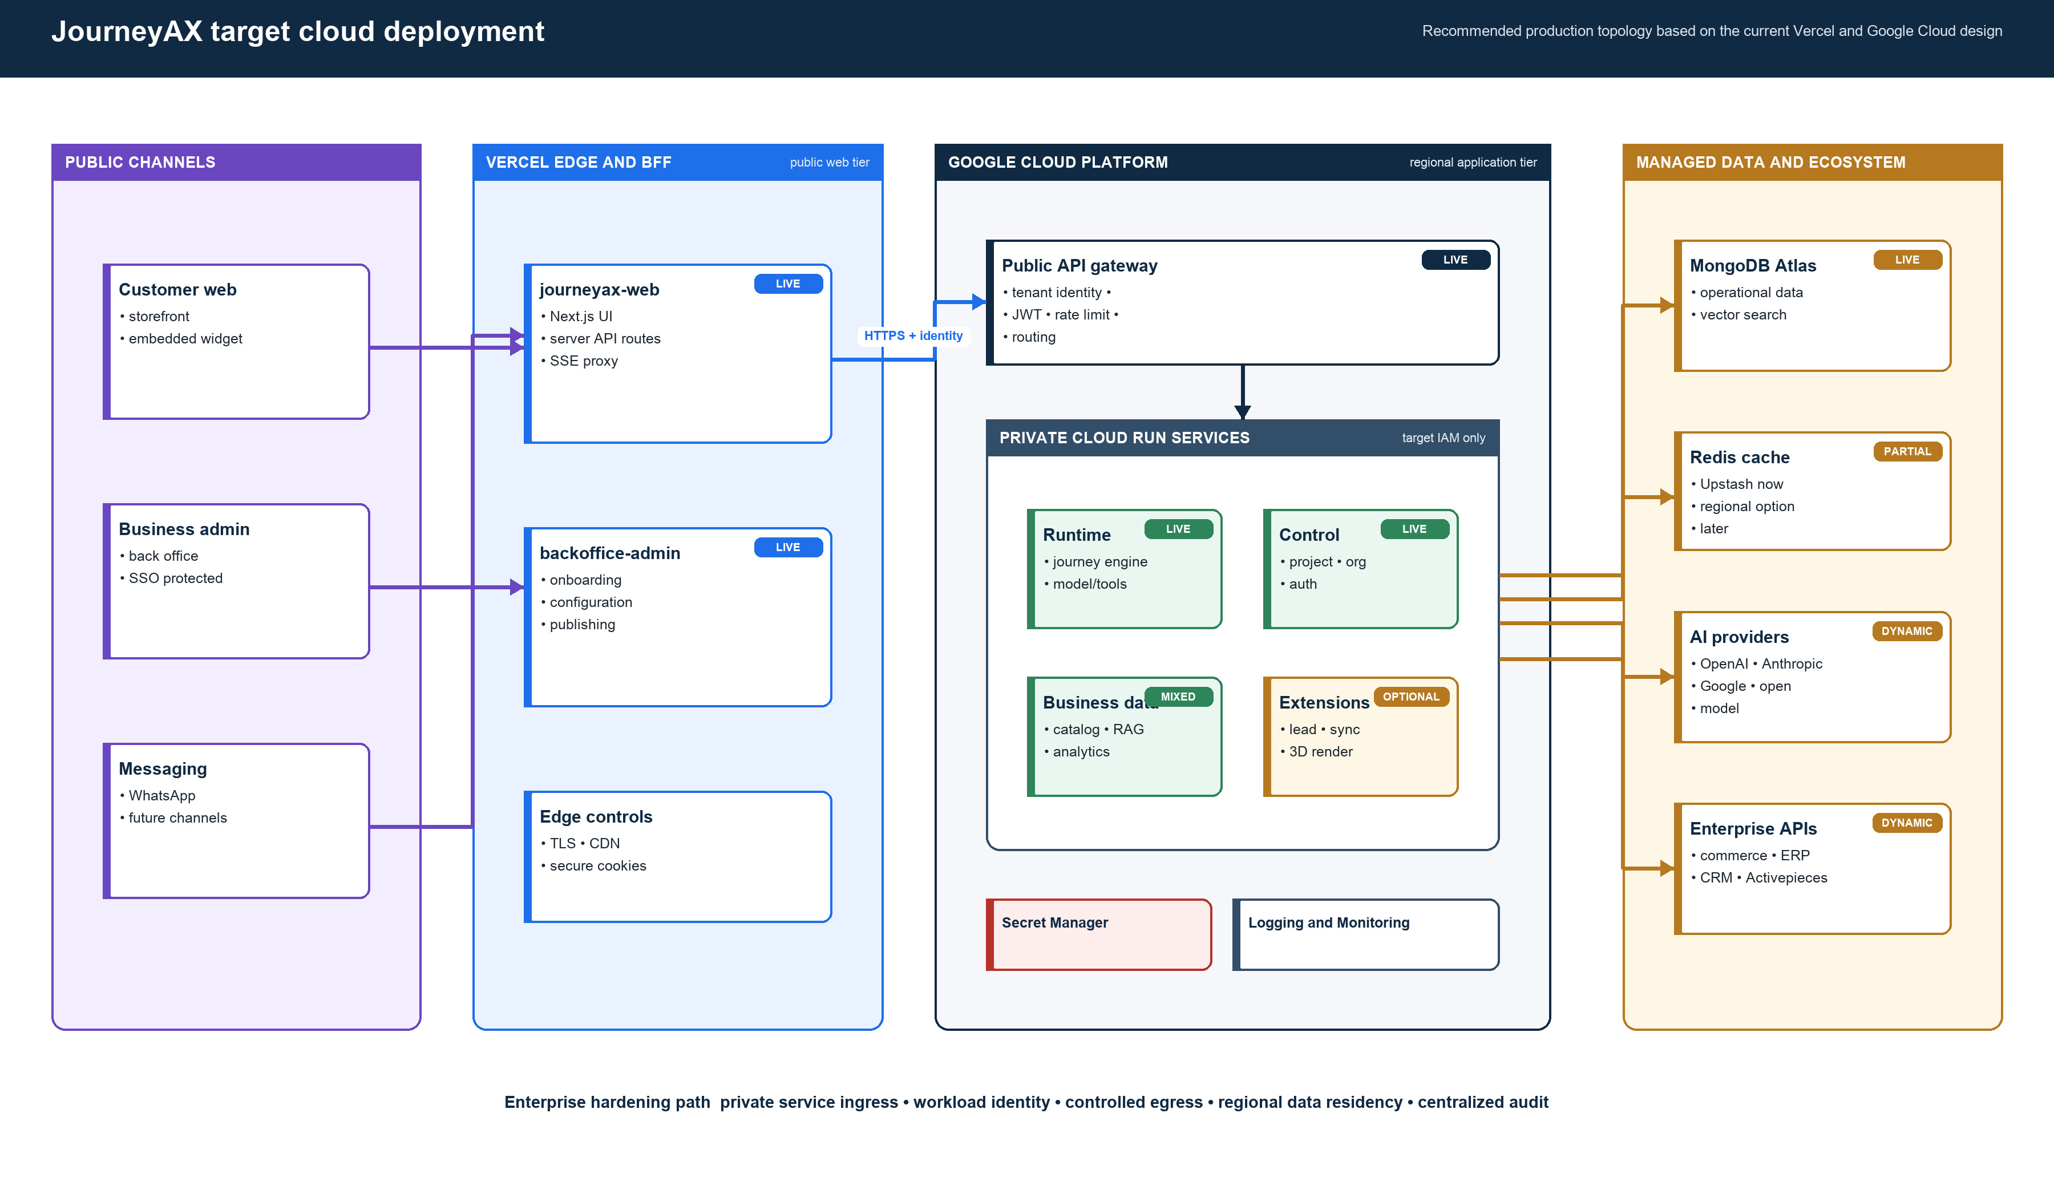
Figure 3 Target production cloud topology
The current repository already follows the Vercel plus Cloud Run direction. The enterprise target makes the gateway the only public backend, moves service-to-service access to workload identity, centralizes secrets, controls outbound connectivity, and keeps operational, vector, cache, and external-provider dependencies explicit.

3 Business customer onboarding
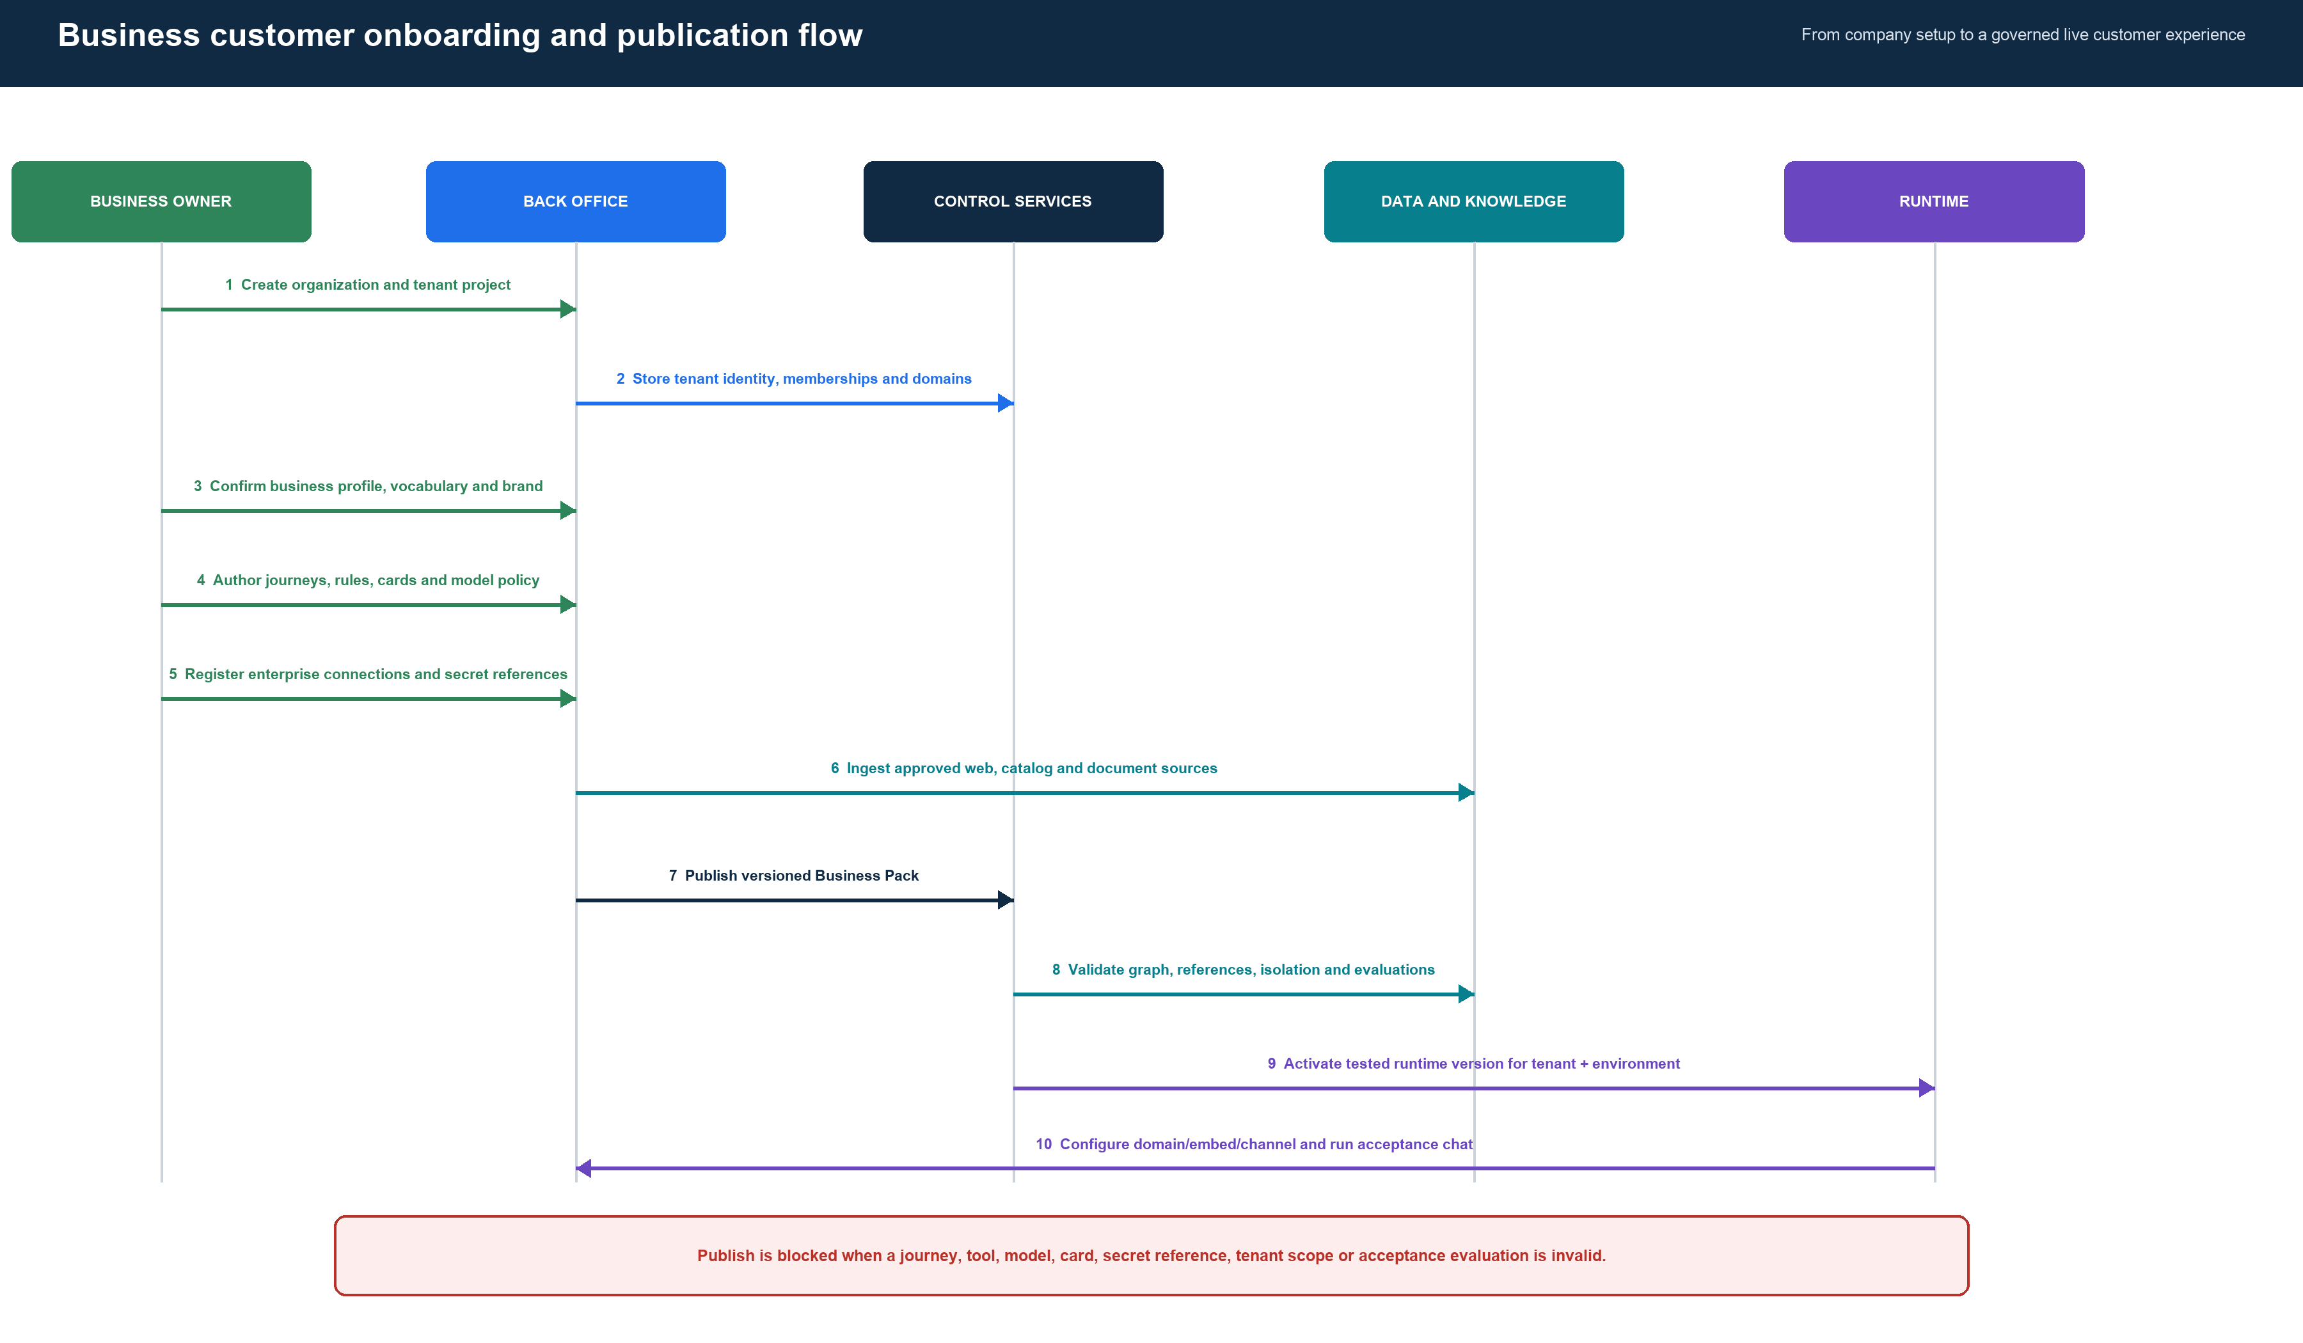
Figure 4 Business onboarding, validation, publication, and activation
Onboarding is a business configuration process, not a code migration. The operator creates the organization and tenant project, confirms discovered brand information, configures the journey, registers integrations, ingests knowledge, publishes a Business Pack, activates a tested version, and verifies the real channel. No customer-specific deployment should be required.

4 End customer conversation flow
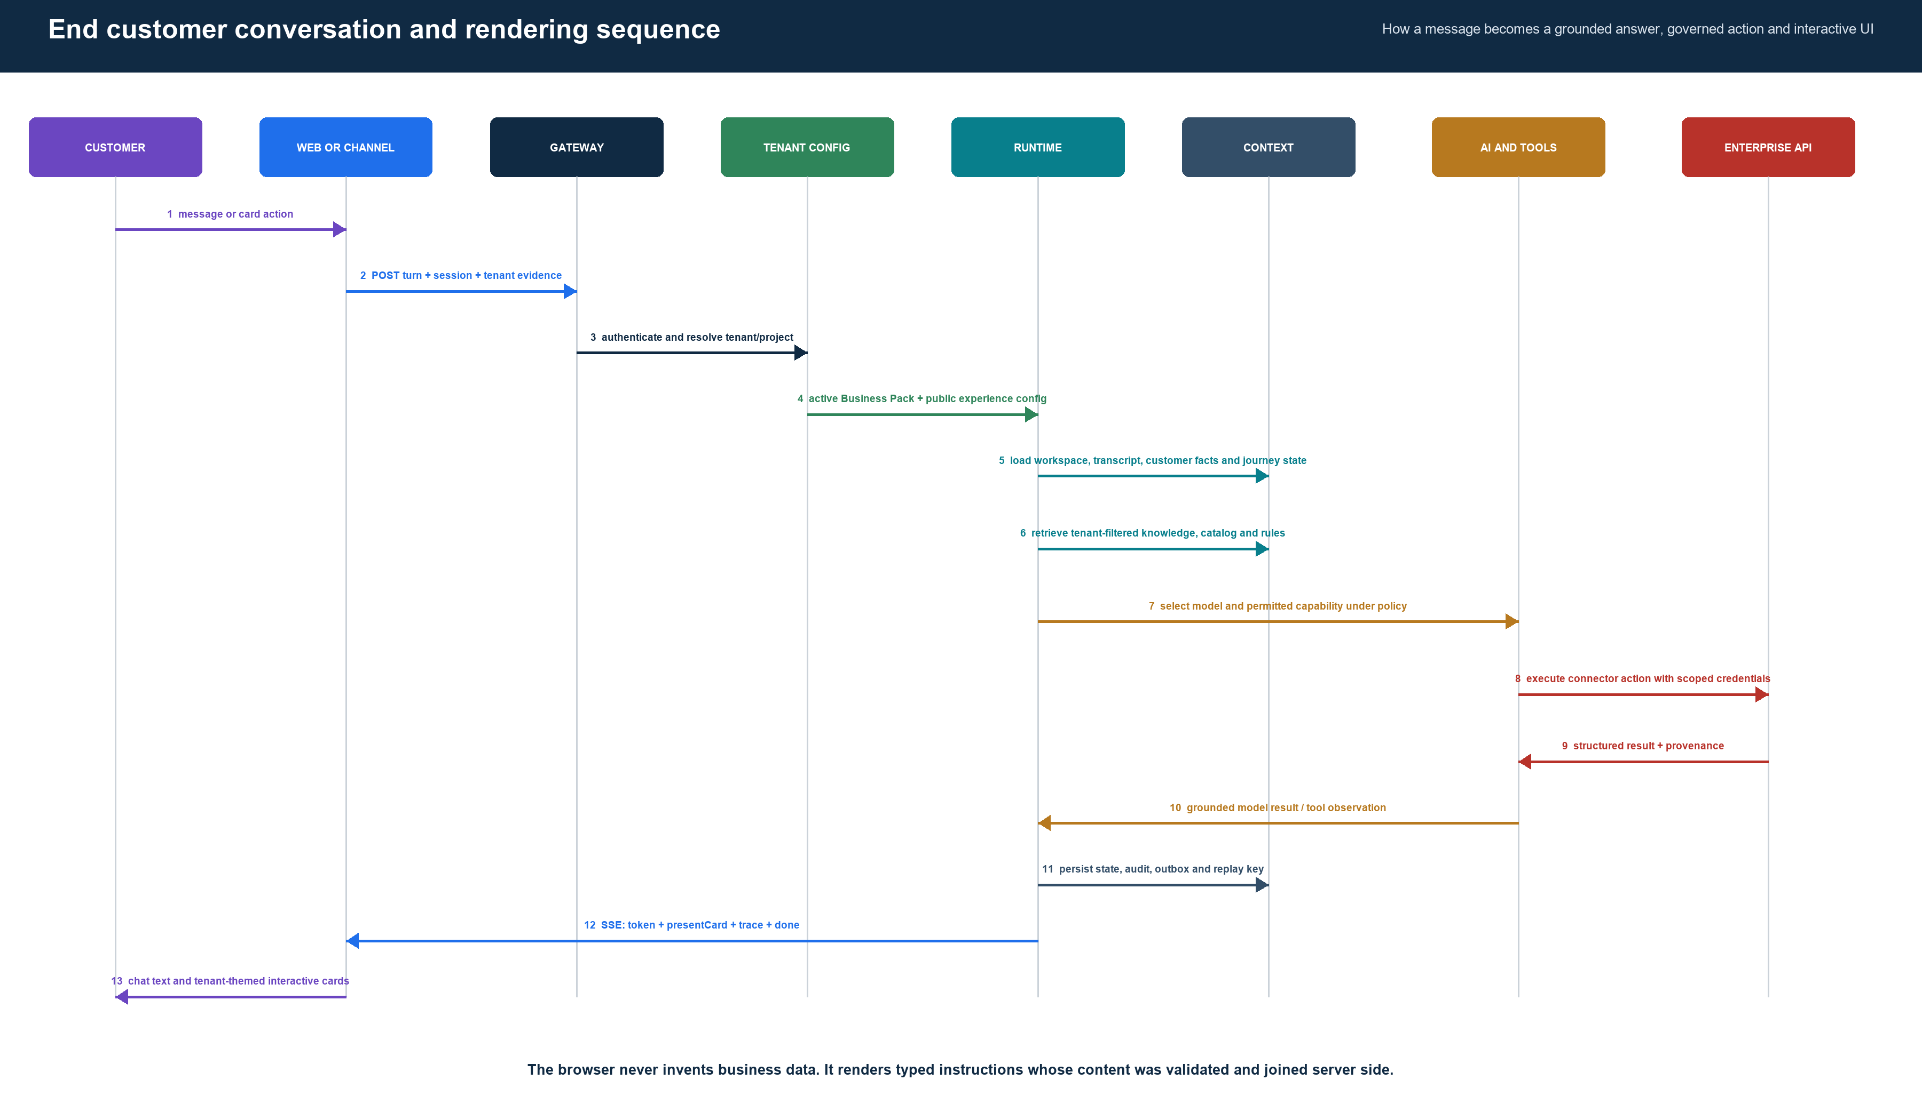
Figure 5 End-to-end message, context, tool, response, and rendering sequence
The public conversation path is one trace. Tenant identity is resolved before configuration or data access. The runtime loads the active pack and workspace, retrieves tenant-filtered context, selects an allowed model and capability, validates connector results, persists evidence, and streams a response that the channel can render deterministically.

5 Runtime context and decision architecture
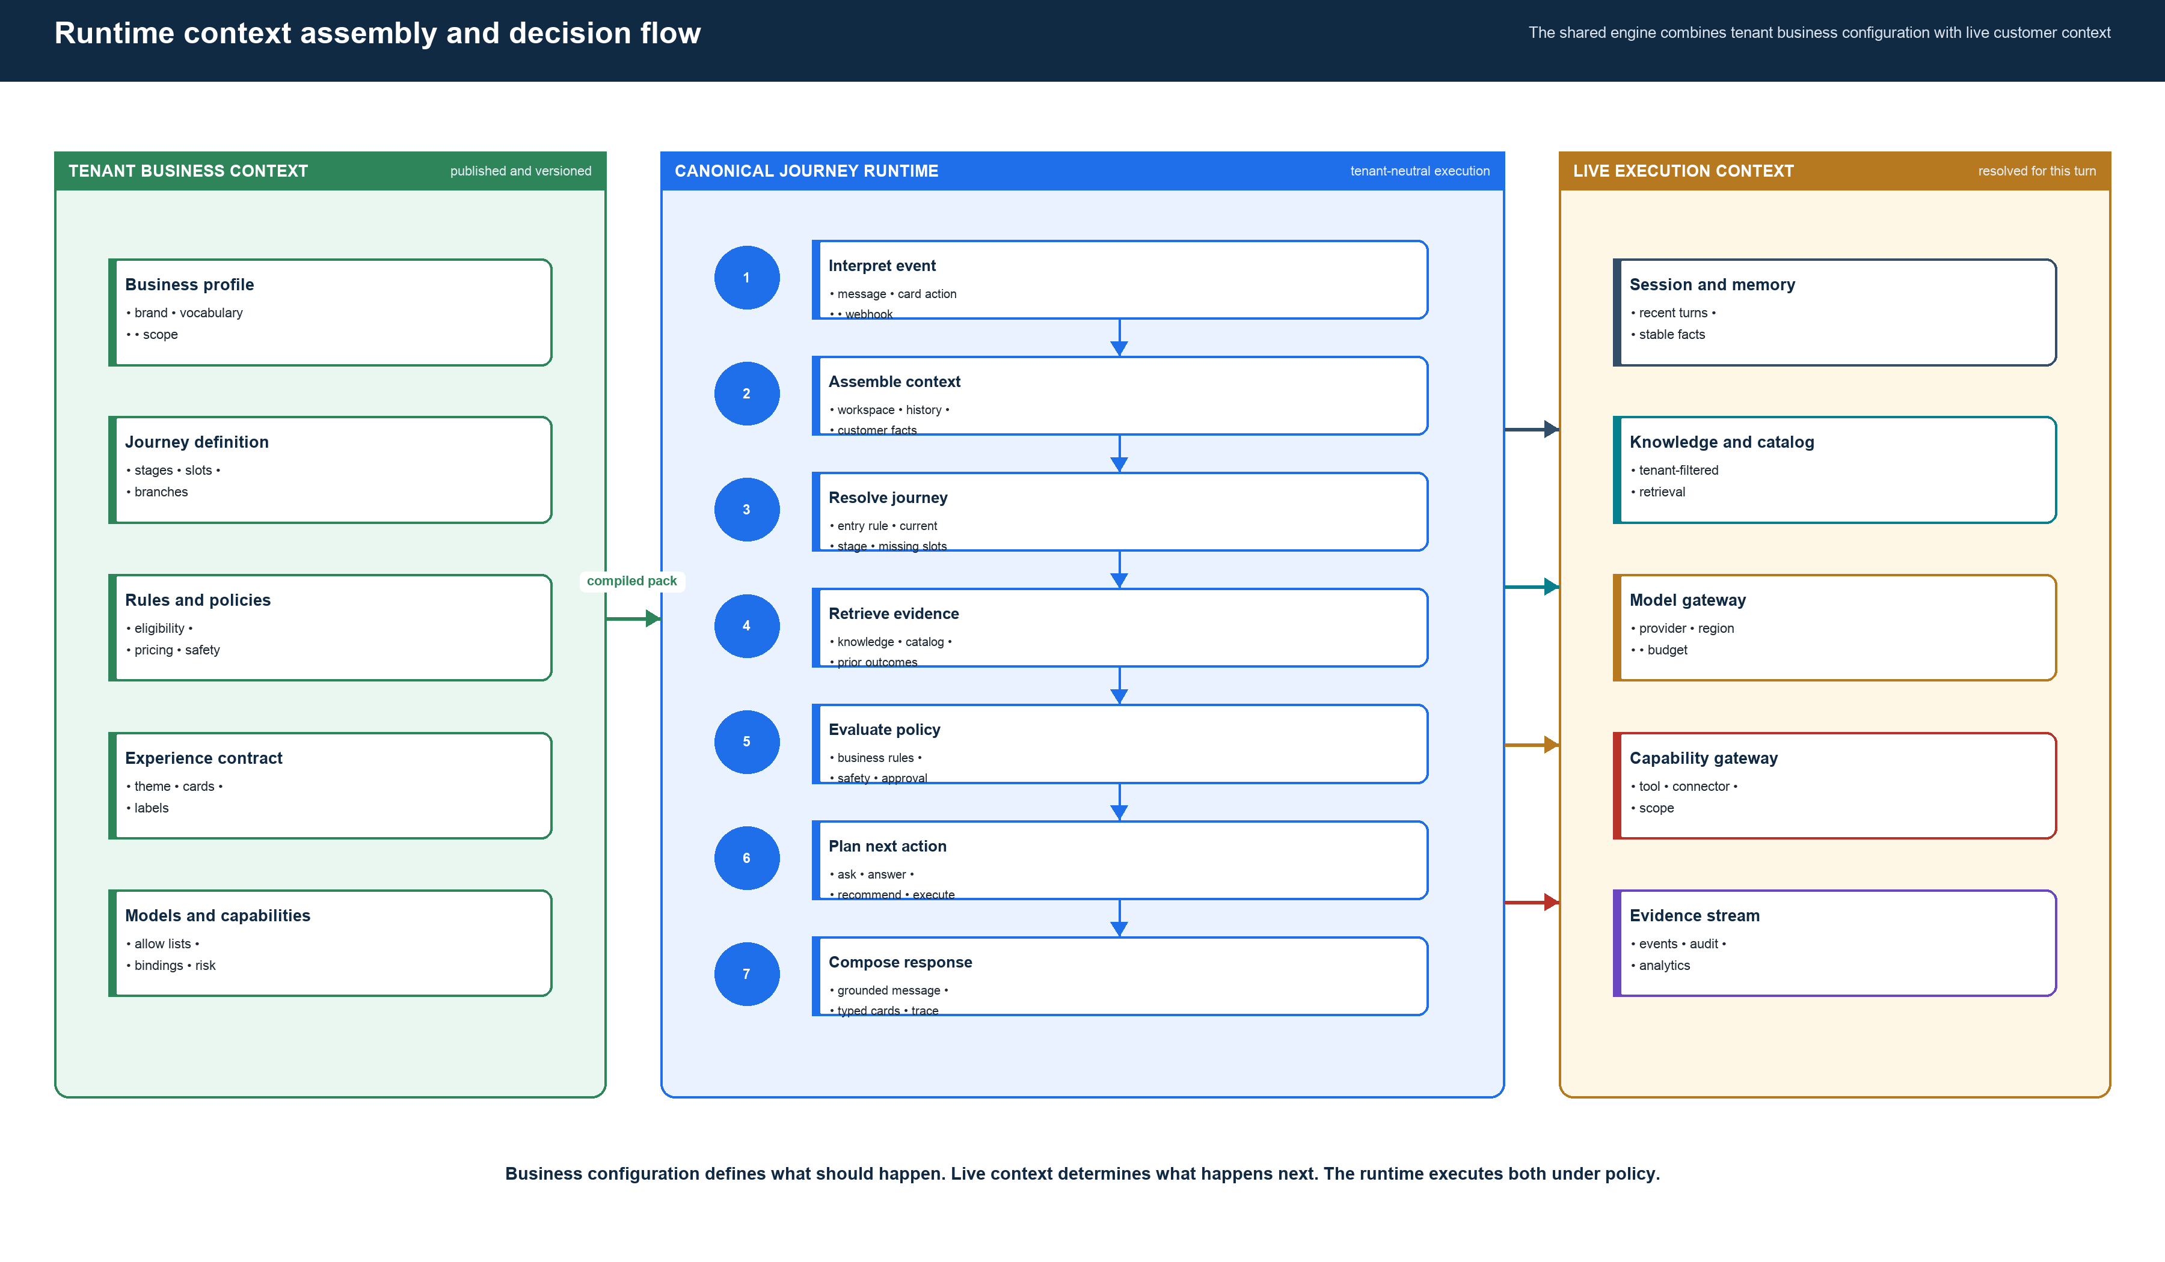
Figure 6 Business context plus live context entering the shared runtime
Business context changes only when a tenant publishes a configuration version. Live context changes on every turn. Keeping these inputs separate allows the platform to be dynamic without letting model output redefine business rules, tool permissions, pricing, or presentation contracts.

6 Dynamic models connectors and rendering
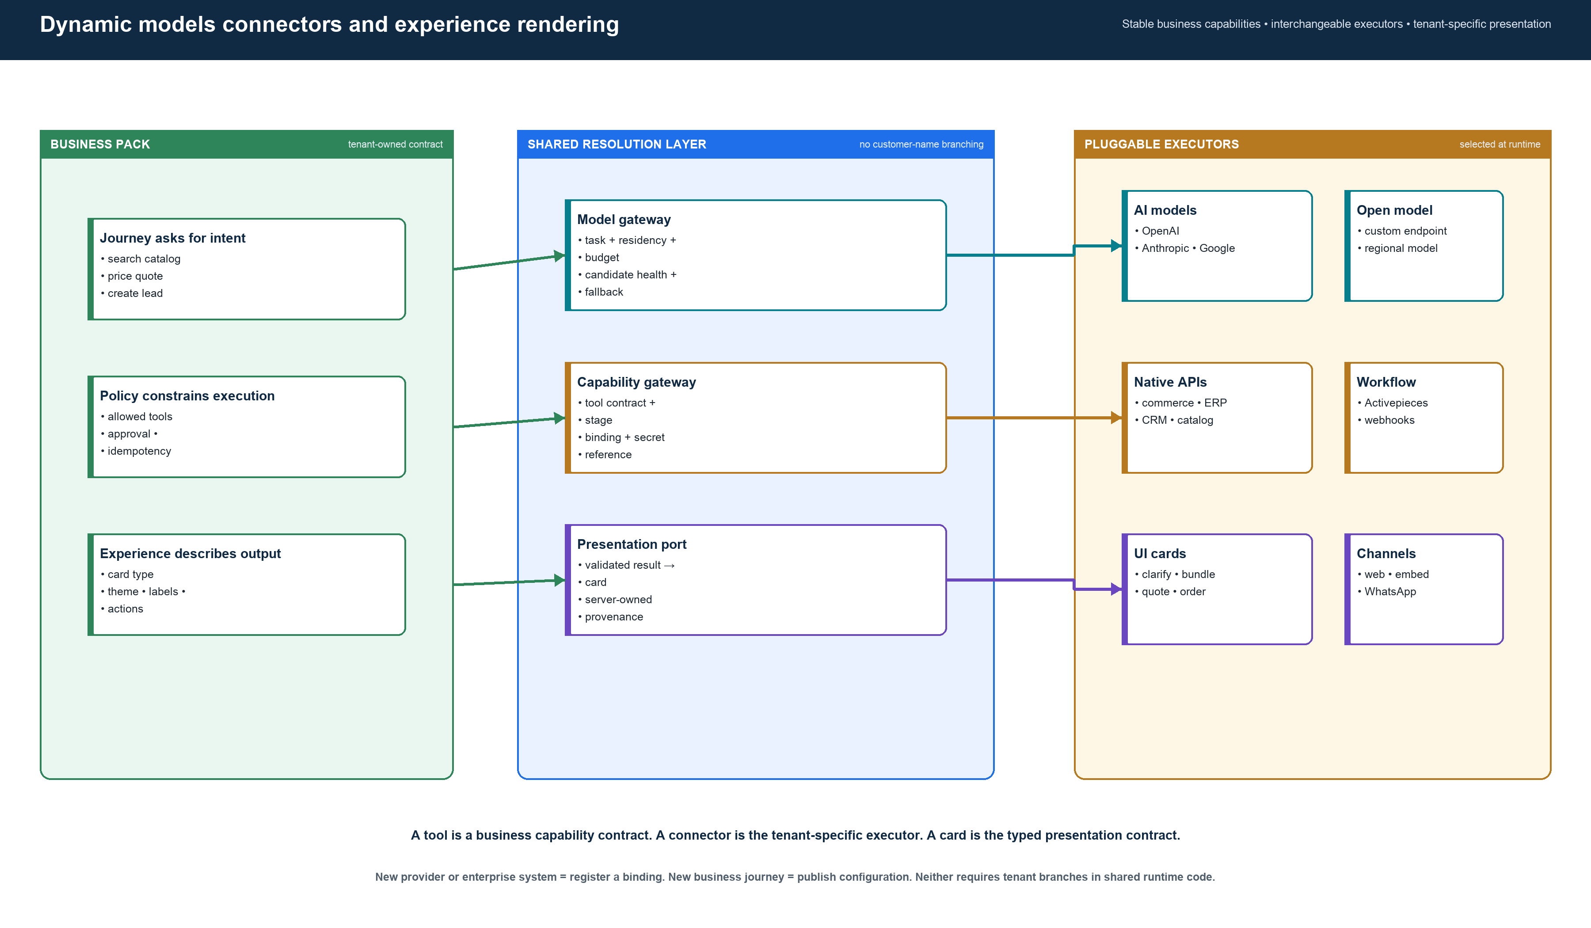
Figure 7 Resolution of models, connector executors, and interface cards
The key separation is tool versus connector. A tool is the domain-neutral capability requested by a journey. A connector is the tenant-specific executor. A card is a typed presentation contract. This allows the same journey runtime to work with different AI providers, commerce stacks, ERP and CRM systems, and channels without hardcoded tenant behavior.

7 Business configuration and Business Pack contents
The Business Pack is the deployable business definition consumed by the runtime. It is compiled from the tenant project configuration and validated as one coherent release.
Business concern | Owned by business or platform | Business Pack representation | Runtime use
Identity and vocabulary | Business | Business profile, locale, currency, entity vocabulary | Names concepts correctly and limits business scope
Customer journeys | Business | Multiple journey graphs with entry rules, stages, slots, branches, outcomes | Selects and advances the applicable journey
Business rules | Business | Eligibility, pricing, compliance, escalation and decision rules | Constrains recommendations and actions
Knowledge and catalog | Business plus integration | Source references, retrieval policy and catalog capability bindings | Retrieves tenant-filtered evidence
Model policy | Platform with tenant choice | Allowed providers, models, regions, budgets and fallback | Selects a model without embedding provider code in journeys
Tools and connectors | Platform contracts plus tenant bindings | Tool definitions, stage allow-lists, executor binding and secret reference | Invokes only permitted, scoped capabilities
Experience | Business plus design system | Theme, labels, cards, templates and allowed actions | Streams typed rendering instructions
Evaluations | Business acceptance plus quality engineering | Scenarios and blocking assertions | Blocks publication when required behavior fails

Publication lifecycle
- The business edits a draft in the back-office.
- The project service compiles journey graphs, model policy, capability bindings, experience configuration, entities, and evaluations.
- The Business Pack validator checks schema, graph reachability, references, tenant scope, and release integrity.
- The publisher stores an immutable release and checksum.
- A tenant and environment selects one active version. Rollback selects a prior immutable version; it never rewrites a release.

8 Application catalog and why each app exists
Application | Business or platform purpose | Primary callers | Architecture decision
journeyax-web | End-customer storefront, embedded widget, chat thread, SSE client, tenant-themed card rendering | Browsers and embedded host sites | Core channel. Keep thin; no business decisions or secrets.
backoffice-admin | Business onboarding and management of journeys, rules, knowledge, integrations, cards, users, analytics and publication | Tenant administrators and JourneyAX operators | Core control-plane experience.
api-gateway | Single backend entry, tenant route parsing, authentication, rate limits, request assertions and service routing | Vercel BFF routes and channels | Core public boundary. Internal services should become private.
journey-runtime-service | Canonical domain-neutral journey execution, context, models, capabilities, approvals, outbox and presentation | Gateway runtime routes | Strategic core runtime.
project-service | Tenant project configuration, memberships, domain/channel resolution, draft versions, Business Pack publication and rollback | Back-office, storefront resolver and runtime services | Strategic control-plane service.
auth-service | Account authentication, JWT and refresh-token lifecycle | Gateway and both web applications | Core identity service; enterprise SSO is a future adapter.
organization-service | Organization lifecycle and mapping organizations to tenant projects | Back-office onboarding and billing operations | Core SaaS account boundary.
product-service | Catalog, knowledge retrieval, vector search, availability, product media and specialised product operations | Runtime capabilities, storefront and back-office | Core retrieval service but currently broad; split specialised extensions only when justified.
analytics-service | Session evidence, funnel, runtime health, pack comparison, reports, alerts and retention operations | Back-office and event consumers | Core read and evidence service.

Application catalog continued
Application | Purpose | Architecture decision
agent-commerce-service | Existing broad commerce agent, SSE endpoints, WhatsApp and legacy business flows | Transition component. Freeze new tenant logic and route migrated tenants to the canonical runtime. Retain only compatibility or reusable adapters until safely retired.
lead-service | Pushes lead or customer information into CRM | Keep as a capability executor only after removing tenant-name CRM selection and resolving bindings dynamically.
data-service | Thin data synchronisation endpoint | Treat as an extension. Define specific sync contracts or retire it; it should not become a generic data dumping service.
retexture-service | Specialised Python service for 3D texture and image-generation jobs | Optional vertical extension invoked through a capability contract. Not part of the core conversation engine.
WhatsApp controller | Receives and sends WhatsApp messages for a tenant resolved by phone-number identity | Channel adapter. Convert channel events into the same runtime command and presentation response.
Next.js BFF routes | Keep backend URLs, internal keys and session cookies server-side; proxy browser calls and streams | Channel boundary only. They should not choose business logic, models, products, or connectors.

What should not become another app
Do not create a microservice for every journey stage, card, model, customer, or connector. Journeys and cards are configuration; models and connectors are registry entries; stages are runtime state. A new deployable app is justified only by an independent scaling profile, security boundary, runtime technology, or operational ownership.

9 Shared packages and extension model
Package | Why it exists | Who should depend on it
business-pack | Schemas, compiler, validator, immutable publisher and loader for tenant business definitions | Project service, runtime and quality tooling
journey-core | Domain-neutral journey state, commands, results, evaluator and routing primitives | Runtime, capability layer and tests
capability-sdk | Resolves, policy-checks and dispatches tools without exposing vendor code to the journey engine | Runtime and connector executors
integration | Business-domain ports and per-platform adapters such as commerce or CRM | Capability handlers only; agent and UI must not import vendors
ui-cards | Typed card catalog, default templates, React renderer and theme tokens | Runtime presentation port, storefront and card studio
database | Mongo connections, activation repository, outbox, replay and persistence contracts | Backend services through scoped repositories
events | Typed platform event contracts | Runtime, analytics and workflow integrations
cache | Redis-compatible cache with controlled fallback | Config loaders, rate limiting and retrieval acceleration
ingestion | Reusable source ingestion primitives | Knowledge onboarding and scheduled refresh jobs
configurator-core | BOM, pricing and configuration calculations | Configurator capability handlers
activepieces-piece | JourneyAX triggers and actions exposed to Activepieces | Workflow automation deployments
shared-types | Stable API DTOs and shared identifiers | Apps at contract boundaries
design-system | Brand-neutral design tokens and components | Both web applications and UI cards

Extension registration contract
A new model provider, commerce platform, ERP, CRM, workflow, channel, or specialist processor must register an implementation behind a stable contract. The Business Pack selects it by identifier and supplies only tenant-scoped references. Shared runtime code must not infer a provider from a tenant name.

10 Data security and evidence architecture
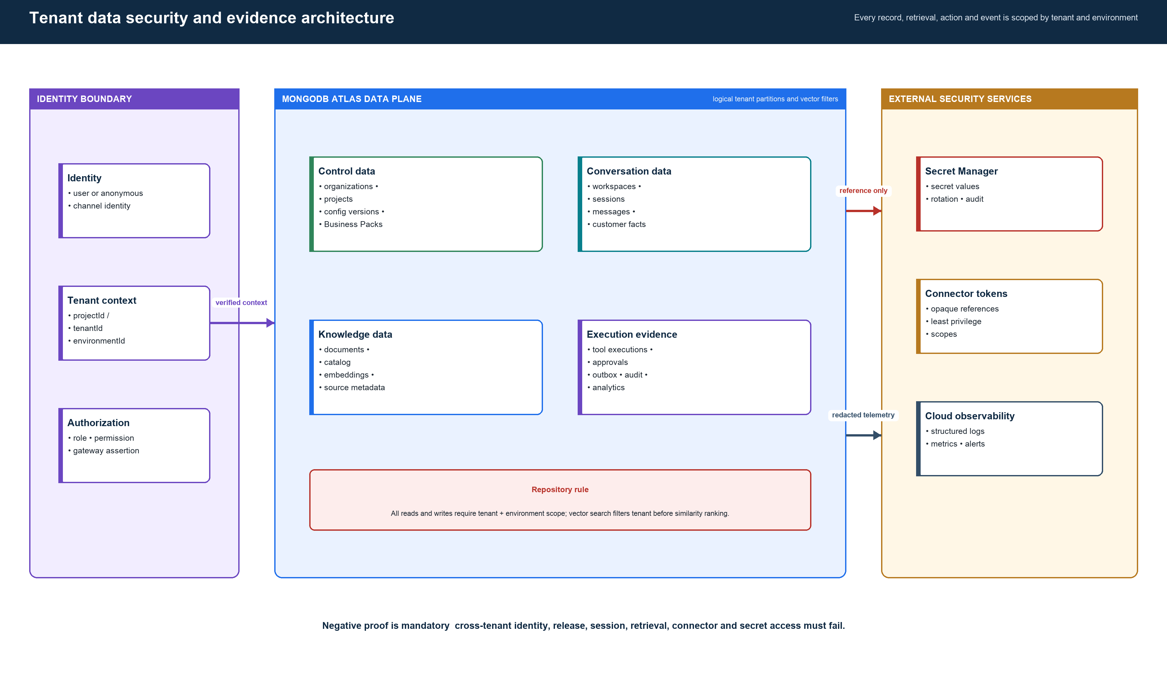
Figure 8 Tenant-scoped data, secrets, and observability boundaries
The tenant and environment identity is part of every repository key, vector filter, workspace key, release lookup, connector binding and event. Business Packs contain secret references, never secret values. Evidence records connect every response to the configuration version, journey decision, model route and capability execution that produced it.

11 Tenant runtime activation and release safety
Tenant Runtime Activation is the permanent architecture concept. It states which runtime and immutable Business Pack version is active for one tenant and environment. Version integrity, controlled canaries, atomic pointer updates, and rollback remain part of the platform after every legacy path is gone. Some current code still uses the migration-era word “cutover”; that wording is deprecated and must not appear in product or operator architecture.
Current internal label | Enterprise architecture term | Purpose
tenant_cutovers storage alias | Tenant runtime activation record | States which runtime and immutable Business Pack version is approved for a tenant and environment.
legacy/new proxy | Runtime version router | Routes the conversation to the approved engine only while both runtimes coexist.
checksum gate | Release integrity verification | Proves the active Business Pack is exactly the version that was approved.
canary | Controlled activation cohort | Allows a stable subset of workspaces to exercise a new runtime version before full activation.
rollback | Activate prior known-good version | Moves the active reference back without mutating published releases.

Why it is needed now. It prevents split state, accidental legacy fallback, and execution of a pack that was changed after approval while two runtimes coexist.
What happens later. After every supported tenant uses the canonical runtime and the legacy engine is retired, the migration-routing part disappears. The permanent capability is simply version activation, integrity verification, canary release, and rollback.
Migration compatibility. Use Tenant Runtime Activation and Active Runtime Version everywhere. Preserve the old collection name only behind a repository adapter until existing records are migrated; do not expose it through public APIs, headers, UI, reports, or diagrams.

12 Current implementation versus target architecture
Capability | Current evidence | Target state | Priority
Business control plane | Back-office, project configuration, version publishing and Business Pack compiler exist | One authoritative pack publication path with complete reference and evaluation gates | P0
Canonical runtime | Journey runtime, models, capabilities, approvals, outbox and presentation exist | All active customer traffic uses it; no new tenant behavior enters legacy agent | P0
Dynamic connectors | Integration ports, capability bindings and Activepieces support exist | Every CRM, ERP, commerce and workflow action resolves from tenant binding; no tenant-name conditions | P0
Dynamic experience | Public config, themes, labels, card templates and shared renderer exist | All rendered business data arrives through validated card contracts; remove remaining legacy panel paths | P1
Cloud boundary | Vercel, Cloud Run and deployment automation exist | Gateway-only public backend, private services, workload identity, controlled egress and centralized audit | P1
Tenant data isolation | Project/tenant scoping is broadly present and negative tests exist | One canonical identifier vocabulary and repository-enforced scope on every collection and vector query | P0
Observability | Analytics endpoints, trace fields, outbox and health endpoints exist | End-to-end trace, SLOs, redaction, security alerts and release evidence dashboards | P1
Customer onboarding | Wizard, URL probe, project creation, config, knowledge ingest and publish exist | One guided workflow with readiness checklist and channel acceptance test | P1

13 Development sequence before more customer migrations
Keep PlaceMakers as the reference tenant. Do not start another customer migration until the shared platform checkpoint below is complete.
1. Make the Business Pack schema and runtime validator one authoritative contract.
2. Replace remaining tenant-name decisions in shared runtime paths with capability or configuration lookup.
3. Make active runtime version resolution the single path after activation; remove post-activation filesystem and legacy fallback.
4. Prove tenant identity through gateway, release, workspace, retrieval, connector, secret and rendering boundaries.
5. Run the public storefront through the canonical runtime and retain a sanitized sequence transcript and evidence record.
6. Publish one platform readiness report that distinguishes implemented, partial and target capabilities.

Definition of platform ready
The platform is ready for the next customer when a new tenant can be created, configured, connected, supplied with knowledge, published, activated, exercised through the public chat, and rolled back without editing application code or exposing another tenant’s data.

Appendix Repository map
Architecture responsibility | Primary repository location
Customer experience and typed rendering | apps/journeyax-web and packages/ui-cards
Business administration and onboarding | apps/backoffice-admin
Tenant project, version and Business Pack publication | apps/project-service and packages/business-pack
Public service boundary and tenant routing | apps/api-gateway
Canonical journey execution | apps/journey-runtime-service and packages/journey-core
Dynamic tool policy and dispatch | packages/capability-sdk
External system adapters | packages/integration and packages/activepieces-piece-journeyax
Catalog, product knowledge and vector retrieval | apps/product-service and packages/ingestion
Identity and SaaS account boundary | apps/auth-service and apps/organization-service
Persistence, outbox, replay and activation state | packages/database
Evidence and reporting | apps/analytics-service and packages/events
Migration-era compatibility | apps/agent-commerce-service

End of enterprise architecture handover

