源代码1：
using System;
using System.Collections.Generic;
using System.Linq;
using System.Text;

namespace ConsoleApplication1
{
class Program
{
static int add(int a, int b)
{
return a + b;
}

public int sub(int a, int b)
{
return a - b;
}

static void Main(string[] args)
{
Console.WriteLine(add(3, 4));
}
}
}
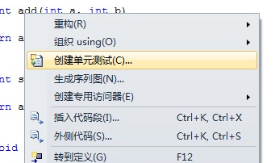
源代码2：
using System;
using System.Collections.Generic;
using System.Linq;
using System.Text;

namespace ConsoleApplication1
{

class Test
{
private int a;
private int b;

Test()
{
a = 3;
b = 4;
}

public int pow()
{
return int.Parse(Math.Pow(a, b).ToString());
}
}
class Program
{
static int add(int a, int b)
{
return a + b;
}

public int sub(int a, int b)
{
return a - b;
}

static void Main(string[] args)
{
Console.WriteLine(add(3, 4));
}
}
}

