AI-Driven Social Media Dashboard

### AWS Serverless Data Lake - Implementation Guide

April 2020



#### Contents

Overview 3

Cost 3

Architecture Overview 4

Solution Components 5

Tweet Ingestion 5

Social Media Data Lake 5

Design Considerations 6

Supported Languages 6

Data Visualization 6

Stack Deletion 6

Regional Deployment 6

AWS CloudFormation Template 7

Automated Deployment 7

Prerequisites 7

What We’ll Cover 7

Step 1. Launch the Stack 8

Step 2. Build the Queries 10

Step 3. Create the Data Source 10

Step 4. Build the Dashboard 12

Security 16

Solution Security 16

Additional Resources 16

Appendix A: Cost Estimate Breakdown 17

Appendix B: Auto-Generated Data Model 18

Source Code 20

About This Guide

This implementation guide discusses architectural considerations and configuration steps for deploying an AI-Driven Social Media Dashboard on the Amazon Web Services (AWS) Cloud. It includes links to an [AWS CloudFormation](https://aws.amazon.com/cloudformation/) template that launches, configures, and runs the AWS services required to deploy this solution using AWS best practices for security and availability.

The guide is intended for IT Infrastructure Architects, Administrators, and DevOps professionals who have practical experience architecting on the AWS Cloud.

# Overview

Companies can gain valuable insight and deepen brand awareness by analyzing their social media interactions with customers. Using machine learning (ML) and business intelligence (BI) services from Amazon Web Services (AWS), including [Amazon Translate](https://aws.amazon.com/translate/), [Amazon](https://aws.amazon.com/comprehend/) [Comprehend](https://aws.amazon.com/comprehend/), [Amazon Kinesis](https://aws.amazon.com/kinesis/), [Amazon Athena](https://aws.amazon.com/athena/), and [Amazon QuickSight](https://aws.amazon.com/quicksight/), businesses can build meaningful, low-cost social media dashboards to analyze customer sentiment, which can lead to better opportunities for acquiring leads, improve website traffic, strengthen customer relationships, and improve customer service.

To help customers more easily build a natural-language-processing (NLP)-powered social media dashboard for customer feedback, AWS offers the AI-Driven Social Media Dashboard. This solution automatically provisions and configures the AWS services necessary to capture multi-language tweets in near real-time, translate them, and display them on a dashboard powered by Amazon QuickSight.

You can also capture both the raw and enriched datasets and durably store them in the solution's data lake. This allows data analysts to quickly and easily perform new types of analytics and ML on this data.

## Cost

You are responsible for the cost of the AWS services used while running this reference deployment. As of the date of publication, the total cost for running this solution with default settings in the US East (N. Virginia) Region is approximately **$190 per month** for ingesting 10,000 tweets per day and storing them for one year. Refer to Appendix A for a breakdown of the cost.

## Architecture Overview

Deploying this solution builds the following environment in the AWS Cloud.

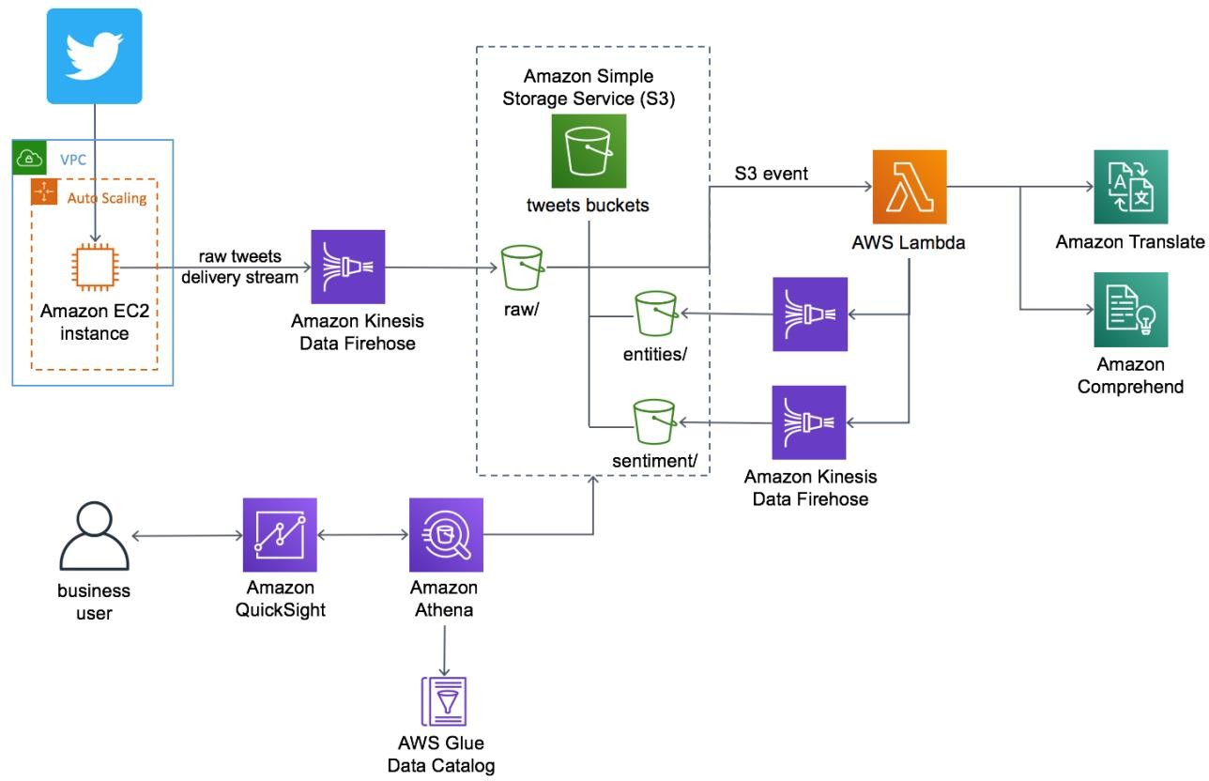

**Figure 1: AI-Driven Social Media Dashboard architecture on AWS**

The AWS CloudFormation template deploys an [Amazon Elastic Compute Cloud](https://aws.amazon.com/ec2/) (Amazon EC2) instance in an [Amazon Virtual Private Cloud](https://aws.amazon.com/vpc/) (Amazon VPC) that ingests tweets from Twitter. An [Amazon Kinesis Data Firehose](https://aws.amazon.com/kinesis/data-firehose/) delivery stream loads the streaming tweets into the raw prefix in the solution's [Amazon Simple Storage Service](https://aws.amazon.com/s3/) (Amazon S3) bucket. Amazon S3 invokes an [AWS Lambda](https://aws.amazon.com/lambda/) function to analyze the raw tweets using Amazon Translate to translate non-English tweets into English, and Amazon Comprehend to use natural- language-processing (NLP) to perform entity extraction and sentiment analysis.

A second Kinesis Data Firehose delivery stream loads the translated tweets and sentiment values into the sentiment prefix in the Amazon S3 bucket. A third delivery stream loads entities in the entities prefix in the Amazon S3 bucket.

The solution also deploys a data lake that includes [AWS Glue](https://aws.amazon.com/glue/) for data transformation, Amazon Athena for data analysis, and Amazon QuickSight for data visualization. AWS Glue Data Catalog contains a logical database (ai_driven_social_media_dashboard) which

is used to organize the tables for the data in Amazon S3. Athena uses these table definitions to query the data stored in Amazon S3 and return the information to an Amazon QuickSight dashboard.

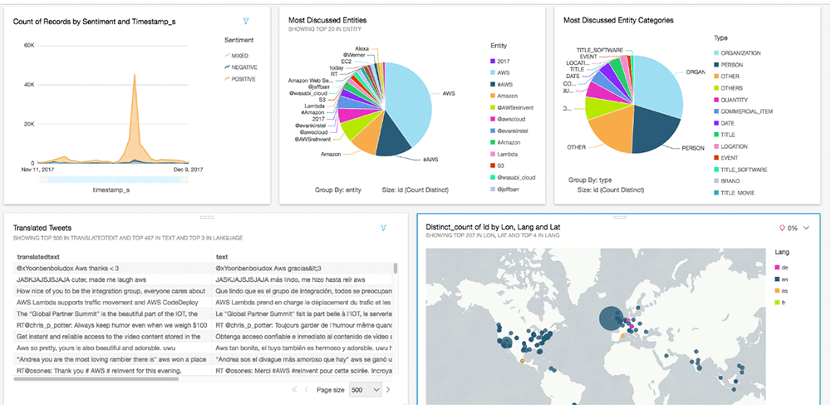

**Figure 2: Sample Amazon QuickSight dashboard for visualizing tweet analysis**

# Solution Components

## Tweet Ingestion

The solution's Amazon Elastic Compute Cloud (Amazon EC2) instance has a Node.js application that monitors tweets for a list of terms you specify during initial deployment. When the solution finds a tweet containing one or more of the terms, the solution will ingest that tweet. You can modify the terms that will be pulled from the Twitter streaming API. By default, this solution uses stream processing for tweets. After tweet ingestion, AWS Lambda analyzes your tweets using Amazon Translate and Amazon Comprehend.

To retrieve tens or hundreds of tweets per second, you can perform batch calls or leverage AWS Glue with triggers to perform batch processing.

## Social Media Data Lake

This solution includes a data lake to store your tweet data. The data lake consists of Amazon S3 to store raw and enriched datasets, Amazon Kinesis Data Firehose delivery streams to write the ingested tweet data to the data lake, and AWS Glue Data Catalog to be the metadata

catalog for analytics. By default, this solution uses Amazon Athena to query data in the data lake. But, you can extend this solution to use [Amazon Redshift Spectrum](https://docs.aws.amazon.com/redshift/latest/dg/c-getting-started-using-spectrum.html), [Amazon EMR](https://aws.amazon.com/emr/), and [Amazon SageMaker](https://aws.amazon.com/sagemaker/).

# Design Considerations

## Supported Languages

By default, this solution can ingest tweets in English, Spanish, German, French, Arabic, and Portuguese. To add additional languages, add the language code to the list in the **Twitter Language** AWS CloudFormation template parameter.

Note that this solution does not automatically map the language codes in Twitter to the codes in Amazon Translate. The solution includes a default set of language codes that match in Twitter and Amazon Translate. Customers who want to add additional languages should either verify that Twitter and Amazon Translate use the same language code, or modify the included Lambda function to map the languages. For a list of codes for Amazon Translate, see [Supported Language Codes](https://docs.aws.amazon.com/translate/latest/dg/how-it-works.html#how-it-works-language-codes) in the *Amazon Translate Developer Guide*.

## Data Visualization

You can use Amazon QuickSight to build dashboards that enable you to visualize tweets over time, the sentiment of the tweets, and the relationship between the entities being discussed and the sentiment values from the tweets. For more information on how to leverage Amazon QuickSight to visualize tweet data, see Step 4 of the Automated Deployment section.

## Stack Deletion

The AI-Driven Social Media Dashboard is designed to enable you to retain the tweet data stored in Amazon S3. If you delete the solution stack, the Amazon S3 bucket with your tweet data will not be deleted. You must manually delete this bucket.

## Regional Deployment

This solution uses Amazon QuickSight, Amazon Athena, Amazon Translate, Amazon Comprehend, and AWS Glue which are currently available in specific AWS Regions only. Therefore, you must launch this solution in an AWS Region where these services are available. For the most current service availability by AWS Region, see [AWS service offerings](https://aws.amazon.com/about-aws/global-infrastructure/regional-product-services/) [by regions](https://aws.amazon.com/about-aws/global-infrastructure/regional-product-services/).

# AWS CloudFormation Template

This solution uses AWS CloudFormation to automate the deployment of AI-Driven Social Media Dashboard on the AWS Cloud. You can download the following template before deployment:

**ai-driven-social-media-dashboard.template:** This is the primary solution template you use to launch AI-Driven Social Media

**[View template](https://s3.amazonaws.com/solutions-reference/ai-driven-social-media-dashboard/latest/ai-driven-social-media-dashboard.template)**

Dashboard and all associated components. The default configuration deploys an Amazon Elastic Compute Cloud (Amazon EC2) instance, Amazon Kinesis Data Firehose delivery streams, an AWS Lambda function, Amazon Athena, AWS Glue Data Catalog, Amazon Translate, and Amazon Comprehend, but you can also customize the template based on your specific needs.

# Automated Deployment

Before you launch the automated deployment, please review the architecture, configuration, and other considerations discussed in this guide. Follow the step-by-step instructions in this section to configure and deploy the AI-Driven Social Media Dashboard template into your account.

**Time to deploy:** Approximately five minutes

## Prerequisites

Before you launch this solution, you must have a Twitter consumer key (API key) and secret, and a Twitter access key and secret. If you do not already have these keys, you must [create an](https://developer.twitter.com/en/apps) [app in Twitter](https://developer.twitter.com/en/apps).

You must also have an Amazon Elastic Compute Cloud (Amazon EC2) key pair. If you do not already have a key pair, see [Creating a Key Pair Using Amazon EC2](https://docs.aws.amazon.com/AWSEC2/latest/UserGuide/ec2-key-pairs.html#having-ec2-create-your-key-pair) in the *Amazon EC2 User Guide for Linux Instances*.

## What We’ll Cover

The procedure for deploying this architecture on AWS consists of the following steps. For detailed instructions, follow the links for each step.

Step 1. Launch the Stack

* Launch the AWS CloudFormation template into your AWS account.
* Enter values for required parameters: **Stack Name**, **Auth Access Token**, **Auth Access Token Secret, Twitter Consumer Key, Twitter Consumer Key Secret**.
* Review the other template parameters and adjust if necessary.

Step 2. Build the Queries

* Build the Amazon Athena queries.

Step 3. Create the Data Source

* Create the Amazon QuickSight data source.

Step 4. Build the Dashboard

* Create the Amazon QuickSight dashboard to visualize the data.

## Step 1. Launch the Stack

This automated AWS CloudFormation template deploys the AI-Driven Social Media Dashboard on the AWS Cloud. Please make sure that you have completed the prerequisites before launching the stack.

|  |
| --- |
| **Note:** You are responsible for the cost of the AWS services used while running this |
| solution. See the Cost section for more details. For full details, see the pricing webpage |
| for each AWS service you will be using in this solution. |

1. Sign in to the AWS Management Console and click the button to the right to launch the ai-driven-social-media- dashboard AWS CloudFormation template.

**Launch Solution**

You can also [download the template](https://s3.amazonaws.com/solutions-reference/ai-driven-social-media-dashboard/latest/ai-driven-social-media-dashboard.template) as a starting point for your own implementation.

1. The template is launched in the US East (N. Virginia) Region by default. To launch the solution in a different AWS Region, use the region selector in the console navigation bar.

|  |
| --- |
| **Note**: This solution uses Amazon QuickSight, Amazon Athena, Amazon Translate, |
| Amazon Comprehend, and AWS Glue, which are currently available in specific AWS |
| Regions only. Therefore, you must launch this solution in an AWS Region where these |
| services are available. For the most current service availability by region, see [AWS](https://aws.amazon.com/about-aws/global-infrastructure/regional-product-services/) |
| [service offerings by region](https://aws.amazon.com/about-aws/global-infrastructure/regional-product-services/). |

1. On the **Select Template** page, verify you selected the correct template and choose **Next**.
2. On the **Specify Details** page, assign a name to your solution stack.
3. Under **Parameters**, review the following parameters for the template and modify them as necessary. This solution uses the following default values.

|  |  |  |
| --- | --- | --- |
| **Parameter** | **Default** | **Description** |
| **Tweets Configuration** | | |
| **Twitter Term List** | *<Requires input>* | A comma-delimited list of terms for which the solution will monitor tweets. For example: 'AWS', 'Amazon'. |
| **Twitter Languages** | 'en','fr','vi' | A list of language codes for incoming tweets. Note that the format is single quotation marks and comma separated (for multiple values). |
| **AWS Environment Parameters** | | |
| **Application Name** | AI-Driven-Social-Media | The name of the application. This name is used to name or tag resources that the solution creates. |
| **VPC CIDR**  **Block** | 10.10.0.0/18 | CIDR block for the solution created VPC. You can modify the VPC and subnet CIDR address ranges to avoid collisions with your network. |
| **Public Subnet 1 CIDR Block** | 10.10.0.0/24 | CIDR block for the solution's VPC subnet created in AZ1. |
| **Twitter API Parameters** | | |
| **Auth Access Token** | *<Requires input>* | The access token used to call Twitter. |
| **Auth Access Token Secret** | *<Requires input>* | The access token secret used to call Twitter. |
| **Twitter Consumer Key** | *<Requires input>* | The consumer key used to access Twitter. |
| **Twitter Consumer Key Secret** | *<Requires input>* | The consumer key secret used to access Twitter. |
| **Other Parameters** | | |
| **Instance Key Name** | *<Requires input>* | Public/private key pair, which allows you to connect securely to the solution's instance after it launches. When you created an AWS account, this is the key pair  you created in your preferred region. |
| **Latest AMI ID** | /aws/service/ami-amazon- linux-latest/amzn2-ami-hvm- x86_64-gp2 | The ID of the latest Amazon Machine Image used for the solution's Amazon EC2 instance. **Important**: Do not change this parameter's default value. |

1. Select **Next.**
2. On the **Options** page, select **Next**.
3. On the **Review** page, review and confirm the settings. Be sure to check the box acknowledging that the template will create AWS Identity and Access Management (IAM) resources.
4. Select **Create** to deploy the stack.

You can view the status of the stack in the AWS CloudFormation Console in the **Status**

column. You should see a status of CREATE_COMPLETE in approximately five minutes.

## Step 2. Build the Queries

1. Navigate to the [Amazon Athena console](https://console.aws.amazon.com/athena/).
2. In the navigation pane under **Database**, select

ai_driven_social_media_dashboard.

1. Use the Athena Query Editor query pane to run queries on the data. The following table contains a list of queries and their descriptions.

|  |
| --- |
| **Note:** For additional information about the data generated and stored in Amazon |
| Athena, see Appendix B. |

|  |  |
| --- | --- |
| **Query** | **Description** |
| SELECT * FROM tweets limit 10; | Returns information for the last 10 tweets. |
| SELECT * FROM tweet_sentiments limit 10; | Returns sentiment information for the last 10 tweets. |
| SELECT * FROM tweet_entities limit 10; | Returns entity information for the last 10. |
|  | Returns a count of the number of entities for each entity type. |
| SELECT type, count(*) cnt FROM  tweet_entities GROUP BY type ORDER BY cnt desc |  |
|  | Returns a count of the number of tweets in each language. |
| SELECT lang, count(*) cnt FROM tweets  GROUP BY lang ORDER BY cnt desc |  |

## Step 3. Create the Data Source

1. Navigate to the [Amazon QuickSight console](https://us-east-1.quicksight.aws.amazon.com/sn/start).
2. Select **Manage data**.
3. Select **New data set**.
4. Select **Athena**.
5. For **Data source name**, enter a name (for example, tweet_sentiment) and select

##### Create data source.

After a few minutes, a success message should appear that shows that the Amazon Athena data imported into Amazon QuickSight.

1. Select the **ai_driven_social_media_dashboard** database.
2. When the list of available tables populates, select the **tweet_sentiments** table.
3. Select **Edit/Preview Data**.
4. Enter the following custom query to count the distinct tweet IDs:

SELECT s.*,

e.entity, e.type, e.score,

t.lang as language, coordinates.coordinates[1] AS lon, coordinates.coordinates[2] AS lat , place.name,

place.country,

t.timestamp_ms / 1000 AS timestamp_in_seconds, regexp_replace(source,

'\<.+?\>', '') AS src

FROM ai_driven_social_media_dashboard.tweets t

JOIN ai_driven_social_media_dashboard.tweet_sentiments s ON (s.tweetid = t.id)

JOIN ai_driven_social_media_dashboard.tweet_entities e ON (e.tweetid = t.id)

1. Select **Finish**.

You should be able to see the sampled data.

1. In the navigation pane, select **Fields**, **timestamp_in_seconds**, **Change data type**

and select **Date**.

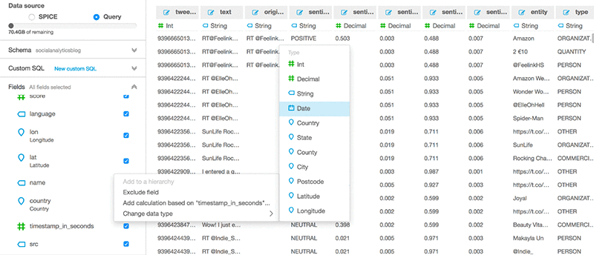

1. Select **Save and Visualize**.

## Step 4. Build the Dashboard

1. On the **All analyses** tab of the Amazon QuickSight start page, choose **New analysis**. You are taken to the **Your Data Sets** page.
2. Choose the data set and then choose **Create analysis**.
3. Choose **Add** on the application bar, and then choose **Add visual**.
4. In the **Fields list** pane, select the drop-down menu and select **type** and **tweetid**. If the Fields list isn't visible, choose **Visualize** to display it.

The field wells display the fields that are visualized.

1. Select **Field wells** to access the options.
2. In the **Fields list** pane, drag the **tweetids** field to the **Value** field wells.
3. Select **tweetid**, **Aggregate**, **Count Distinct.**
4. For **Visual types**, select the pie chart icon. Amazon QuickSight creates the visual.
5. Select **+ Add** to build the second visual for the dashboard.
6. Resize the second visual so it matches the size of the first visual and position it next to the first visual.

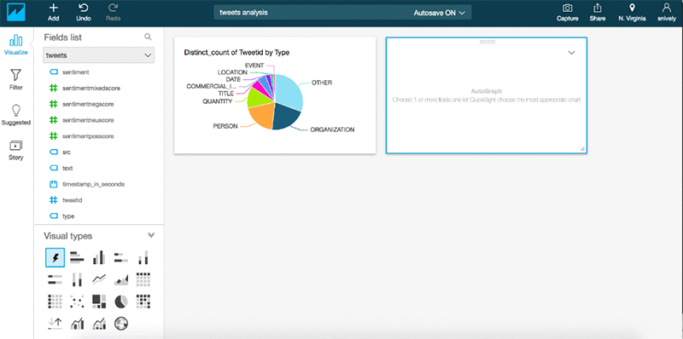

1. In the **Fields list** pane, select the drop-down menu and select **sentiment** and

##### timestamp_in_seconds.

1. In the **Field wells**, zoom either in or out of the time element until hours is shown.

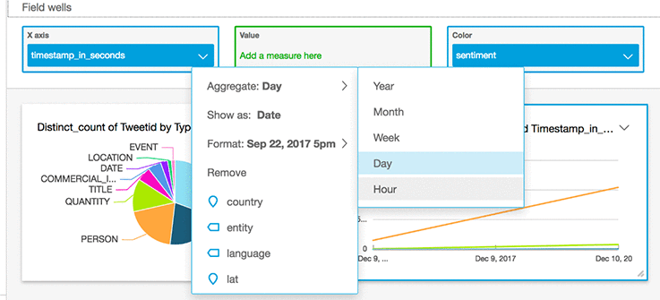

Amazon QuickSight creates the second visual.

1. Optional: Open the context menu (right-click) for the neutral line and select **Exclude NEUTRAL**.

Do this when there are a disproportionate number of neutral tweets affecting the visual display of the data range of the other tweets.

1. Select the **+ Add** option to build the third visual for the dashboard.
2. Position the third visual in the bottom half of the workspace.
3. For **Visual types**, select the table icon.

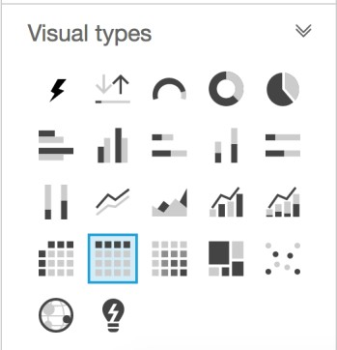

1. From the **Fields** list, select the following (to add the translated tweets to the visual):
   * language
   * text
   * originalText
2. On the toolbar, select **Filter**.
3. Select **One: language**.
4. Select **Custom filter**, **Does not equal**, and enter en.

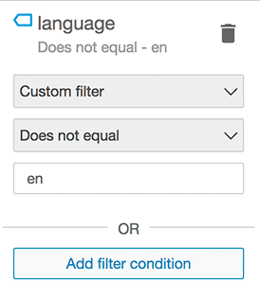

|  |
| --- |
| **Note**: You may need to adjust the column widths in the table view to see the last |
| column. |

Now you can view graphical representations of your tweet entities, tweet sentiment over time, and translated tweets.

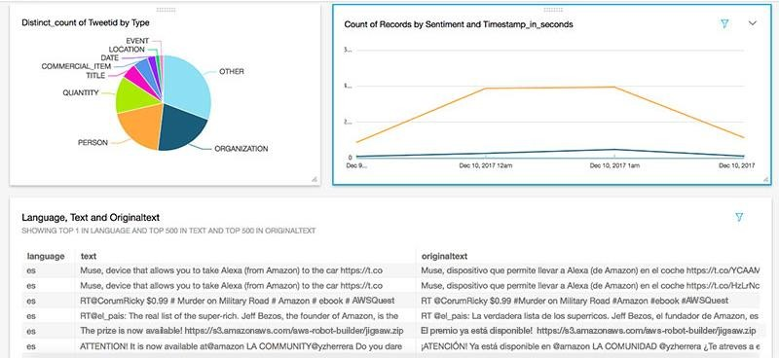

You can create additional visuals to create a more robust visualization of your tweet data.

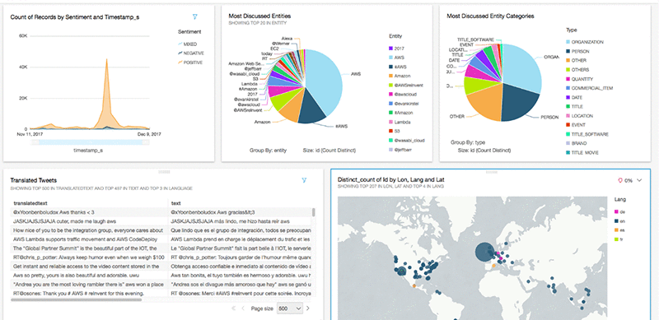

# Security

When you build systems on AWS infrastructure, security responsibilities are shared between you and AWS. This shared model can reduce your operational burden as AWS operates, manages, and controls the components from the host operating system and virtualization layer down to the physical security of the facilities in which the services operate. For more information about security on AWS, visit the [AWS Security Center](http://aws.amazon.com/security/).

## Solution Security

This solution’s Amazon Elastic Compute Cloud (Amazon EC2) instance has an encrypted Amazon EBS root volume. The Amazon Simple Storage Service (Amazon S3) bucket has S3- SSE AES 256 encryption enabled by default. The Twitter API credentials are stored in AWS Secrets Manager and the Amazon EC2 instance pulls the credentials out as part of the user data script. The solution’s VPC contains a public subnet with a security group that blocks all incoming traffic and allows outgoing traffic.

# Additional Resources

##### AWS services

|  |  |
| --- | --- |
| * [AWS CloudFormation](https://aws.amazon.com/cloudformation/) * [Amazon Elastic Compute Cloud](https://aws.amazon.com/ec2/) * [Amazon Kinesis Data Firehose](https://aws.amazon.com/kinesis/data-firehose/) * [AWS Lambda](https://aws.amazon.com/lambda/) * [Amazon Simple Storage Service](https://aws.amazon.com/s3/) * [Amazon Translate](https://aws.amazon.com/translate/) | * [Amazon Comprehend](https://aws.amazon.com/comprehend/) * [Amazon Athena](https://aws.amazon.com/athena/) * [AWS Glue](https://aws.amazon.com/glue/) * [Amazon QuickSight](https://aws.amazon.com/quicksight/) * [Amazon QuickSight](https://aws.amazon.com/quicksight/pricing/) Pricing |

# Appendix A: Cost Estimate Breakdown

This appendix breaks down the estimated cost to run the AI-Driven Social Media Dashboard solution with default settings in the US East (N. Virginia) Region. Note that this cost estimate breakdown was based on pricing as of the date of publication and is based on the following assumptions:

* Assumes 10,000 tweets per day; 300,000 per month (on the high end for most companies)
* Assumes keeping the last year of data
* Assumes tweets are 24/7 (will be lower in practice, which reduces costs)

Prices are subject to change. For full details, see the pricing webpage for each AWS service you will be using in this solution.

|  |
| --- |
| **Note:** Amazon QuickSight pricing is not included in this estimate since it is dependent |
| on the number of users each company has. Refer to [Amazon QuickSight Pricing](https://aws.amazon.com/quicksight/pricing/) to |
| determine your estimate. |

|  |  |
| --- | --- |
| **Service** | **Total Cost/Month** |
| Amazon Kinesis Data Firehose (includes tweet ingest, entities, and sentiment; approximately 2.7 GB/month) | $0.08 |
|  |  |
| AWS Lambda (256 MB of RAM allocated for approximately 43,200 invocations per month) | $148.74 |
|  |  |
| Amazon S3 (standard bucket) | $0.75 |
|  |  |
| Amazon EC2 (t2.medium) | $33.41 |
|  |  |
| Amazon EBS (8 GB of GP2) | $0.80 |
|  |  |
| Amazon Athena (total load into SPICE per day is approximately 200 MB) | $3.65 |
|  |  |
| AWS Secrets Manager (4 secrets for API) | $1.60 |
|  |  |
| **Total:** | **$189.03** |

# Appendix B: Auto-Generated Data Model

The AI-Driven Social Media Dashboard creates columns and data types in Athena after tweets are ingested, translated, and analyzed.

The following table contains tweets data types.

|  |  |
| --- | --- |
| Name | Type |
| **coordinates** | struct<type:string,coordinates:array<double>> |
| **retweeted** | boolean |
| **source** | string |
| **entities** | struct<hashtags:array<struct<text:string,indices:array<bigint>>>,urls:array<struct<u rl:string,expanded_url:string,display_url:string,indices:array<bigint>>>> |
| **reply_count** | bigint |
| **favorite_count** | bigint |
| **geo** | struct<type:string,coordinates:array<double>> |
| **id_str** | string |
| **timestamp_ms** | bigint |
| **truncated** | boolean |
| **text** | string |
| **retweet_count** | bigint |
| **id** | bigint |
| **possibly_sensitive** | boolean |
| **filter_level** | string |
| **created_at** | string |
| **place** | struct<id:string,url:string,place_type:string,name:string,full_name:string,country_cod e:string,country:string,bounding_box:struct<type:string,coordinates:array<array<arra y<float>>>>> |
| **favorited** | boolean |
| **lang** | string |
| **in_reply_to_screen_na me** | string |
| **user** | struct<id:bigint,id_str:string,name:string,screen_name:string,location:string,url:string  ,description:string,translator_type:string,protected:boolean,verified:boolean,followers  _count:bigint,friends_count:bigint,listed_count:bigint,favourites_count:bigint,statuse s_count:bigint,created_at:string,utc_offset:bigint,time_zone:string,geo_enabled:boole |

|  |  |
| --- | --- |
|  |  |
| Name | Type |
|  | an,lang:string,contributors_enabled:boolean,is_translator:boolean,profile_background  _color:string,profile_background_image_url:string,profile_background_image_url_h ttps:string,profile_background_tile:boolean,profile_link_color:string,profile_sidebar_ border_color:string,profile_sidebar_fill_color:string,profile_text_color:string,profile_ use_background_image:boolean,profile_image_url:string,profile_image_url_https:str ing,profile_banner_url:string,default_profile:boolean,default_profile_image:boolean> |
| **quote_count** | bigint |

The following table contains tweet_sentiment data types.

|  |  |
| --- | --- |
| Name | Type |
| **tweet_id** | bigint |
| **text** | string |
| **originaltext** | string |
| **sentiment** | string |
| **sentimentposscore** | double |
| **sentimentnegscore** | double |
| **sentimentneuscore** | double |
| **sentimentmixedscore** | double |

The following table contains tweet_entities data types.

|  |  |
| --- | --- |
| Name | Type |
| **tweet_id** | bigint |
| **entity** | string |
| **type** | string |
| **score** | double |

# Source Code

You can visit our [GitHub repository](https://github.com/awslabs/ai-driven-social-media-dashboard) to download the templates and scripts for this solution, and to share your customizations with others.