KiCad originalne komponente i bolje zamene za iste
2N3904  ⁠2N3904 datasheet | BC549 ⁠BC549 datasheet
LF353 ⁠LF353 Datasheet | OPA134 ⁠ OPA134 Datasheet
3046 ⁠LM3046 Texas Instruments | CA3046 ⁠CA3046 Datasheet
4558⁠ RC4558 datasheet | NE5532 ⁠NE5532x,
TL081 ⁠TL081 datasheet | AD8066 ⁠AD8066 Datasheet
LM393 ⁠LM393 Datasheet | LM393BIPWR ⁠LM393B, LM2903B, LM193, LM293, LM393 and LM2903 Dual Comparators datasheet

Tranzistor 2N3904 (Stara komponenta)
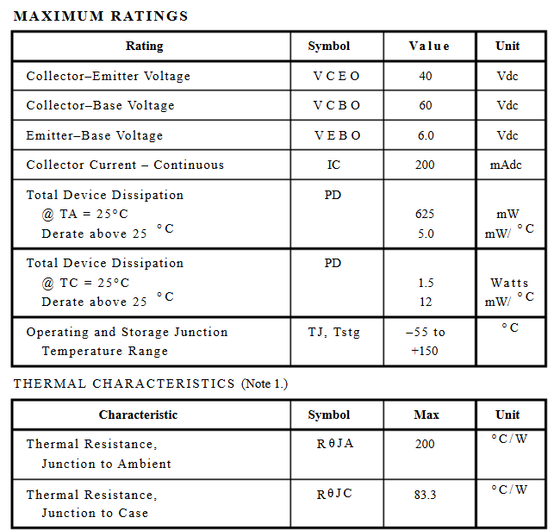
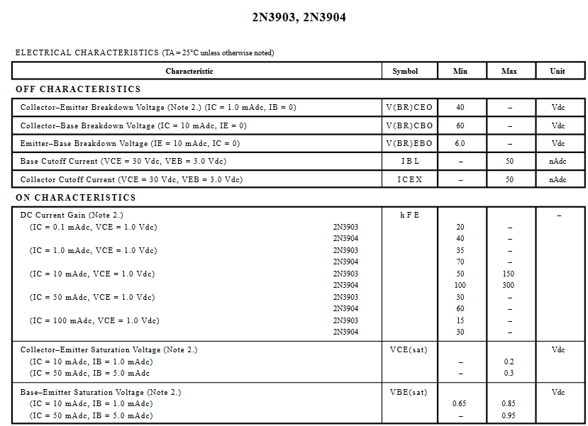
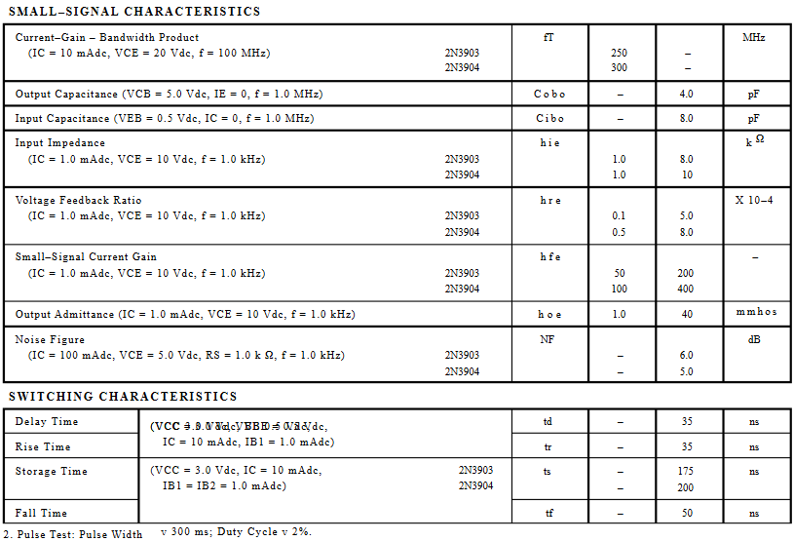
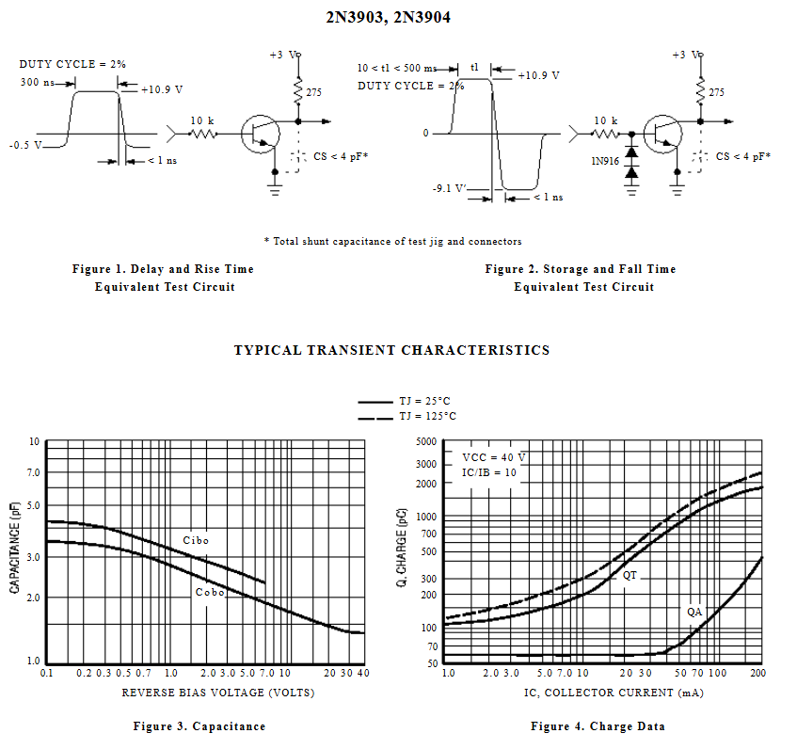

Zamena BC549 (Nova komponenta)
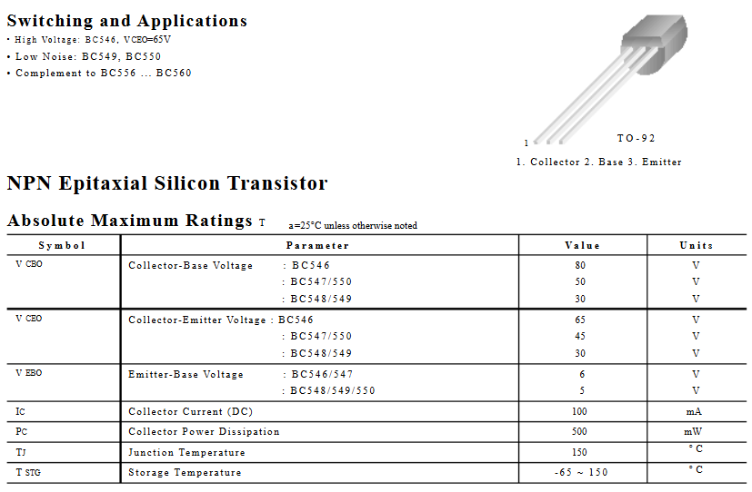
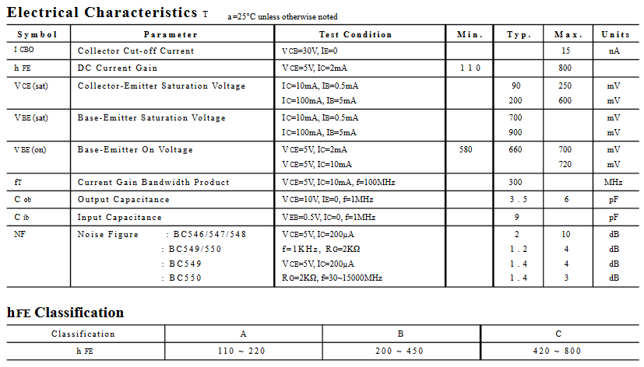

LF353 ⁠LF353 Datasheet (Stara komponenta)

• Input Offset Voltage of 5.0 mV Max (LF347B)
• Low Input Bias Current: 50 pA
• Low Input Noise Voltage: 16 nV/√Hz
• Wide Gain Bandwidth: 4.0 MHz
• High Slew Rate: 13V/µs
• Low Supply Current: 1.8 mA per Amplifier
• High Input Impedance: 1012 Ω
• High Common Mode and Supply Voltage Rejection Ratios: 100 dB
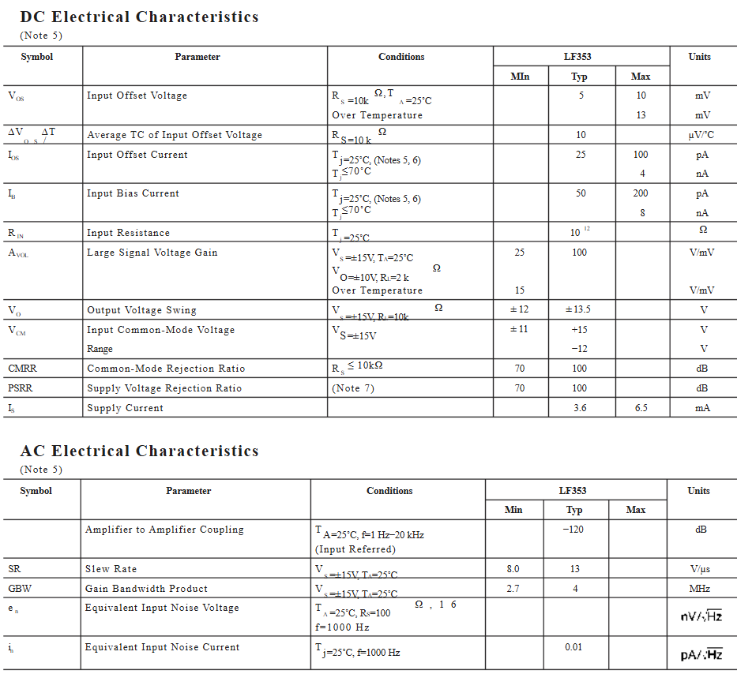

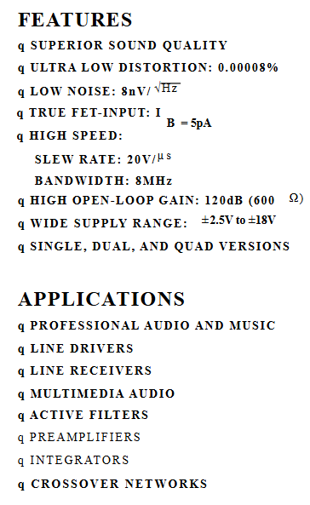
Zamena OPA134 (Nova komponenta)
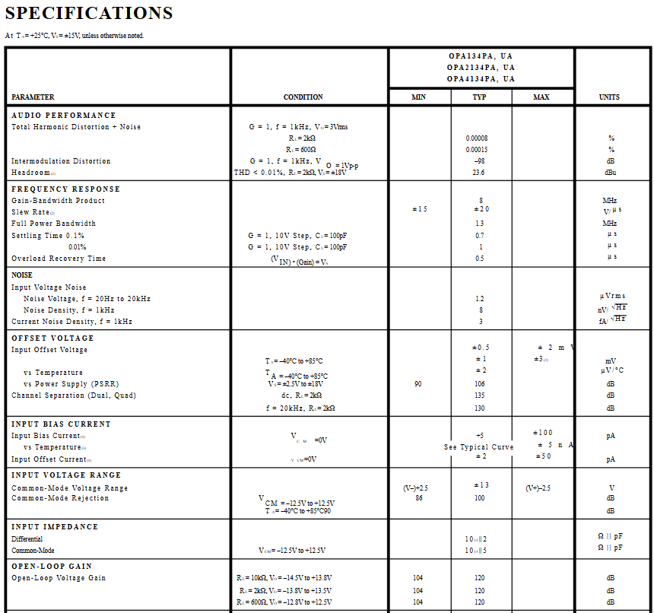
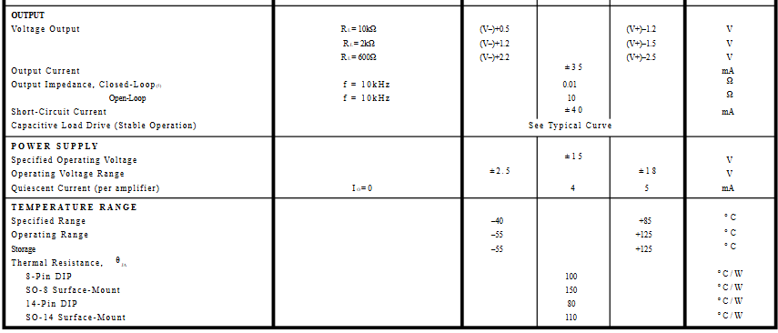
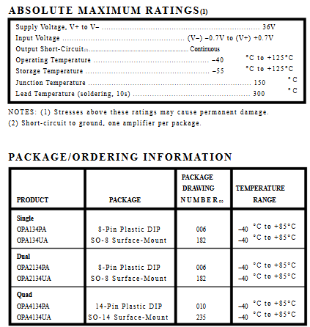

3046 ⁠LM3046 Texas Instruments (Stara komponenta)
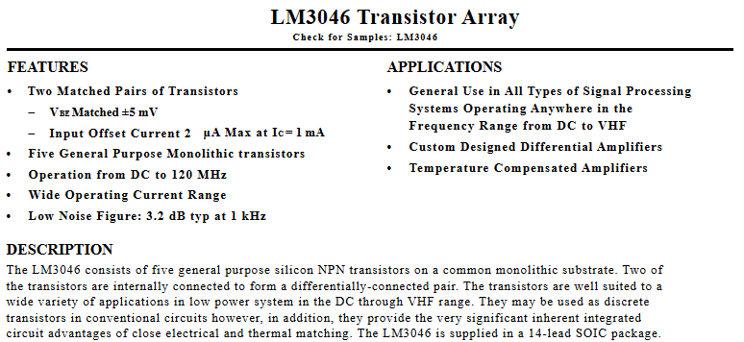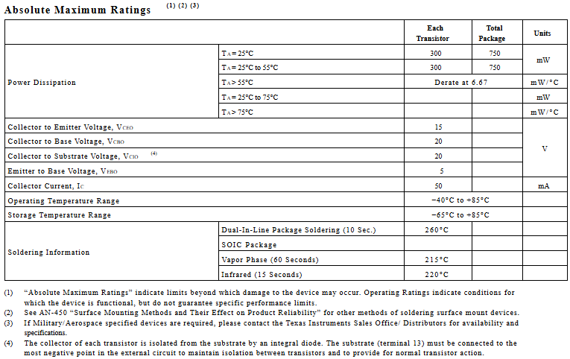
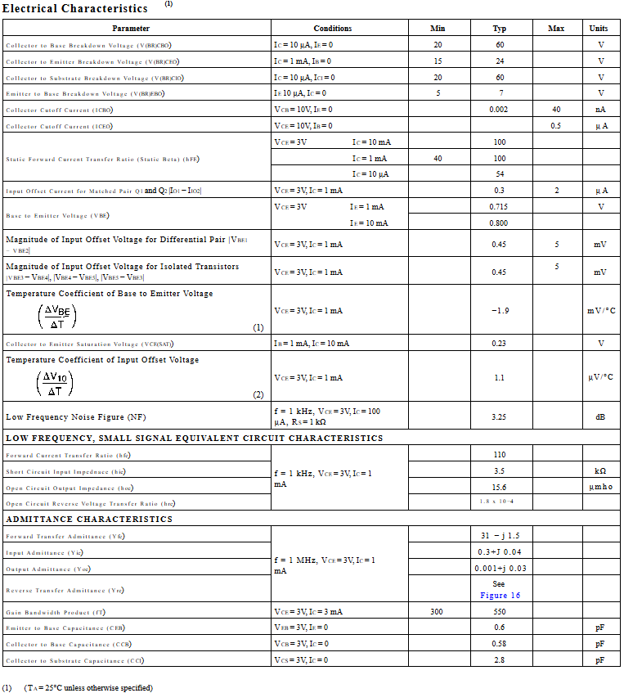

3. CA3046 ⁠CA3046 Datasheet (Nova komponenta)
Features
• Two Matched Transistors
- VBE Match . . . . . . . . . . . . . . . . . . . . . . . . . . . . . . ±5mV
- IIO Match. . . . . . . . . . . . . . . . . . . . . . . . . . . . 2µA (Max)
• Low Noise Figure . . . . . . . . . . . . . . . . 3.2dB (Typ) at 1kHz
• 5 General Purpose Monolithic Transistors
• Operation From DC to 120MHz
• Wide Operating Current Range
• Full Military Temperature Range
Applications
• Three Isolated Transistors and One Differentially
Connected Transistor Pair for Low Power Applications at
Frequencies from DC Through the VHF Range
• Custom Designed Differential Amplifiers
• Temperature Compensated Amplifiers
• See Application Note, AN5296 “Application of the CA3018
Integrated-Circuit Transistor Array” for Suggested
Applications
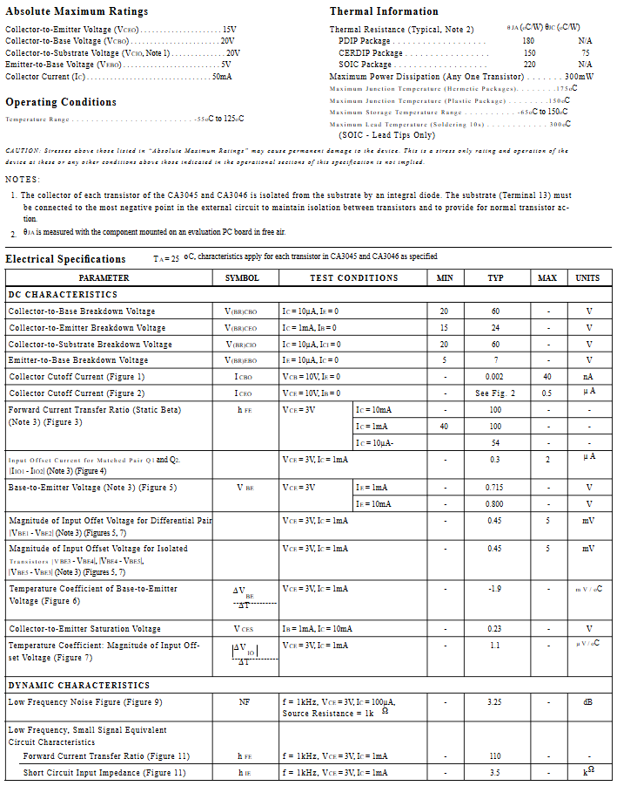
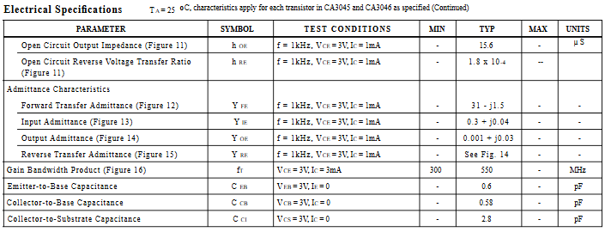

4558⁠ RC4558 datasheet (Stara komponenta)
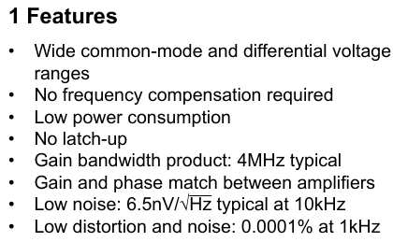
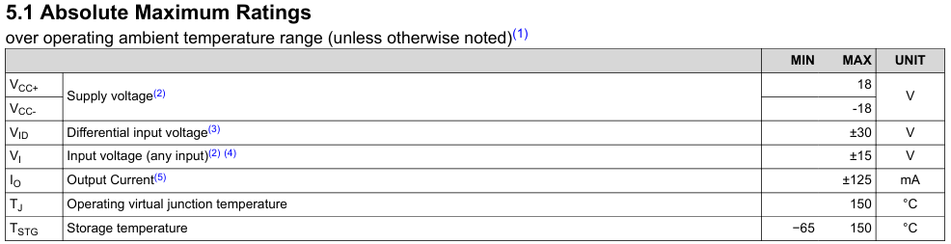
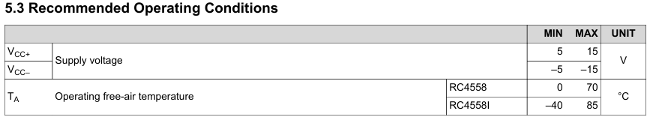
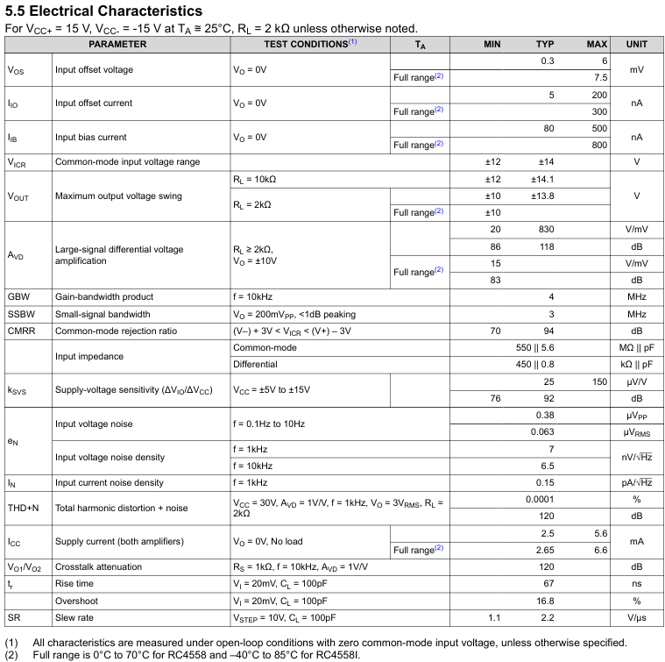
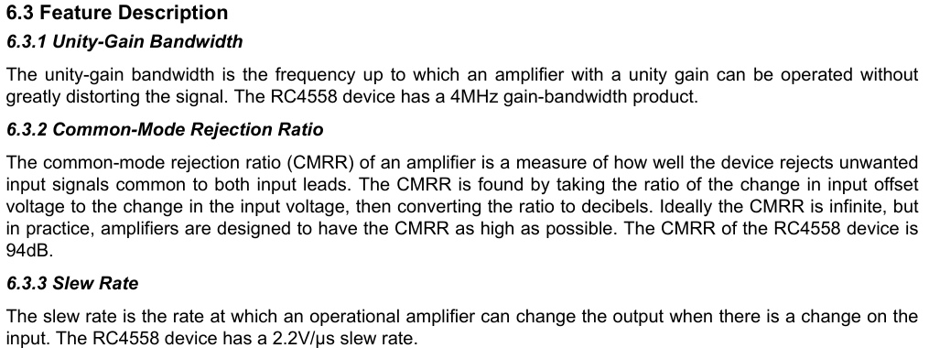

4. NE5532 ⁠NE5532x, (Nova komponenta)
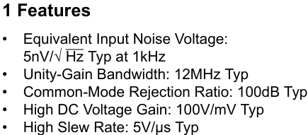
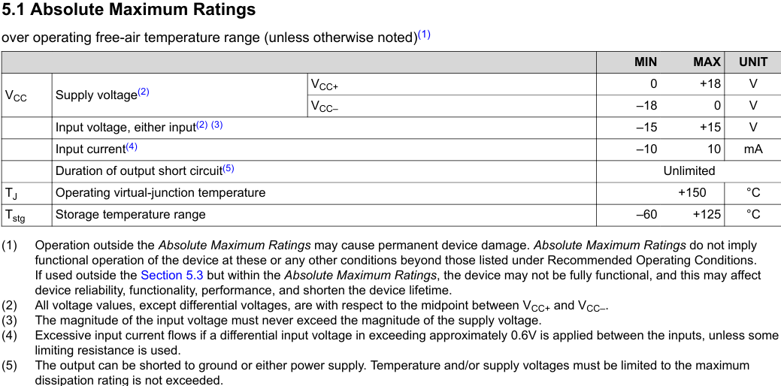
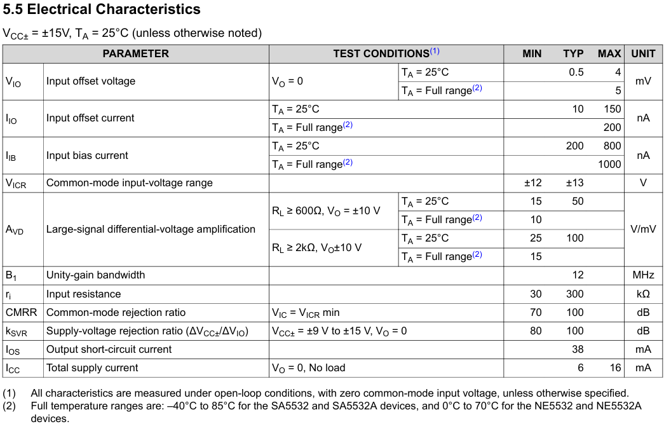
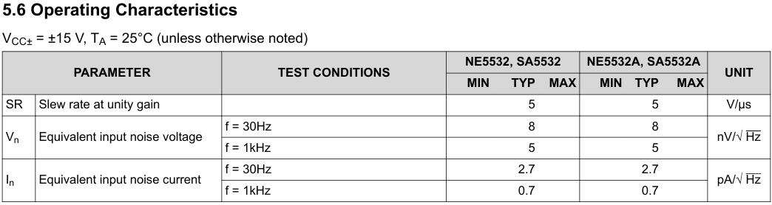

TL081 ⁠TL081 datasheet (Stara komponenta)
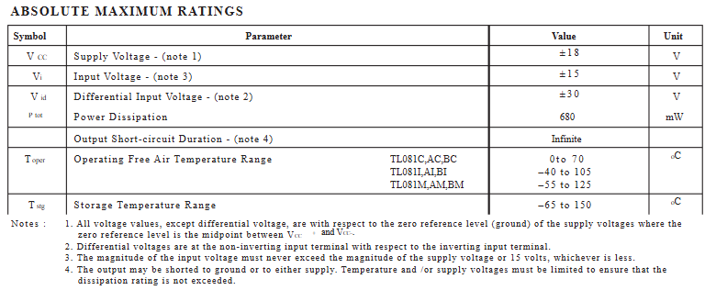
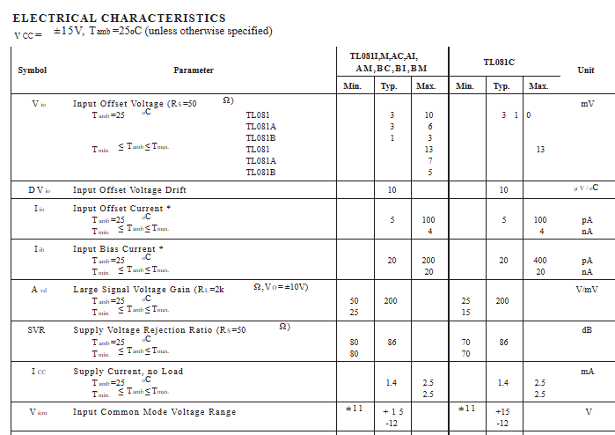
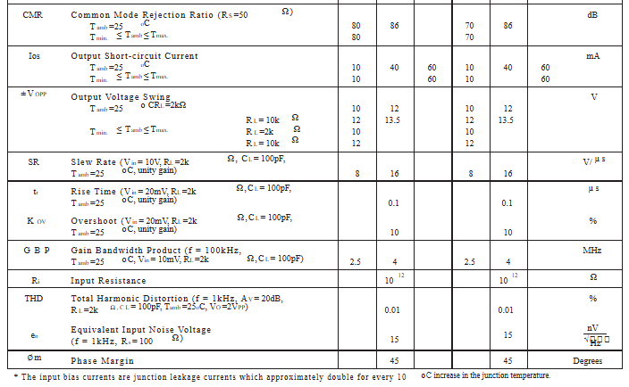
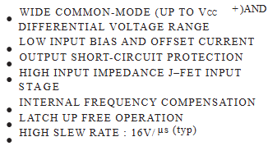

AD8066 ⁠AD8066 Datasheet (Nova komponenta)
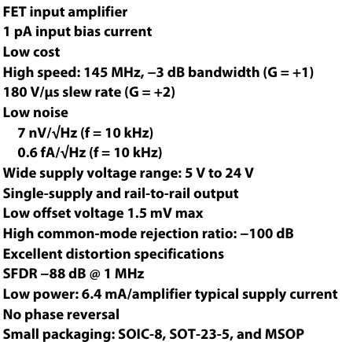
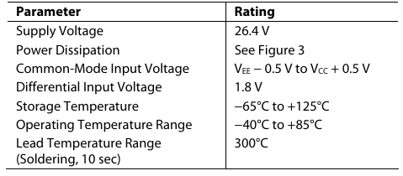
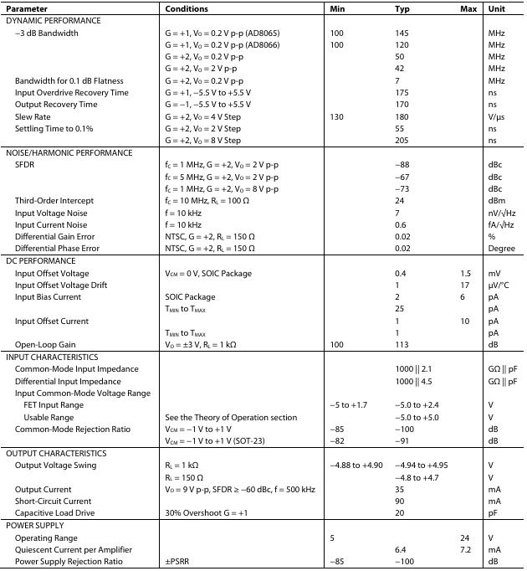
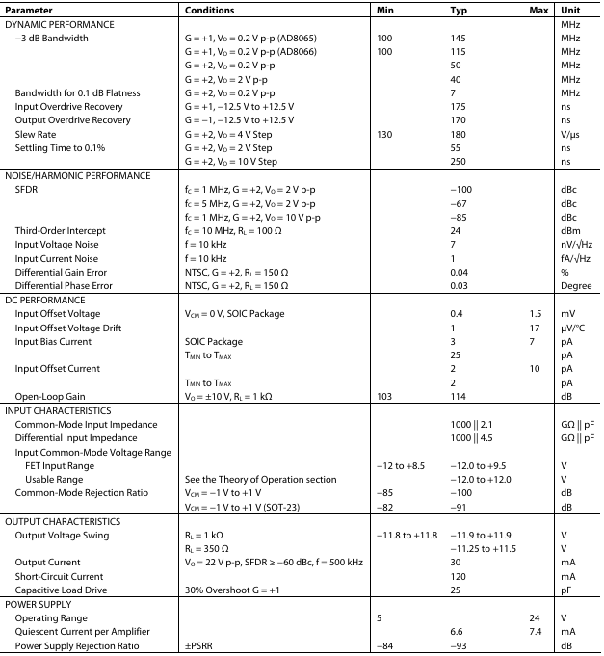
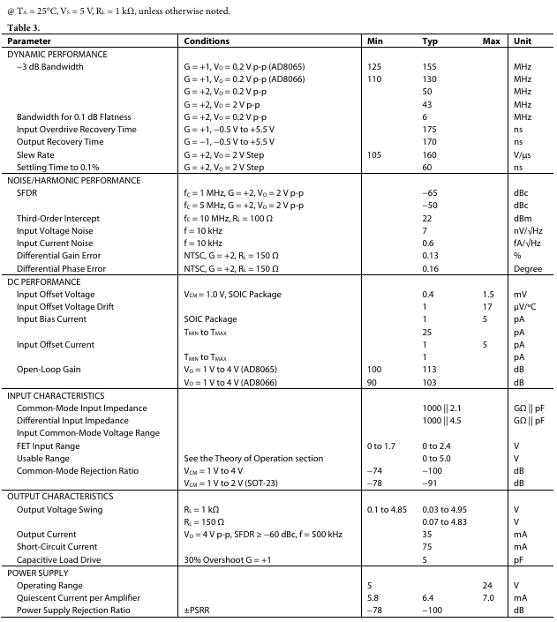

LM393 ⁠LM393 Datasheet (Stara komponenta)
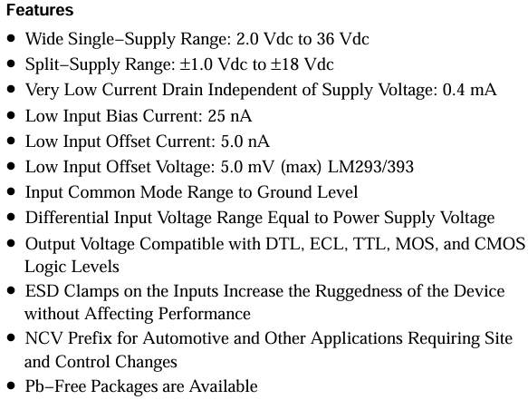
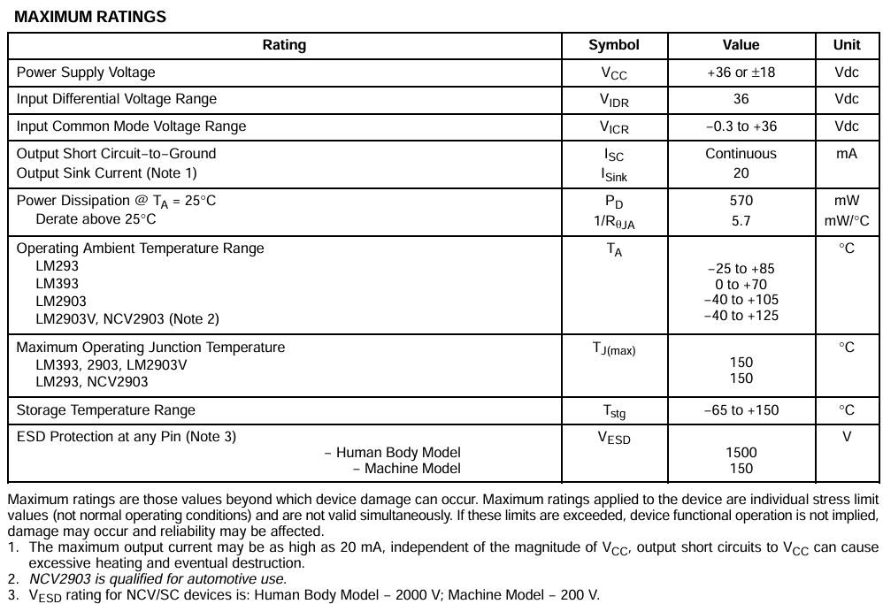
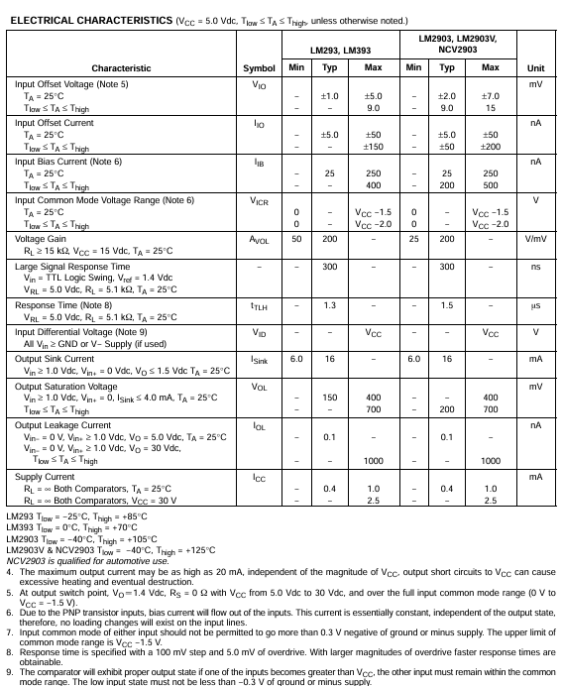

LM393BIPWR ⁠LM393B, LM2903B, LM193, LM293, LM393 and LM2903 Dual Comparators datasheet (Nova komponenta)
