**Jovan Vučeljić**

FRONT-END WEB DEVELOPER

**EDUCATION**

Economic Technician - Degree. 2007 – 2011

High school of Economics, Belgrade, Serbia.

Informatics - Withdrawn. 2011 – 2014

University of Belgrade, Faculty of Mathematics

Web Programing - Current. 2014 – Present

ICT College of Vocational Studies. Belgrade. Serbia.

**EXPERIENCE**

|  |  |
| --- | --- |
| April 2018 – Present | Development of website and web application dashboard, UI/UX |
| Frontend Developer |
| VR-All-Art |
| April 2018 – Present | Website maintenance, web support for VR activations, web controllers, simple apps |
| Web Developer |
| Digital Mind d.o.o. |
| Nov 2018 – Nov 2019 | Platform development, UI/UX, database development and management |
| Full Stack Developer |
| GladniSmo.com |

**SKILLS**

React.js, JavaScript, Node.js, Meteor.js, Git, MongoDB, SQL, PHP, HTML5, CSS3.

**ABOUT ME**

I am passionate about developing utilities that can help people irrespective of its age and capabilities. My areas of interest are User Experience, Web and Mobile Development. Love to spend my spare time in identifying the solutions of challenging problems. For me, programming is a way of thinking.

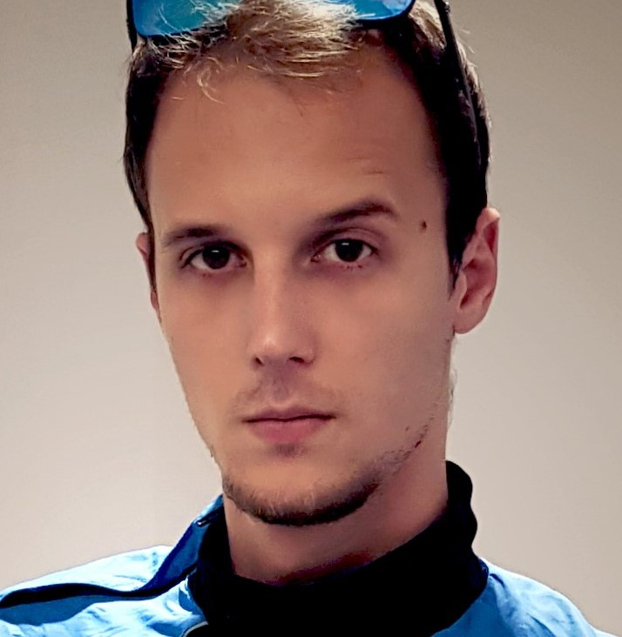

|  |  |
| --- | --- |
| **Date of Birth:** | 07.07.1992 |
| **Birth Place:** | Belgrade, Serbia |

**CONTACT**

|  |  |
| --- | --- |
| **Email:** | [jovanvuceljic@gmail.com](mailto:jovanvuceljic@gmail.com) |
| **Website:** | jovanvuceljic.github.io/portfolio/ |
| **Phone:** | +381645066848 |
| **Address:** | Bogdana Žerajića 15, Belgrade |
| **LinkedIn** | jovan-vuceljic |

**INTERESTS**

Problem solving

User Experience

Web and Mobile Applications

Science and Technology

**HOBBIES**

Gaming

Speedcubing

Cycling