1. How and when to use the AutoSum command in excel?

In the home bar, we have autosum in the top right corner and in the formula section. The basic function is to sum up all the values in a particular column when we click the autosum option. We select all the values from a dataset when there’s a huge number of data, we use autosum as it add up all the values and declare the sum value in the bottom of the selected column.

2. What is the shortcut key to perform AutoSum?

Alt + = is the shortcut key to perform autosum in the excel.

3. How do you get rid of Formula that omits adjacent cells?

Go to the file in the excel and select options in the left bottom of the page. Then select formulas and get to the error checking rules. Then uncheck the formulas which omit cells in a region. Then click ok. By this we can omit the formulas in the adjacent cells.

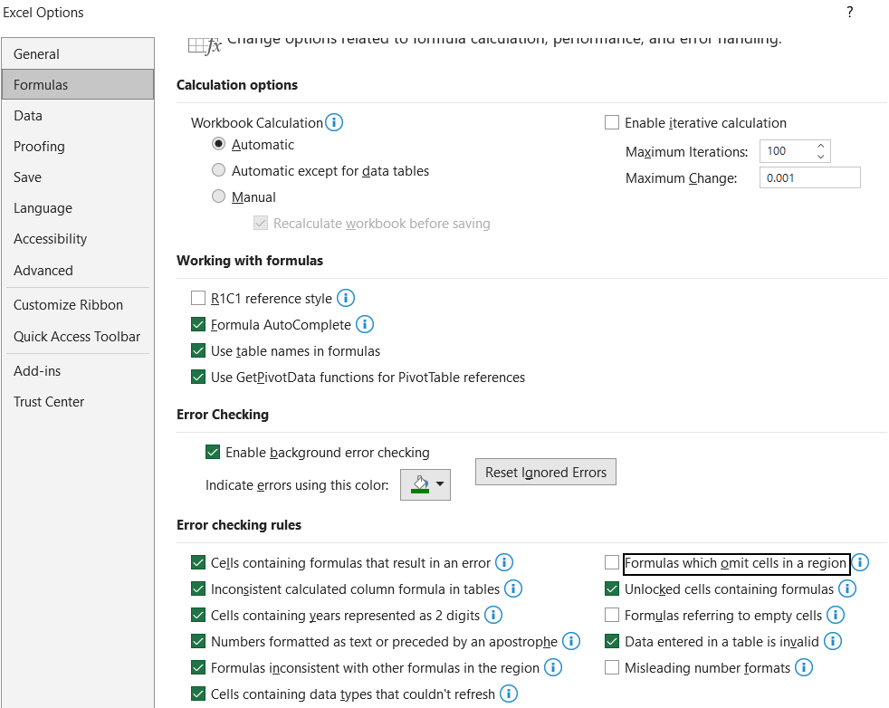

4. How do you select non-adjacent cells in Excel 2016?

Select ctrl key and hold it. Select all the cells to be selected. It may be non-adjacent cells. Then click shift + F8. Now you can select any cells that need to be select without holding the ctrl key.

The other way is to click Home then fid and select and navigate to Go to option. The Go to pop-up will appear in the screen. In the go to space, give the cell value and in the reference tab, give all the values which has to be select. Click OK.

5. What happens if you choose a column, hold down the Alt key and press the letters ocw in quick succession?

The pop-up for custom views open when we perform the above selection.

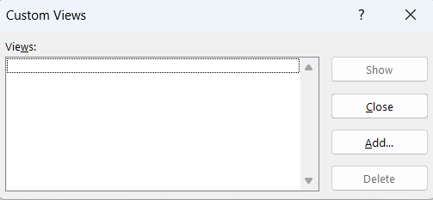

6. If you right-click on a row reference number and click on Insert, where will the row

be added?

It will insert an empty row in the selected row and the values present before in that row will be move to the next row.