1. **Using Insert Function, give examples of any function available in the different dropdowns present in the function library. For example AutoSum, Recently Used, Text, Date & Time, etc.**

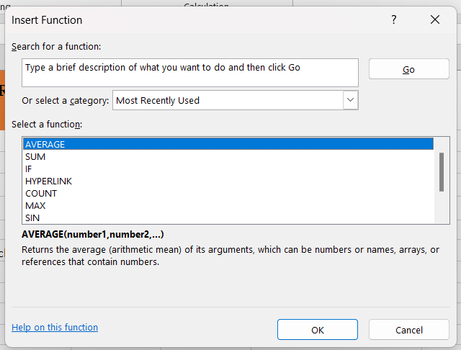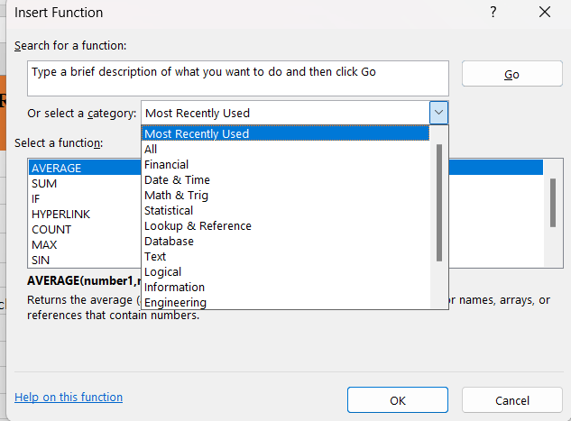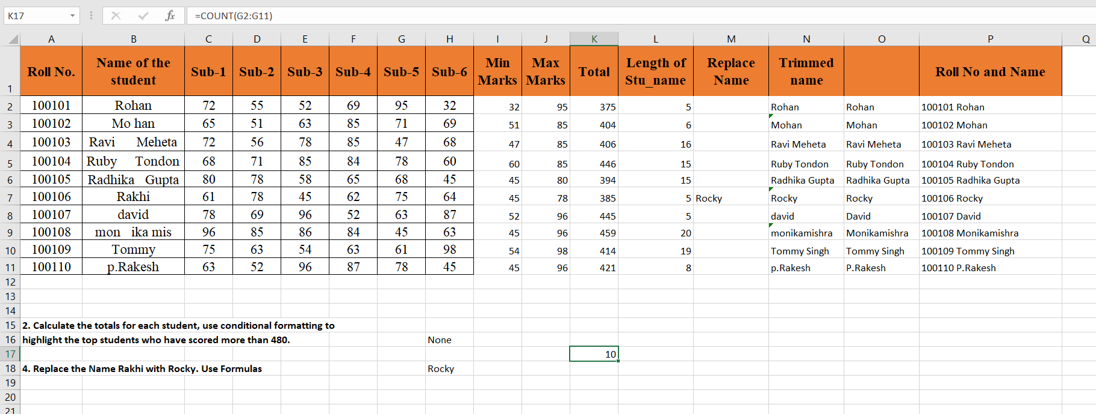

1. **What are the different ways you can select columns and rows?**

* Method 1: By clicking on the Select all button.
* Method 2: By the help of Mouse i.e by dragging the mouse
* Method 3: For Columns: Click on the cell and then press Ctrl+ Space For Rows: Click on the cell and then press Shift+ Space
* Method 4: Hold Shift and then click on the Row or Column
* Method 5: Hold Ctrl and then click on the Row or Column
* Method 6: Hold Shift and the press arrow key

1. **What is AutoFit and why do we use it?**

Autofit is a command in excel which is used to adjust the text into the cell quickly. We can use the autoFit command by following ways:

* Using the mouse double-click method
* Using the AutoFit option in the ribbon
* Using a keyboard shortcut:
  + For Rows: ALT + H+O+A
  + For Column: ALT + H+0+1

1. **How can you insert new rows and columns into the existing table?**

* Step 1: Click on the Insert Menu.
* Step 2: Click on table and then create the table. For Inserting the row or column
* Step 3: Right Click on the table where we want to add the row or column.
* Step 4: Then go to the insert option and then click on the option to add the row or column.

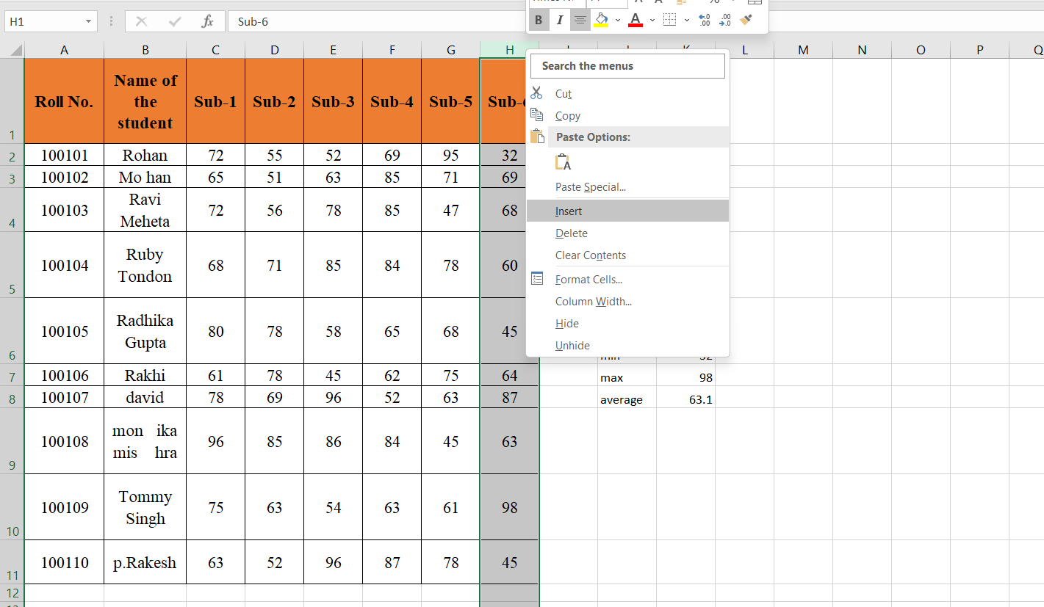

1. **How do you hide and unhide columns in excel?**

* **To Hide:**
  + Method 1: Select the Column, Right Click on column Number and then choose Hide.
  + Method 2: Select the column, Click on the Format option in Ribbon and then click on hide and unhide option click on hide column
  + Method 3: Select the column. And then press Ctrl +0
* **Unhide:-**
  + Method 1: In the Column no we will see two vertical lines then expand by mouse to unhide
  + Method 2: Select the multiple Columns, right Click on column Number and then choose Unhide
  + Method 3: Select the multiple column, Click on the Format option in Ribbon and then click on hide and unhide option Click on unhide column

1. **Create an appropriate table within the worksheet and use different functions available in the AutoSum command**.

