**1. What do you mean by AutoComplete feature in Excel and what are the benefits of using this feature?**

AutoComplete is a feature in Excel that helps you enter data faster and with fewer errors by suggesting matches from existing text entries in the same column. You can accept the suggested match by pressing Enter or a directional key. AutoComplete also works for formulas, functions, names, and text strings after you type an = sign and some letters or a display trigger. You can insert an item from the drop-down list into the formula by using an insert trigger. The benefits of using this feature include minimizing typing and syntax errors while quickly inserting functions and arguments.

**2. Explain working with workbooks and working with cells.**

An Excel file, is also referred as a workbook, contains one or more spreadsheets, or worksheets. Each box in the worksheet area is referred to as a cell. Each cell has a cell address, which is composed of a column reference and a row reference Also the worksheet contains cells you can use to start entering and editing data.

**3. What is fill handle in Excel and why do we use it?**

Fill handle in excel can be defined as, it is a feature to extend (and fill) several numbers, dates, or even text to other cells. In the active cell of the spreadsheet, the fill handle is a small black box at the bottom-right corner.

**4. Give some examples of using the fill handle.**

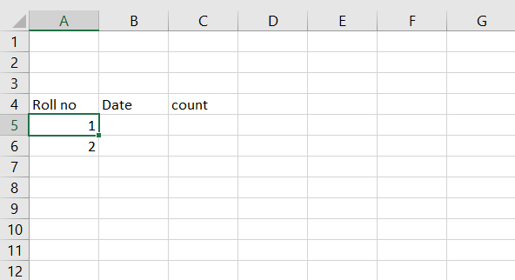

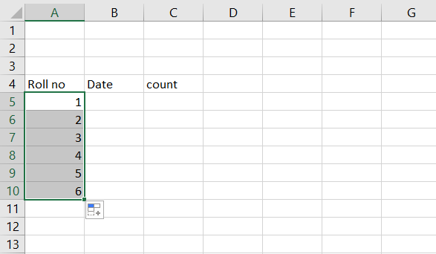

**5. Describe flash fill and what the different ways to access the flash fill are.**

Flash Fill automatically fills your data when it senses a pattern. For example, you can use Flash Fill to separate first and last names from a single column or combine first and last names from two different columns. Ex: Ctrl + E.

**6. Extract first name and last name from the mail id and then from the address column, extract the city, state, and pin code using the flash fill. Given below is an example of the columns you have to create. Paste the screenshot of what you have created using the flash fill command.**

**Example: Mail Id, Address, First name, Last name, State, City, Pincode**

