**1. In the below elements which of them are values or an expression? eg:- values can be integer or string and expressions will be mathematical operators.**

* - Expressions

'hello' - Strings

-87.8 - Integer

- - Expression

/ - Expression

* - Expression

6 - Integer

**2. What is the difference between string and variable?**

Strings are the set of charachters (Alphabets) that is used in inputs and to print the output. Strings are declared in python within single quotes and double quotes. Whereas variable is the one which stores the value in it.

Ex: String: “Hello World”, ‘Welcome’

Variable: num_1 = 10

num_2 = 30

**3. Describe three different data types.**

* Integer - This value is represented by int class. It contains positive or negative whole numbers. Ex: number = 10
* Float - This value is represented by the float class. It is a real number with a floating-point representation. Ex: length = 10.8
* Strings - A string is a collection of one or more characters put in a single quote, double-quote, or triple-quote. Ex: name = “Jebastian”

**4. What is an expression made up of? What do all expressions do?**

* **Arithmetic expression:** A combination of numeric values, operators. The result of this type of expression is also a numeric value. The operators used in arithmetic operators are addition, subtraction, etc.

+ - Addition

– - Subtraction

* - Multiplication

/ - Division

// - Quotient

% - Remainder

** - Exponentiation

* Relational expression: It compares the both sides of the operands accordingly.

> : Greater than

< : Less than

>= : Greater than equal to

<= : Less than equal to

* Logical Expression : By specific conditions, these expressions compare both and result in either True or False.

and - It returns true if both are true otherwise returns false

or - It returns true if at least one is true

not - It returns true if condition one is false

**5. This assignment statements, like spam = 10. What is the difference between an expression and a statement?**

Expressions can be assigned or used as operands. Whereas statements can only be declared.

**6. After running the following code, what does the variable bacon contain?**

**bacon = 22**

**bacon + 1**

The value 22 is stored in the variable bacon. Since we have bacon+1, the value will be incremented by 1. And the final answer will be 23 and it will be relaced in the bacon variable.

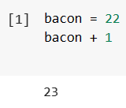

**7. What should the values of the following two terms be?**

**'spam' + 'spamspam'**

**'spam' * 3**

The two terms perform the concatenation which is the special feature in python. The two statements return the same values as the output.

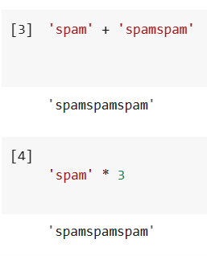

**8. Why is eggs a valid variable name while 100 is invalid?**

Eggs is the character(alphabet) and it starts with alphabet and doesn’t starts with numbers nor special characters. Whereas 100 is an integer and integer can’t be a variable name.

**9. What three functions can be used to get the integer, floating-point number, or string version of a value?**

int() for integer, float() for float and str() for string.

**10. Why does this expression cause an error? How can you fix it?**

**'I have eaten ' + 99 + ' burritos.'**

We can’t concatenate string with an integer. So we can convert the integer into string by including single quotes to it.

