OIM3641 Assignment 2 - Report
Author: Joshua Bell
Course: OIM3641 - AI Driven App Development (Spring 2026)
Dataset: UCI Bank Marketing (id 222), 8,000-row sample
Repo: https://github.com/JovonBell/OIM3641/tree/main/assignments/assignment-02

1. PyCaret model comparison table
Output of compare_models() ranked by accuracy. Random Forest Classifier wins (top row, highlighted) at 0.8998 mean accuracy across 10-fold CV. The full leaderboard is committed as pycaret_leaderboard.csv.
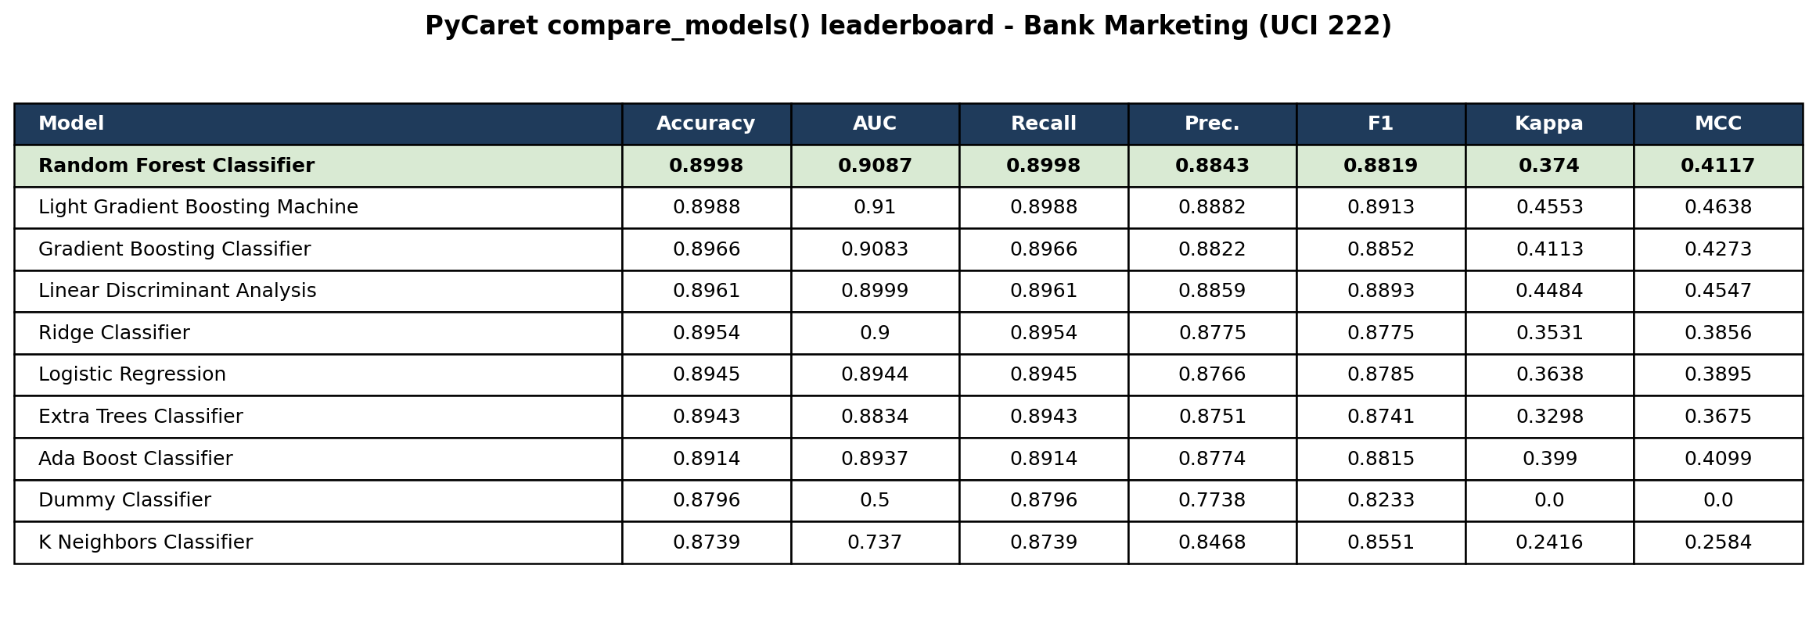

2. FastAPI Swagger UI - successful test prediction
Live capture of the Swagger UI at http://127.0.0.1:8765/docs after clicking 'Try it out' and 'Execute' on POST /predict with the default request body. Server response: HTTP 200 with the JSON {"prediction": "no", "score": 0.86}.
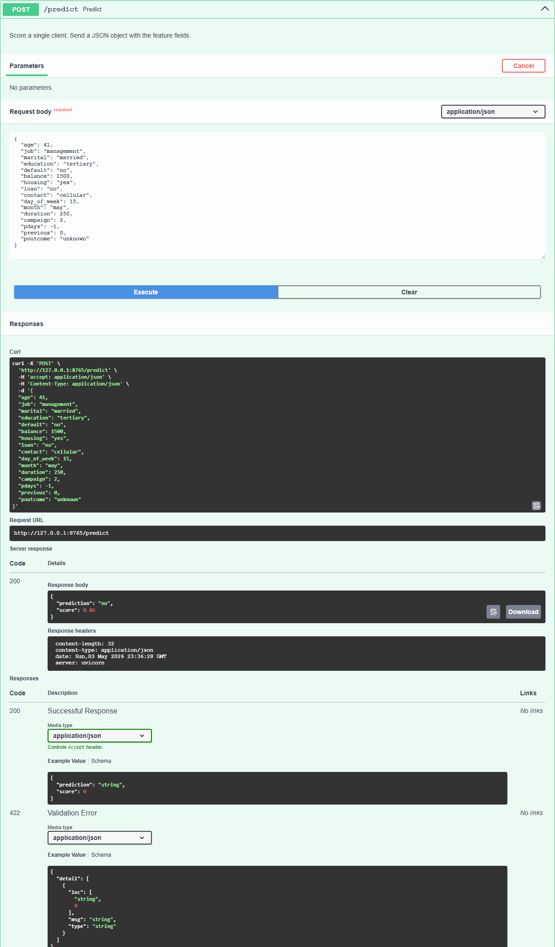

3. Outcome summary
PyCaret's low-code workflow surfaced Random Forest as the strongest candidate (0.8998 CV accuracy). Replicating it manually with scikit-learn (ColumnTransformer + train_test_split + RandomForestClassifier) on an 80/20 split scored 0.8975 - within 0.2 pts of PyCaret's 10-fold mean, as expected given the methodological differences. The dataset is heavily imbalanced (~88% 'no'), so accuracy understates the real challenge: the 'yes' class recall is only 0.35 in the manual sklearn report. PyCaret wins for breadth-first model discovery; sklearn wins for an auditable production pipeline.

