Date: 07-03-2025

No. Invoice : KING 3

Bill to: RYAN LIM

INVOICE
Payment Method:
Bank Name: Public Bank Account Number: 312863415 Name: King Seng Wei

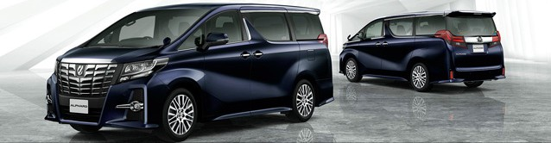
DATE | ITEM DESCRIPTION | PRICE | QTY | TOTAL

07-03-2025 | KLIA - Melaka | RM 300 | 1 | RM 300
 | Mazda CX-30

RM 300
TOTAL
THANK YOU

