UD-2 Tasca 01

Exercici1

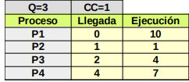

FIFO
X | X | X | X | X | X | X | X | X | X
 |  |  |  |  |  |  |  |  |  | X
 |  |  |  |  |  |  |  |  |  |  | X | X | X | X
 |  |  |  |  |  |  |  |  |  |  |  |  |  |  | X | X | X | X | X | X | X

SRTF
X |  |  |  |  |  |  |  |  |  |  |  |  | X | X | X | X | X | X | X | X | X
 | X
 |  | X | X | X | X
 |  |  |  |  |  | X | X | X | X | X | X | X

RR
X | X | X |  |  |  |  |  |  |  | X | X | X |  |  |  |  | X | X | X |  | X
 |  |  | X
 |  |  |  | X | X | X |  |  |  |  |  |  | X
 |  |  |  |  |  |  | X | X | X |  |  |  |  | X | X | X |  |  |  | X

Exercici2
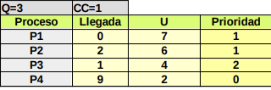

FIFO

X |  |  |  |  | X | X | X | X | X | X
 |  |  |  |  |  |  |  |  |  |  | X | X | X | X | X | X
 | X | X | X | X
 |  |  |  |  |  |  |  |  |  |  |  |  |  |  |  |  | X | X

SRFT

X
 | X | X | X | X

RR
X | X |  |  |  |  |  |  | X | X |  |  |  |  |  |  | X
 |  |  |  |  |  | X | X |  |  |  |  |  |  | X | X
 |  |  |  | X | X |  |  |  |  |  |  | X | X
 |  | X | X |  |  |  |  |  |  | X | X

