## Tests for Step1.py

## Written by B00319125

## 2017-04

## Step 1

### Functional Requirements

|  |  |  |  |
| --- | --- | --- | --- |
| Functional Requirement | Description of Functionality | Description of Test | Test Case # |
| 1 | Create a six digit random number | Capacity to create a new 6 digits random number | 1 |
| 2 | Maintain a list of currently used random numbers | Save the random numbers created in a list | 2 |
| 3 | Ensure number is unique | Find if the created random number is in the list of all random numbers | 3 |
| 4 | Have a “Request” class with all of the attributes listed in project brief | Ensure the exists of the class Request | 4 |
| 5 | Request class must have appropriate __init__ and display_all methods | Ensure if the __init__ and display_all methods are properly created and functionals | 5 |
| 6 | Must create an instance of the Request class, with a unique random ID, allow the user to populate all attributes of the class and, when input is complete, call the display_all method to display details of the instance attributes. | Verify the properly use and operations of the Class Request and their methods | 6 |

### Test Cases

|  |  |  |  |
| --- | --- | --- | --- |
| Test Case | Description of Functionality | Test Data | Expected Result |
| 1 | Create a six digit random number | None | New 6 digits Random Number |
| 2 | Maintain a list of currently used random numbers | None | A way to save in memory all the random numbers created |
| 3 | Ensure number is unique | Request ID in memory | Save the current request id in memory if it not exists in the list of all request |
| 4 | Ensure the exists of the class Request | None | The class Request already created |
| 5 | Request class must have appropriate __init__ and display_all methods | None | Check if the Request class must have appropriate __init__ and display_all methods are correctly created |
| 6 | Must create an instance of the Request class, with a unique random ID, allow the user to populate all attributes of the class and, when input is complete, call the display_all method to display details of the instance attributes. | None | The successful operation if the Request class methods |
|  |  |  |  |

### Test Results & Actions

|  |  |  |
| --- | --- | --- |
| Test Case | Actual Results | Action Required |
| 1 | Success | None |
| 2 | Success | None |
| 3 | Success | None |
| 4 | Success | None |
| 5 | Success | None |
| 6 | Success | None |

### Evidence

Test Case 1 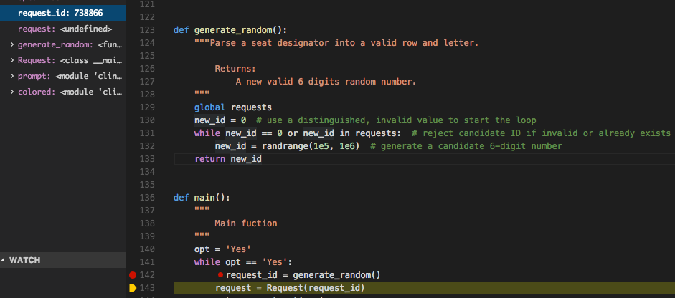

In the screenshot we can see the script1.py in runtime and the “request_id” are created successfully in memory and match with the requirement of the 6 digits.

Test Case 2 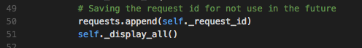

In the screenshot we can see the line 50, we save the current “request_id “ when the request is successfully created. The request list is a global scope list.

Test Case 3

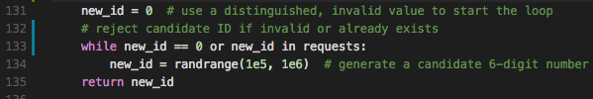

Test Case 4

The class Request

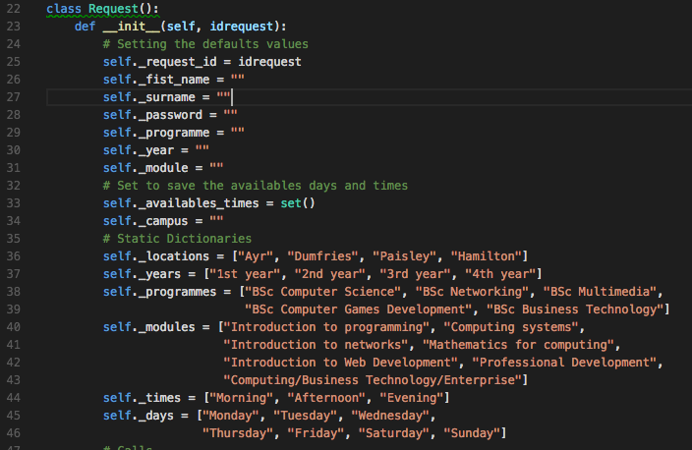

Test Case 5

The __init__ method

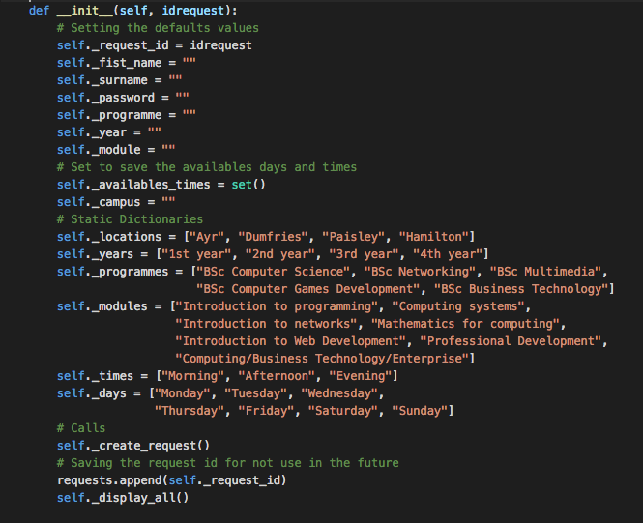

The display_all method

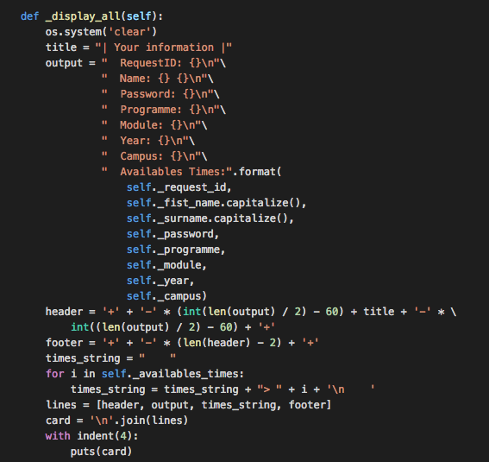

Test Case 6

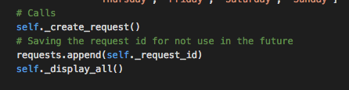

first create the request with the current valid random id, then print the request with the display_all method:

